Supplementary Table 1: Summary and sources of Markov model parameters.
Model parameters | Values | Sensitivity analysis |  | Sources
 |  | Low value | High value
Annual death rate (‰) | 7.13 | 6.21 | 8.84 | Nation Bureau of Statistics [5]
Newly HIV infections rate (‰) | 0.024 | 0.10 | 0.41 | Liu XJ, et al [6]
HIV mortality (%)
Total HIV population | 2.46 | 2.31 | 2.59 | Liu XJ, et al [6]
Viral suppression population | 0.56 | 0.32 | 1.02 | Chen Y, et al [7]
Viral suppression rate (%)
Rapid group | 73.5 | 68.3 | 82.1 | The present research
Conventional group | 61.1 | 57.9 | 66.3 | The present research
Viral suppression rate based second-line ART (%) | 73.7 | 69.3 | 79.5 | Li HQ, et al [8]
Health utility value
Health status | 1.00 | 1.00 | 1.00 | Assumption
HIV/AIDS status | 0.73 | 0.69 | 0.77 | Fan C, et al [9]
Rapid ART status | 0.83 | 0.45 | 1.00 | Honiden S, et al [10]
Conventional ART status | 0.83 | 0.45 | 1.00 | Honiden S, et al [10]
Death status | 0 | 0 | 0 | Assumption
Average cost ( CNY/years)
HIV patients | 11810 | 9840 | 14210 | Fan C, et al [9] and Honiden S, et al [10]
Rapid group | 11150 | 10050 | 13180 | The present research
Conventional group | 12470 | 11460 | 13700 | The present research
ART: Antiretroviral therapy; CHSY: China Health Statistical Yearbook 2019.

Supplementary Table 2: Baseline characteristics of HIV patients with rapid ART strategies or conventional ART strategies before PSM.
Characteristics | Rapid group (n = 123) | Conventional group (n = 334) | Total (n = 457) | Statistical values | P-value
age at registration (years) | 38 (30–53) | 35 (30–49) | 36 (30–50) | -1.178§ | 0.239
Age group (years) |  |  |  | 1.417† | 0.492
18–29 | 26 (21.1) | 80 (24.0) | 106 (23.2)
30–50 | 61 (49.6) | 174 (52.0) | 235 (51.4)
>50 | 36 (29.3) | 80 (24.0) | 116 (25.4)
Gender (Male ) | 113 (91.9) | 304 (91.0) | 417 (91.2) | 0.082† | 0.775
BMI (kg/m²) | 21.73 ± 3.04 | 22.48 ± 3.55 | 22.27 ± 3.43 | 2.081* | 0.038
CD4⁺ count (cells/μL) | 204.00 ± 178.31 | 268.50 ± 184.27 | 272.42 ± 184.63 | 3.272* | 0.001
CD4⁺ count group |  |  |  | 14.959† | 0.001
≤200 (cells/μL) | 60 (48.8) | 101 (30.2) | 161 (35.2)
201–350 (cells/μL) | 39 (31.7) | 123 (36.8) | 162 (35.4)
>350(cells/μL) | 24 (19.5) | 110 (32.9) | 134 (29.3)
Comorbidity | 16 (13.0) | 6 (1.8) | 22 (4.8) | 24.660† | < 0.001
Initial ART regimens |  |  |  | 0.283† | 0.595
TDF + 3TC + EFV (TLE) | 94 (76.4) | 263 (78.8) | 357 (78.1)
Others | 29 (23.6) | 71 (21.2) | 100 (21.9)
Data are presented as n (%), median (interquartile range) or mean ± standard deviation. §Z values. †χ² values. *t values. ART: Antiretroviral therapy; BMI: Body mass index; CD: cluster of differentiation; HIV: human immunodeficiency virus; TLE: Tenofovir (TDF), plus Lamivudine (3TC), and Efavirenz (EFV).

Supplementary Table 3: Baseline and clinical outcomes characteristics of HIV patients with rapid ART strategies or conventional ART strategies after PSM.
Characteristics | Rapid group (n = 113) | Conventional group (n = 113) | Total (n = 226) | Statistical values | P-value
Age at registration (years) | 38 (30–53.5) | 35 (30–48.5) | 37 (30–51) | -0.613§ | 0.540
Age group |  |  |  | 1.654† | 0.437
18–29 years | 32 (28.3) | 30 (26.5) | 62 (27.4)
30–50 years | 47 (41.6) | 56 (49.6) | 103 (45.6)
>50 years | 34 (30.1) | 27 (23.9) | 61 (27.0)
Gender (Male) | 104 (92.0) | 107 (94.7) | 211 (93.4) | 0.643† | 0.423
BMI (kg/m²) | 21.81 ± 3.13 | 22.01 ± 2.91 | 21.91 ± 3.02 | -0.491 | 0.624
CD4⁺ count (cells/μL) | 238.95 ± 177.64 | 275.38 ± 187.56 | 257.16 ± 183.17 | -1.499* | 0.135
CD4⁺ count group |  |  |  | 3.619† | 0.164
≤200 (cells/μL) | 52 (46.0) | 38 (33.6) | 90 (39.8)
201–350 (cells/μL) | 52 (46.0) | 64 (56.6) | 116 (51.3)
>350 (cells/μL) | 9 (8.0) | 11 (9.7) | 20 (8.8)
Comorbidity | 3 (2.7) | 3 (2.7) | 6 (2.7) | < 0.001† | 1.000
Co-infection | 6 (5.3) | 6 (5.3) | 12 (5.3) | < 0.001† | 1.000
Initial ARTregimen |  |  |  | 0.242† | 0.623
TDF + 3TC + EFV (TLE) | 88 (77.9) | 91 (80.5) | 179 (79.2)
Others | 25 (22.1) | 22 (19.5) | 47 (20.8)
Median time from diagnosis to treatment initiation (days) | 5 (3–7) | 25 (14–42) | 8 (5–25) | -13.019§ | < 0.001
Clinical outcomes
Virology suppression^{ǂ} | 83 (73.5) | 69 (61.1) | 152 (67.3) | 3.938† | 0.047
Immunological indicators¶ | 96 (85.0) | 97 (85.8) | 193 (85.4) | 0.035† | 0.851
Data are presented as n (%), median (interquartile range) or mean ± standard deviation. ^{ǂ}HIV-1 RNA < 20 (copies/mL) after 1 year of ART. ¶CD4+ count increases >100 (cells/μL) or >30% after 1 year of ART. §Z values. †χ² values. *t values. 3TC: Lamivudine; ART: Antiretroviral therapy; BMI: Body mass index; EFV: Efavirenz; HIV: Human immunodeficiency virus; PSM: Propensity score matching; TDF: Tenofovir; TLE: Tenofovirplus Lamivudineand Efavirenz.

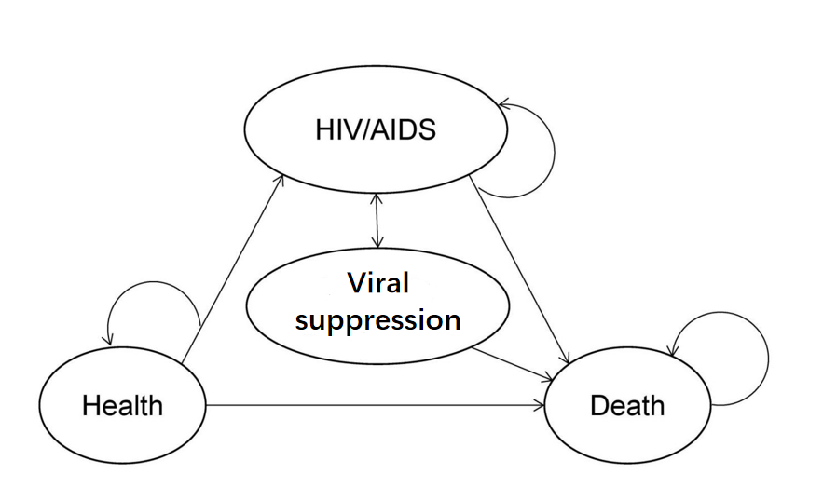
Supplementary Figure 1: The HIV development process in Markov model in ART status. ART: Antiretroviral therapy.

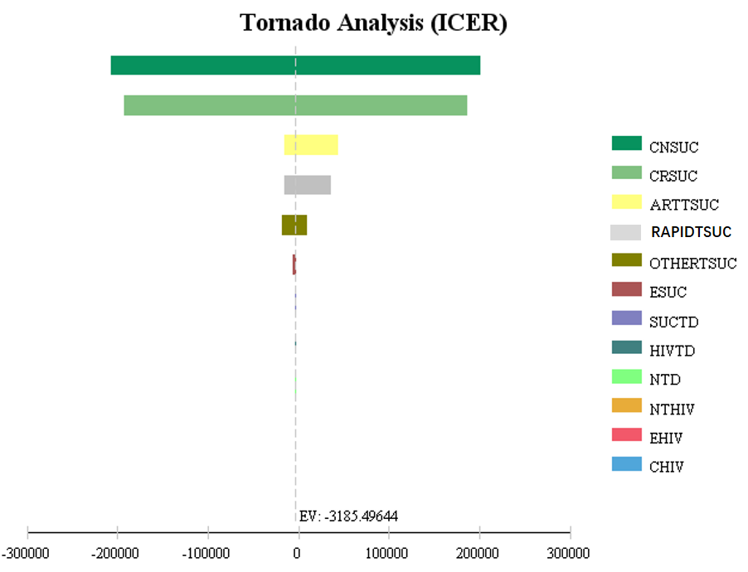
Supplementary Figure 2: Tornado map comparing conventional ART strategy and rapid ART strategy. CNSUC: Average cost of conventional group; CRSUC: Average cost of rapid group; ARTTSUC: Virologic suppression rate of conventional group; RAPIDTSUC: Virologic suppression rate of rapid group; OTHERTSUC: Virologic suppression rate based second-line ART; ESUC: Health utility value of rapid ART status ; SUCTD: HIV mortality of viral suppression population; HIVTD: HIV mortality of total HIV population; NTD: Annual death rate; NTHIV: Newly HIV infections rate; EHIV: Health utility value of HIV/AIDS status; CHIV: Average cost of HIV patients; EV: Expected value; ART: Antiretroviral therapy; ICER: Incremental cost-effectiveness ratio.

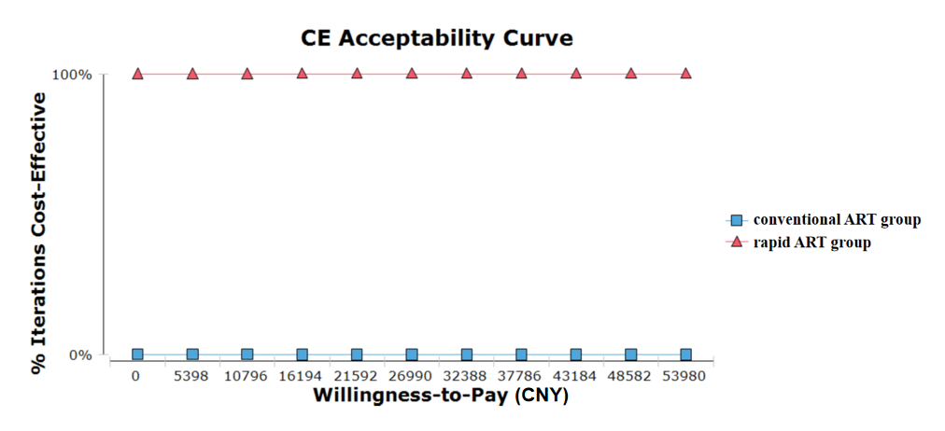
Supplementary Figure 3: Cost-effectiveness acceptability curve in terms of QALYs for two strategies in probabilistic sensitivity analysis. ART: Antiretroviral therapy; QALYs: Quality-adjusted life years.

