Supplementary Figure 1: Flow chart of inclusion of inpatients with AECOPD in the present study. AECOPD: Acute exacerbation of chronic obstructive pulmonary disease; DBP: Diastolic Blood Pressure.

Supplementary Figure 2: Procedure of LASSO regression in the overall population. (A) LASSO coefficient profiles of the expression of all variables showed P < 0.05 in univariate Cox analysis. (B) Selection of the penalty parameter (λ) in the LASSO model via 100-fold cross-validation. The dotted vertical lines are plotted at the optimal values following the minimum criteria (left) and “one standard error” criteria (right).
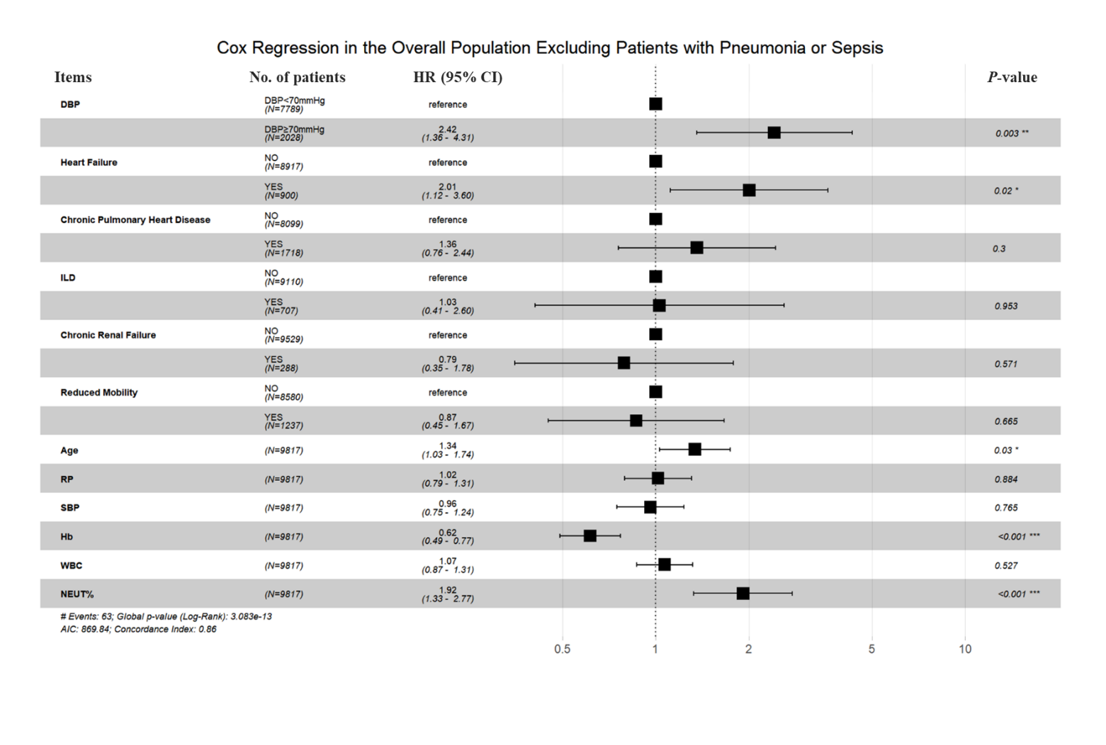
Supplementary Figure 3: Forest plot showing HRs for the risk factors of in-hospital mortality based on multivariate Cox regression in the overall population excluding patients with pneumonia or sepsis. DBP: Diastolic blood pressure; Hb: Hemoglobin; HRs: Hazard ratios; ILD: Interstitial lung disease; NEUT%: Neutrophil ratio; RP: Radial pulse; SBP: Systolic blood pressure; WBC: White blood cell.
Supplementary Table 1: Univariate Cox analysis on in-hospital mortality in the overall cohort of AECOPD inpatients.
Variables |  | HR (95% CI) | Z-value | P-value
Age |  | 1.68 (1.46– 1.95) | 49.46 | <0.01
BMI (kg/m²)
 | <30 | 1.00 [Reference]
 | ≥30 | 0.31 (0.04–2.21) | 0.17 | 0.24
DBP (mmHg)
 | ≥70 | 1.00 [Reference]
 | <70 | 3.02 (2.28–4.00) | 59.29 | <0.01
Sex
 | Female | 1.00 [Reference]
 | Male | 0.97 (0.70–1.35) | 0.03 | 0.86
Currently smoking
 | Without | 1.00 [Reference]
 | With | 0.94 (0.71–1.25) | 5.70 | 0.68
Hypertension
 | Without | 1.00 [Reference]
 | With | 1.20 (0.90–1.59) | 1.56 | 0.21
Coronary heart disease
 | Without | 1.00 [Reference]
 | With | 1.17 (0.82–1.68) | 0.76 | 0.38
Heart failure
 | Without | 1.00 [Reference]
 | With | 2.57 (1.92–3.45) | 37.46 | <0.01
Pulmonary tuberculosis
 | Without | 1.00 [Reference]
 | With | 0.76 (0.36–1.61) | 0.53 | 0.47
Chronic pulmonary heart disease
 | Without | 1.00 [Reference]
 | With | 1.93 (1.44–2.57) | 19.90 | <0.01
Pneumonia
 | Without | 1.00 [Reference]
 | With | 3.02 (2.24– 4.07) | 52.35 | <0.01
Bronchiectasis
 | Without | 1.00 [Reference]
 | With | 0.77 (0.52– 1.14) | 1.75 | 0.19
OSAHS
 | Without | 1.00 [Reference]
 | With | 0.05 (0.00–65.05) | 0.67 | 0.41
ILD
 | Without | 1.00 [Reference]
 | With | 1.56 (1.06– 3.20) | 4.98 | 0.03
Asthma
 | Without | 1.00 [Reference]
 | With | 0.84 (0.34–2.02) | 0.16 | 0.69
Osteoporosis
 | Without | 1.00 [Reference]
 | With | 1.01 (0.53–1.92) | 0.00 | 0.97
GERD
 | Without | 1.00 [Reference]
 | With | 0.88 (1.77–4.58) | 1.95 | 0.16
Active cancer
 | Without | 1.00 [Reference]
 | With | 1.00 (0.60– 1.67) | 0.00 | 0.99
Sepsis (<1 month)
 | Without | 1.00 [Reference]
 | With | 4.37 (2.36– 8.07) | 22.10 | <0.01
Stroke (<1 month)
 | Without | 1.00 [Reference]
 | With | 1.53 (1.06– 2.22) | 5.21 | 0.02
Diabetes
 | Without | 1.00 [Reference]
 | With | 1.58 (1.15–2.18) | 7.96 | <0.01
Chronic renal failure
 | Without | 1.00 [Reference]
 | With | 2.27 (1.57–3.30) | 18.58 | <0.01
Reduced mobility
 | Without | 1.00 [Reference]
 | With | 3.02 (2.26–4.03) | 55.54 | <0.01
Anxiety–depression
 | Without | 1.00 [Reference]
 | With | 1.47 (0.83–2.60) | 1.75 | 0.19
Vital signs
 | Systolic blood pressure | 0.77 (0.67–0.89) | 13.02 | <0.01
 | Diastolic blood pressure | 0.56 (0.50–0.64) | 82.62 | <0.01
 | Pulse pressure | 1.16 (1.02–1.32) | 5.09 | 0.02
 | Radial pulse | 1.25 (1.11– 1.42) | 12.92 | <0.01
 | Respiratory rate | 1.07 (0.96– 1.19) | 1.47 | 0.23
 | Mean arterial pressure | 0.60 (0.53– 0.68) | 59.01 | <0.01
Laboratory tests
 | Red blood cell | 0.64 (0.54– 0.76) | 27.13 | <0.01
 | Hemoglobin | 0.98 (0.98– 0.99) | 45.78 | <0.01
 | White blood cell | 1.05 (1.03– 1.07) | 23.82 | <0.01
 | NEUT | 1.05 (1.03– 1.06) | 44.71 | <0.01
 | EOSR | 0.83 (0.75– 0.91) | 14.85 | <0.01
 | Platelet | 1.00 (0.99– 1.00) | 10.90 | <0.01
 | pH | 0.24 (0.09– 0.67) | 7.40 | <0.01
 | PaO₂ | 1.00 (1.00– 1.01) | 2.41 | 0.12
 | PaCO₂ | 1.01 (1.00– 1.02) | 2.87 | 0.09
 | Lactate | 1.19 (1.10– 1.30) | 16.96 | <0.01
AECOPD: Acute exacerbation of chronic obstructive pulmonary disease; BMI: Body mass index; CI: Confidence interval; DBP: Diastolic blood pressure; EOSR: Eosinophil ratio; GERD; Gastroesophageal reflux disease; HR: Hazard ratio; ILD: Interstitial lung disease; NEUT: Neutrophil ratio; OSAHS: Obstructive sleep apnea-hypopnea syndrome; PaCO₂: partial pressure of carbon dioxide; PaO₂: Arterial oxygen partial pressure.

