Supplementary file 1…Page 1
Supplementary file 2…Page 2
Supplementary figure 1…Page 3
Supplementary figure 1…Page 4
Supplementary figure 1…Page 5
Supplementary file 1: CENTRAL search strategy
- MeSH descriptor: [Pancreatitis] explode all trees
- pancreatitis
- 1 or 2
- MeSH descriptor: [Fluid Therapy] this term only
- MeSH descriptor: [Resuscitation] explode all trees and with qualifier(s): [Methods - MT]
- fluid near/3 resuscitation
- fluid near/2 balance
- fluid near/2 restriction*
- MeSH descriptor: [Colloids] this term only
- MeSH descriptor: [Hydration] this term only
- colloid* or crystalloid*
- 4 or 5 or 6 or 7 or 8 or 9 or 10 or 11
- 3 AND 12

Supplementary file 2: MEDLINE search strategy
- exp pancreatitis/
- pancreatitis.mp.
- 1 or 2
- Fluid Therapy/
- exp Resuscitation/mt
- (fluid adj3 resuscitation).mp.
- (fluid adj2 balance).mp.
- (fluid adj2 restriction*).mp.
- Hydration/
- Colloids/
- colloid*.tw.
- crystalloid*.tw.
- 4 or 5 or 6 or 7 or 8 or 9 or 10 or 11 or 12
- randomized controlled trial.pt.
- controlled clinical trial.pt.
- randomized.ab.
- placebo.ab.
- drug therapy.fs.
- randomly.ab.
- trial.ab.
- groups.ab.
- 14 or 15 or 16 or 17 or 18 or 19 or 20 or 21
- 3 AND 13 AND 22

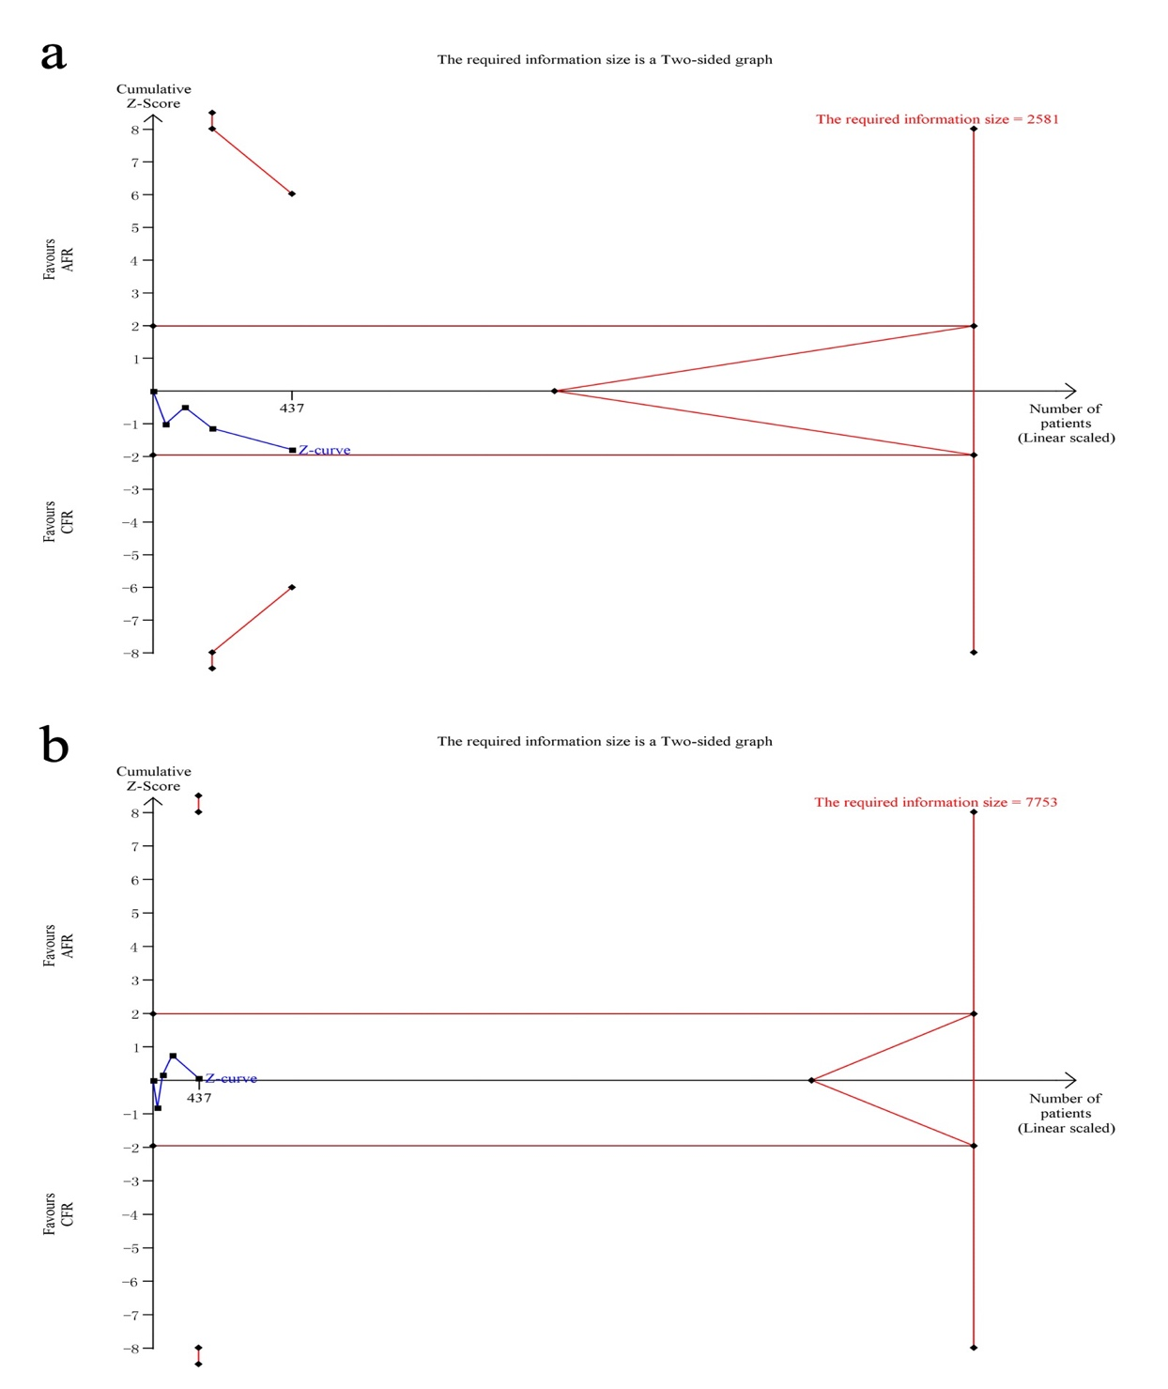
Supplementary Figure 1: TSA for primary outcomes: (A) Development of SAP; (B) hypovolemia. AFR: Aggressive fluid resuscitation; CFR: Controlled fluid resuscitation; SAP: Severe AP; TSA: Trial sequential analysis.
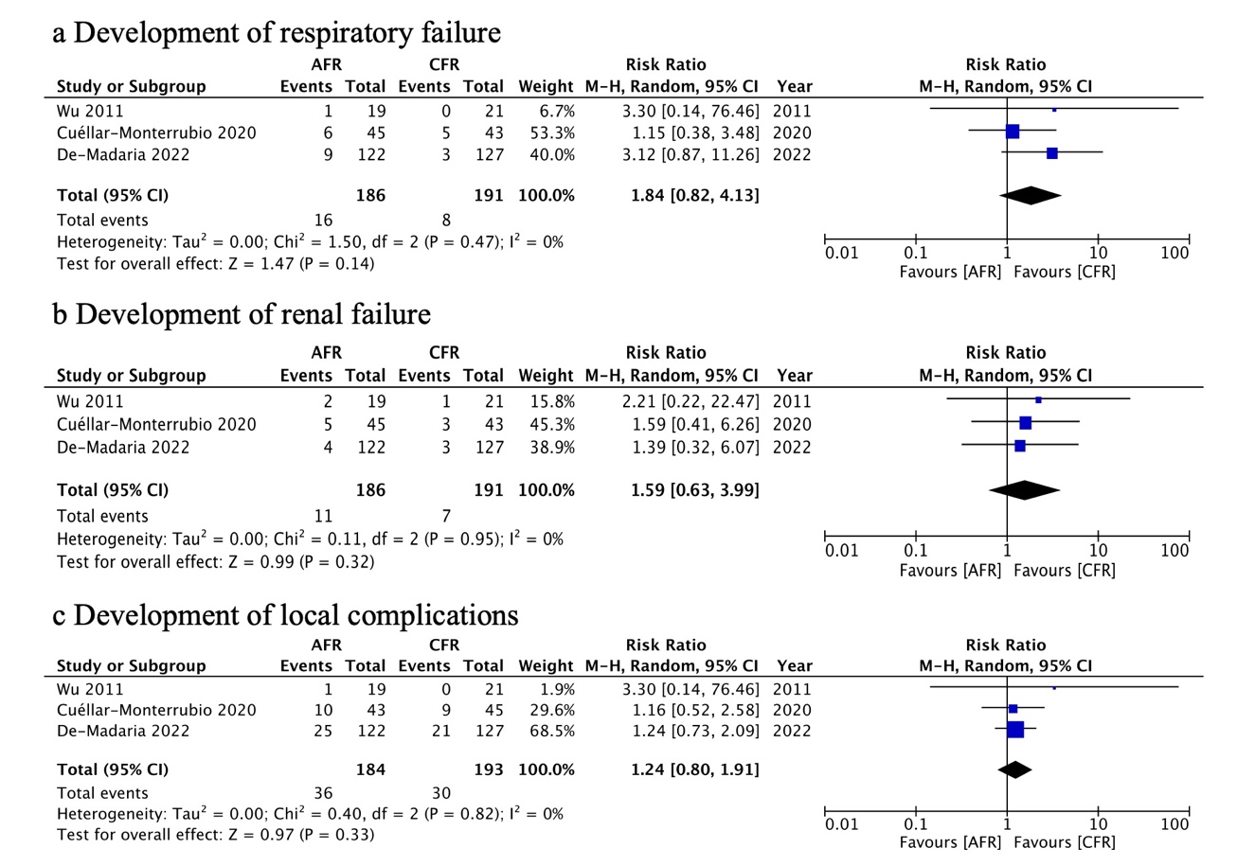Supplementary Figure 2: Forest plots illustrating secondary outcomes: (A) development of respiratory failure; (B) development of renal failure; (C) development of local complications. AFR: Aggressive fluid resuscitation; CFR: Controlled fluid resuscitation; CI: Confidence interval.
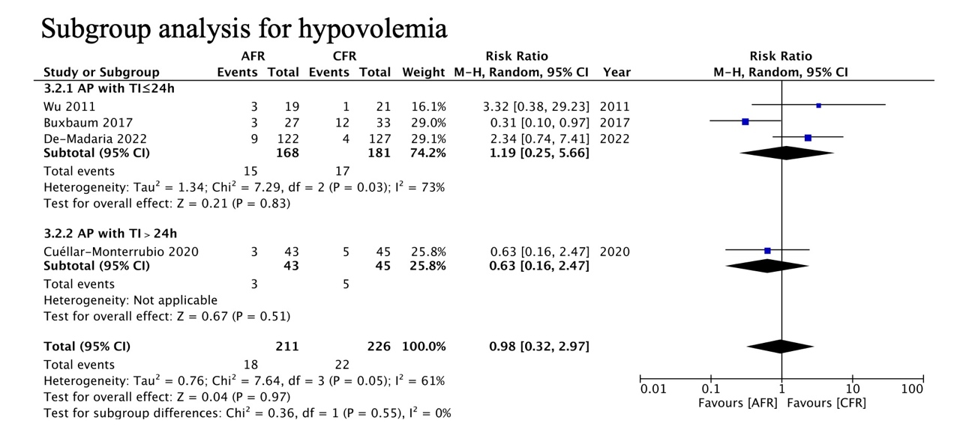
Supplementary Figure 3: Forest plots illustrating subgroup analysis for safety outcome as hypovolemia based on TI between disease onset and treatment. AFR: Aggressive fluid resuscitation; AP: Acute pancreatitis; CFR: Controlled fluid resuscitation; CI: Confidence interval; TI: Time interval.

