Supplementary Figure
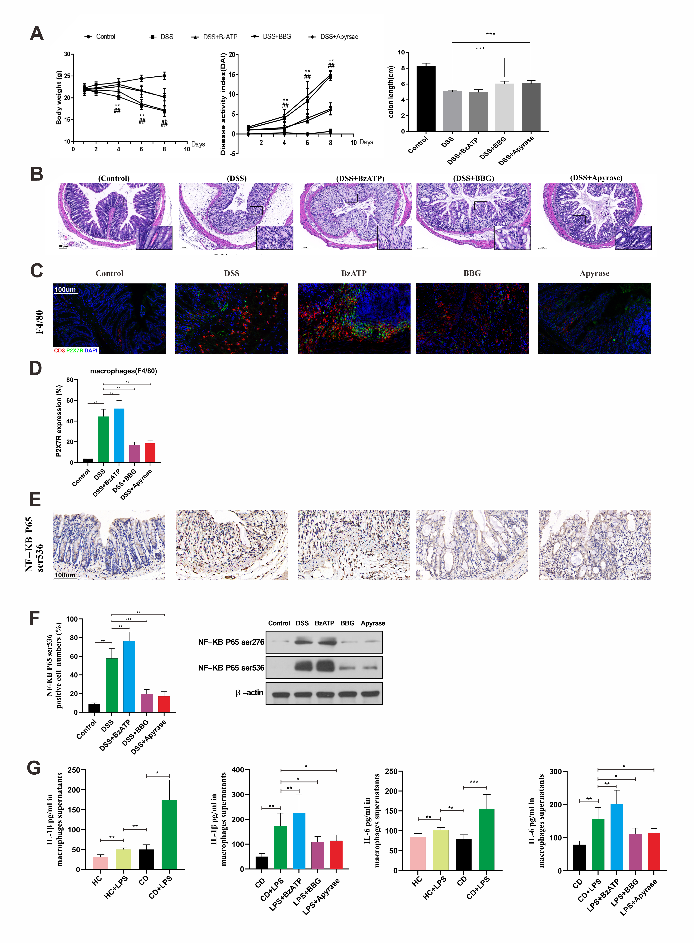
(A) Changes of body weight and alteration of DAI in mice of each group; (B) H&E staining of the colonic sections in mice of each group (magnification, ×100/1000); (C) the co-localization of P2X7R in colonic macrophages (f4/80) in mice from all groups; (D) percentages of phosphorylated NF-κB (P65-)Ser536-positive cells in colon tissue of mice from all groups; (E) the co-localization of P2X7R in colonic macrophages (F4/80) in mice from all groups; (F) the detection of protein expressions of phosphorylated NF-κB (P65-)Ser536 by western blot; **P < 0.01 and ***P < 0.001. (G) IL-1β (A) and IL-6 (B) release after treatment with LPS, BzATP, BBG, apyrase, JSH-23, and BBG + JSH-23. *P < 0.05, **P < 0.01, ***P < 0.001. CD: Crohn’s disease; DAI: Disease activity index; H&E: Hematoxylin & eosin; LPS: Lipopolysaccharide.

