Supplementary File

Case 1: MS-based proteomics analysis of a patient with AL amyloidosis (AL Lamda). AL: Light chain amyloidosis; MS: Mass spectrometry.

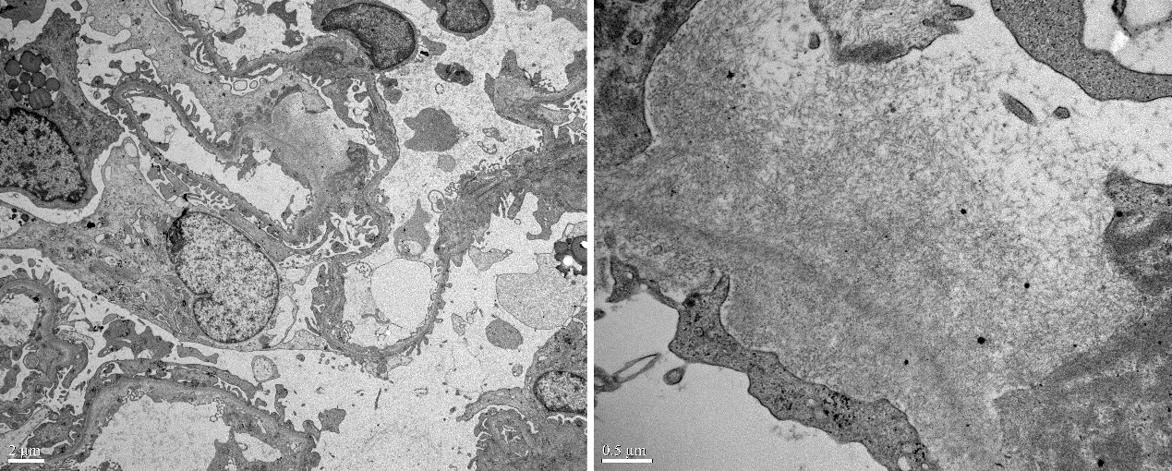
Supplementary Figure 1: Electron microscopy pictures of a confirmed amyloidosis patient. Amyloid fiber appears as randomly oriented 10–12 nm thin fibrils, with a loose and flocculent background.

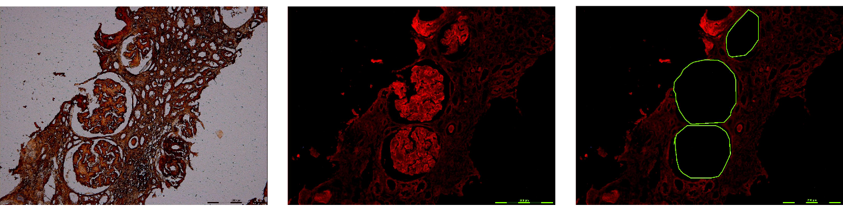
Supplementary Figure 2: Process of laser microdissection. Congo red stain positive under light microscope (left). Congo red stain positive under fluorescence microscope (middle). Empty space following microdissection of glomeruli (right).

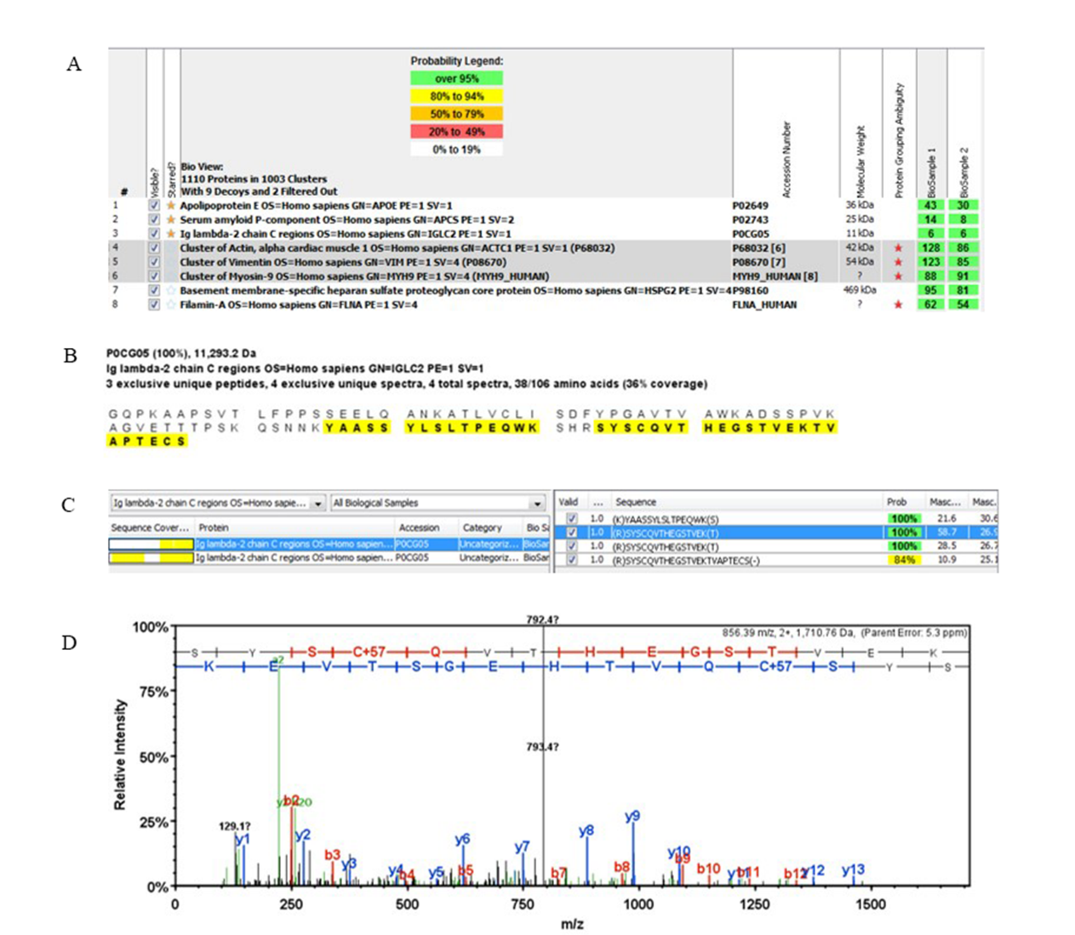

Supplementary Figure 3: Representative mass spectrometry data by spectral analyses from a case of AL Lamda light chain amyloidosis. (A) Mascot software presents renal biopsy mass spectrometry results, besides Apoliporotein E and serum amyloid P component; the most abundant amyloidosis-related protein identified was Ig-lambda. (B) Mass spectometry formation of the Ig-lambda protein sequence detected in the sample. (C) Peptides sequence of Ig-lambda dectected by LC-MS/MS. (D) MS/MS spectrum of the (R) SYSCQVTHEGSTVEK (T) peptide detected in the amyloid deposits. AL: Light chain amyloidosis; LC-MS/MS: Liquid chromatography-tandem mass spectrometry.

Case 2: MS-based proteomics analysis of a patient with AA amyloidosis. AA: Amyloid A; MS: Mass spectrometry.

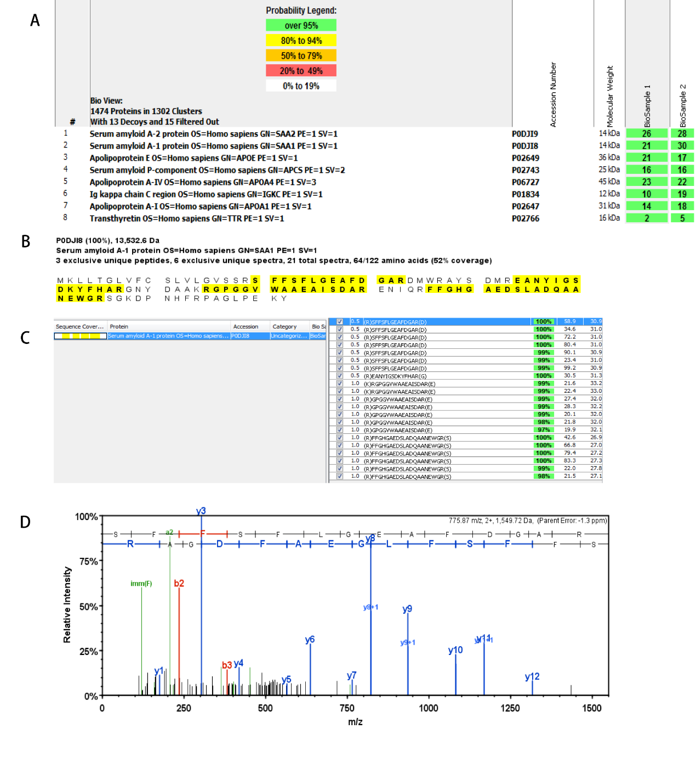

Supplementary Figure 4: Representative mass spectrometry data by spectral analyses from a case of AA amyloidosis. (A) Readout from Mascot software. MS proteomic data were analyzed from two samples from two separate laser microdissections of Congo Red–positive glomeruli. The most abundant amyloidosis-related proteins were SAA2 and SAA1. (B) The detailed MS information of SAA1 protein; amino acid sequences were highlighted on yellow background. (C) Peptide sequence of SAA1 detected by LC-MS/MS. (D) MS/MS spectrum of the (R)SFFSFLGRAFDGAP(D) peptide detected in the amyloid deposit (m/z: mass-to-charge ratio of the peptide ions, relative intensity: relative intensity of the peaks). AA: Amyloid A; ApoE: Apolipoprotein E; ApoA IV: Apolipoprotein A-IV; LC-MS/MS: Liquid chromatography-tandem mass spectrometry; MS: Mass spectrometry.

