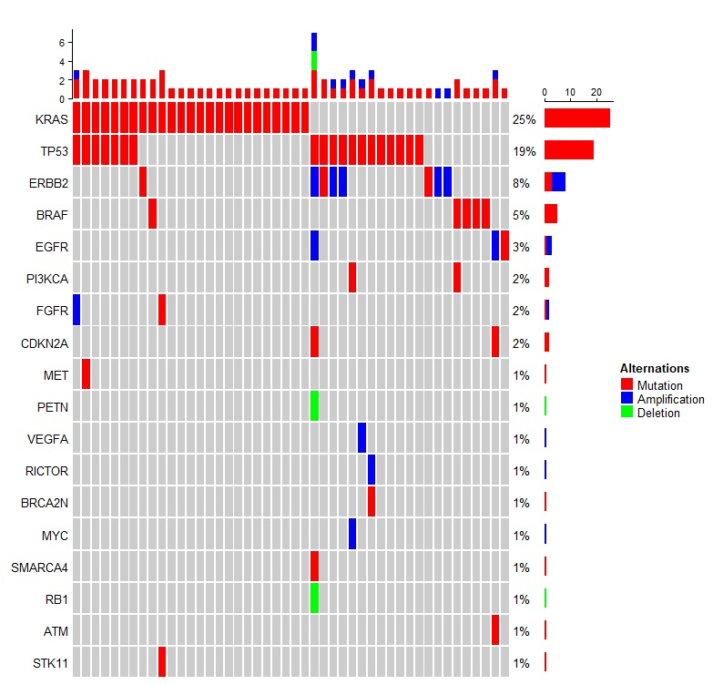
Supplementary Figure 1: Oncoprint summarizing the baseline somatic mutational profile of patients who received ICIs with chemotherapy (n = 102). Different colors denote different mutation types, including mutation, amplifications, and deletions. Genes are indicated on the left, and mutation detection rates are indicated on the right. ICIs: Immune checkpoint inhibitors.
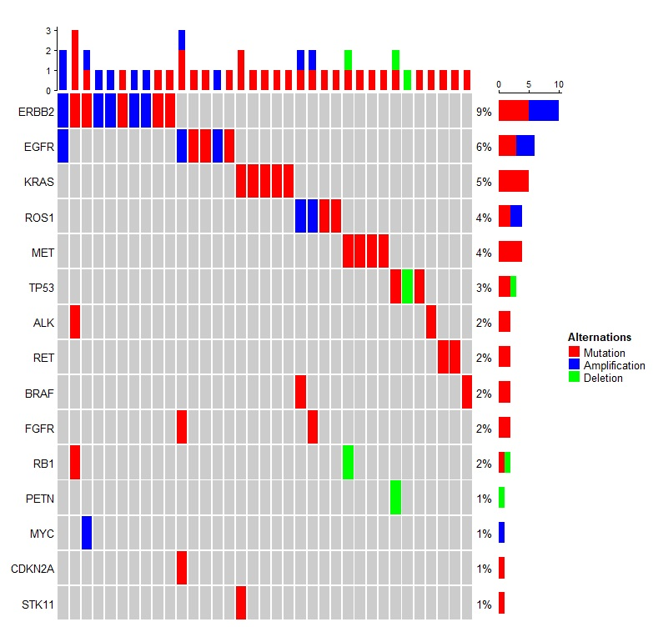

Supplementary Figure 2: Oncoprint summarizing the baseline somatic mutational profile of patients who received chemotherapy (n = 109). Different colors denote different mutation types, including mutation, amplifications, and deletions. Genes are indicated on the left, and mutation detection rates are indicated on the right.
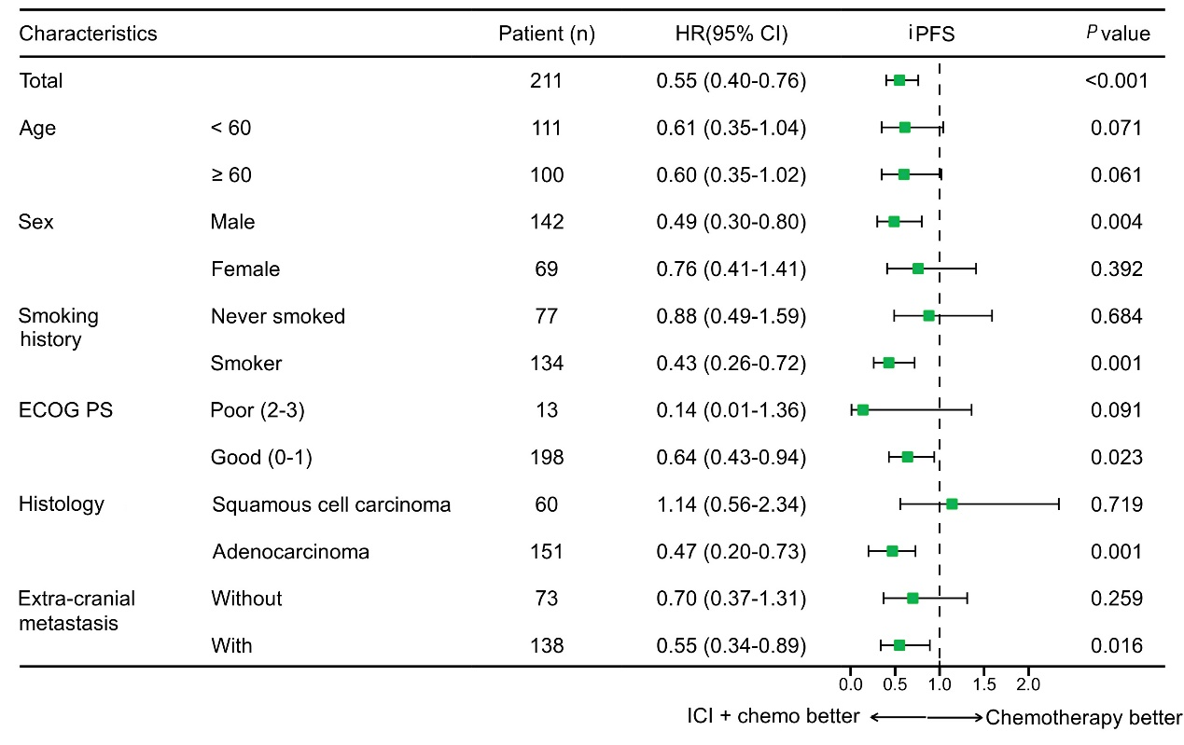

Supplementary Figure 3: Forest plot showing univariable subgroup analysis of the effect of various clinical variables on iPFS of patients who received ICI combined with chemotherapy and chemotherapy-based regimens. CI: Confidence interval; ECOG PS: Eastern Cooperative Oncology Group performance status; HR: Hazard ratio; ICI: Immune checkpoint inhibitor; iPFS: intracranial progression-free survival.
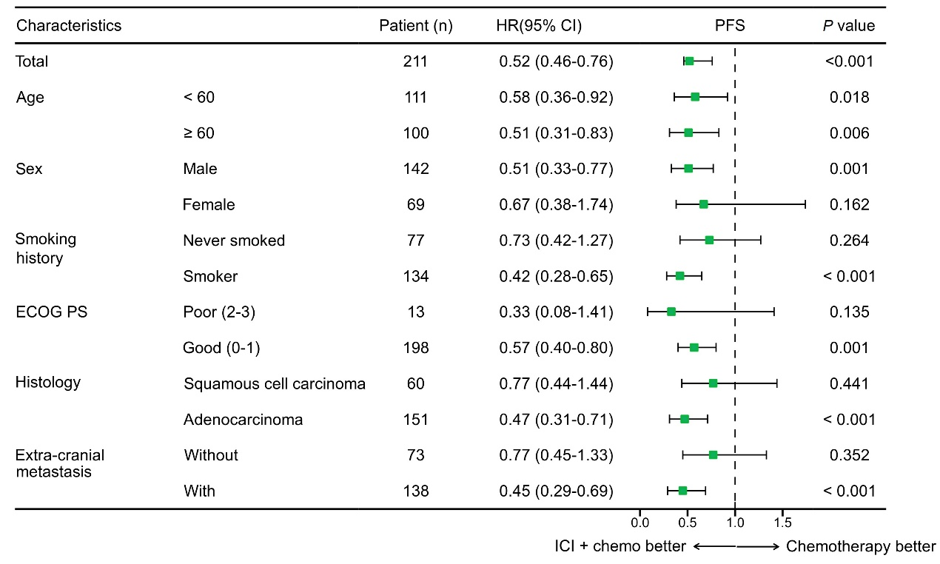

Supplementary Figure 4: Forest plot showing univariate subgroup analysis of the effect of various clinical factors on systemic PFS of patients who received ICI-containing regimens and chemotherapy-based regimens. CI: Confidence interval; ECOG PS: Eastern Cooperative Oncology Group performance status; HR: Hazard ratio; ICI: Immune checkpoint inhibitor; PFS: Progression-free survival.
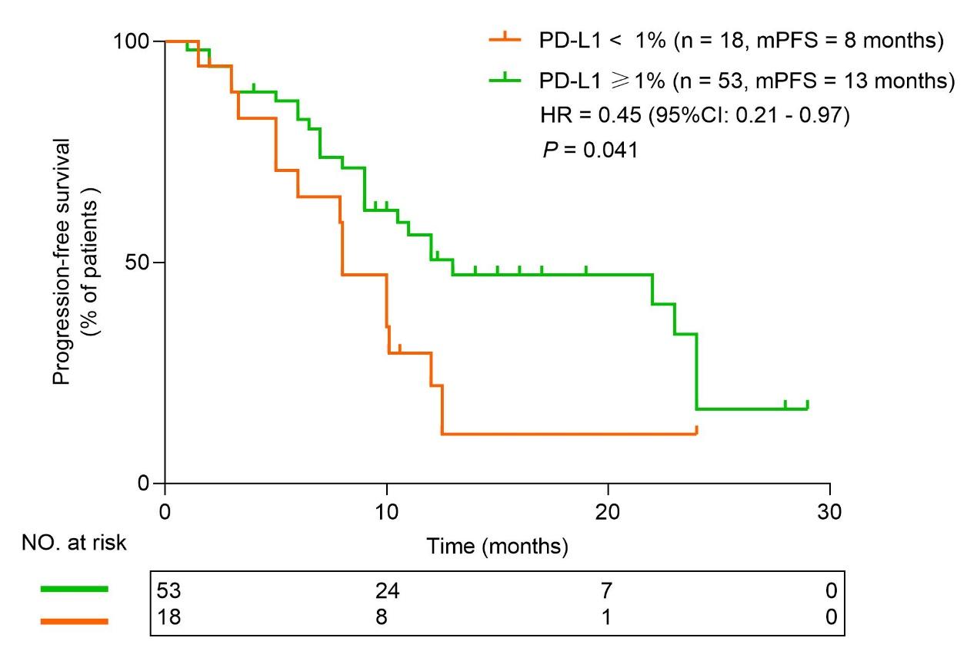

Supplementary Figure 5: PD-L1 expression status is associated with progression-free survival (PFS). Kaplan‒Meier survival curve comparing the sPFS of patients who received first-line ICIs plus chemotherapy with available PD-L1 expression data (n = 71) and stratified according to PD-L1 expression status as PD-L1 positive (n = 53) or negative (n = 18). PD-L1 positivity was defined as a tumor proportion score ≥1%. Tick marks denote censored data. CI: Confidence interval; HR: Hazard ratio; ICIs: Immune checkpoint inhibitors; mPFS: Median progression-free survival; PD-L1: Programed death-ligand 1; PFS: Progression-free survival; sPFS: systemic PFS.
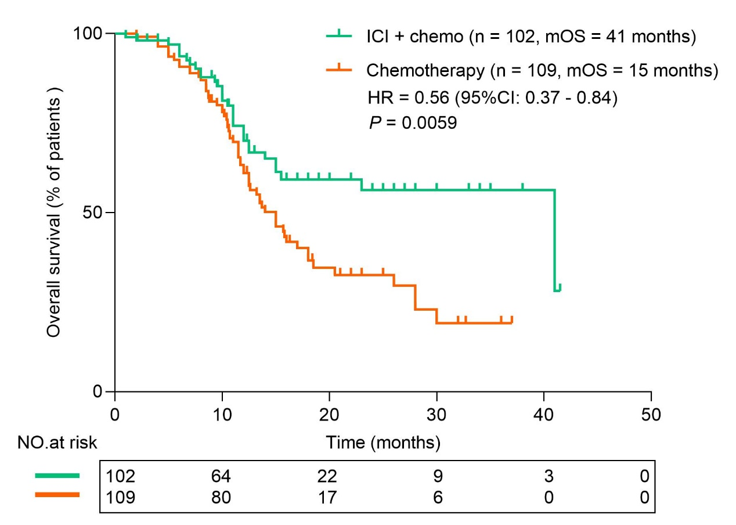
Supplementary Figure 6: Immunotherapy combined with chemotherapy prolongs the OS of patients with brain metastasis at initial diagnosis. Kaplan‒Meier survival curve comparing OS between patients who received first-line ICIs combined with chemotherapy and those who received chemotherapy alone. Tick marks denote censored data. CI: Confidence interval; HR: Hazard ratio; ICIs: Immune checkpoint inhibitors; mOS: Median overall survival; OS: Overall survival.

