Supplementary Table 1: List of nucleotide sequences of siRNA.
Name | Forward sequence (5′–3′) | Reverse sequence (5′–3′)
NC (negative control) | UUCUCCGAACGUGUCACGUTT | ACGUGACACGUUCGGAGAATT
Fibronectin siRNA | GCAGCACAACUUCGAAUUATT | UAAUUCGAAGUUGUGCUGCTT
ITGB5 siRNA | GCCAACGAGUACACUGCAUTT | AUGCAGUGUACUCGUUGGCTT
ITGAV siRNA | GCAGGUCUCAGUGUCUCUATT | UAGAGACACUGAGACCUGCTT
FoxO1 siRNA | CCACACAGUGUCAAGACAATT | UUGUCUUGACACUGUGUGGTT
Beclin1 siRNA | GUGGAAUGGAAUGAGAUUATT | UAAUCUCAUUCCAUUCCACTT
FoxO1: Forkhead Box Protein O1; ITGAV: Integrin subunit αv; ITGB5: Integrin subunit β5; siRNA: Small interfering ribonucleic acid.
Supplementary Table 2: List of antibodies used for western blotting and immunofluorescence.
Target antigen | Source | Catalog | Working concentration
Integrin αv subunit (ITGAV) | Proteintech | 27096-1-AP | WB: 1:1000
Integrin β5 subunit (ITGB5) | Proteintech | 28543-1-AP | WB: 1:1000
Integrin αvβ5 | Abcam | ab177004 | IF: 1:200
Fibronectin | Abcam | ab2413 | WB: 1:1000  IF: 1:200
GAPDH | Proteintech | 10494-1-AP | WB: 1:1000
Caspase-3 | Cell Signaling Tech | 9662 | WB: 1:1000
Bcl2 | Proteintech | 12789-1-AP | WB: 1:1000
Bax | Cell Signaling Tech | 2772 | WB: 1:1000
Atg7 | Cell Signaling Tech | 8558 | WB: 1:1000
Beclin1 | Cell Signaling Tech | 3495 | WB: 1:1000
LC3 | Sigma | L8918 | WB: 1:1000
FoxO1 | Cell Signaling Tech | 2880 | WB: 1:1000  IF: 1:200
Histone-H3 (H3) | Proteintech | 17168-1-AP | WB: 1:1000
Flag tag | Abcam | ab205606 | WB: 1:1000
Bcl2: B-cell lymphoma-2; FoxO1: Forkhead Box Protein O1; GAPDH: Glyceraldehyde 3-phosphate dehydrogenase; IF: Immunofluorescence; ITGAV: Integrin subunit αv; ITGB5: Integrin subunit β5; LC3: microtubule associated protein light chain 3; WB: Western blotting.

Supplementary Table 3: List of primer sequences used for RT-qPCR.
Gene | Forward sequence (5′–3′) | Reverse sequence (5′–3′)
Fibronectin | ACAACACCGAGGTGACTGAGAC | GGACACAACGATGCTTCCTGAG
ITGB5 | TCTCGGTGTGATCTGAGGG | TGGCGAACCTGTAGCTGGA
ITGAV | AGGAGAAGGTGCCTACGAAGCT | GCACAGGAAAGTCTTGCTAAGGC
GAPDH | GTCTCCTCTGACTTCAACAGCG | ACCACCCTGTTGCTGTAGCCAA
IL-1α | TGTATGTGACTGCCCAAGATGAAG | AGAGGAGGTTGGTCTCACTACC
IL-1β | CCACAGACCTTCCAGGAGAATG | GTGCAGTTCAGTGATCGTACAGG
VCAM-1 | GATTCTGTGCCCACAGTAAGGC | TGGTCACAGAGCCACCTTCTTG
IL-6 | AGACAGCCACTCACCTCTTCAG | TTCTGCCAGTGCCTCTTTGCTG
PIK3R3 | CCACCTAAGCCAATGACTTCAGC | GTTGAGGCATCTCGGACCAAGA
STAT1 | ATGGCAGTCTGGCGGCTGAATT | CCAAACCAGGCTGGCACAATTG
STAT3 | CTTTGAGACCGAGGTGTATCACC | GGTCAGCATGTTGTACCACAGG
NOS3 | GCTCTACACCTCCAATGTGACC | CTGCCGAGATTTGAGCCTCATG
MAPK13 | GTCATTGGGCTCCTGGATGTCT | CACCAGGTACTGGATCTTCTCC
PLCD1 | AGCAGCACTGAAGCCTACATCC | CTGAGCACATCGCAGAAGAGGA
RT-qPCR: Real-time quantitative polymerase chain reaction.

Supplementary Table 4: statistical analysis in this article.
One-way ANOVA followed by Bonferroni multiple comparisons post-test | Figure 1A, 1B  Figure 3A,3B, 3C, 3D, 3E  Figure 4A, 4B, 4C, 4D  Figure 6A, 6B  Figure 7A, 7B, 7C, 7D  Figure 8A, 8B, 8C  Figure 9A, 9B  Figure S4A, S4B, S4C, S4D  Table 4
Wilcoxon rank test  (Mann-Whitney test, two-tailed) | Figure 2A, 2B, 2C, 2D, 2E, 2F  Figure 5E, 5F
Kolmogorov–Smirnov test | Figure 1A, 1B  Figure 2A, 2B, 2C, 2D, 2E, 2F  Figure 3A,3B, 3C, 3D, 3E  Figure 4A, 4B, 4C, 4D  Figure 5E, 5F  Figure 6A, 6B  Figure 7A, 7B, 7C, 7D  Figure 8A, 8B, 8C  Figure 9A, 9B  Figure S4A, S4B, S4C, S4D  Table 4

Supplementary Table 5: List of Gene Abbreviations.
Gene | Abbreviations | Gene ID
FoxO1 | Forkhead box O1 | 2308
IL-1 alpha | Interleukin 1 alpha | 3552
VCAM1 | vascular cell adhesion molecule 1 | 7412
PIK3R3 | phosphoinositide-3-kinase regulatory subunit 3 | 8503
IL-1 beta | interleukin 1 beta | 3553
IL-6 | Interleukin 6 | 3569
PLCB2 | phospholipase C beta 2 | 5330
MAPK13 | mitogen-activated protein kinase 13 | 5603
STAT1 | signal transducer and activator of transcription 1 | 6772
NOS3 | nitric oxide synthase 3 | 4846
STAT3 | signal transducer and activator of transcription 3 | 6774
PLCD1 | phospholipase C delta 4 | 84812
cyclin D1 | Cyclin D1 | 595
PLCD4 | phospholipase C delta 1 | 5333

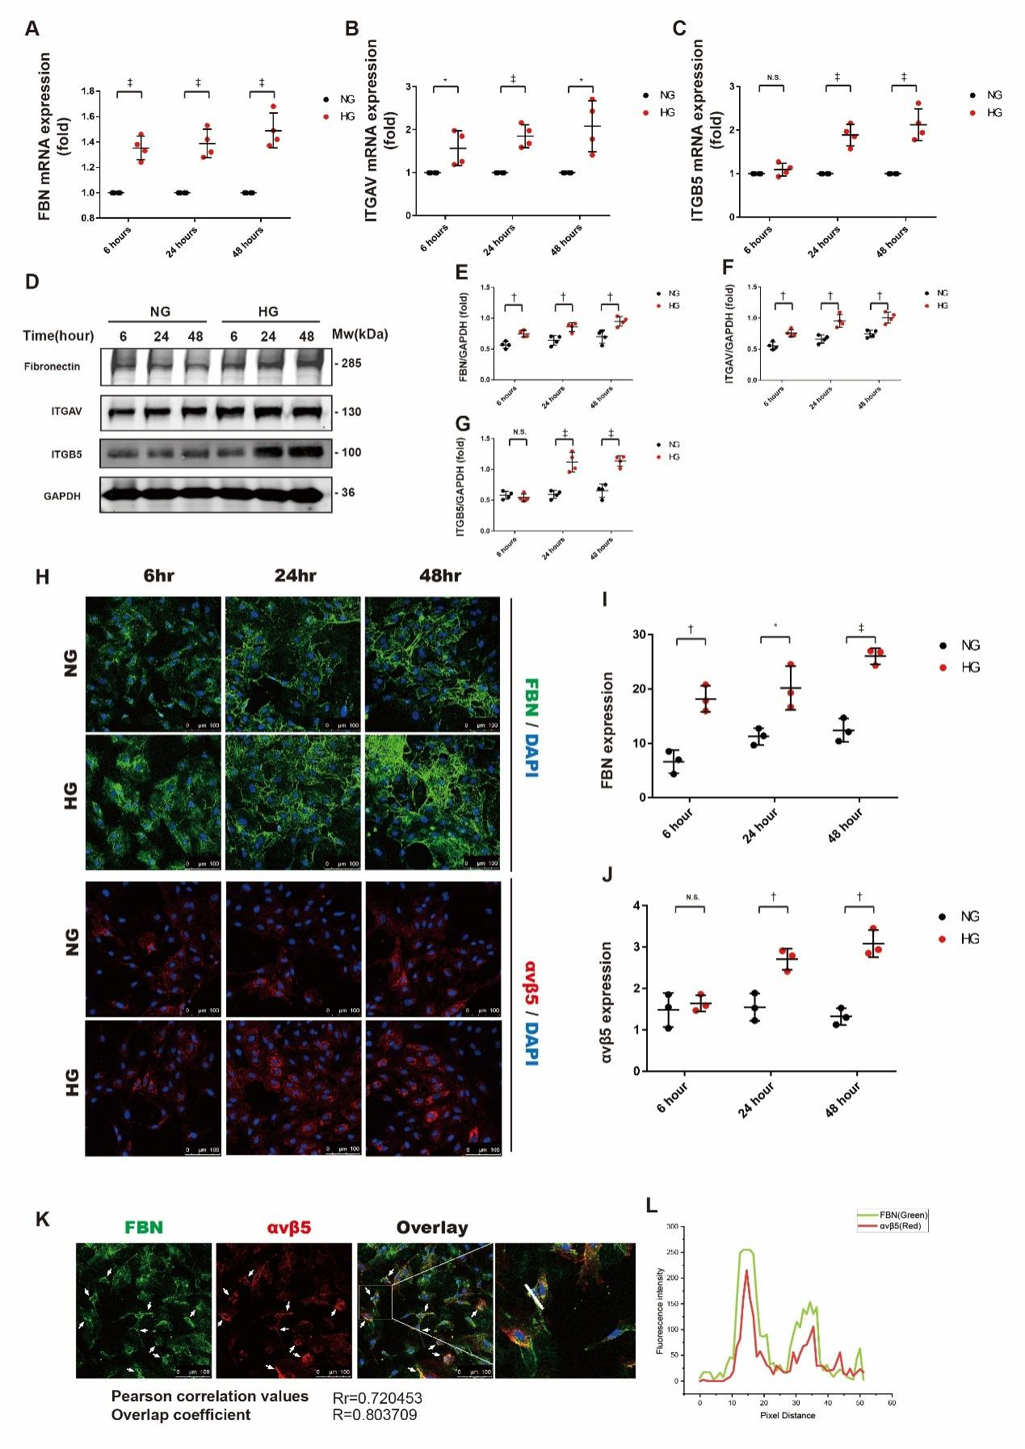
Supplementary Figure 1
High glucose induced the overexpression of integrin αvβ5 and fibronectin in HUVECs. HUVECs were incubated in high-glucose ECCM (containing 0.2% FBS and 33 mmol/L glucose) or normal-glucose ECCM (containing 0.2% FBS and 5 mmol/L glucose) for 6 h, 24 h, and 48 h. (A–C) Total RNA was extracted from each group and subjected to RT‒qPCR analysis. The graphs show the results of RT‒qPCR analysis. Expression levels of target genes are expressed as relative expression intensity (n = 4/group). (D) Total protein was extracted from each group and subjected to western blotting analysis. (E-G) The graphs show the expression levels of target proteins. Relative gray values were used to indicate the expression intensity of target proteins (n = 4/group). (H) Immunofluorescence microscopy was performed to investigate the expression levels of target proteins. Fibronectin was stained green, and αvβ5 was stained red. (I-J) Expression levels were quantified by calculating total fluorescent intensity versus cell counts (fluorescent intensity/cells, n = 3/group). (K) After incubating HUVECs in high glucose medium for 24 h, confocal microscopy was performed, and images were taken and subjected to colocalization analysis. Representative confocal microscopy images are shown, and Pearson correlation values and overlap coefficients were calculated by Image-Pro Plus 6.0. The proper area for one-dimensional analysis is indicated by the square. (L) The graph shows the colocalization of fibronectin (green) and αvβ5 (red) on the line (marked in white). In the graphs, the data are expressed as the mean ± standard deviation; *P <0.05, †P <0.01, ‡P <0.001. DAPI: 4’,6-diamidino-2-phenylindole; ECCM: Endothelial cell culture medium; ECCM: Endothelial cell culture medium; FBN: Fibronectin; FBS: Fetal bovine serum; GAPDH: Glyceraldehyde-3-phosphate dehydrogenase; HG: High-glucose medium; HUVECs: Human umbilical vascular endothelial cells; ITGAV: Integrin subunit αv; ITGB5: Integrin subunit β5; mRNA: messenger RNA; NG: Normal-glucose medium; N.S.: Not significant; RT‒qPCR: Real-time quantitative polymerase chain reaction.

Supplementary Figure 2
ITGB5 knockdown alleviated the autophagy induced by high glucose or fibronectin. (A) HUVECs were transfected with negative control siRNA or ITGB5 siRNA and then incubated in high-glucose ECCM (containing 0.2% FBS and 33 mmol/L glucose) or normal-glucose ECCM (containing 0.2% FBS and 5 mmol/L glucose) for 26 h. In several groups, chloroquine (CQ, 50 µmol/L) was added to the medium in the last 2 h of incubation. Protein was extracted from each sample and subjected to western blotting analysis (n = 4/group). (B–D) Relative gray values were used to indicate the expression intensity of target proteins. ∆LC3 II represents LC3 II degradation, which positively correlates with the autophagy flux. (E) HUVECs were transfected with negative control siRNA or ITGB5 siRNA and then incubated in fibronectin-containing ECCM (5 µg/mL fibronectin, 0.1% FBS, 5 mmol/L glucose) for 8 h. In several groups, CQ (50 µmol/L) was added to the medium in the last 2 h of incubation. Protein was extracted from each sample and subjected to western blotting analysis (n = 4/group). (F–H) Relative gray values were used to indicate the expression intensity of target proteins. ∆LC3 II represents LC3 II degradation, which positively correlates with the autophagy flux. (I) HUVECs that expressed GFP-mRFP-LC3were subjected to gene interference. After transfection with negative control siRNA or ITGB5 siRNA, cells were incubated in high-glucose ECCM or normal-glucose ECCM for 24 h. Immunofluorescence images of each sample were taken (n = 3/group). (J) The average autolysosome percentage in each group was quantified and expressed in stacked bars. (K) HUVECs that expressed GFP-mRFP-LC3were subjected to gene interference. After transfection with negative control siRNA or ITGB5 siRNA, cells were incubated in fibronectin-containing ECCM (5 μg/mL fibronectin, 0.1% FBS, 5 mmol/L glucose) or vehicle-containing ECCM for 6 h. Immunofluorescence images of each sample were taken (n = 3/group). (L) The average autolysosome percentage in each group was quantified and expressed in stacked bars. In the graphs, the data are expressed as the mean ± standard deviation. In the stacked bar graphs, the data are expressed as the mean of percentage. *P <0.001, †P <0.05, ‡P <0.01. FBN: Fibronectin; FBS: Fetal bovine serum; GAPDH: Glyceraldehyde 3-phosphate dehydrogenase; GFP-mRFP-LC3: Green fluorescent protein-monomeric red fluorescent protein-microtubule associated protein light chain 3; HG: High-glucose medium; HUVECs: Human umbilical vascular endothelial cells; ITGB5: Integrin subunit β5: KD: Knockdown; LC3: Microtubule associated protein light chain 3; n.s.: Not significant; NC: Negative control siRNA; NG: Normal-glucose medium; siRNA: Small interfering RNA.

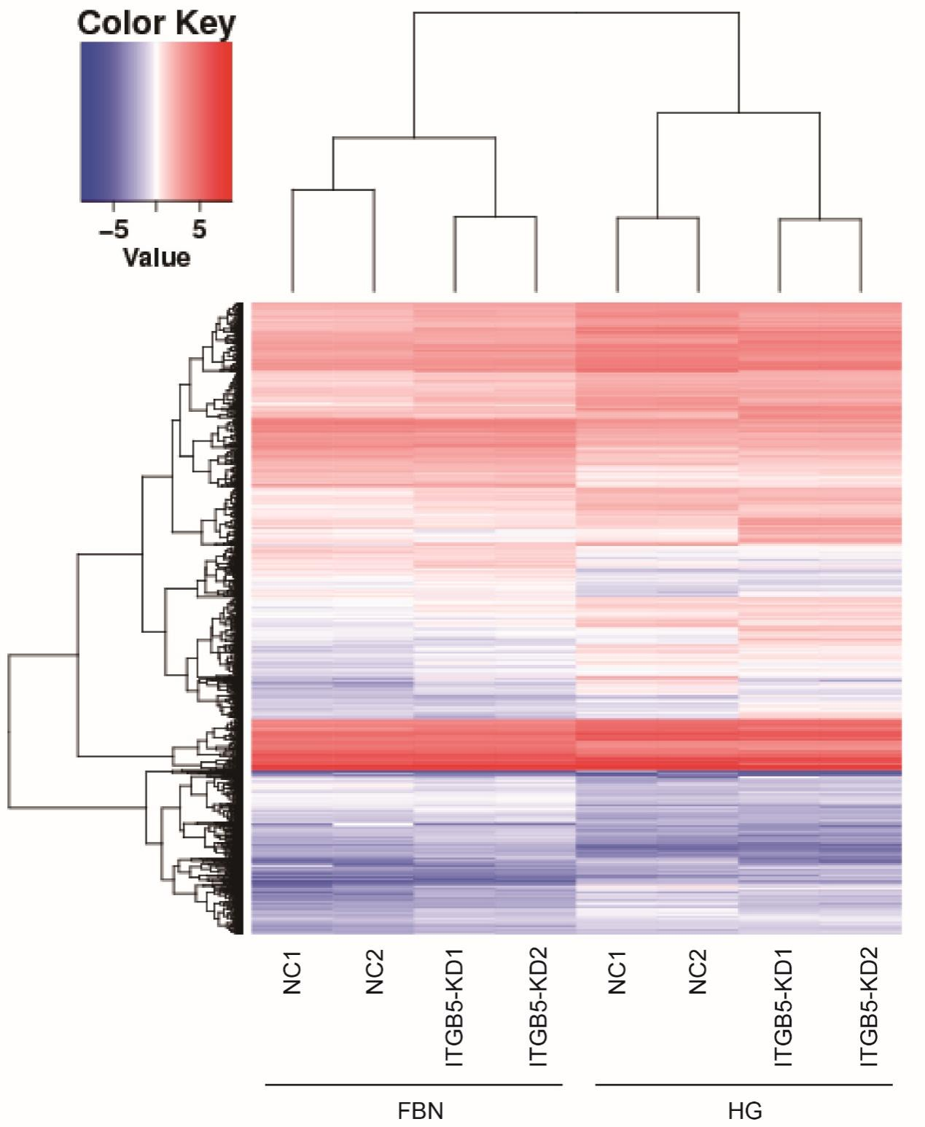
Supplementary Figure 3
Heat map of differentially expressed genes in each comparison group. According to the results of differential expression analysis, the genes of q < 0.05 and log2 (fold change) > = 1 were extracted, and then the heat map was made according to the expression of each sample. The gradient of blue, white and red indicates the gene expression level. Blue indicates a low expression level and red indicates a high expression level.

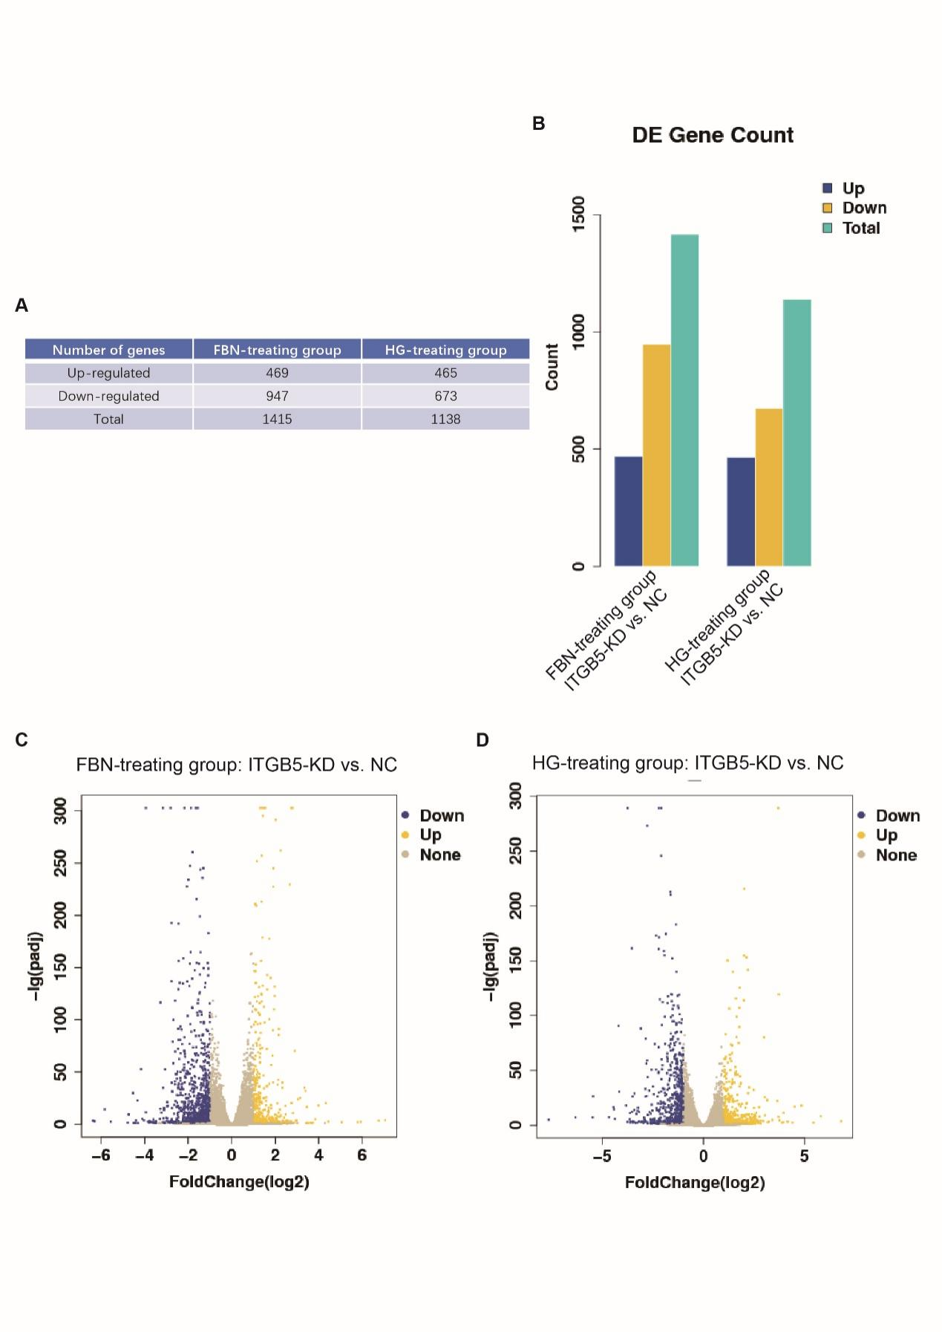
Supplementary Figure 4
A-B. The number of differential expression genes of q < 0.05 in each group was showed. C-D. The genes of q < 0.05 and |log2 (fold change) | > = 1 in each group were showed in volcanic map.

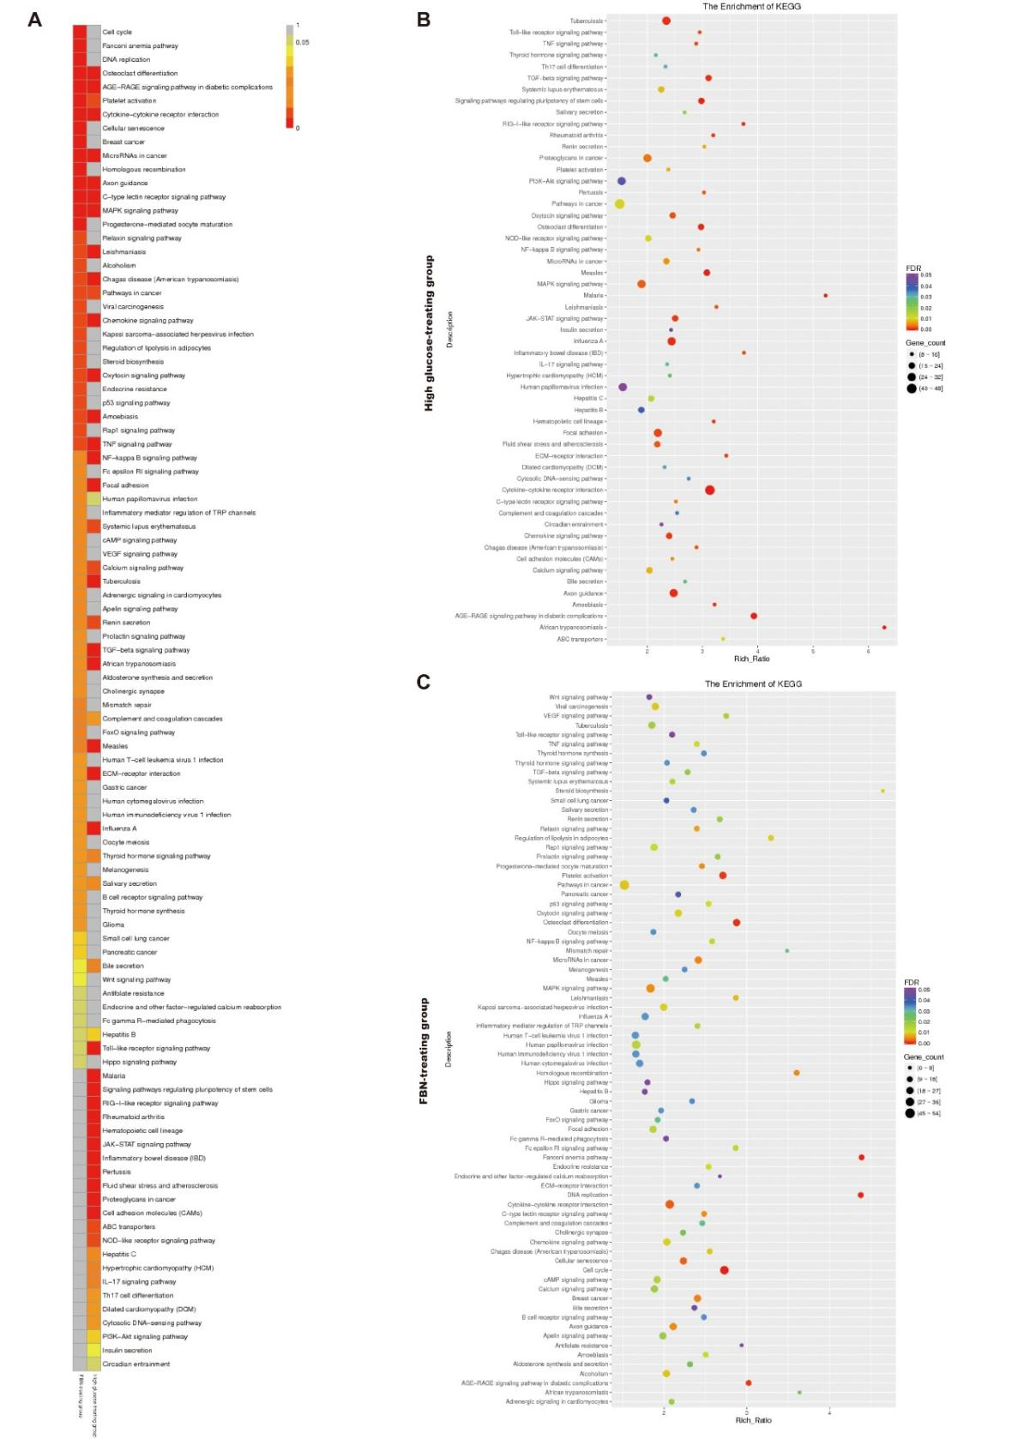
Supplementary Figure 5
Kyoto Encyclopedia of Genes and Genomes (KEGG) pathway analysis was used to rank the differentially regulated pathways in β5-knockdown HUVECs. A. The heat map shows the differentially regulated pathways in β5-knockdown groups under the stimulation of high-glucose ECM or fibronectin-containing ECM. The color indicates the size of FDR of pathways, and the FDR that less than 0.05 was considered to be statistical significant. B-C. The bubble maps indicate the FDR, rich ratio and relevant gene counts of differentially regulated pathways in β5-knockdown groups.
Supplementary Figure 6
The knockdown of ITGB5 significantly modulated the AGE-RAGE pathway. HUVECs were transfected with negative control siRNA or ITGB5 siRNA and then incubated in high-glucose ECCM for 24 h or fibronectin-containing ECCM for 6 h. RNA-seq technology was used to investigate gene expression in samples. (A,B) KEGG pathway analysis was used to rank the differentially regulated pathways in the ITGB5-knockdown groups. The 10 pathways with the most significant differences (according to their FDR) were selected and ranked in line with their rich ratio. (C,D) Fragments per kilobase of exon model per million mapped fragments (FPKM) was used to assess the gene expression intensity. The expression intensity of genes controlled by the AGE-RAGE pathway was evaluated by the standard score (Z score, Z = (x–μ)/σ. Z score was used to measure the difference between the values in a sample and the mean of the sample population) of log₂(fpkm). (E,F) The expression levels of genes regulated by the AGE-RAGE pathway were evaluated by RT‒qPCR analysis (n = 4/group). In the bar graphs, the data are expressed as the mean ± standard deviation. *P <0.001, †P <0.01. AGE-RAGE: Advanced glycation end products-receptor of advanced glycation end product; ECCM: Endothelial cell culture medium; FBN: Fibronectin; FDR: False discovery rate; FoxO1: Forkhead Box Protein O1; FPKM: Fragments per kilobase of exon model per million mapped fragments; HG: High-glucose medium; HUVECs: Human umbilical vascular endothelial cells; ITGB5: Integrin subunit β5; KD: Knockdown; KEGG: Kyoto Encyclopedia of Genes and Genomes; mRNA: Messenger RNA; NC: Negative control siRNA; NG: Normal-glucose medium; RIG-I: Retinoic acid-inducible gene I; RNA-seq: RNA sequencing; RT-qPCR: Real-time quantitative polymerase chain reaction; siRNA: Small interfering RNA. List of gene abbreviations is shown in Supplementary Table 5.

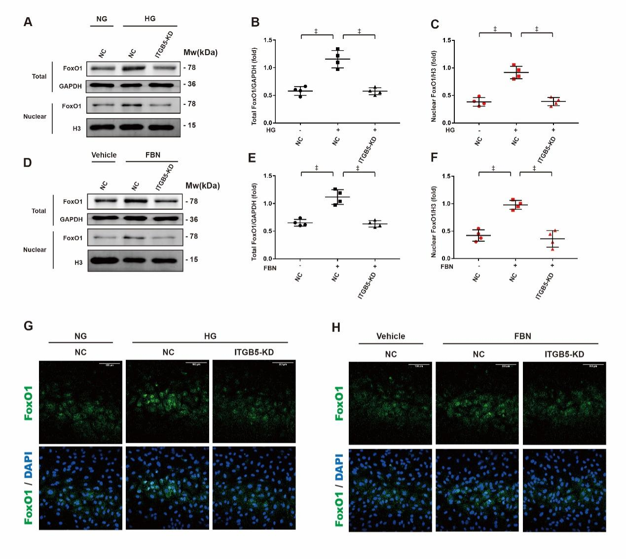
Supplementary Figure 7
The knockdown of ITGB5 controlled FoxO1 expression and nuclear translocation. We knocked down the expression of ITGB5 in HUVECs and incubated them in high-glucose medium for 24 h or fibronectin-containing medium for 6 h. (A) Whole protein and nuclear protein were extracted and subjected to western blotting analysis. (B,C) Relative gray values were used to indicate the expression intensity of target proteins. (D) Whole protein and nuclear protein were extracted and subjected to western blotting analysis. (E,F) Relative gray values were used to indicate the expression intensity of target proteins. (G,H) In immunofluorescence analysis, FoxO1 was stained green, and nuclei were stained blue. In the graphs, the data are expressed as the mean ± standard deviation; ‡P <0.001. DAPI: 4’,6-diamidino-2-phenylindole; FBN: Fibronectin; FoxO1: Forkhead Box Protein O1; GAPDH: Glyceraldehyde 3-phosphate dehydrogenase; HG: High-glucose medium; HUVECs: Human umbilical vascular endothelial cells; ITGB5: Integrin subunit β5; KD: Knockdown; NC: Negative control siRNA; NG: Normal-glucose medium; siRNA: Small interfering RNA.

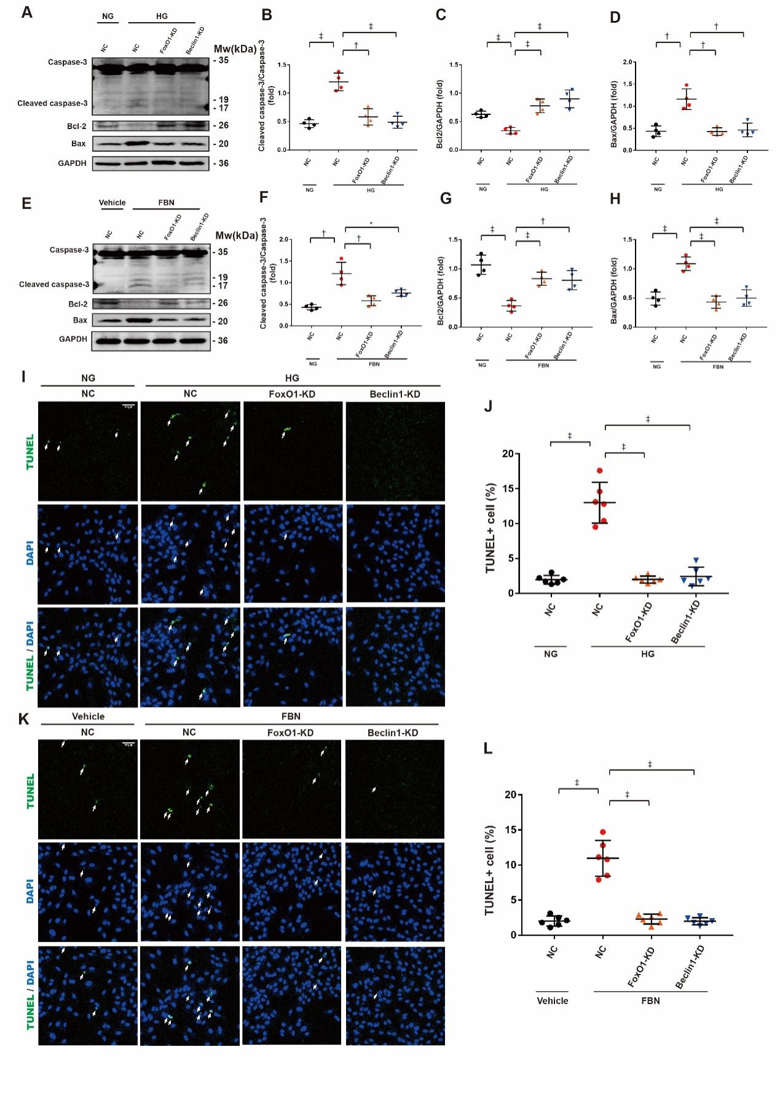
Supplementary Figure 8
FoxO1 regulated excessive autophagy induced by high glucose and fibronectin, which contributed to HUVEC apoptosis (A) We knocked down the expression of FoxO1 or beclin1 in HUVECs and incubated them in high-glucose medium for 24 h. Western blotting was used to analyze the expression of target proteins. Relative gray values were used to indicate the expression intensity of target proteins (n = 4/group). (B-D) Relative gray values were used to indicate the expression intensity of target proteins (n = 4/group). (E) We knocked down the expression of FoxO1 or beclin1 in HUVECs and incubated them in fibronectin-containing medium for 6 h. Western blotting was used to analyze the expression of target proteins(n = 4/group). (F-H) Relative gray values were used to indicate the expression intensity of target proteins (n = 4/group). (I) We knocked down the expression of FoxO1 or beclin1 in HUVECs and incubated them in high-glucose medium for 24 h. TUNEL analysis was used to detect cell death. The nuclei of dead cells were stained green (n = 6/group, TUNEL-positive nuclei are marked by arrows). (J) The apoptosis rate was quantified by calculating the percentage of TUNEL-positive cells (n = 6/group). (K) We knocked down the expression of FoxO1 or beclin1 in HUVECs and incubated them in fibronectin-containing medium for 6 h. TUNEL analysis was used to detect cell death. The nuclei of dead cells were stained green (n = 6/group, TUNEL-positive nuclei are marked by arrows). (L) The apoptosis rate was quantified by calculating the percentage of TUNEL-positive cells (n = 6/group). In the graphs, the data are expressed as the mean ± standard deviation; *P <0.05, †P <0.01, ‡P <0.001. DAPI: 4',6-diamidino-2-phenylindole; FoxO1: Forkhead Box Protein O1; FBN: Fibronectin; GAPDH: Glyceraldehyde 3-phosphate dehydrogenase; HG: High-glucose medium; HUVEC: Human umbilical vascular endothelial cells; KD: Knockdown; NC: Negative control siRNA; NG: Normal-glucose medium; siRNA: Small interfering RNA. TUNEL: Terminal deoxynucleotidyl transferase mediated dUTP nick-end labeling.
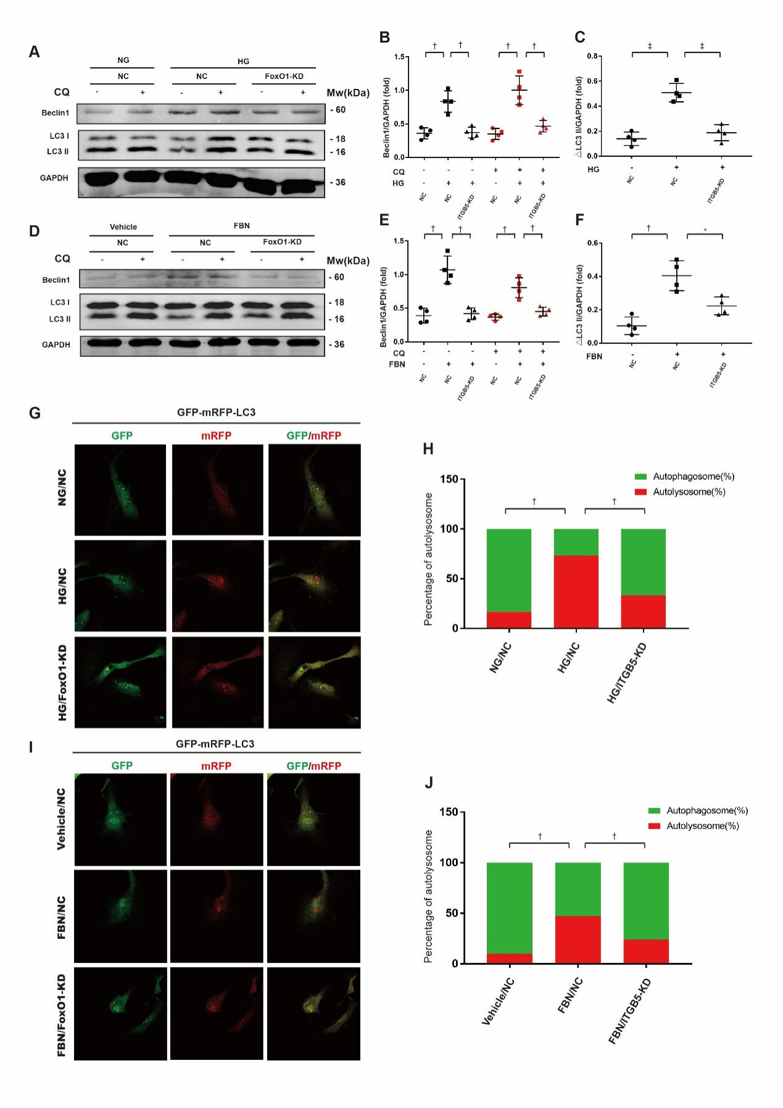
Supplementary Figure 9
FoxO1 knockdown alleviated autophagy induced by high glucose or fibronectin. (A) HUVECs were transfected by negative control siRNA or FoxO1 siRNA, and then they were incubated in high-glucose ECM (containing 0.2% FBS, 33mM Glucose) for 26h. In several groups, chloroquine (CQ, 50μM) was added to medium in the last 2h of incubation. Protein of each sample was extracted and subjected to western blot analysis (n=4/group). (B-C) Relative grey values were used to indicate the expression intensity of target proteins. D. HUVECs were transfected by negative control siRNA or FoxO1 siRNA, and then they were incubated in normal-glucose ECM (containing 0.2% FBS, 5mM glucose) for 26h. In several groups, CQ (50μM) was added to medium in the last 2h of incubation. Protein of each sample was extracted and subjected to western blot analysis (n=4/group). (E-F) Relative grey values were used to indicate the expression intensity of target proteins. (G) HUVECs that expressed mRFP-GFP-LC3 were subjected to gene intervening. After transfected by negative control siRNA or FoxO1 siRNA, cells were incubated in high-glucose ECM or normal-glucose ECM for 24h. Immunofluorescence images of each sample was taken (n=3/group). (H) The average of autolysosome percentage in each group was quantified and expressed in stacked bars. (I) HUVECs that expressed mRFP-GFP-LC3 were subjected to gene intervening. After transfected by negative control siRNA or FoxO1 siRNA, cells were incubated in fibronectin-containing ECM (5μg/ml fibronectin, 0.1 % FBS, 5mM glucose) for 8h. Immunofluorescence images of each sample was taken (n=3/group). (J) The average of autolysosome percentage in each group was quantified and expressed in stacked bars. NC: negative control siRNA. FBN: fibronectin. KD: knockdown N.S.: not significant. NG: normal-glucose medium. HG: high-glucose medium. In plot graphs, data are expressed in mean±SD. In stacked bar graphs, data are expressed in the mean of percentage; *p<0.05, **p<0.01, ***p<0.001

