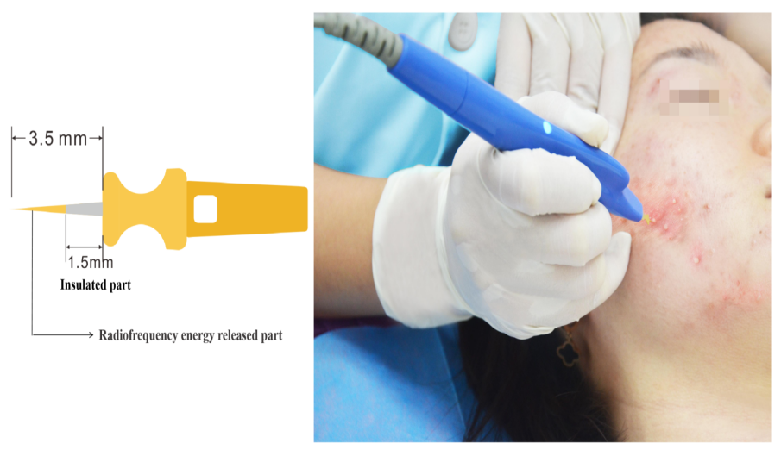
Supplementary Figure 1: The 3.5-mm-long needle with 1.5-mm insulation is inserted into the lesional follicular pore, and an electrical current is delivered to treat the acne.

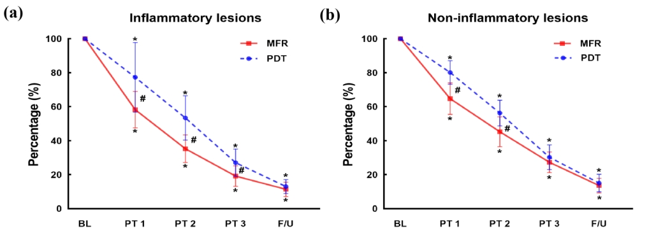
Supplementary Figure 2: Percent change in (A) inflammatory acne lesion counts and (B) non-inflammatory acne lesion counts during the time window of treatment sessions and the final F/U. *P < 0.05 vs. BL; †P < 0.05 between MRF and PDT groups. BL: Baseline; F/U: Follow‐up; MRF: Single microneedle radiofrequency; PDT: Photodynamic therapy; PT: Post‐treatment.
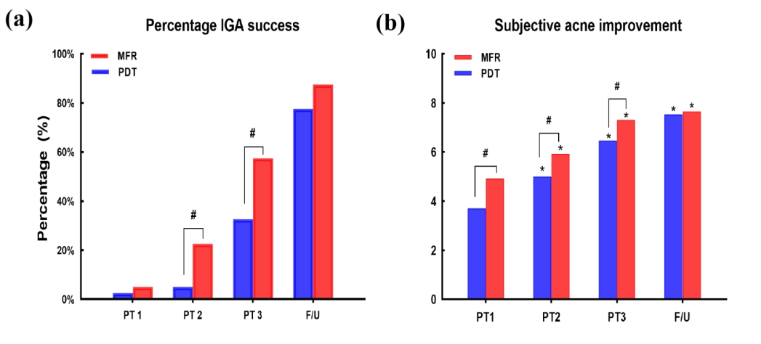
Supplementary Figure 3: (A) Success rate based on the IGA of “clear” or “almost clear.” (B) Comparison of subjective treatment assessments. *P < 0.05 vs. PT1; †P < 0.05 between MRF and PDT groups. F/U: Follow‐up; IGA: Investigator Global Assessment; MRF: Single microneedle radiofrequency; PDT: Photodynamic therapy; PT: Post‐treatment.
Supplementary Table 1: Baseline characteristics of the enrolled subjects (n = 80).
Items | MRF group  (n = 40) | PDT group  (n = 40) | P-value
Male, n (%) | 24 (60.0) | 21 (52.5) | 0.652
Age (years, mean + SD) | 22.4 ± 3.4 | 23.8 ± 4.0 | 0.087
Skin phototype (Fitzpatrick), n (%)
III | 33 (82.5) | 35 (87.5) | 0.531
IV | 7 (17.5) | 5 (12.5)
Acne lesion counts (mean + SD)
Inflammatory lesion | 45.5 ± 7.1 | 46.7 ± 7.8 | 0.491
Non-inflammatory lesion | 48.5 ± 11.7 | 50.1 ± 11.5 | 0.545
Acne severity grade (IGA), n (%)
3 | 28 (70.0) | 25 (62.5) | 0.478
4 | 12 (30.5) | 15 (37.5)
ECCA (mean + SD) | 93.4 ± 23.2 | 99.9 ± 21.9 | 0.201
IGA: Investigator Global Assessment; MRF: Single microneedle with radiofrequency; PDT: Photodynamic therapy; SD: Standard deviation.

Supplementary Table 2: Safety profiles of the MRF and PDT treatment groups.
Items | MRF group | PDT group | P-value
Pain (10-point VAS) | 4.9 ± 0.6 | 6.6 ± 0.9 | <0.05
Erythema | 1.7 ± 0.5 | 2.6 ± 0.3 | <0.05
Edema | 1.4 ± 0.5 | 2.4 ± 0.4 | <0.05
Scaling and dryness | 0.8 ± 0.4 | 1.9 ± 0.5 | <0.05
Scar formation (ECCA) | 96.3 ± 15.1 | 105.4 ± 16.0 | <0.05
Pigmentary changes | 4/40 | 17/40 | <0.05
Acneiform eruption | None | 13/40 | <0.05
MRF: Single microneedle with radiofrequency; PDT: Photodynamic therapy; VAS: Visual analog scale.

