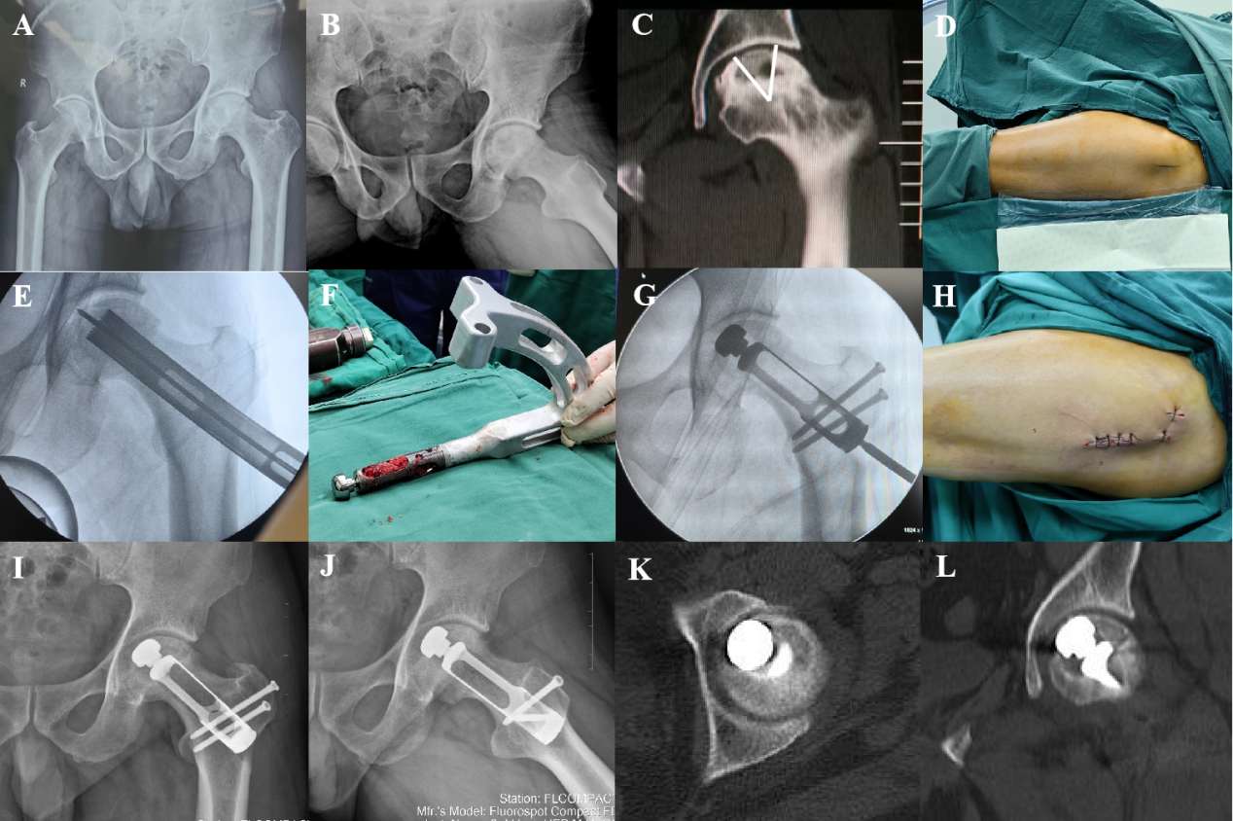
Supplementary Figure 1: (A,B) Preoperative anteroposterior and frog position radiographs of the pelvis. (C) Preoperative coronal CT scans of the hip joint showed necrosis in the weight-bearing dome. (D–H) Main operation steps of this novel hip preservation surgery. (I,J) The anteroposterior and frog position hip radiographs at 6 months after surgery. (K,L) CT scans of the hip joint at 6 months after surgery. CT: Computed tomography.
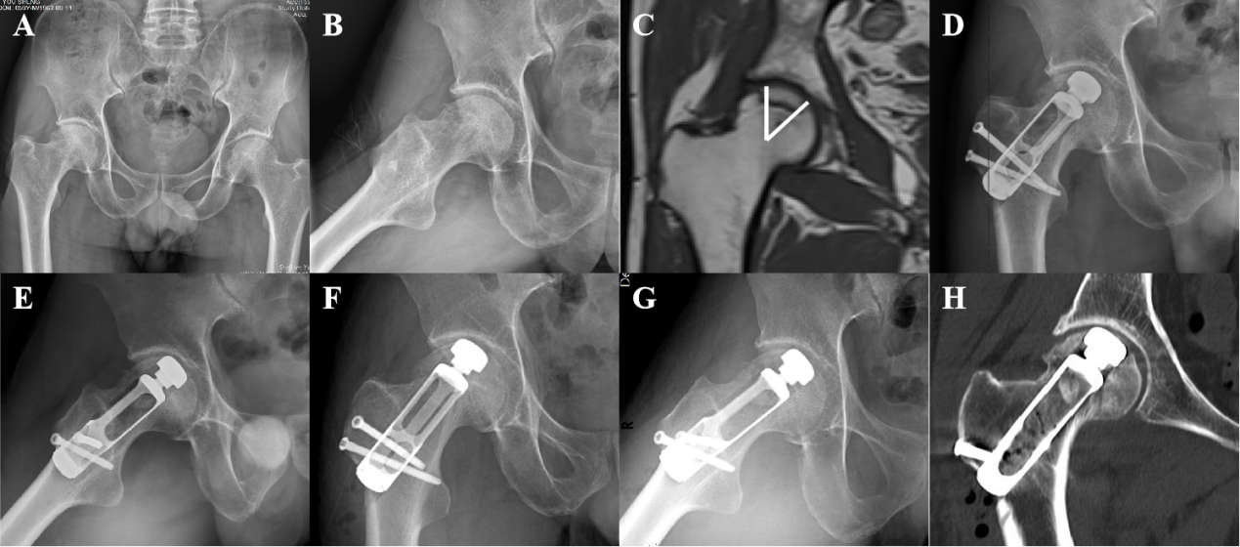
Supplementary Figure 2: (A,B) Preoperative anteroposterior and frog position radiographs of the pelvis. (C) Preoperative coronal MRI scans of the hip joint showed necrosis in the weight-bearing dome. (D,E) The anteroposterior and frog position hip radiographs at 1 month after surgery. (F–H) The anteroposterior and frog position hip radiographs and CT scans of the hip joint at 6 months after surgery. CT: Computed tomography; MRI: Magnetic resonance imaging.
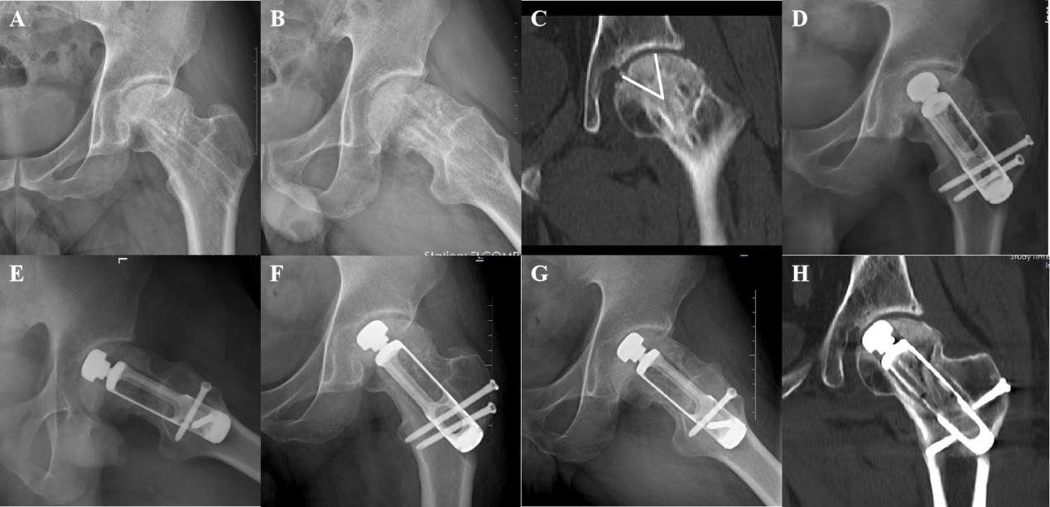
Supplementary Figure 3: (A,B) Preoperative anteroposterior and frog position radiographs of the pelvis. (C) Preoperative coronal CT scans of the hip joint showed necrosis in the weight-bearing dome. (D,E) The anteroposterior and frog position hip radiographs at 1 month after surgery. (F–H) The anteroposterior and frog position hip radiographs and CT scans of the hip joint at 6 months after surgery. CT: Computed tomography.
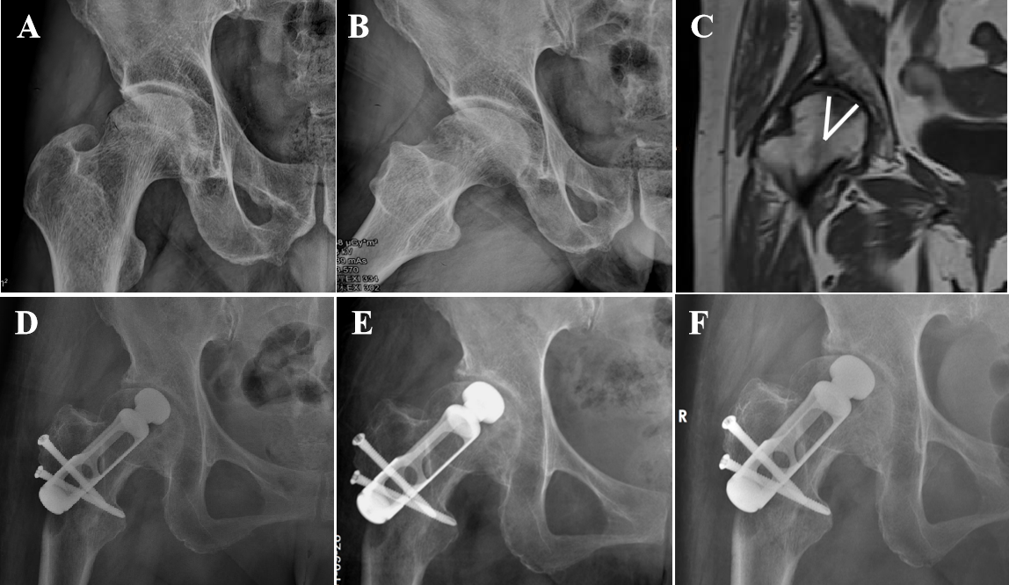
Supplementary Figure 4: (A,B) Preoperative anteroposterior and frog position radiographs of the pelvis. (C) Preoperative coronal MRI scans of the hip joint showed necrosis in the weight-bearing dome. (D–F) The anteroposterior position hip radiographs at 1 month, 3 months, and 6 months after surgery. MRI: Magnetic resonance imaging.
Supplementary Table 1: Characteristics of patients with ONFH.
ID | Age (years)/Sex | Side | Etiology | Necrotic volume (mm³) | ARCO stage | Pre-operation |  | Follow-up time (months) | Post-operation (1 month) |  | Post-operation (3 months) |  | Post-operation (6 months)
 |  |  |  |  |  | VAS | HSS |  | VAS | HSS | VAS | HSS | VAS | HSS
1 | 47/Male | Left | Hormone | 10×12×6 | IIIA | 7/10 | 61 | 9 | 3/10 | 78 | 1/10 | 82 | 1/10 | 86
2 | 49/Male | Right | Alcohol | 15×10×4 | IIIB | 5/10 | 70 | 9 | 2/10 | 80 | 1/10 | 88 | 1/10 | 92
3 | 52/Female | Left | Traumatic | 12×8×6 | IIIB | 7/10 | 65 | 8 | 3/10 | 80 | 2/10 | 80 | 2/10 | 80
4 | 51/Male | Right | Idiopathic | 10×10×8 | IIIA | 7/10 | 68 | 7 | 4/10 | 75 | 3/10 | 80 | 3/10 | 80
ARCO: Association Research Circulation Osseous; ONFH: Osteonecrosis of the femoral head; VAS: Visual analog scale.

