1
Supplementary Figure 1: Zenith fenestration stent grafts (A) and Anaconda fenestration stent grafts (B); Off-the-shelf devices: (C,D) two design styles of p-Branch; (E) Ventana, (F,G) WeFlow-JAAA. CA: Celiac artery; LRA: Left renal artery; RRA: Right renal artery; SMA: Superior mesenteric artery.

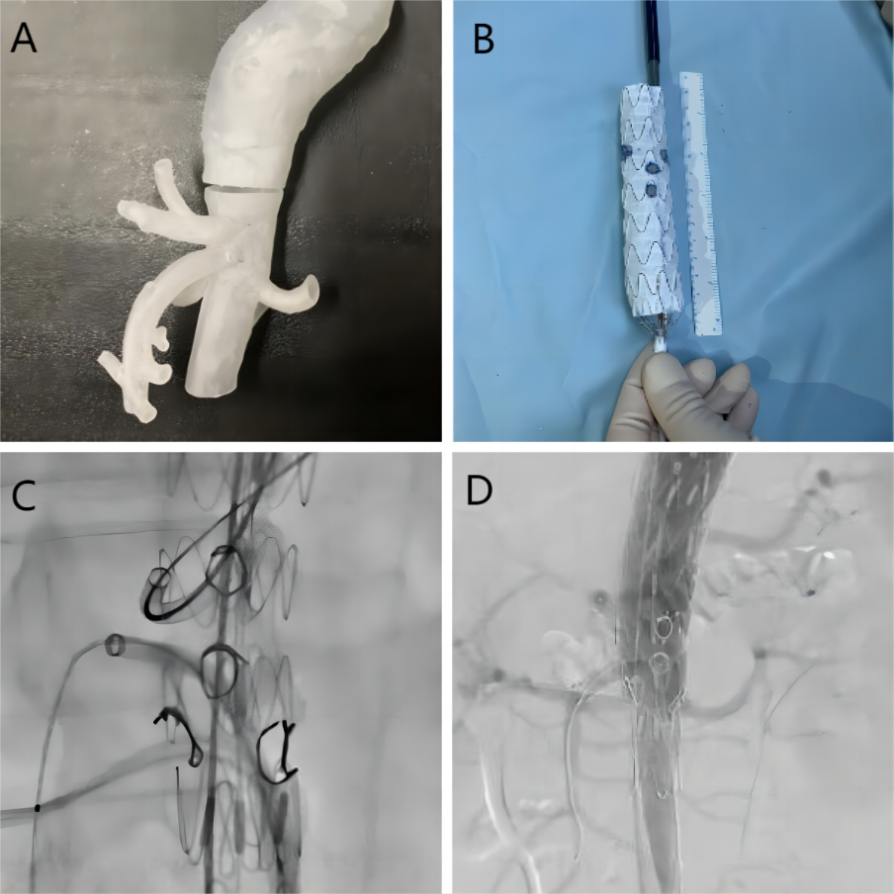
Supplementary Figure 2: (A) a hollow 3D-printed aortic model; (B) Aortic stents with completed fenestrations based on the 3D-printed model; (C) Intraoperative fenestrations are accurately aligned; (D) The angiogram shows good blood flow in the branch arteries and without endoleaks.

