Supplementary Table 1: Patient characteristics (N=78).
Patient characteristics | Number (%)
Age(years)
<65 | 53 (67.9%)
≥65 | 25 (32.1%)
Gender
Female | 19 (24.4%)
Male | 59 (75.6%)
Histology
Non-squamous | 49 (62.8%)
Squamous | 29 (37.2%)
Tobacco use history
Never | 30 (38.5%)
Previous | 48 (61.5%)
ECOG performance status
0 | 39 (50.0%)
1 | 39 (50.0%)
Clinical staging
III | 16 (20.5%)
IV | 62 (79.5%)
Lines of immunotherapy
1 | 39 (50.0%)
≥2 | 39 (50.0%)
PD-L1 expression level, n (%)
<1% | 18 (23.1%)
1%–49% | 16 (20.5%)
≥50% | 16 (20.5%)
Unknown | 28 (35.9%)
TMB
Low | 17 (21.8%)
High | 20 (25.6%)
Unknow | 41 (52.6%)
Evaluation of efficacy
PR | 44 (56.4%)
SD | 34 (43.6%)
Type of immunotherapy (prior therapies before AR)
Monotherapy | 15 (19.2%)
Combination therapy | 63 (80.8%)
AR: Acquired resistance; ECOG: Eastern Cooperative Oncology Group; PD-L1: Programmed death ligand 1; PR: Partial response; SD: Stable disease; TMB: Tumor mutation burden.
Supplementary Table 2: Univariable and multivariable analyses of clinical parameters on OS.
Parameters | Univariable analysis  HR (95% CI) | P-value | Multivariable analysis  HR (95% CI) | P-value
Age <65years* vs. ≥65 years | 1.30 (0.67-2.53) | 0.450 | — | —
Female* vs. male | 1.67 (0.76-3.64) | 0.179 | — | —
Non-squamous* vs. squamous | 1.05 (0.54-2.02) | 0.890 | — | —
Never smoker* vs. previous smoker | 1.05 (0.55-2.00) | 0.887 | — | —
ECOG PS 0* vs. ≥1 | 1.08 (0.57-2.02) | 0.820 | — | —
Stage III* vs. IV | 1.32 (0.55-3.17) | 0.516 | — | —
Lines of immunotherapy
1 (ref) | — | ref | — | —
≥2 | 1.14 (0.60-2.16) | 0.686 | — | —
PD-L1 expression level (%)
<1 |  | ref
1–49 | 1.46 (0.54-3.94) | 0.456 | — | —
≥50 | 2.58 (0.99-6.70) | 0.052 | — | —
Unknown | 1.17 (0.46-3.00) | 0.747 | — | —
TMB |  |  | — | —
Low |  | ref
High | 1.48 (0.60-3.64) | 0.396 | — | —
Unknown | 0.99 (0.43-2.28) | 0.988 | — | —
Bone metastasis, yes vs. no | 1.17 (0.54-2.55) | 0.698 | — | —
Brain metastasis, yes vs. no | 2.92 (1.41-6.03) | 0.008 | 5.47(2.44-12.25) | ＜0.001
Treatment strategy |  |  | — | —
SOC | — | ref | — | Ref
I-alone | 0.13 (0.04-0.39) | 0.000 | 0.08(0.02-0.26) | ＜0.001
I + A | 0.19 (0.07-0.52) | 0.001 | 0.14(0.05-0.40) | ＜0.001
I + C | 0.58 (0.28-1.19) | 0.135
*Represents reference. CI: Confidence interval; ECOG PS: Eastern Cooperative Oncology Group performance status; HR: Hazard ratio; I + A: Immune checkpoint inhibitors plus antiangiogenetic treatment; I-alone: Immune checkpoint inhibitors alone; I + C: Immune checkpoint inhibitors plus chemotherapy; OS: Overall survival; PD-L1: Programmed death ligand 1; PR: Partial response; SD: Stable disease; SOC: Standard of Care; TMB: Tumor mutation burden.
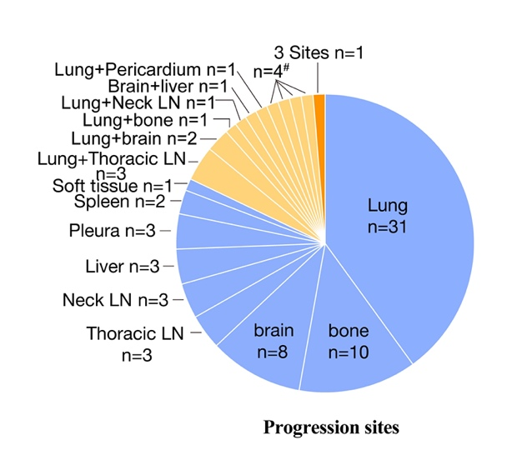

Supplementary Figure 1: Progression patterns and sites of AR. #represents 4 patients with 2 sites progression (Liver + Bone, Adrenal gland + Bone, Brain + soft tissue, and Brain +Bone). Pie chart showing number of patients with one site (blue), two sites (yellow), or three or more sites (orange) of PD. AR: Acquired resistance; LN: Lymph node; PD: Progressive disease.
Supplementary Figure 2: Kaplan–Meier curves of the OS and PFS of all eligible patients (N = 78). (A) the OS and (B) PFS. I + A: Immune checkpoint inhibitors plus antiangiogenetic treatment; I-alone: Immune checkpoint inhibitors alone; I + C: Immune checkpoint inhibitors plus chemotherapy; CI: Confidence interval; OS: Overall survival; PFS: Progression-free survival; SOC: Standard of Care.
Supplementary Figure 3: Kaplan–Meier curves of the OS and PFS of patients receiving I + A and I + C treatment. (A) OS, and (B) PFS. CI: Confidence interval; I + A: Immune checkpoint inhibitors plus antiangiogenetic treatment; I + C: Immune checkpoint inhibitors plus chemotherapy; OS: Overall survival; PFS: Progression-free survival.

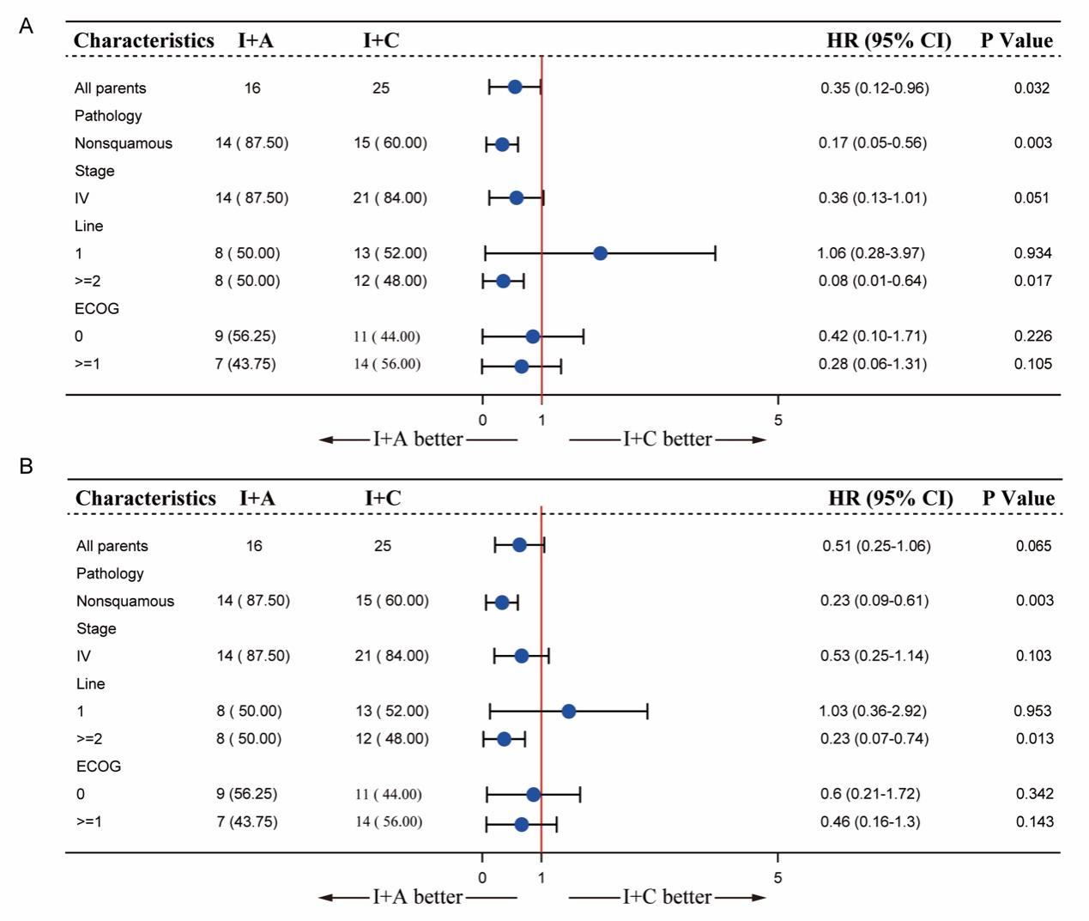
Supplementary Figure 4. Subgroup analysis of OS and PFS in patients who received I+A and I+C treatment. (A) overall survival (OS) and (B) Progression-free survival (PFS). Only 2 patients were pathologically diagnosed with squamous cells in I+A group and 2 patients were diagnosed with stage III NSCLC in I+A group. These two subgroups are not shown because of the sample number (<5). ECOG: Eastern Cooperative Oncology Group performance score. I+A: immune checkpoint inhibitors plus antiangiogenetic treatment. I+C: immune checkpoint inhibitors plus chemotherapy.

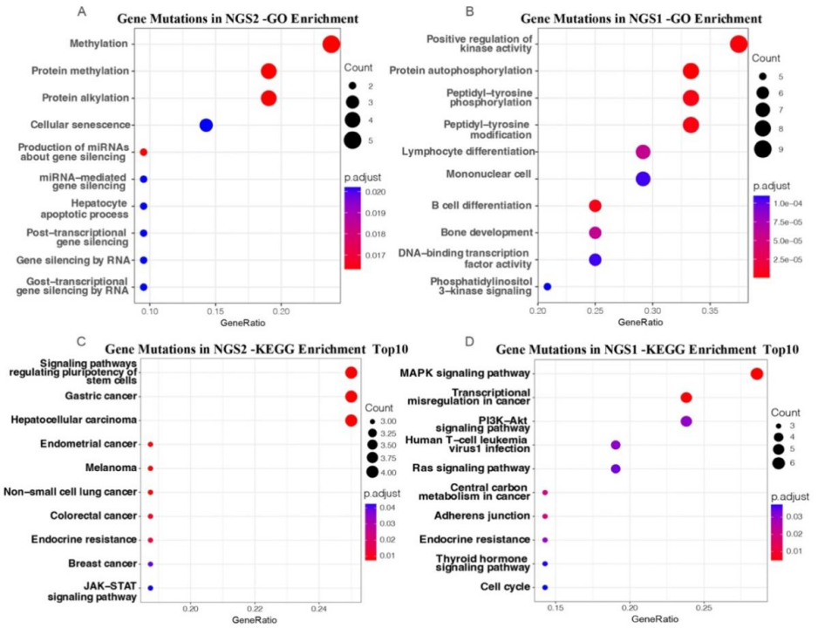
Supplementary Figure 5. GO and KEGG Enrichment analysis of NGS data for 5 patients before AR and after AR. A and C show the GO and KEGG Enrichment analysis of NGS detection after AR, respectively. B and D show the GO and KEGG Enrichment analysis of NGS detection before AR, respectively.

