Supplementary Figure 1. Patient inclusion and exclusion based on prior immunoglobulin replacement therapy.

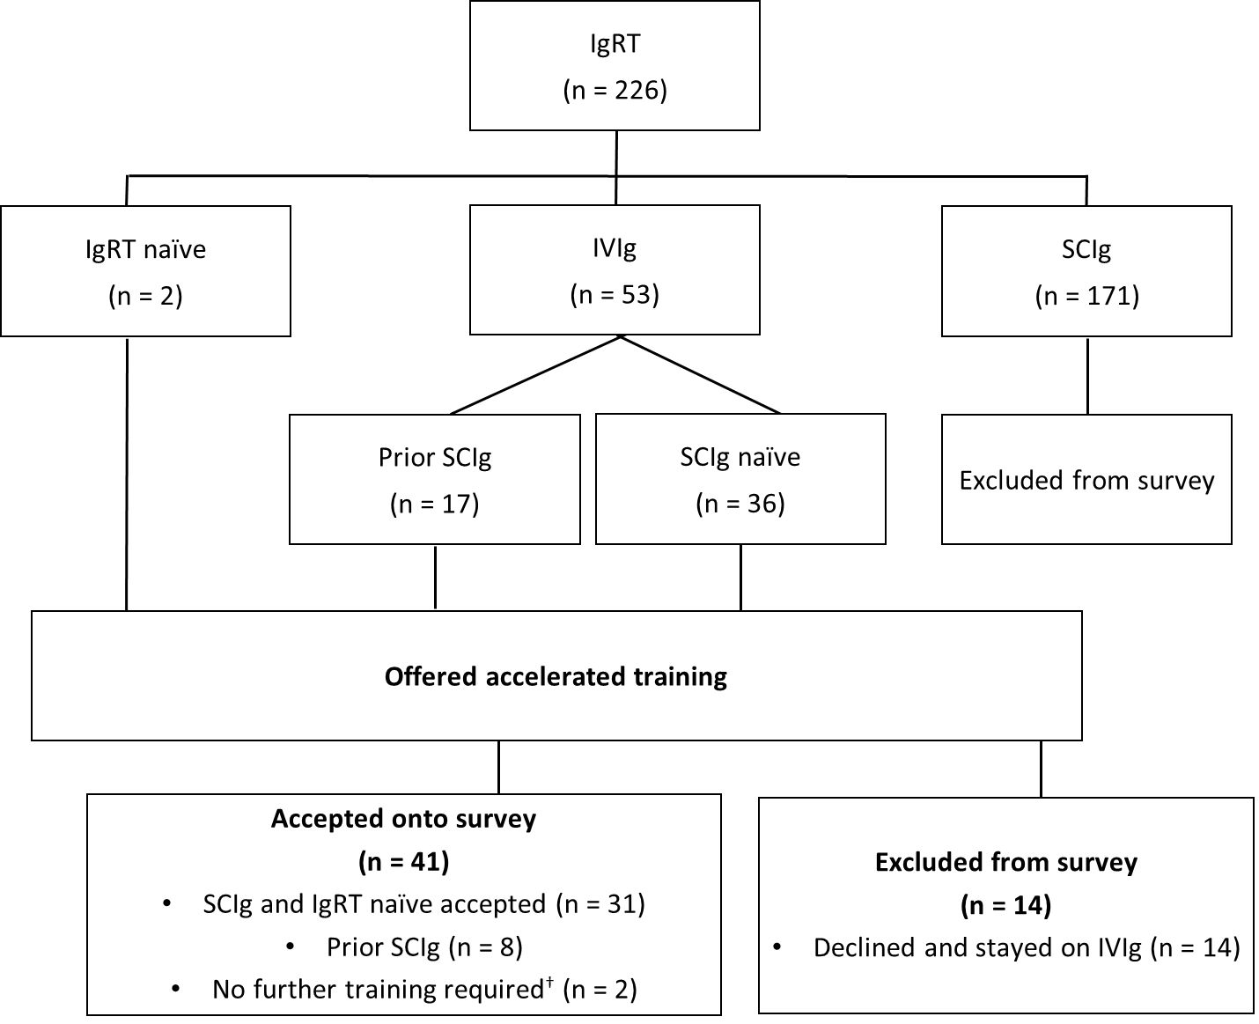
†Patients had previously received SCIg training but reverted to IVIg.
Ig, immunoglobulin; IgRT, immunoglobulin replacement therapy; IVIg, intravenous immunoglobulin; SCIg, subcutaneous immunoglobulin

