Supplementary file items 1-8

Item 1. Doctor/Nurse protocol Norwood Surgery: T2D, pre-diabetes, lower carb dietary option.
Updated Jan 2020 DJU

At the first appointment:
- Explore possible benefits/ risks of a lower carb approach to T2diabetes (eg medications risk of hypo) and make a start on motivation. The idea of diabetes remission or coming off meds is very motivating for many people.
An example of the type of question you can ask.
‘You have a range of different possible futures WRT to your diabetes, which will you choose?’ ‘Average weight loss on low carb is 9Kg is this of interest to you?’ etc..,

- Check are the patients interested in the low carb approach?

-Visit basic physiology of sugar starting with the fact that 'your HbA1c shows how sugary your diet has been in the last few months, and explaining sugar can almost be seen as a metabolic poison to someone with T2D.
Ask ‘where do you think the sugar has come from in your diet?’
- Explain dietary sources of glucose with Nice endorsed sugar equivalence infographics.
- Give the Norwood standard diet sheet for low carb approach.
- Establish baseline data; Wt., waist, height, bloods HbA1c, renal, fasting lipids, FBC. Possibly ACR if not done recently
-Enter EMIS computer code ‘low carbohydrate diet’.
Medications
? Risk of hypoglycaemia (Insulin, gliclazide) reduce dose/stop but monitor
? Risk of DKA (SGL2Inhibitors). stop but monitor blood glucose.
? Risk of hypotension, explain that with weight loss BP may well improve and medications for this may be reduced or cut back

-Salt; Due to the renal sodium retaining properties of insulin for those with T2D going low carb and therefore lower insulin results in considerable loss of sodium and consequently a diuresis. Patients may well need to increase their salt intake –particularly in the first few weeks of the diet.

-Suggest a review date - often 2 or 4 weeks depending on assessed risks. Perhaps longer for pre-diabetes

On review
Weigh, measure waist, BP. Do medications need to be changed? See above
How is it going? Problems/suggestions
Remember if both weight and HbA1c are climbing the most common reason is ‘carb creep’ NOT failure of the diet needing medication So check for this by rechecking dietary intakes. Over time many patients drift. It’s better to see this as a learning opportunity. We all learn from our mistakes!
Weight loss alongside a climbing HbA1c is worrying –ask a doctor about this.
HbA1c ‘too good’ eg. 28mmol/mol Could the patient be anaemic?
Produce Emis graphs of Wt, HbA1c etc. as feedback to maintain motivation.
Do they wish to continue?
Are they happy to share anonymised data?
If so enter Emis GP computer code 'obtaining consent'
Would they like to attend the group sessions –do they know how to find out when the next one is? Next steps
Review date and agree next blood test (HbA1c etc) -usually at 2 months from the start, but this depends on a risk analysis.
Lipid profiles Fasting profiles are preferable as triglyceride/HDL ratios are a better predictor of risk than LDL Lipid profiles usually (but not always) improve on low carb[1]

Finally, NICE UK guidelines 1.3.6 Individualise recommendations for carbohydrate and alcohol intake, and meal patterns. Reducing the risk of hypoglycaemia should be a particular aim for a person using insulin or an insulin secretagogue. [2009]
Often this is achieved by increasing dietary carbs at the expense of weight gain An alternative is to reduce carbs and the drugs involved this has the advantage of weight loss and improvements in BP

Item 2. Four infographics used to help participants understand insulin and glucose
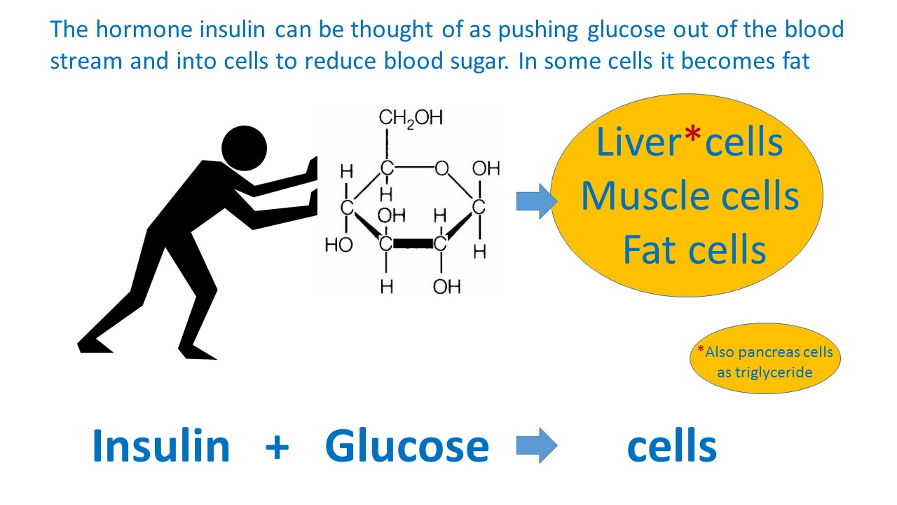
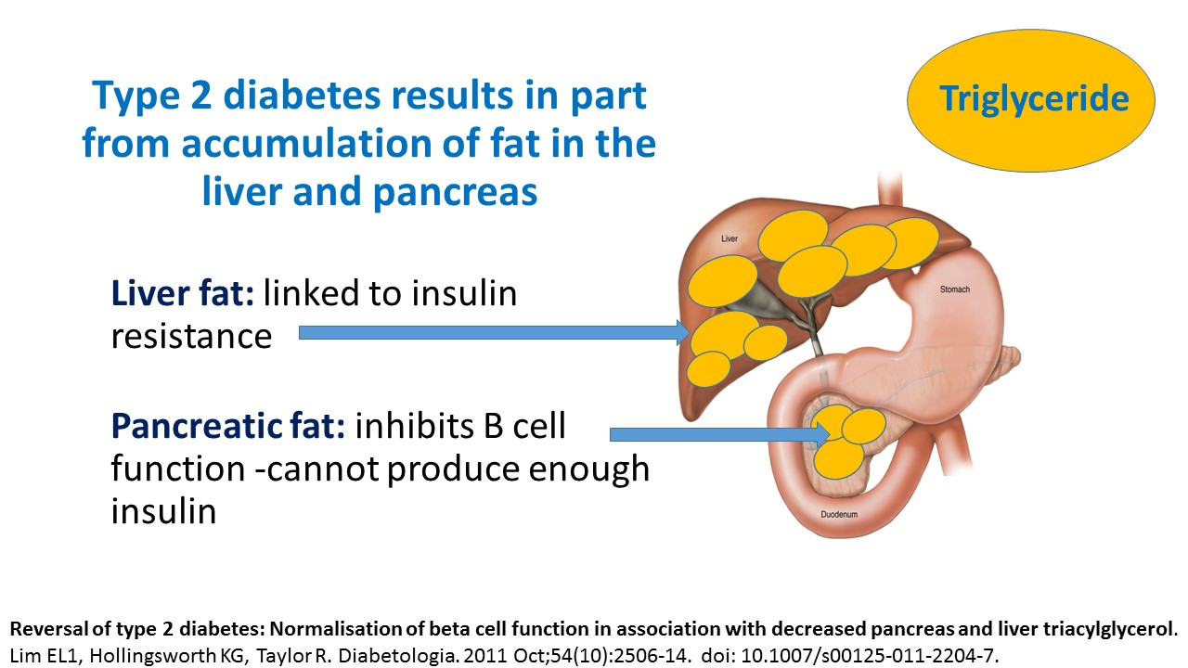

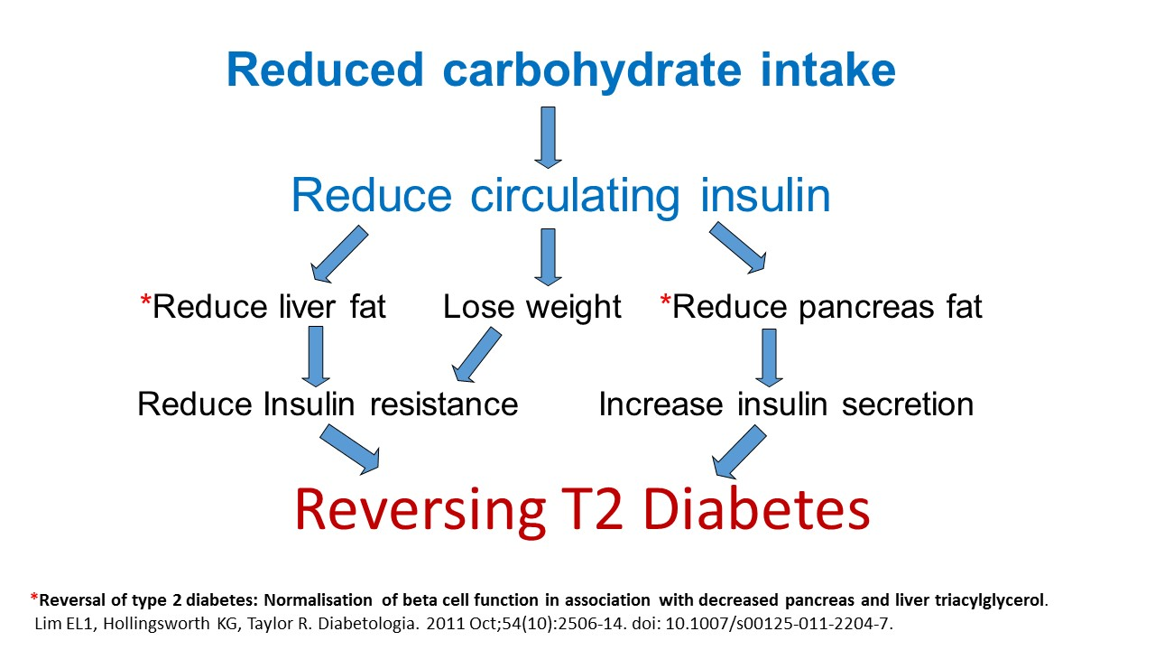

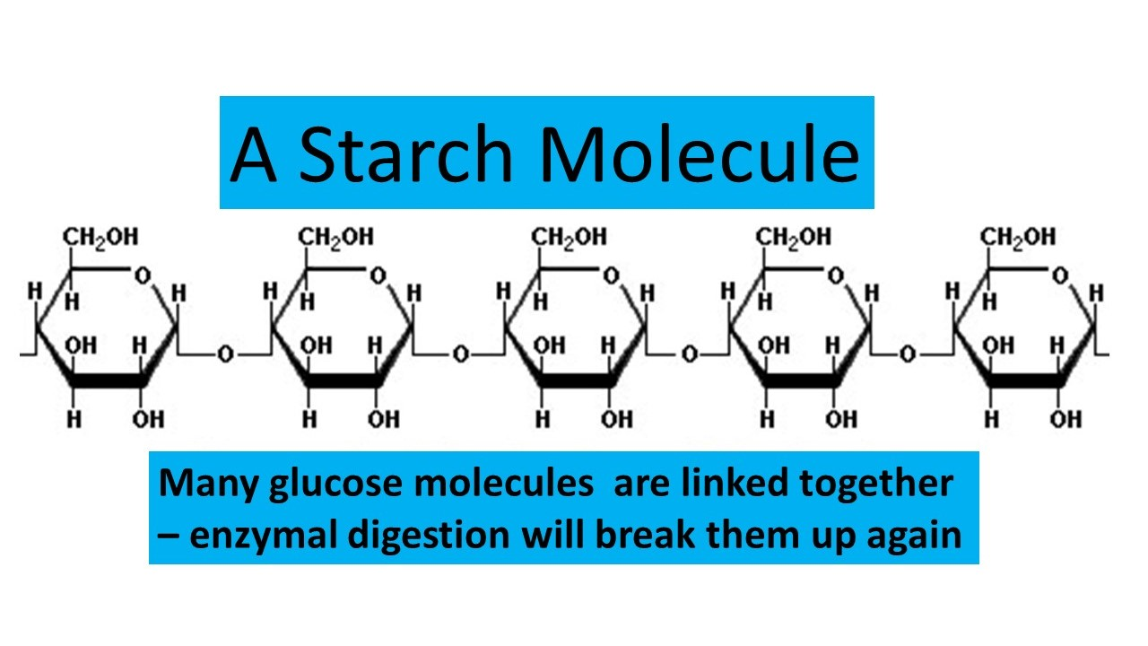

Item 3. To facilitate patient and staff understanding of the concept of glycaemic load
To facilitate patient and staff understanding of the concept of glycaemic load, a set of seven approximately indicative infographics were generated [2]. These represent the glycaemic load of example food portions alongside an approximately equivalent number of standard (4 gram) teaspoons of table sugar. In March 2019, these infographics were shortlisted for a prize by the National Institute for Health and Care Excellence (NICE) as a useful tool to support their guidelines for T2D in adults. These tools have now been used extensively in our clinical practice and have helped patients better understand the glycaemic consequences of their dietary choices. Many express surprise on discovering the amounts of glucose that foods such as potatoes, rice, and breakfast cereals eventually digest into

The clinical monitoring and support offered to each individual was guided by clinical need and patient preference and was very much integrated into routine care. In addition to 10-minute ‘one to one’ doctor or nurse appointments patients are also invited to monthly 90-minute group sessions (on a Monday night, with up to 30 people at a time). During the COVID-19 pandemic restrictions these were replaced by virtual meetings via Zoom. Patients are encouraged to attend with interested family members and friends, particularly those who help them shop or prepare food. Group sessions included a psychologist who facilitated behaviour change by encouraging participants to consider; their individual health goals, the resources available to them, setting realistic steps and enabling the individual to notice what works for them[3] . Group sessions also provided a forum for patients to offer practical support to their peers and for the training of new practice staff. From 2018, staff training was formalised through completion of a Royal College of General Practitioners (RCGP) e-learning module on T2D and the low GI diet, written by one of the authors [4]. We also used the practice electronic health record to produce “progress graphs” (for example weight over time or HbA1c over time) as a form of visual feedback for patients.

More on the statistical analysis: In all cases a p-value < 0.05 was considered statistically significant. Variables with a skewed distribution, such as weight and HbA1c are given as median (IQR) and more normally distributed variables such as duration of diet are given as mean (SD). The data for LDL cholesterol presented in table 1 were calculated by subtracting HDL-cholesterol from total serum cholesterol because these results were not routinely reported for the first few years of the LCD service being available.
Linear regression models were fitted with creatinine reduction as the outcome and improvement in either systolic or diastolic blood pressure, improvement in HbA1c or improvement in weight as the explanatory variable.

Two infographics to help patients with T2D make better dietary choices

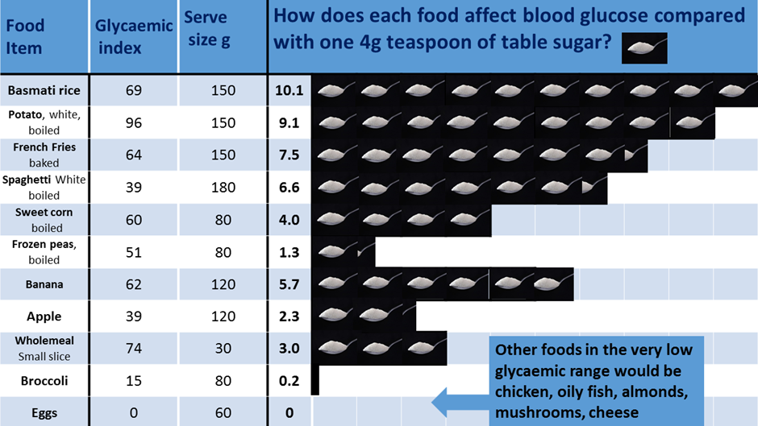

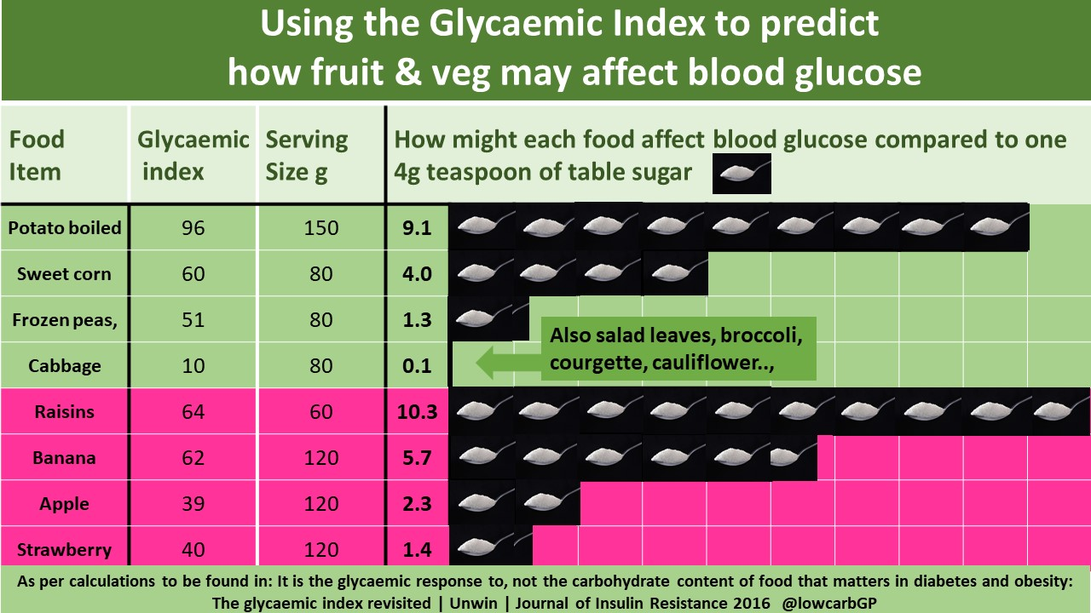

Item 4. We also used the practice computer system to produce graphs of individuals’
progress as feedback; an example.
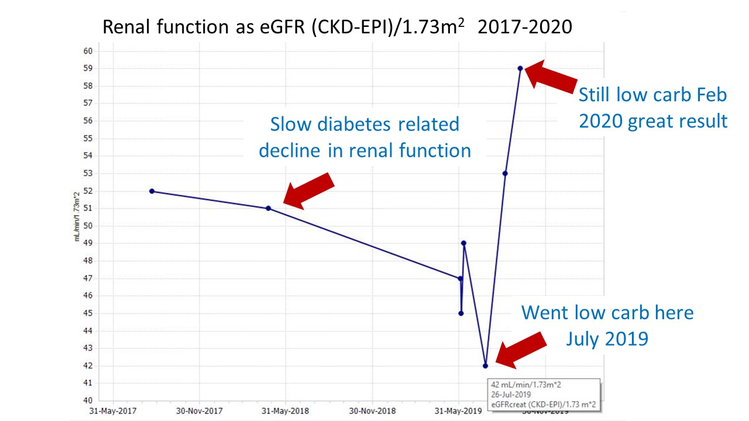

Item 5. What were the ethical considerations for setting up the ‘low carb’ approach at Norwood and publishing our results?
The BMA ethics dept were consulted about both the approach and our intention to publish in 2012-13. They did not feel ethics approval was required as this is really an audit of our service provision and the work is ‘innovative but not ground breaking’. For the same reason they did not feel we needed to consent the patients to share anonymised data, as long as data are effectively anonymised in-line with the UK Information Commissioner’s Office code of practice on anonymisation. As a voluntary and extra level of protection we decided independently to consent each patient verbally and enter an appropriate computer code on their records. No patients refused permission.
The National Research Ethics Service of the Health Research Authority in England decision tree also clearly states that this type of service evaluation is exempt from approval by an NHS Research Ethics Committee. Audit of service provision like this is encouraged and generally regarded as good practice for clinicians

Item 6.T2D remission rates Norwood March 2017- March 2021
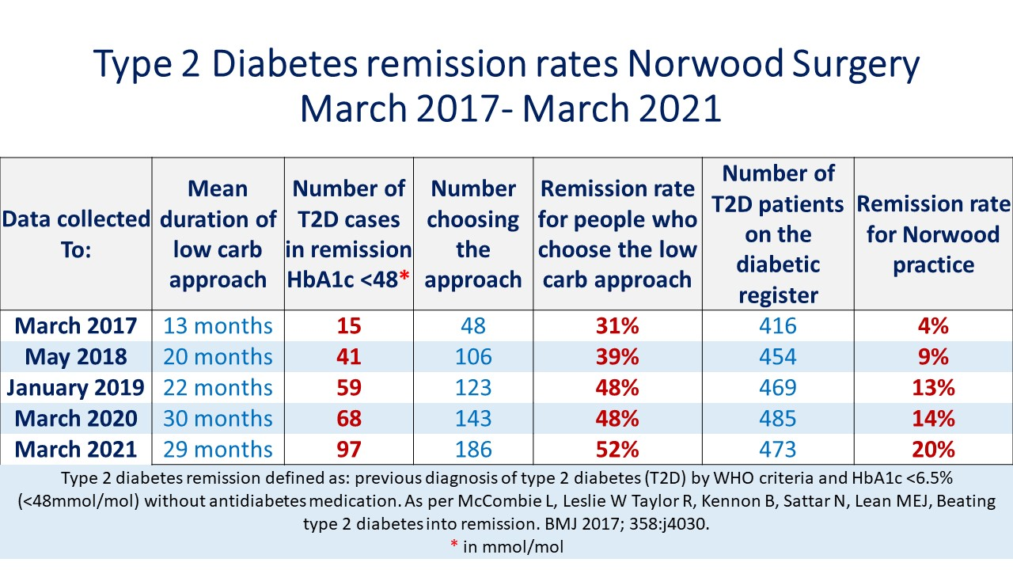

Item 7. The Norwood practice spending over £50,000 per year less than the local practice average on drugs for diabetes
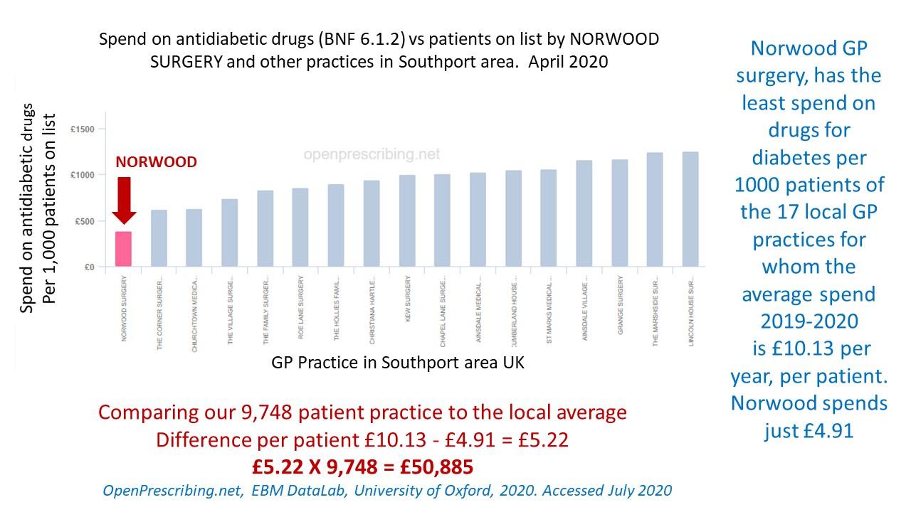

Item 8 more on the limitations of the cohort work
Ours is an audit of routine service provision. The patients involved all chose to follow the LCD approach when it was offered to them as part of routine practice. Though in some ways this is a weakness of the work, personal choice is one key factor to long-term dietary adherence. As David Sacket pointed out in 1996, “evidence based medicine is not "cookbook" medicine, it requires a bottom-up approach that integrates the best external evidence with individual clinical expertise and patients' choice” [5]. Some of the patients in this cohort have been following a LCD approach for 7 years now and the average duration is 30 months.
One major limitation of real-world results is incomplete datasets, especially for urinary ACR results, for which only 52 (36%) out of a possible 143 pairs of data were available. This is partly because until 2017 some results were reported as < 1.00 rather than the specific figure, making future comparison against future results impossible. Also many ACR tests were not run by the lab as urine samples were collected in inappropriate (i.e boric acid containing) bottles.
The absence of a formal control group means our results have no direct comparator representing outcomes of the current standard of T2D care. Whilst direct statistical comparisons cannot be made, some context can be gained from elsewhere in the literature. One regional audit of routine NHS primary care for T2D from the south of England (n = 5815) found that, in the 7 years between 2006 and 2013, mean (SD) HbA1c remained remarkably static from 62.1 (16.1) mmol/mol to 61.7 (7.3) mmol/mol[6] In this context, the results we observed of mean (SD) reduction 9.5 (7.5) kg in body weight and mean (SD) reduction 21.5 (19.2) mmol/mol in HbA1c are noteworthy and may indicate broadly the differences between outcomes of usual NHS care for T2D and the possible results of integrating a LCD approach.
Another limitation is that diet is not the only factor that affects glycaemic control and renal function. Stress, exercise, and other drugs such as corticosteroids are just some examples of things we did not measure. Moreover, we have not been able to measure the exact contents or macronutrient compositions of the diets actually followed by the patients accessing our service.

References
1. Gjuladin-Hellon, T., et al., Effects of carbohydrate-restricted diets on low-density lipoprotein cholesterol levels in overweight and obese adults: a systematic review and meta-analysis. Nutr Rev, 2018.
2. David Unwin, D.H., Geoffrey Livesey,, It is the glycaemic response to, not the carbohydrate content of food that maters in diabetes and obesity: The glycaemic index revisited. Journal of Insulin Resistance, 2016. 2016;1(1), a8.(https://insulinresistance.org/index.php/jir/article/view/8/11).
3. Unwin D, U.J., A simple model to find patient hope for positive lifestyle changes: GRIN.Unwin D,Unwin J.Journal of holistic healthcare Volume 16 Issue 2 Summer 2019. Journal of holistic healthcare ● Volume 16 Issue 2 Summer 2019, 2019.
4. Unwin D , M.C., Lake I, An e-Learning course on type 2 diabetes and the low GI diet., in RCGP. August 2018.
5. Sackett, D.L., et al., Evidence based medicine: what it is and what it isn't. BMJ, 1996. 312(7023): p. 71-72.
6. Wainwright, P., et al., Glycaemic control and lipid concentrations in a cohort of people with diabetes over 7 years of follow-up: a regional audit of diabetes care in the UK. Diabetic Medicine, 2016. 33(3): p. 386-390.

