SUPPLEMENTAL INFORMATION

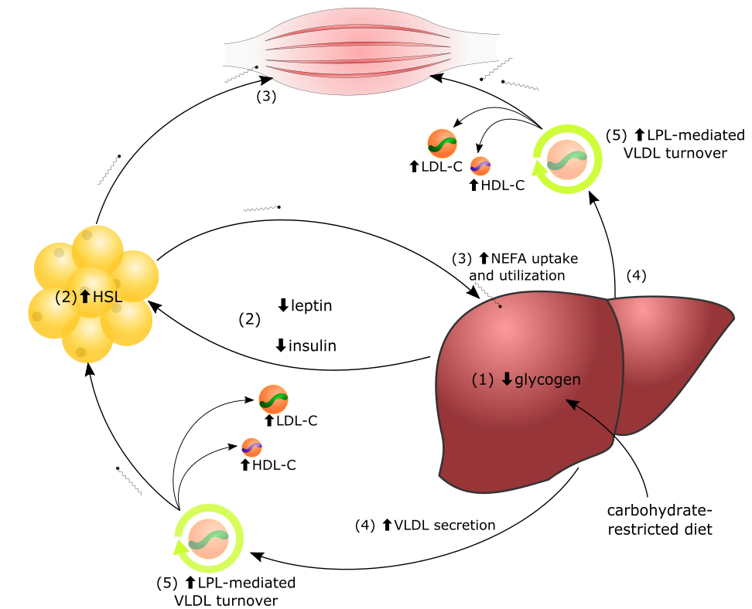

Lipid Energy Model. In the context of carbohydrate restriction, (1) glycogen depletion and (2) changes in circulating hormones stimulate hormone-sensitive lipase (HSL)-mediated secretion of non-esterified fatty acids (NEFA) by adipocytes to fuel oxidative tissues. (3) The liver captures circulating NEFAs and repackages them into triglycerides (TG), (4) secreted aboard VLDL. (5) Increased lipoprotein-lipase (LPL)-mediated VLDL turnover generates increased LDL-C and HDL-C. *This figure was previously published, but copyright is retained by the authors and reproduced with permission.

Diet composition and living patterns

The experiment takes place over 3 phases, each phase lasting 5 days. Macronutrient composition for each phase can be found in main Table 1. Precise dietary composition with product brand information are noted as follows:

- Maintenance Phase – 2,278 calories/day.
  - 10am/9am – 4 all beef hot dogs (Nathan’s Skinless Beef Franks), ~56g Lucerne Dairy Farms - Colby Jack Cheese, 1 Megafood Multi for Men 40+, 3 tablets Source Naturals Megnesium Malate
  - 3pm/2pm – 4 large, hard-boiled eggs (Nellie’s Free Range Eggs), ~112g Colby Jack Cheese (Lucerne Dairy Farms)
  - 8pm/7pm – 3 large, hard-boiled eggs (Nellie’s Free Range Eggs), ~112g, Colby Jack Cheese (Lucerne Dairy Farms)
- Hypocaloric Phase – 1,135 calories/day. Half-portion sizes of maintenance phase.
  - 10am/9am – 2 all beef hot dogs (Nathan’s Skinless Beef Franks), ~28g Lucerne Dairy Farms - Colby Jack Cheese, 1 Megafood Multi for Men 40+, 3 tablets Source Naturals Megnesium Malate
  - 3pm/2pm – 4 large, hard-boiled eggs (Nellie’s Free Range Eggs), ~112g Colby Jack Cheese (Lucerne Dairy Farms)
  - 8pm/7pm – 3 large, hard-boiled eggs (Nellie’s Free Range Eggs), ~112g, Colby Jack Cheese (Lucerne Dairy Farms)
- Hypercaloric Phase – 4,118 calories/day. Approximately +80% higher portion size of maintenance phase.
  - 10am/9am – 2 all beef hot dogs (Nathan’s Skinless Beef Franks), ~112g Colby Jack Cheese (Lucerne Dairy Farms), 1 Megafood Multi for Men 40+, 3 tablets Source Naturals Megnesium Malate
  - 11:30am/10:30am – 1 serving Keto Chow (2.1 Chocolate), 120g heavy whipping cream
  - 3pm/2pm – 6 large, hard-boiled eggs, ~112g Colby Jack Cheese (Lucerne Dairy Farms)
  - 5:30pm/4:30pm – 1 serving Keto Chow (2.1 Chocolate), 120g heavy whipping cream
  - 8pm/7pm – 1 serving Keto Chow (2.1 Chocolate), 120g heavy whipping cream

Beverages were ad libitum. For V1 beverages were entirely water. For V2, beverages were predominantly water with electrolyte mix (Ultima).

Activity included an average of 6,834 and 6,545 steps for maintenance phases V1 and V2, respectively; 7,255 and 7,716 steps for hypo-caloric phases V1 and V2, respectively; 7,491 and 7,868 steps for hyper-caloric phases V1 and V2, respectively. Sleep included an average of 5.4 and 5.4 hours for maintenance phases V1 and V2, respectively; 5.3 and 5.5 hours for hypo-caloric phases V1 and V2, respectively; 4.6 and 4.3 hours for hyper-caloric phases V1 and V2, respectively.
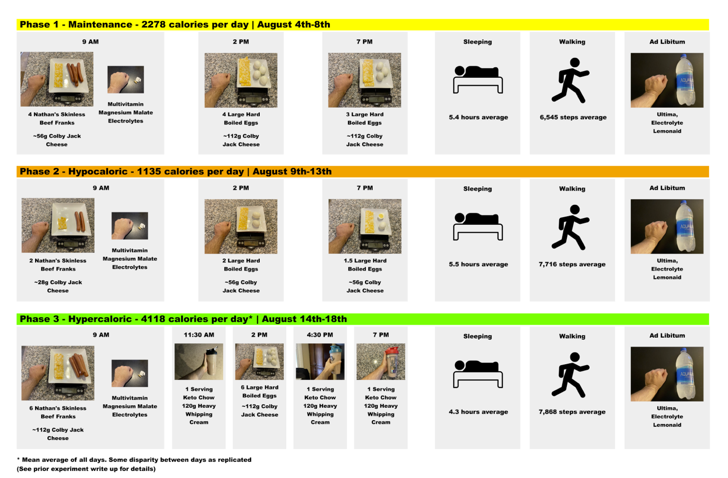
Diet composition and living patterns. Graphic depiction of daily diet composition, eating pattern, sleep, activity, and hydration are shown. Representative images are taken from V2.

Comprehensive lab reports (129 serum metabolites)

Attached.

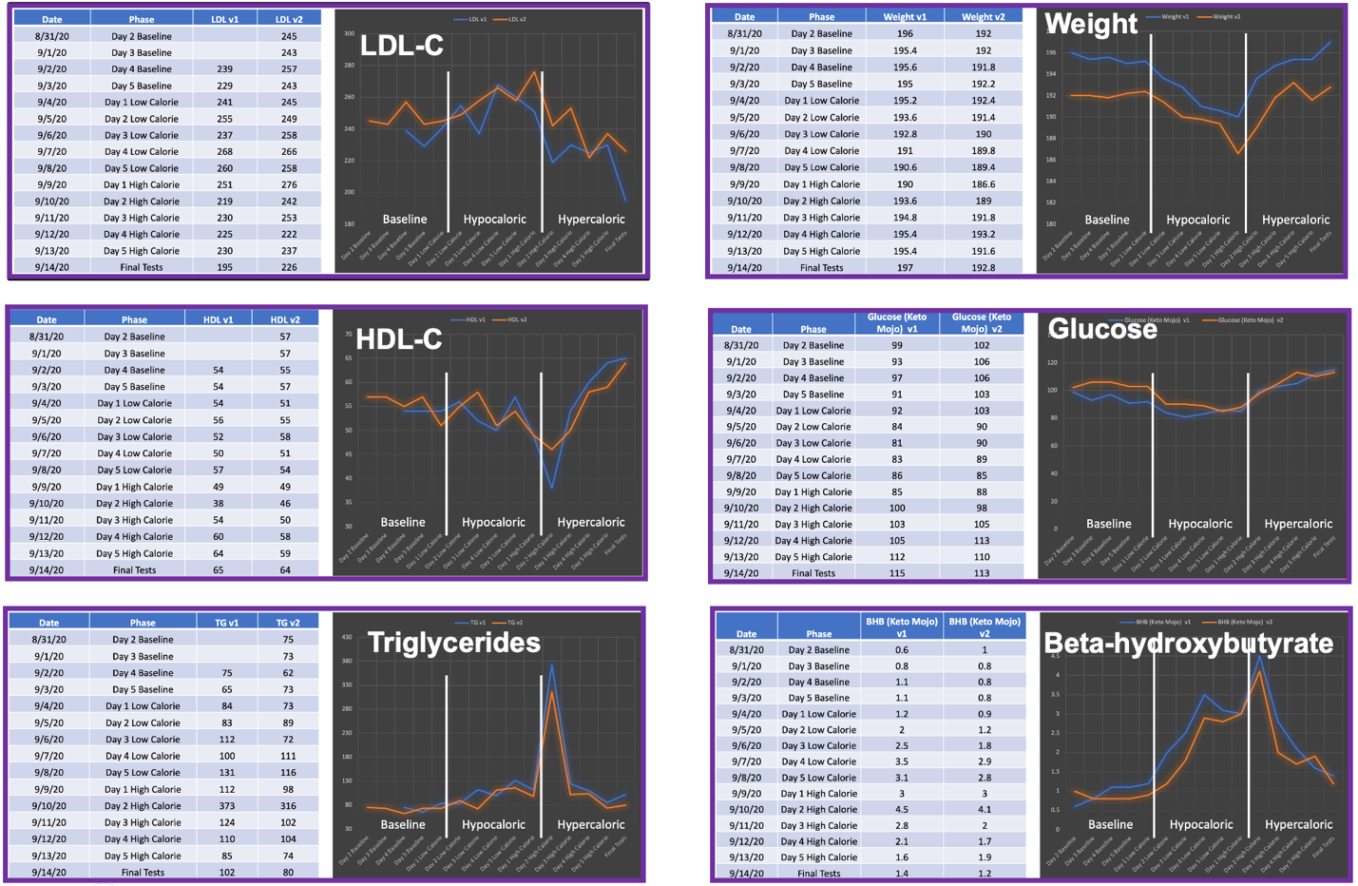

Daily data. On a daily basis in a fasted state, DF measured body weight on the same scale; blood glucose and beta-hydroxybutyrate by Keto-Mojo meter; and total cholesterol, LDL-C, HDL-C, and triglycerides (TG) by CardioChek meter.

Daily data show predictable trends in body weight, glucose, and beta-hydroxybutyrate, with body weight and fasting glucose dropping during the hypo-caloric phase and increasing during the hyper-caloric phase, and beta-hydroxybutyrate exhibiting the inverse pattern.

LDL-C levels and HDL-C levels were noisy, which is to be expected given the lesser precision of the at-home CardioChek meter as compared to that of reputable labs, LabCorp or Boston Heart. Nevertheless, the general trends in these markers over each of the 5-day phases are consistent with the data provided in the main text, in which LDL-C decreased and HDL-C increased with hyper-caloric feeding in both V1 and V2.

TG exhibited an unusual pattern, distinguished by a large, isolated spike when measured on the first day following hyper-caloric feeding. This spike was substantial in magnitude with a consistent tripling of TG levels between duplicate trials.

If the phenomenon is assumed to be genuine, then one simple explanation could be a transitional pile up of TG-rich lipoprotein species, VLDL, chylomicrons, and their remnants. Following the hypo-caloric phase, levels of VLDL secretion would be increased as a result of increased dependence on endogenous fat stores. The roughly four-fold increase in fat intake would subsequently generate an influx of chylomicrons that would compete with VLDL for LPL; and, thus, it is possible there would be a delay in clearance of TG to baseline levels.

Another not mutually exclusive possibility is that there was a delay in the metabolic transition to a state in which adipocyte LPL is equipped to handle higher volumes of TG-rich lipoproteins. The transition from the hypo-caloric to hyper-caloric state would approximate that from a fasted to a fed state in which there is a shift in LPL regulators, including insulin and also the ANGPTL family of LPL inhibitory proteins [5]. Hepatic secretion of ANGPTL8 would increase, complexing with ANGPTL3 to suppress LPL activity at oxidative tissue, cardiac and skeletal muscle. As ANGPTL8 is primarily a hepatokine that acts systemically, this shift could be assumed to happen quite rapidly. By contrast, the primary inhibitor of LPL at adipocytes is ANGPTL4, which could take slightly longer to downregulate in response to feeding. Thus, there could be a period of time where there is a combined relative suppression of LPL at oxidative tissues by ANGPTL-3-8 complex and at adipocytes at ANGPTL4, leading to a temporary depression in total body LPL activity and drop in LPL-mediated TG-rich lipoprotein turnover.

Certainty, invoking the idea of a delayed metabolic transition leading temporary, either relative or absolute, depression of LPL activity may not be necessary to explain the observed TG spike phenomenon. Nevertheless, the speculation is fruitful if for no other reason than that it demonstrates the interesting possibilities that could explain curious phenomenon related to the Lipid Energy Model that, for the time being, remain unexplored.

 | Post-hypocaloric |  |  | Post-hypercaloric |  |  | Change (Δ)
Subject | LDL-C | HDL-C | Trigs | LDL-C | HDL-C | Trigs | LDL-C | HDL-C | Trigs
1 | 132 | 53 | 59 | 100 | 56 | 97 | -32 | 3 | 38
2 | 201 | 31 | 123 | 177 | 35 | 120 | -24 | 4 | -3
3 | 215 | 58 | 75 | 165 | 51 | 180 | -50 | -7 | 105
4 | 192 | 82 | 129 | 170 | 82 | 61 | -22 | 0 | -68
5 | 223 | 49 | 136 | 231 | 50 | 110 | 8 | 1 | -26
6 | 213 | 50 | 154 | 203 | 68 | 115 | -10 | 18 | -39
7 | 119 | 70 | 59 | 116 | 76 | 50 | -3 | 6 | -9
8 | 132 | 44 | 118 | 114 | 51 | 74 | -18 | 7 | -44
9 | 180 | 74 | 113 | 174 | 76 | 111 | -6 | 2 | -2
10 | 143 | 58 | 144 | 141 | 65 | 100 | -2 | 7 | -44
11 | 157 | 58 | 64 | 136 | 64 | 98 | -21 | 6 | 34
12 | 126 | 61 | 83 | 120 | 68 | 55 | -6 | 7 | -28
13 | 149 | 55 | 103 | 173 | 62 | 75 | 24 | 7 | -28
14 | 84 | 90 | 98 | 98 | 94 | 78 | 14 | 4 | -20
15 | 308 | 37 | 98 | 147 | 49 | 51 | -161 | 12 | -47
16 | 238 | 49 | 62 | 101 | 56 | 47 | -137 | 7 | -15
17 | 150 | 47 | 127 | 137 | 54 | 80 | -13 | 7 | -47
28 | 143 | 41 | 125 | 127 | 53 | 69 | -16 | 12 | -56
19 | 265 | 80 | 103 | 182 | 79 | 44 | -83 | -1 | -59
20 | 180 | 40 | 77 | 177 | 45 | 86 | -3 | 5 | 9
21 | 128 | 45 | 111 | 130 | 51 | 105 | 2 | 6 | -6
22 | 238 | 107 | 77 | 223 | 113 | 64 | -15 | 6 | -13
23 | 189 | 35 | 104 | 148 | 40 | 151 | -41 | 5 | 47
24 | 129 | 49 | 116 | 115 | 49 | 120 | -14 | 0 | 4
Mean | 176 | 57 | 102 | 150 | 62 | 89 | -26 | 5 | -13
SD | 53 | 19 | 28 | 38 | 18 | 34 | 44 | 5 | 40

Supplemental Table 1. Data from the citizen scientist case series. N = 24 subjects self-organized and undertook hypo- and hyper-caloric ketogenic feeding protocols analogous to that of the primary subject, DF. Lipids were drawn following a 12–16-hour water-only fast the day after each phase and are reported above. Values are in mg/dl.

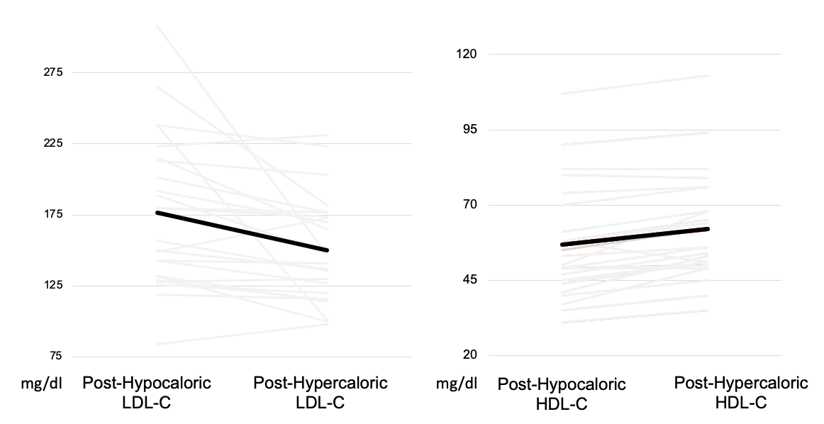

Supplemental Figure 1. Individual subject data are shown for LDL-C and HDL-C levels following hypo-caloric ketogenic phase and hyper-caloric ketogenic phase. The bold black line represent group means, which were a 26 mg/dl decrease in LDL-C and 5 mg/dl increase in HDL-C for post-hypercaloric feeding as compared to post-hypocaloric feeding.

