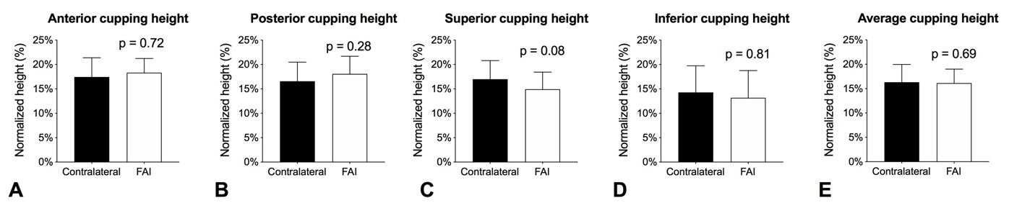
Supplemental Fig. 1A-E Side-to-side differences in (A) anterior cupping, (B) posterior cupping, (C) superior cupping, (D) inferior cupping, and (E) average cupping heights in patients with unilateral FAI.

