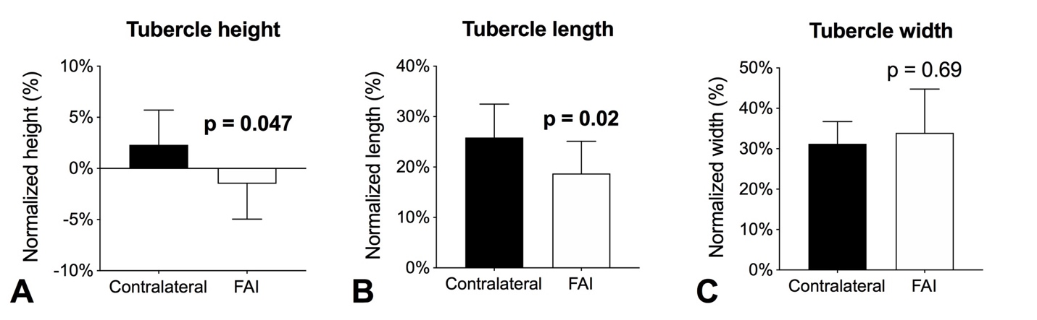
Supplemental Fig. 2A-C Side-to-side differences in (A) tubercle height, (B) tubercle length, and (C) tubercle width in patients with unilateral FAI. Significant differences are highlighted in bold; p < 0.05.

