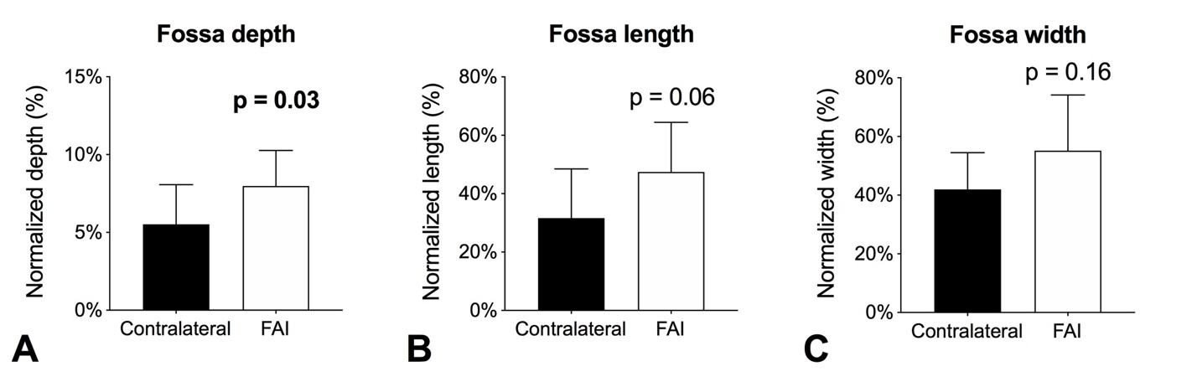
Supplemental Fig. 3A-C Side-to-side differences in (A) fossa depth, (B) fossa length, and (C) fossa width in patients with unilateral FAI. Significant differences are highlighted in bold; p < 0.05.

