Supplementary Material 1. Search strategy
PubMed
((Risk Factors[MeSH Terms]) OR (risk factor)) AND ((((((Rotator Cuff Injury[Title/Abstract]) OR (Rotator Cuff Tears[Title/Abstract])) OR (Rotator Cuff Tear[Title/Abstract])) OR (Rotator Cuff Tears[MeSH Terms])) OR (Rotator Cuff Tendinosis[Title/Abstract])) OR (Rotator Cuff Tendinitis[Title/Abstract]))
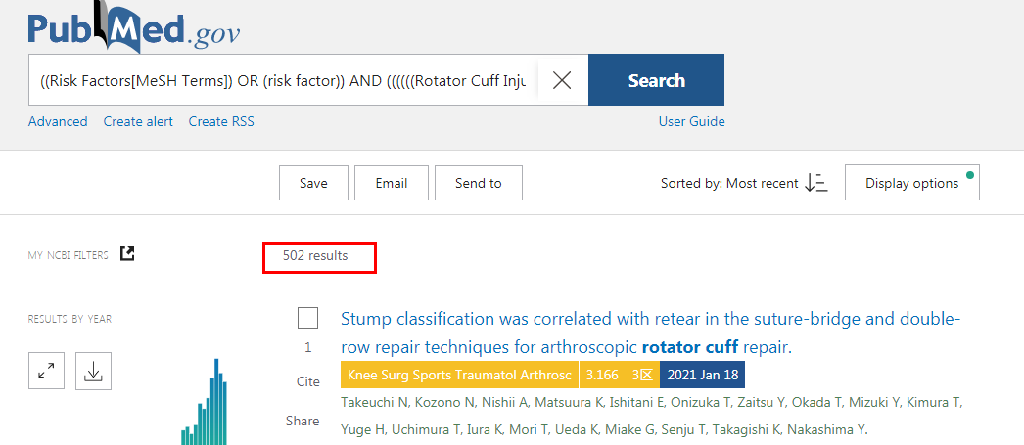
Embase
#1 'risk factors'/exp OR 'risk factors':ab,ti
#2 'rotator cuff injury':ab,ti OR 'rotator cuff tears':ab,ti OR 'rotator cuff tear':ab,ti OR 'rotator cuff tendinosis':ab,ti OR 'rotator cuff tendinitis':ab,ti
#3 #1 AND #2
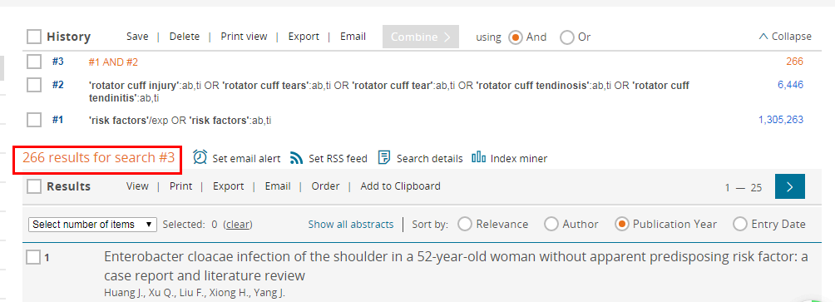
Web of Science
#1 AB=(risk factors OR risk factor)
#2 AB=(Rotator Cuff Injury OR Rotator Cuff Tears OR Rotator Cuff Tear OR otator Cuff Tendinosis OR Rotator Cuff Tendinitis)
#3 #1 AND #2
