Supplementary Material 3. Forest map of all risk factors and their effect on rotator cuff tears (Experimental = rotator cuff tear; Control = no tear)
Demographic factors
Age in years
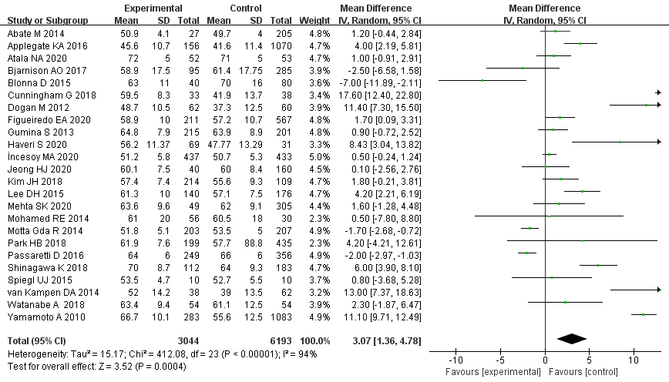

Body Mass Index (BMI) in kg/m²
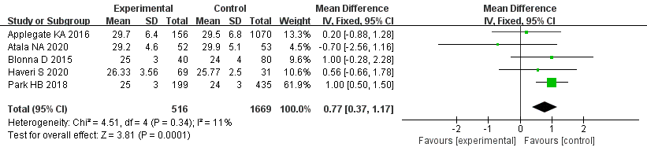

Female sex
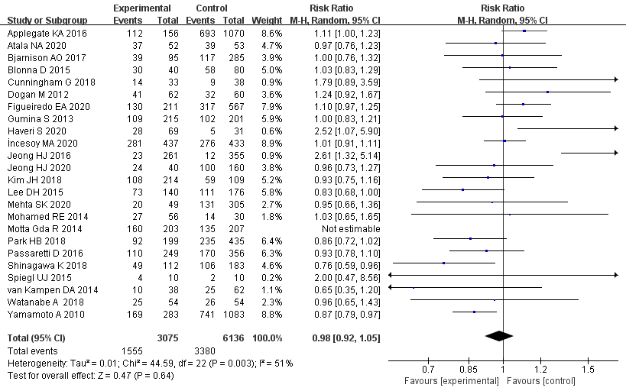

Male sex
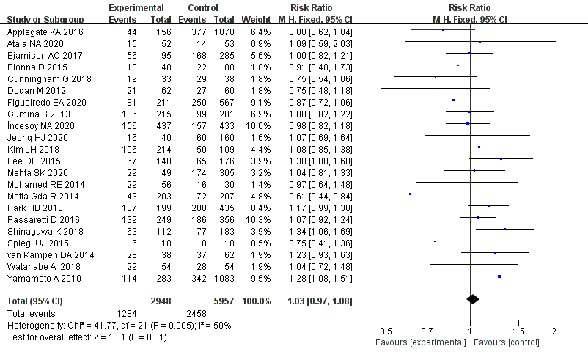

Smoking, yes versus no
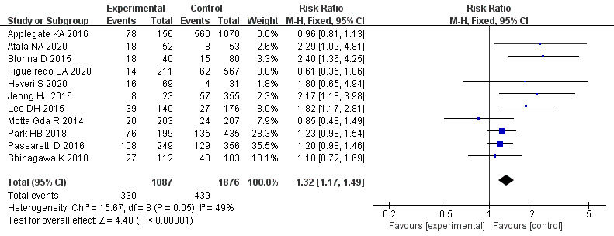

Dominant arm
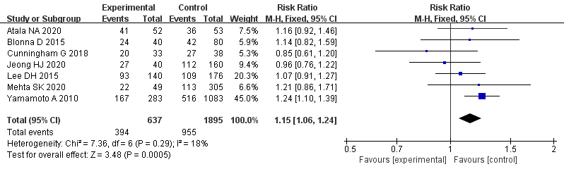

Height in cm
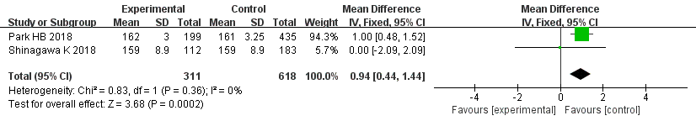

Weight in kg
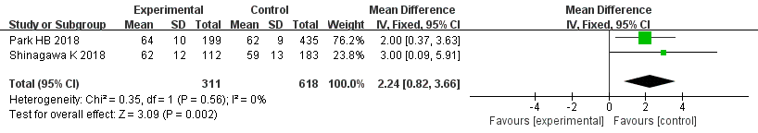

Underlying disease
Traumatic events, yes versus no
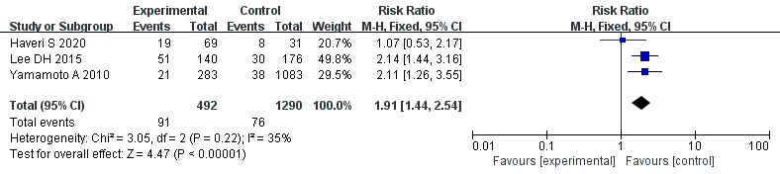

Diabetes mellitus, yes versus no
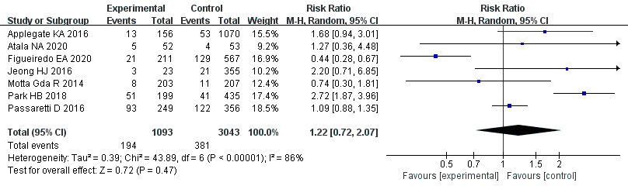

Hypertension, yes versus no
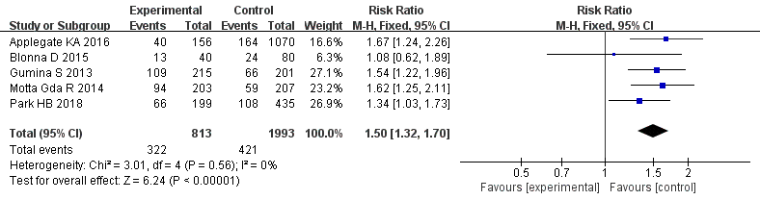

Thyroid disease, yes versus no
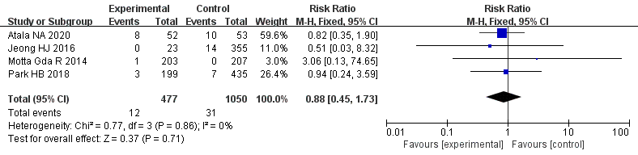

Morphologic parameters
Acromion index
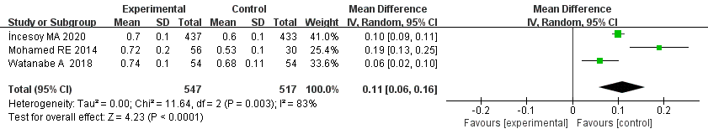
Lateral acromion angle in°
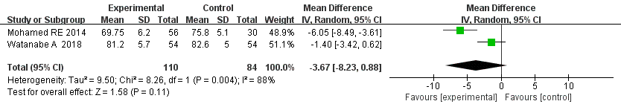
Critical shoulder angle in °
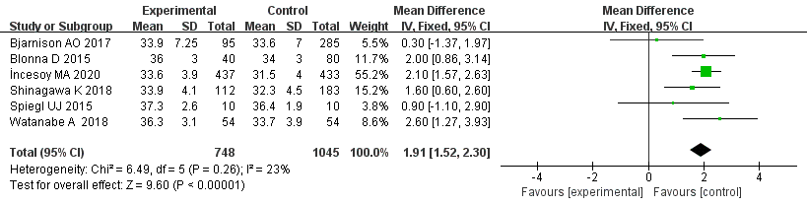

Glenoid version angle in °
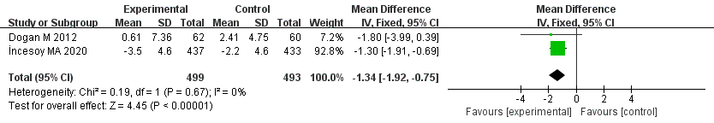

Acromiohumeral distance in mm
