Appendix 1. Radiographic protocol

All patients were imaged in the same department by radiographers (DB, KH, SM) explicitly trained to carry out the study’s radiographs. (Figs. A, E) The sitting lateral images were taken with the affected hip directly adjacent to the detector and the generator approximately 120 cm away. The patient was placed on an adjustable chair to ensure bilateral femurs were parallel with the floor. Where applicable a foam block was used to raise the feet off the floor to accomplish this. The patient was then asked to lean as far forward to touch their toes. This was variable from patient to patient because comfort level inhibited deep forward flexion for some. The beam was centered at L5 (1 inch below the iliac crest).

(Figs. B, F) The standing lateral radiographs were obtained again with the patient’s affected hip positioned directly adjacent to the detector with the generator approximately 120 cm away. The patient was asked to raise and cross their arms as the image was taken. An appropriate lateral radiograph included the bilateral anterosuperior iliac spine (ASIS), pubic symphysis, superior endplate of the sacrum, and superior endplate of the first lumbar vertebrae. The beam was centered at L5 (1 inch below the iliac crest).

(Figs. C, G) The standing AP pelvis was taken with the patient’s back directly adjacent to the detector with bilateral feet internally rotated 15° and arms slightly abducted. This was the only radiograph where the generator was positioned approximately 150 cm away from the detector. The beam was centered 2 inches below the ASIS.

(Figs. D, H) The supine AP pelvis was taken in a routine manner with the patient lying supine on the x-ray table and again with their feet internally rotated 15°. The generator was positioned approximately 120 cm away from the detector. Both AP pelvis radiographs included the whole pelvis and both proximal femurs, including the greater trochanters. The beam was centered 2 inches below the ASIS.

All radiographs were saved centrally in the PACS imaging software (Picture Archiving and Communication System; McKesson, San Francisco, CA, USA) and analyzed by the research team on a 3-megapixel monitor.

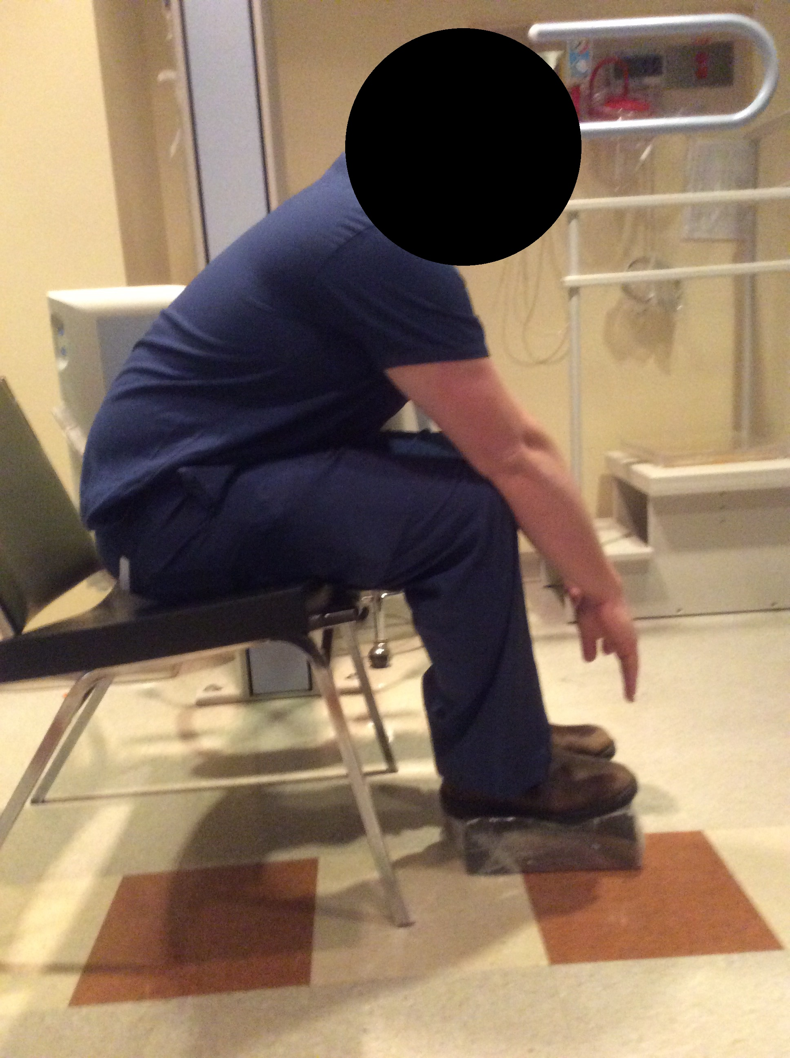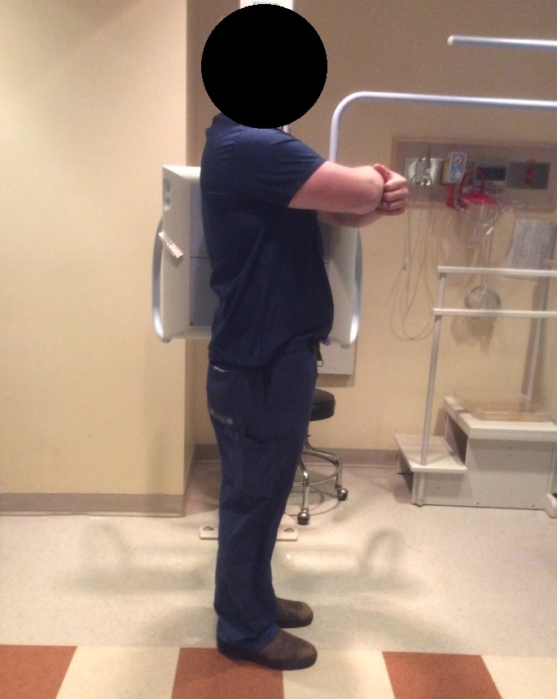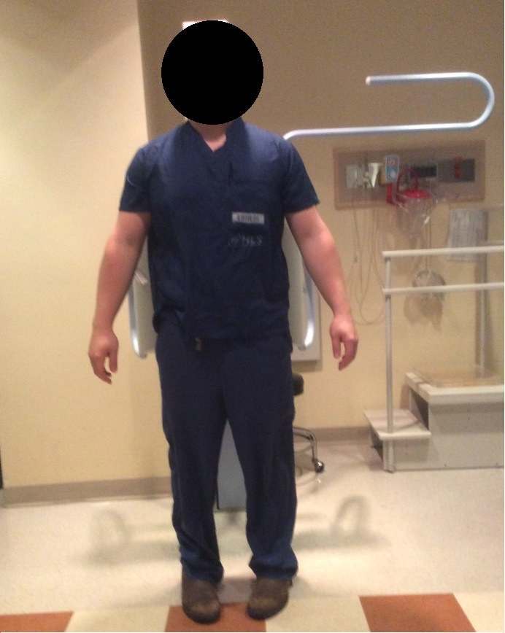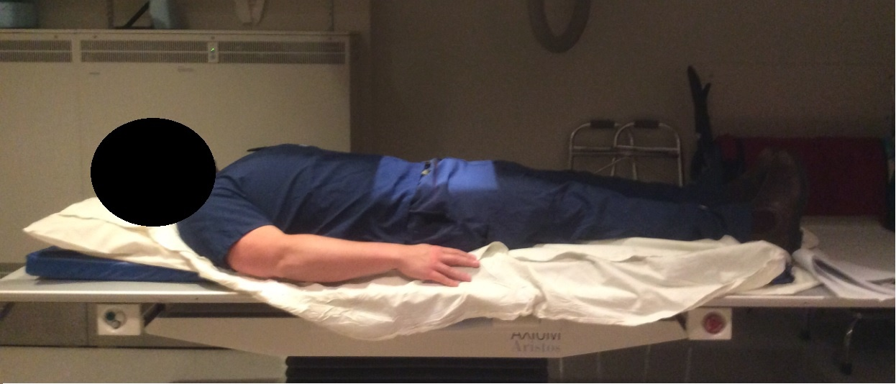
D
C
B
A

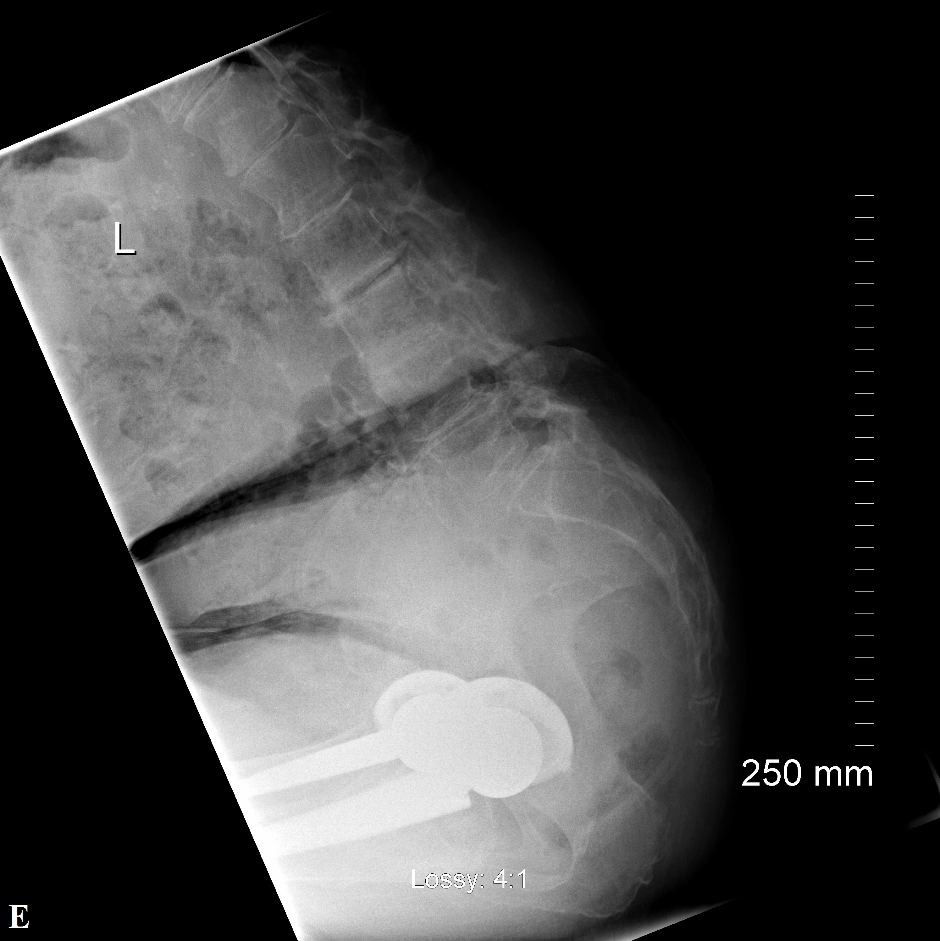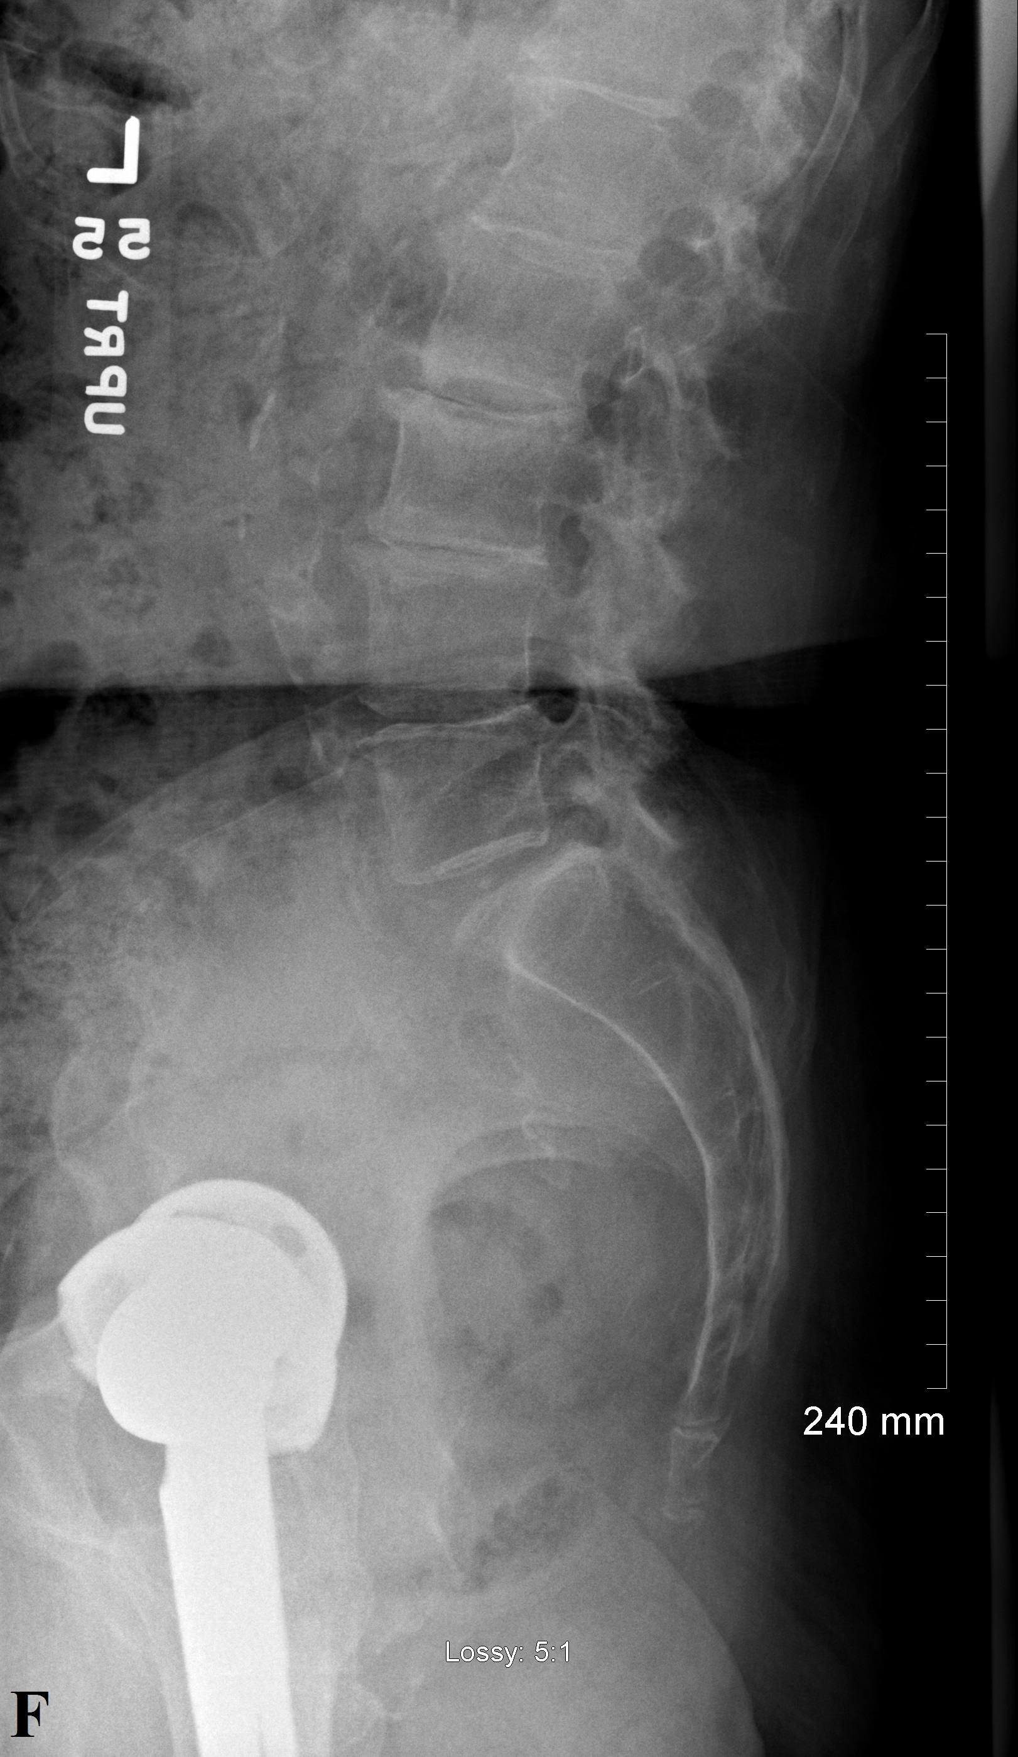
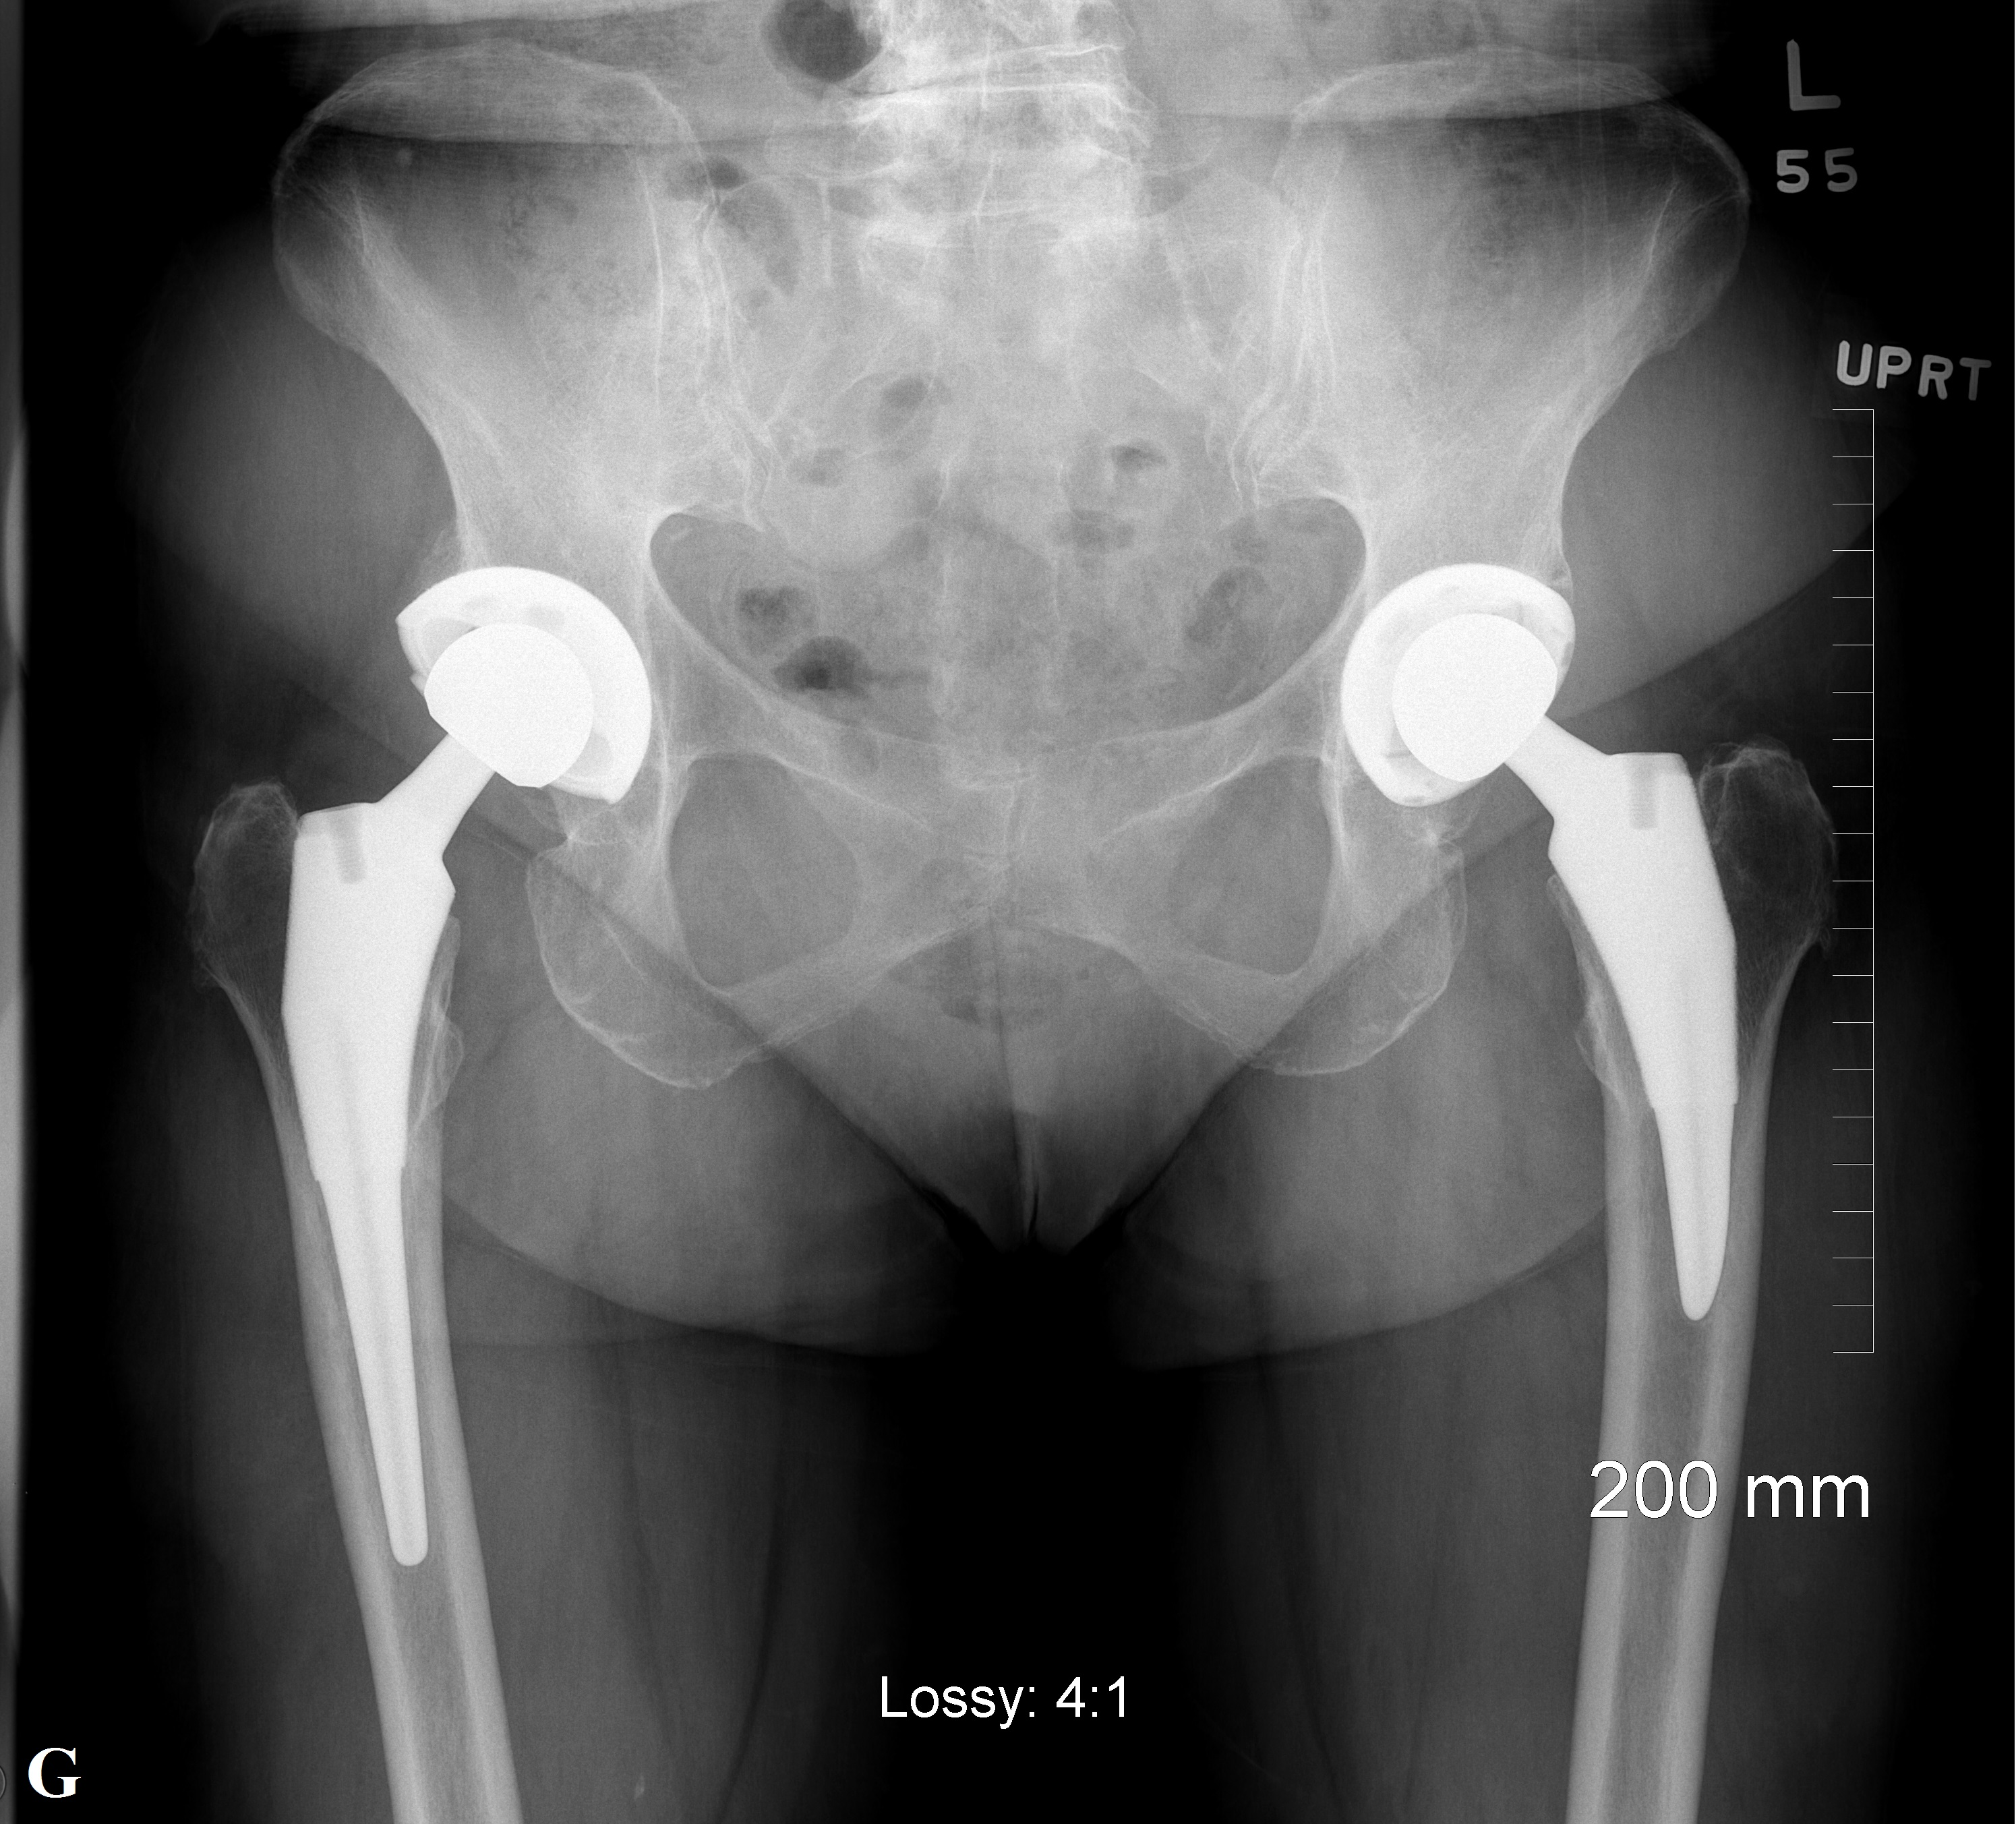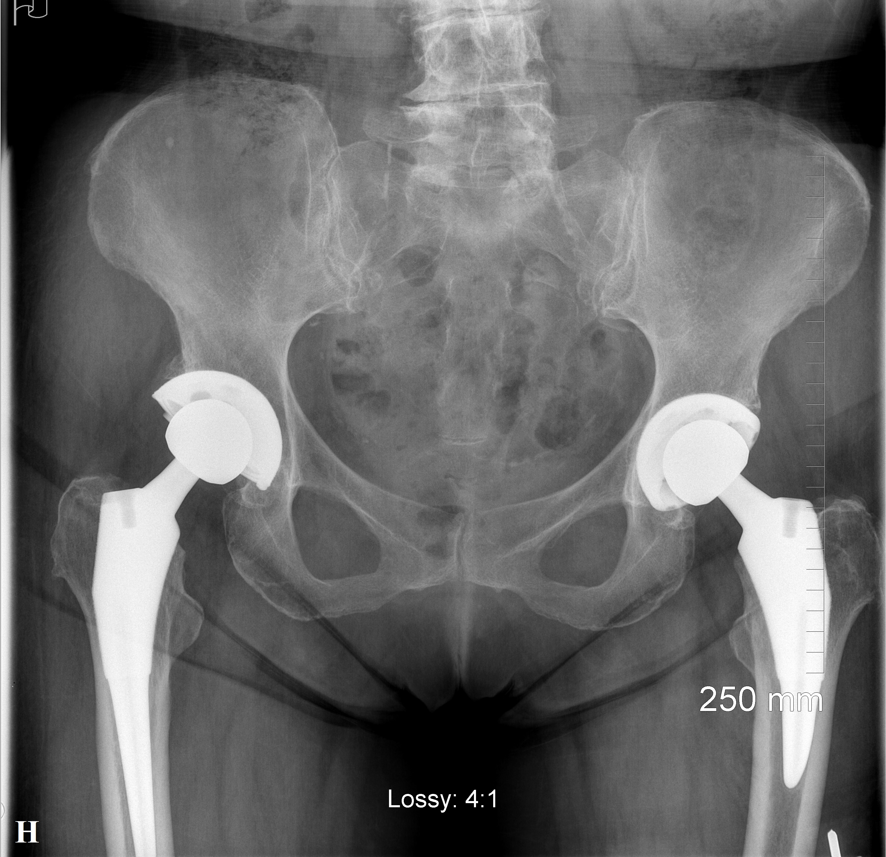

Legends
Fig. A Patient positioning for a sitting lateral radiograph.
Fig. B Patient positioning for a standing lateral radiograph.
Fig. C Patient positioning for a standing AP pelvis radiograph.
Fig. D Patient positioning for a supine AP pelvis radiograph.
Fig. E Radiographic image of a patient in a lateral sitting position.
Fig. F Radiographic image of a patient in a lateral standing position.
Fig. G Radiographic image of a patient in a standing AP pelvis position.
Fig. H Radiographic image of a patient in a supine AP pelvis position.

