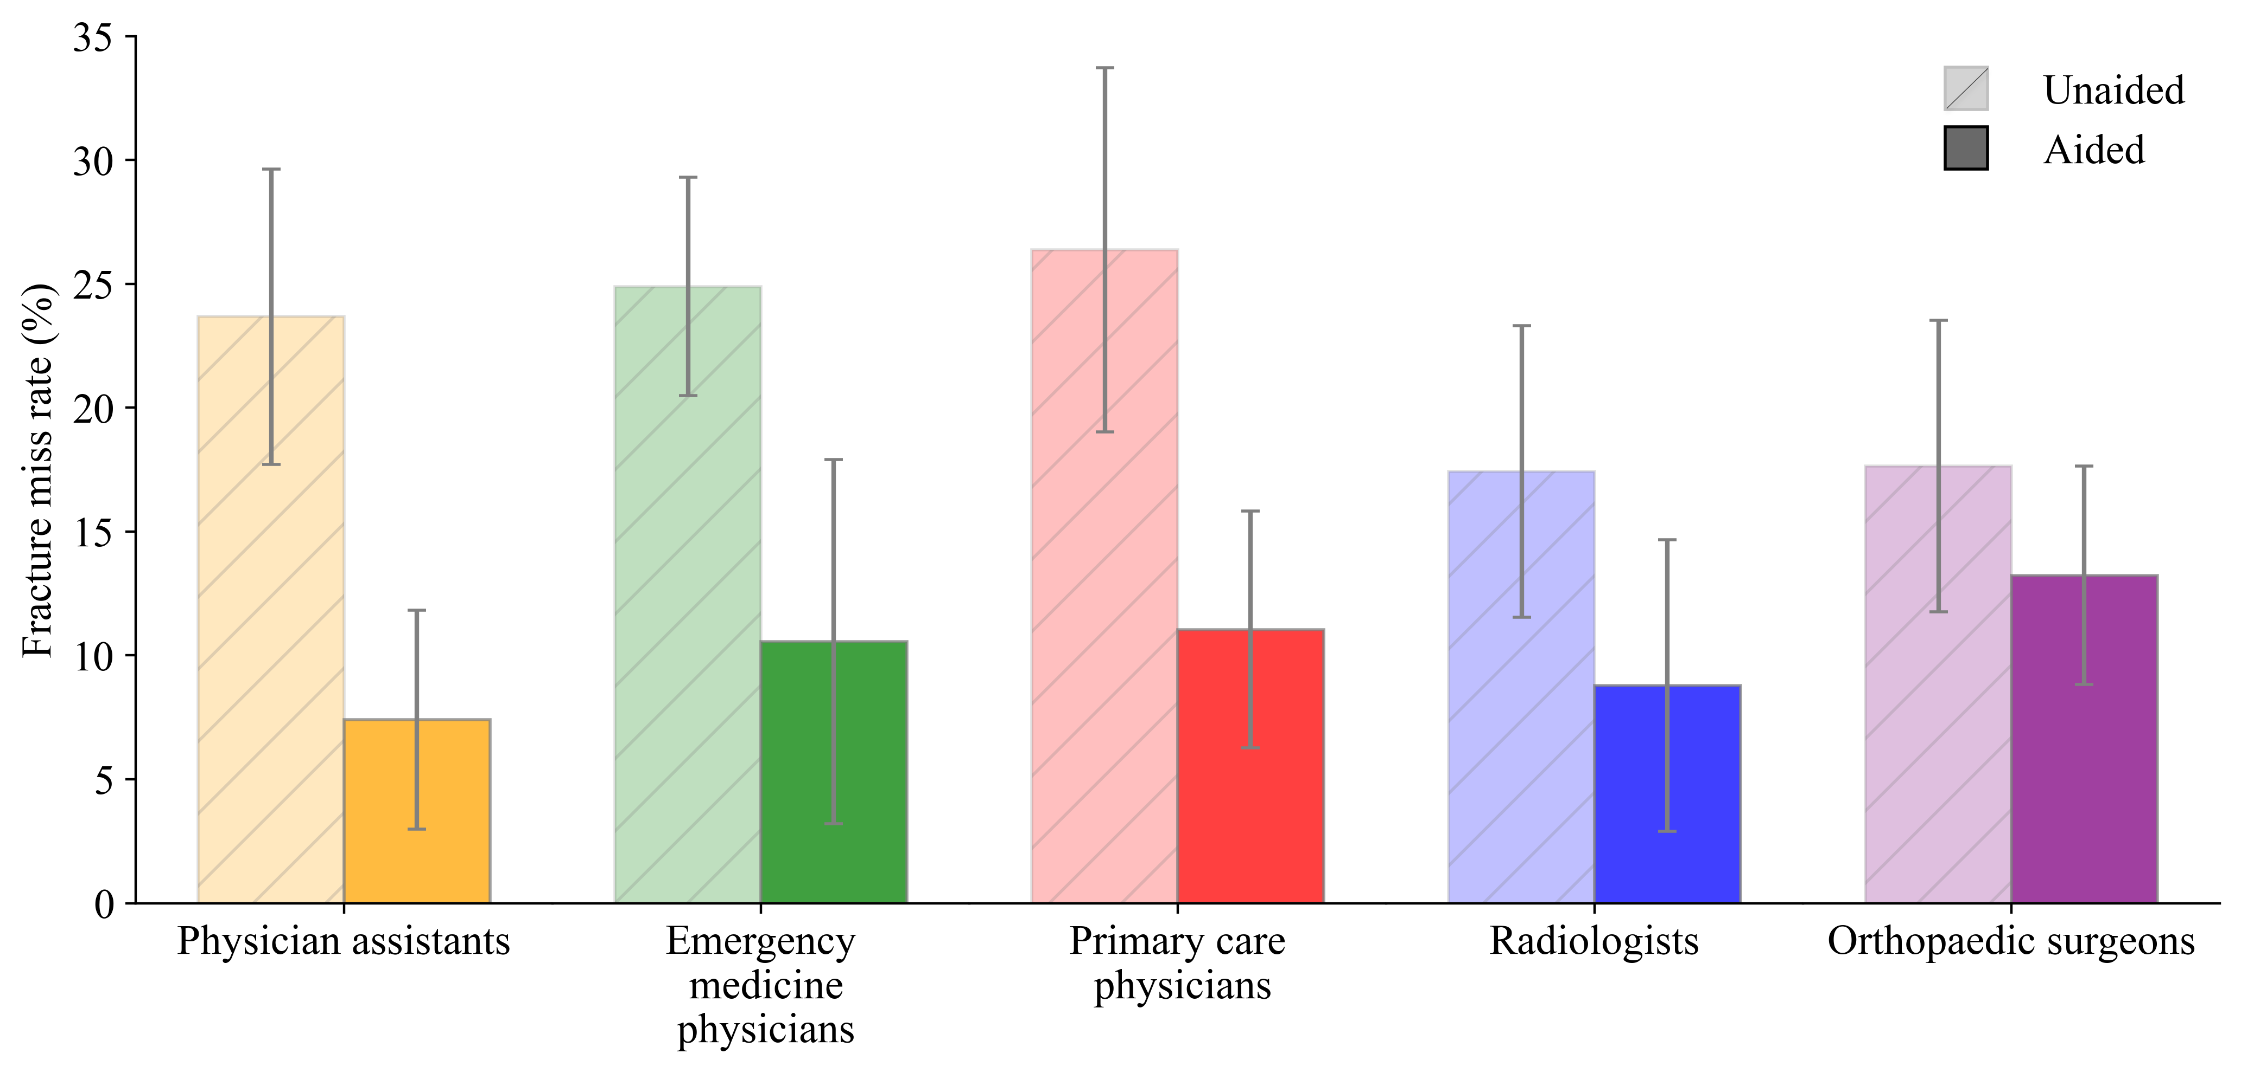
Supplementary Fig. 1 Fracture miss rate for each clinician type in Medicare-age cases when unaided and aided by the deep learning system. The average fracture miss rate for each clinician type interpreting cases from the Medicare-age population is shown when unaided and aided by the deep learning system. The error bars represent the 95% bootstrap CIs (m = 1000).

