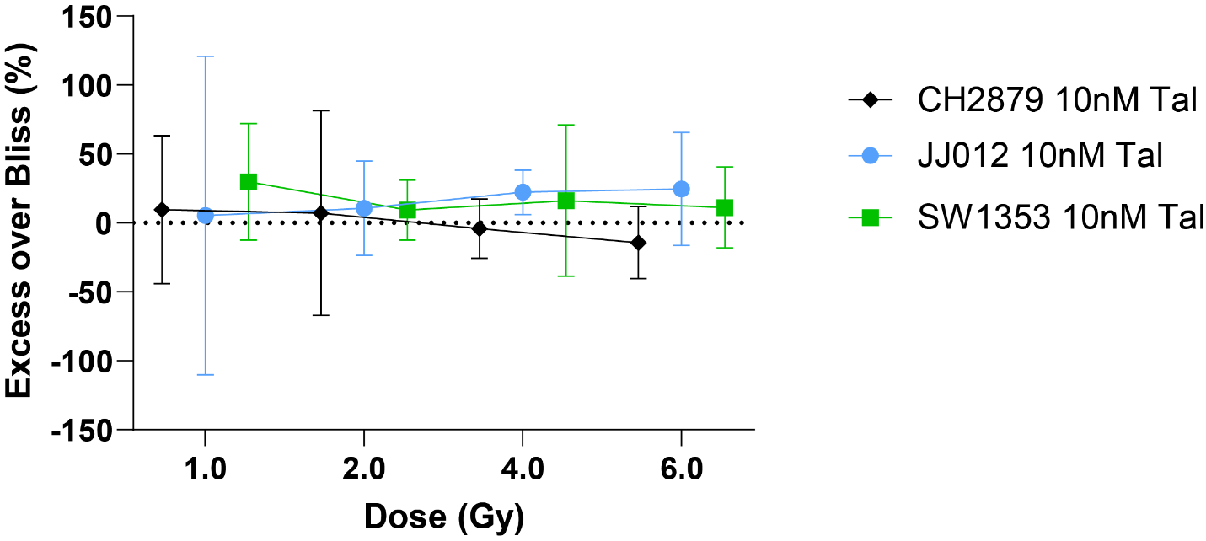

Supplemental Fig. 7 Excess over Bliss score plots visually demonstrate radiotherapy and talazoparib treatment combinations with 95% confidence intervals for CH2879, JJ012 and SW1353 spheroids. Synergy is inferred when the lower 95% CI is above the additive effect threshold of 0.

