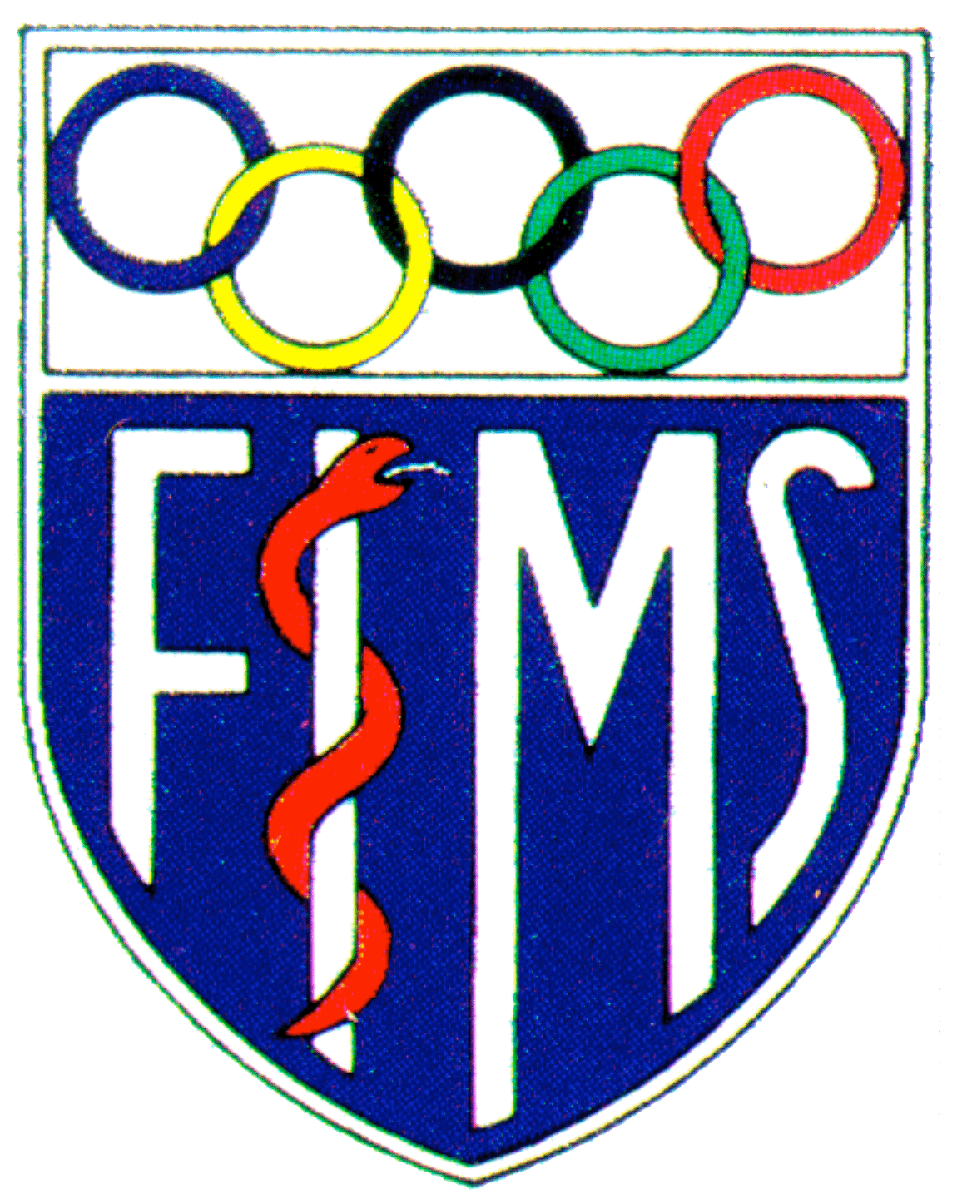FÉDÉRATION INTERNATIONALE DE MÉDECINE DU SPORT INTERNATIONAL FEDERATION OF SPORTS MEDICINE

Eastbourne, March 2018

Dear Participant

We recently published a scientific opinion on the “Implications of a Third Gender for Elite Sports” and the authors have embarked on a series of scientific and public events to assess the response to this viewpoint. Having attended the lecture and/or read the viewpoint (see https://journals.lww.com/acsm-csmr/Citation/2018/02000/Implications_of_a_Third_Gender_for_Elite_Sports.4.aspx and/or request an email copy of the paper below) can you indicate your opinion by ticking only one box that reflects your opinion:

- Agree with the idea of an “athlete gender” ☐

- Disagree with the idea of an “athlete gender” ☐

If you checked disagree then state how you would separate athletes into male and female categories

Chromosome pattern ☐

Gonadal sex ☐

Birth certificate or gender assigned at birth ☐

Passport or current legal status ☐

Gender identity or self-determination ☐

Please explain the reasoning behind your response in the space below.

Please hand in your completed form at the end of the lecture or email to y.pitsiladis@brighton.ac.uk

Many thanks

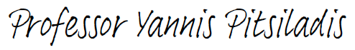

Prof. Yannis Pitsiladis (MMedSci.,PhD, FACSM)

Member of the Executive Committee
Chairman of the Scientific Commission
Head of the FIMS Collaborating Centre of Sport Medicine (CCSM)

Fédération Internationale de Médecine du Sport
International Federation of Sports Medicine
Maison du Sport Internationale Av.de Rhodanie 54 CH-1007 Lausanne

