ADDITIONAL SUPPORTING INFORMATION
Table S1. Markers and LOD scores at chromosome 3p25.2-p22.3 linkage region (29-57 cM). The 95% confidence interval consists of one LOD drop from the maximum LOD score found under the exponential model with a peak linkage at rs2293787 (in bold). Additional markers included for fine-mapping of the region are indicated with an asterisk.
cM | SNP | ZSCORE | Linear LOD | P-Value | Exponential LOD | P-Value
29.098 | rs1618545 | 1.865 | 1.431 | 0.005127 | 0.86 | 0.02331
29.346 | rs12629133 | 1.989 | 1.527 | 0.004008 | 0.949 | 0.01829
30.598 | rs514084 | 2.187 | 1.789 | 0.002052 | 1.232 | 0.008609
30.804 | rs13064319 | 2.251 | 1.865 | 0.00169 | 1.341 | 0.006482
31.156 | rs9843344 | 2.36 | 1.975 | 0.001281 | 1.491 | 0.004388
31.726 | rs2470353 | 2.413 | 2.02 | 0.001144 | 1.538 | 0.003888
32.831 | rs2276755 | 2.383 | 1.983 | 0.001257 | 1.435 | 0.005079
33.247 | rs17040196 | 2.447 | 2.053 | 0.001053 | 1.533 | 0.003946
33.583 | rs7636593 | 2.549 | 2.17 | 0.000786 | 1.73 | 0.00238
33.855 | rs9869512 | 2.628 | 2.24 | 0.00066 | 1.832 | 0.001839
34.327 | rs2470549 | 2.604 | 2.182 | 0.000762 | 1.672 | 0.002758
34.734 | rs15767 | 2.649 | 2.208 | 0.000714 | 1.685 | 0.002674
34.885 | rs690241 | 2.679 | 2.255 | 0.000636 | 1.726 | 0.002406
35.747 | rs17272796 | 2.742 | 2.355 | 0.000496 | 1.821 | 0.001892
36.167 | rs2060628 | 2.732 | 2.354 | 0.000496 | 1.823 | 0.001883
37.722 | rs11923699 | 2.666 | 2.239 | 0.000662 | 1.8 | 0.001993
38.137 | rs13078867* | 2.651 | 2.149 | 0.000828 | 1.716 | 0.002471
38.178 | rs4103004 | 2.645 | 2.131 | 0.000866 | 1.698 | 0.002587
38.427 | rs17006623 | 2.655 | 2.144 | 0.000838 | 1.729 | 0.002389
40.376 | rs7636784 | 2.665 | 2.215 | 0.000702 | 1.866 | 0.001686
42.378 | rs11921580 | 2.691 | 2.236 | 0.000667 | 1.864 | 0.001695
43.436 | rs3752874 | 2.765 | 2.316 | 0.000545 | 2.046 | 0.001072
45.58 | rs7627753 | 2.807 | 2.381 | 0.000464 | 2.213 | 0.000706
46.482 | rs17016865* | 2.831 | 2.4 | 0.000443 | 2.25 | 0.000644
46.484 | rs2293787 | 2.831 | 2.4 | 0.000443 | 2.25 | 0.000644
46.62 | rs7634752* | 2.823 | 2.393 | 0.000451 | 2.238 | 0.000663
46.638 | rs17017016 | 2.823 | 2.392 | 0.000452 | 2.236 | 0.000666
48.213 | rs3213930 | 2.744 | 2.278 | 0.0006 | 1.982 | 0.001258
49.484 | rs17021360 | 2.739 | 2.264 | 0.000621 | 1.971 | 0.001293
51.529 | rs3773022 | 2.746 | 2.244 | 0.000653 | 1.941 | 0.001396
51.794 | rs1371840 | 2.747 | 2.241 | 0.000659 | 1.934 | 0.00142
52.364 | rs1868491 | 2.716 | 2.211 | 0.000709 | 1.894 | 0.001573
53.544 | rs17025864 | 2.54 | 2.027 | 0.001124 | 1.624 | 0.003125
53.875 | rs1494738 | 2.492 | 1.97 | 0.001299 | 1.538 | 0.003893
54.483 | rs17027714 | 2.444 | 1.919 | 0.001474 | 1.475 | 0.004577
54.886 | rs7643025 | 2.41 | 1.886 | 0.001603 | 1.44 | 0.005016
55.427 | rs4639011 | 2.351 | 1.828 | 0.001855 | 1.385 | 0.00578
55.579 | rs13321685 | 2.334 | 1.811 | 0.00194 | 1.368 | 0.006042
56.565 | rs17029526 | 2.226 | 1.689 | 0.002646 | 1.246 | 0.008298
56.766 | rs11558687 | 2.205 | 1.662 | 0.002833 | 1.219 | 0.008912
57.216 | rs7637099 | 2.155 | 1.597 | 0.003349 | 1.153 | 0.01061
57.497 | rs2293250 | 2.101 | 1.524 | 0.00403 | 1.08 | 0.01288

Table S2. Linkage contribution for each SPS family at linkage peak on chromosome 3p25.2-p22.3. The maximum LOD score is reported at marker rs2293787, using the Kong and Cox method (LOD).

Pedigree | z-score | DELTA | LOD
CAR_SPS_1 | 0.691893 | 0.707107 | 0.172965
CAR_SPS_2 | -0.049412 | -0.745356 | -0.015707
CAR_SPS_3 | 1.399295 | 0.955533 | 0.368672
CAR_SPS_4 | 1.072868 | 0.745356 | 0.255192
CAR_SPS_6 | 1.387479 | 0.707107 | 0.296906
CAR_SPS_7 | 1.396011 | 0.707107 | 0.298226
CAR_SPS_8 | 0.25326 | 0.707107 | 0.071544
CAR_SPS_9 | -0.595284 | -0.430331 | -0.099048
CAR_SPS_12 | 1.338181 | 0.707107 | 0.289196
CAR_SPS_13 | 0.783803 | 0.707107 | 0.191516
CAR_SPS_16 | 1.389215 | 0.707107 | 0.297175
DONOS_SPS_5 | 1.084914 | 0.707107 | 0.247273
MOS_SPS_11 | -0.005402 | -0.707107 | -0.001656
MOS_SPS_14 | 1.23476 | 0.707107 | 0.272563
MOS_SPS_15 | -0.224347 | -0.707107 | -0.063948
OUR_SPS_10 | 0.16558 | 0.88028 | 0.059092

Table S3. List of the rare variants (SNVs) used for the family-based association analysis. All variants were found in heterozygosity. The variants were selected based on their pathogenicity in at least 3 out of the 6 predictor tools (0.25 score was added in case the prediction was not available) in case of missense changes or included because they were truncating variants (stop, indels in coding regions, and variants in canonical splice sites).

Chr:position | Ref/Alt | Gene | MAF (ExAC) | Heterozygous individuals | Pathogenic tools | Change
chr3:12957206 | C/T | IQSEC1 | 3.16E-05 | AA3521 | 6 | missense
chr3:13672888 | C/G | FBLN2 | 0.000838 | AA3571,AA3572 | 4.25 | missense
chr3:14174081 | C/T | TMEM43 | 3.95E-05 | AA3531,AA3532 | 4 | missense
chr3:14555171 | A/C | GRIP2 | 0.0003189 | AA3522,AA3524,AA3540,AA3565 |  | splice donor
chr3:14958775 | A/G | FGD5 | 0.000128 | AA3528 | 6 | missense
chr3:15283704 | G/A | CAPN7 | NA | AA3569,AA3570 | 4 | missense
chr3:21552514 | C/G | ZNF385D | NA | AA3528 | 5 | missense
chr3:25781126 | C/T | NGLY1 | 3.95E-05 | AA3571 | 6 | missense
chr3:25824841 | G/A | NGLY1 | 8.13E-06 | AA3531,AA3532 | 6 | missense
chr3:29476277 | C/T | RBMS3 | 6.32E-05 | AA3534 | 5.25 | missense
chr3:32758667 | C/T | CNOT10 | NA | AA3572 |  | stop_gained

Figure S1. Significant peak regions identified on chromosome 3 across all the ten sets of linkage analysis (from 1 to 10) using random SNPs from a selection of 2,487 WES-derived markers. A linkage peak greater than 2 was identified in all 10 replicates in both linear (black line) and exponential models (blue line).
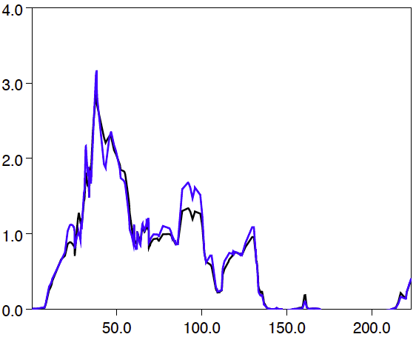
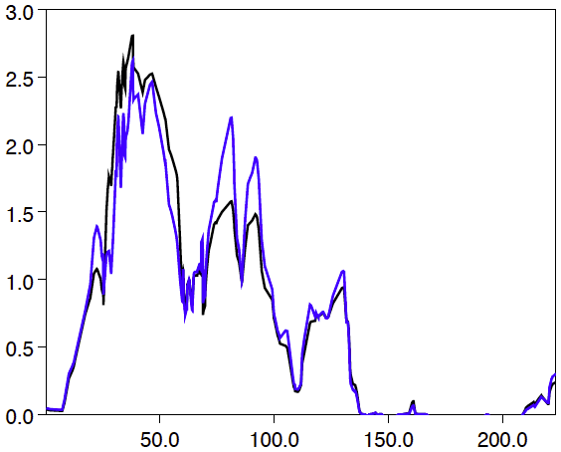
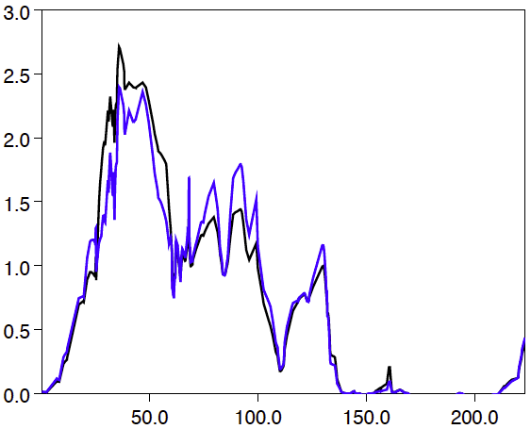
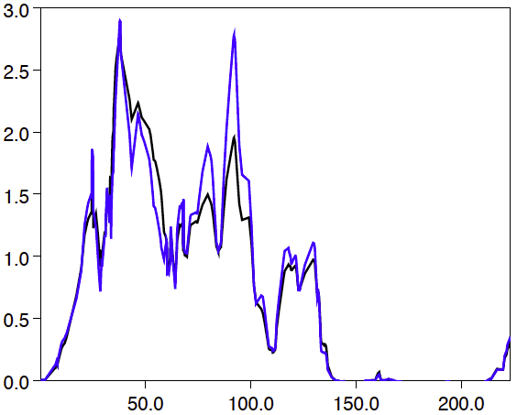
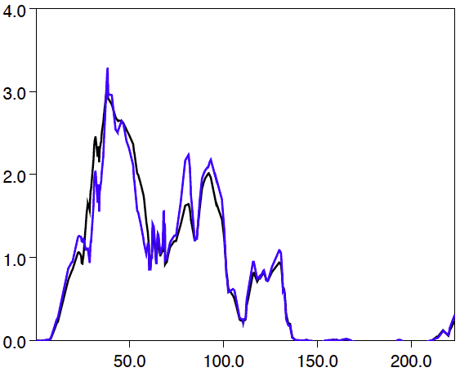
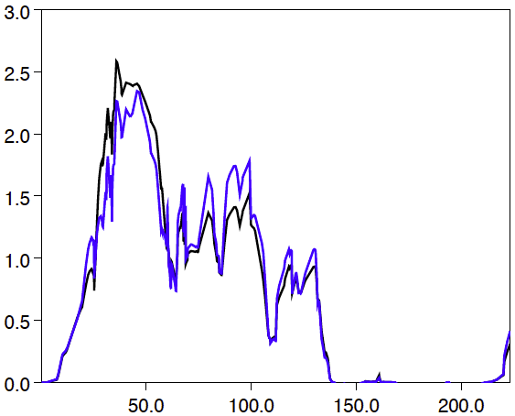
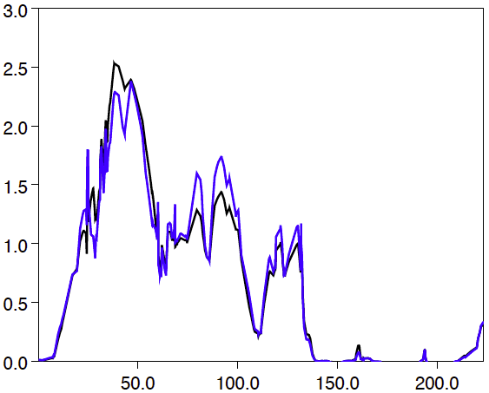
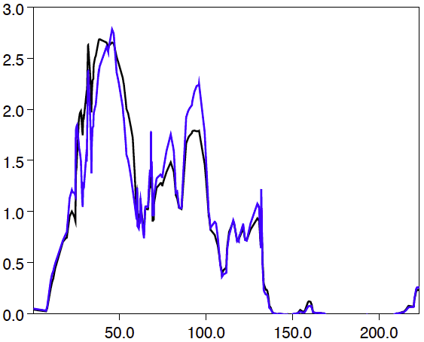
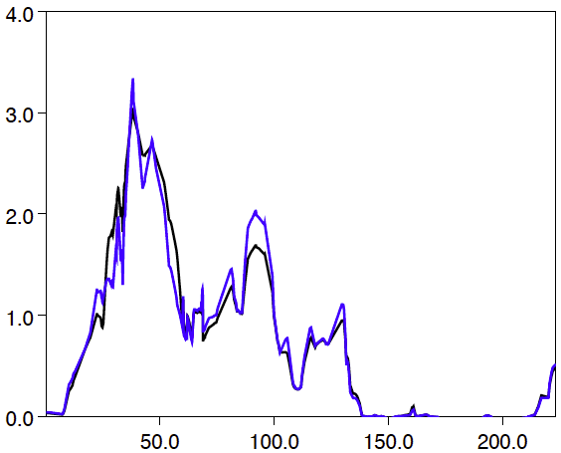
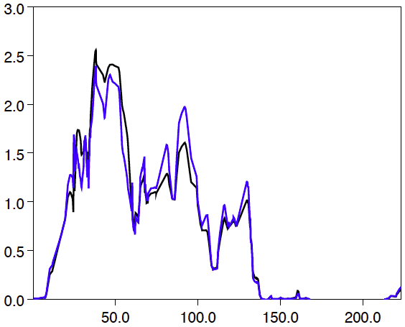
LOD Score
LOD Score
LOD Score
LOD Score
LOD Score
1.
2.
3.
4.
5.
6.
7.
8.
9.
10.
cM
cM
cM
cM
cM

Figure S2. Pathway analysis for statistically-significant candidate genes arising from the family-based association analysis. The only produced network containing FBLN2 as well as some hereditary CRC or cancer predisposition genes is depicted. Continuous lines represent direct interactions and dashed lines correspond to indirect interactions. Shaded nodes represented genes from our input set and empty nodes are those that IPA automatically includes because biologically linked to our genes based on evidence in the literature. Symbols correspondence is as follows: square, cytokine; dashed square, growth factor; vertical diamond, enzyme; vertical rectangle, G-protein coupled receptor; dashed vertical rectangle, ion channel; inverted triangle, kinase; flat rectangle, ligand-dependent nuclear receptor; flat diamond, peptidase; flat triangle, phosphatase; flat oval, transcription regulator; vertical oval, transmembrane receptor; double circle, complex/group; circle, other.

Network 2 (FBLN2)
Top Diseases and Functions
Cancer, Hereditary Disorder, Organismal Injury and Abnormalities
Molecules in Network
14-3-3, CD3, CDKN1B, Cofilin, Cyclin A, ELANE, ERCC2, ERCC4, ERCC5, ERK1/2, F-Actin, FBLN2, GBA, Gsk3, Hsp27, ITK, LDL, MAP2K1/2, Mmp, NF1, PARP, PI3K (complex), Pka, POLE, PRKAR1A, SERPINA1, Smad2/3, SRY, TGFBR1, TSC1, TSC2, Vegf, VHL, WT1, XPA.
- 35 total molecules
- 18 genes hereditary cancer & CRC: CDKN1B, ELANE, ERCC2, ERCC4, ERCC5, GBA, ITK, NF1, POLE, PRKAR1A, SERPINA1, SRY, TGFBR1, TSC1, TSC2, VHL, WT1, XPA
- 1 candidate gene: FBLN2

