Supplementary Figures
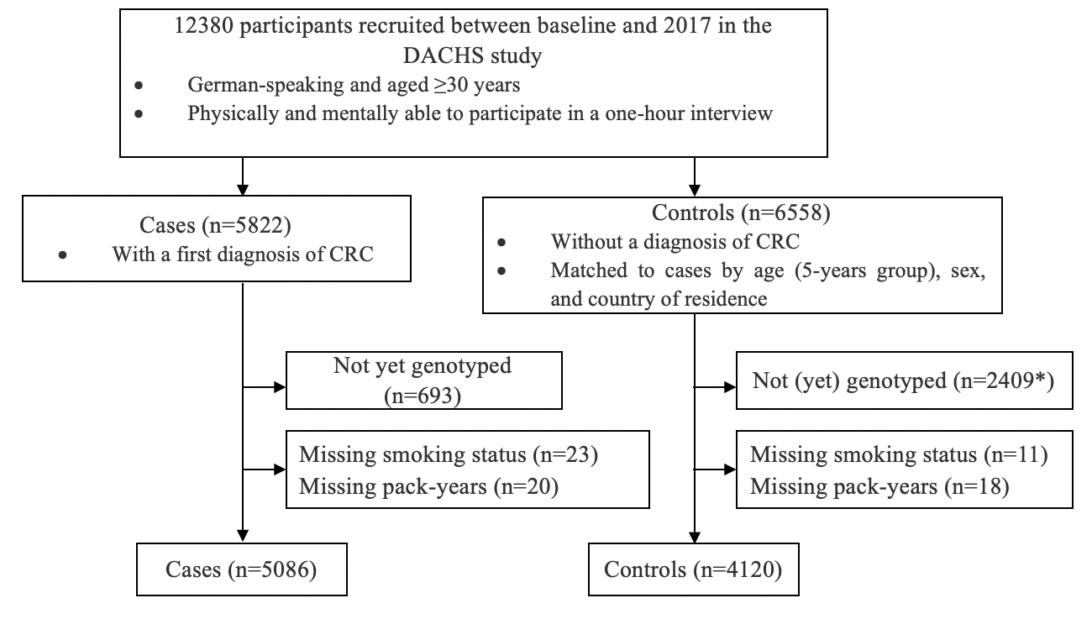

Figure S1. Flowchart of inclusion of study participants.
*1945 of them participating with a short self-administered questionnaire only rather than a personal interview with blood sampling; 464 not genotyped yet.

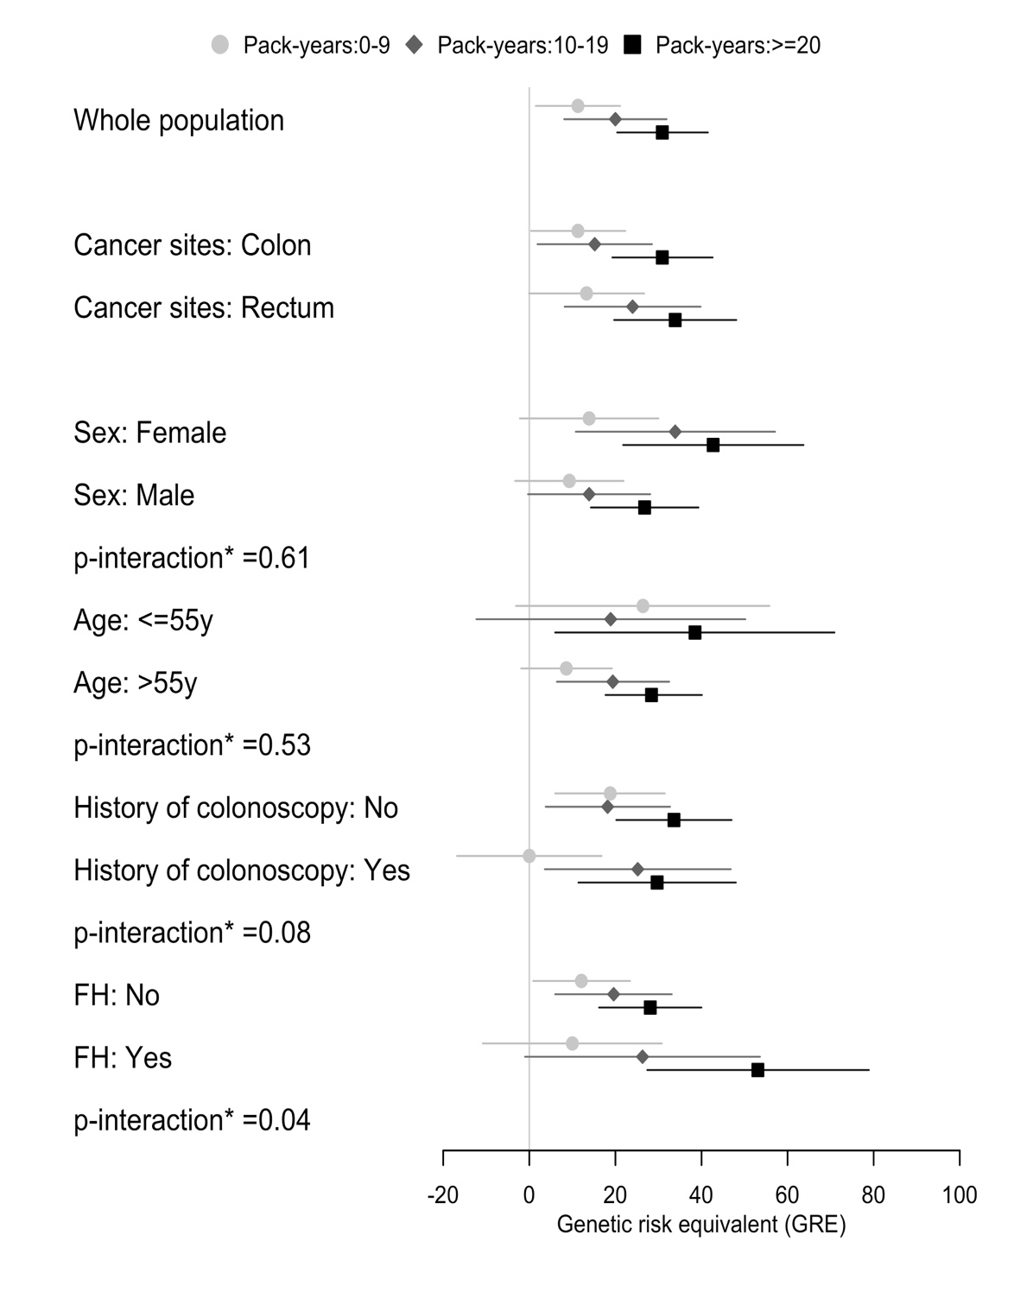
Figure S2. Genetic risk equivalent for comparisons between pack-years of smoking in the whole population and different subgroups
*Interactions were tested by additionally including a cross-product term of stratification factors (sex, age, history of colonoscopy, or FH) and pack-years of active smoking in the model 2 but with polygenic risk score included as percentiles (per 10 percentiles, continuous factor).
Note: Never smokers were used as reference in each subgroup.
Abbreviations: FH, family history of colorectal cancer in a first-degree relative

