Supplementary Table 1. Immunohistochemistry information
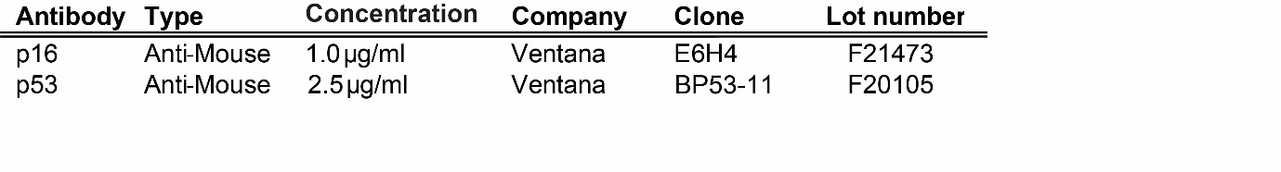
Supplementary Table 2. Details on the detected TP53 mutations, including amino acid change, nucleotide change, variant allele frequency, and protein expression of p53.
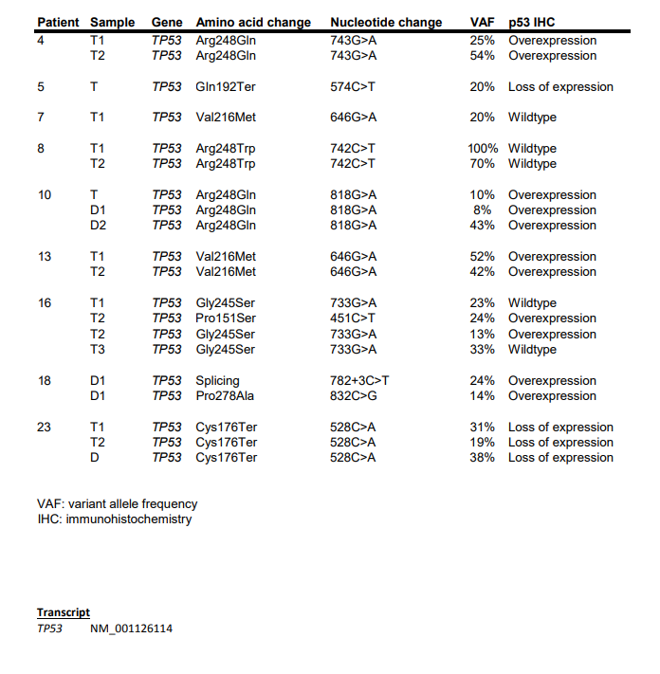

Supplementary Figure 1. Micro-image of p53 and p16 staining in PSC-CCA, illustrating the different categories.
