Figure S1. The first stage of RSF analysis: comparing minimal depth and VIMP rankings.
A. The 35 behavioral factors. (MFA, monounsaturated fatty acid; PFA, polyunsaturated fatty acid; RSF, random survival forest; SFA, saturated fatty acid; VIMP, variable of importance. Note: The 9 variables within the gold ellipse were identified as the most influential predictors and carried over to the second RSF stage; the 4 variables in the red ellipse were finally selected as the topmost behavioral markers)
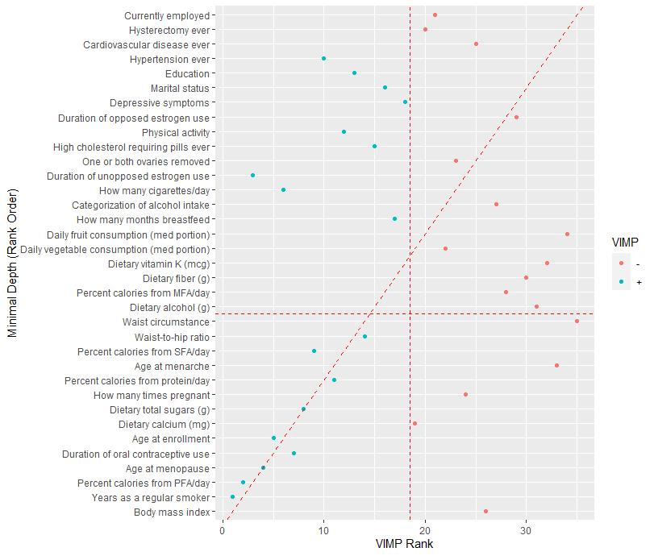
B. The 34 index single-nucleotide polymorphisms (SNPs) in relation to fasting glucose. Note: The 8 SNPs within the gold ellipse were identified as the most influential predictors and carried over to the second RSF stage; the 2 SNPs in the red ellipses were finally selected as the topmost genetic markers.
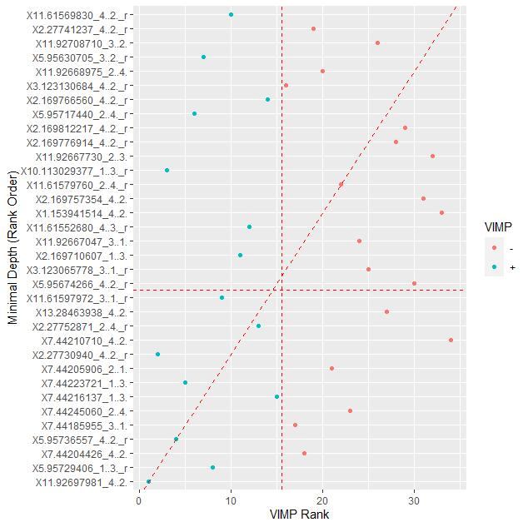
C. The 94 individual SNPs (including the 34 index SNPs) in relation to fasting glucose. Note: The 6 SNPs within the gold ellipse were identified as the most influential predictors and carried over to the second RSF stage; the 2 individual SNPs in the red ellipses were finally selected as the topmost genetic markers.
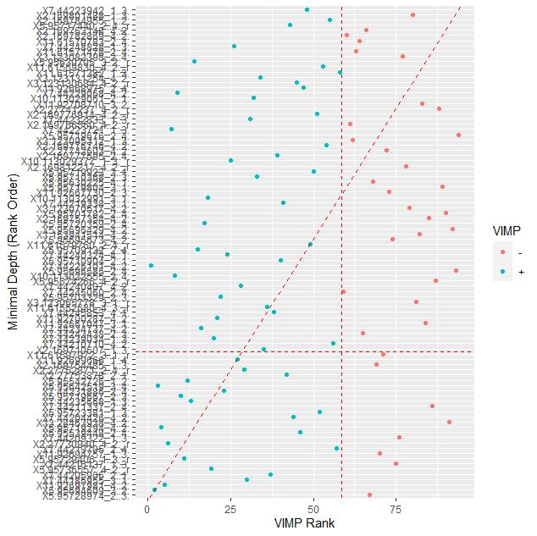
D. The 4 index SNPs in relation to fasting insulin. Note: The 1 SNP within the gold ellipse was identified as the most influential predictor and carried over to the second RSF stage.
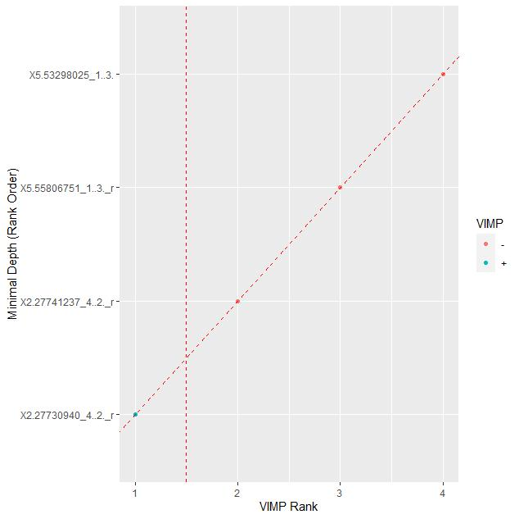
E. The 8 individual SNPs (including the 4 index SNPs) in relation to fasting insulin. Note: The 1 SNP within the gold ellipse was identified as the most influential predictor and carried over to the second RSF stage.
