Supplementary Tables and Figures

Supplementary Table 1: Distribution of the 40 PGV by penetrance status

 | PGM | Total (n=40)
High Penetrance | BRCA1 | 1 (2.5%)
 | BRCA2 | 9 (22.5%)
 | CDKN2A | 1 (2.5%)
 | MSH6 | 1 (2.5%)
 | PALB2 | 2 (5.0%)
 | SDHA | 2 (5.0%)
 | TP53 | 1 (2.5%)
Moderate Penetrance | ATM | 7 (17.5%)
 | CHEK2 | 4 (10.0%)
 | HOXB13 | 1 (2.5%)
 | NBN | 2 (5.0%)
 | RAD51C | 1 (2.5%)
Low Penetrance | APC (I1307K) | 1 (2.5%)
 | MUTYH-monoallelic | 3 (7.5%)
Recessive | FH | 1 (2.5%)
 | MSH3 | 1 (2.5%)
 | NTHL1 | 2 (5.0%)

Supplementary Table 2: Predictors of Positive Germline variant, Univariate unadjusted

 | OR | 95% CI | p.value
Gender  Female (vs Male) | 0.71 | 0.34-1.42 | 0.336
Age Group  Age <60 Years (vs >60 years) | 1.36 | 0.61-2.87 | 0.439
Staging AJCC 8th edition  Late Stage (3-4) vs Early Stage (1-2)  Stage 4 vs Other stages (1-3) | 1.01  1.55 | 0.50-2.14  0.77-3.12 | 0.979  0.212
Family History of cancer in a first degree relative  Yes (vs No) | 2.36 | 1.14-5.20 | 0.025
Tumor Location  Body (vs Head)  Tail (vs Head) | 1.04  2.27 | 0.36-2.61  0.94-5.22 | 0.936  0.058
Smoking  No (vs Yes) | 0.60 | 0.30-1.19 | 0.146
Diabetes Mellitus  No (vs Yes) | 1.11 | 0.52-2.52 | 0.802
Obese  No (vs Yes) | 1.35 | 0.49-4.78 | 0.591
CA19-9  >37 (vs <37)  >300 (vs <300) | 1.01  0.64 | 0.47-2.30  0.30-1.31 | 0.993  0.231

Supplementary Table 3: Hazards ratio for survival and Median overall survival of the groups
 | HR | 95% CI | P value | Median overall survival
Gender  Male  Female | 1.0  1.15 | 0.76-1.73 | 0.52 | 16.5 vs. 16.4 months
Age  > 60 years  < 60 years | 1.0  1.28 | 0.80-2.03 | 0.30 | 16.4 vs. 16.7 months
PGV (carriers vs. non-carriers)  Non-carrier  Carrier | 1.0  0.51 | 0.25-1.01 | 0.049 | 16.8 vs. 16.5 months
BRCAness PGV  No  Yes | 1.0  0.46 | 0.20-1.05 | 0.057 | 16.4 vs 21.1 months
CA 19-9  >300  <300 | 1.0  0.48 | 0.31-0.73 | <0.001 | 19.1 vs. 13.5 months
Disease Stage  Early Stage (1-2)  Late stage (3-4) | 1.0  3.75 | 2.15-6.54 | <0.001 | 16.8 vs. 16.5 months
Tumor location (Body vs. Tail)  Head  Body  Tail | 1.0  1.49  0.68 | 0.90-2.47  0.33-1.37 | 0.11 | 17.0 vs. 13.8 vs. 15.9 months

Supplementary Table 4: Systemic treatments for pathogenic germline carriers

Case | Gene | Clinical effect | Stage | NEOTT | RES | ADJ | MTX 1 | RES | MTX 2 | RES | MTX 3 | RES | MTX 4 | RES
1 | BRCA2 | Splice acceptor | 1 | FF-> Cap + RDT | PR | No | No | NA | No | NA | No | NA | No | NA
2 | NBN | p.Ser292Valfs*12 | 2 | No | NA | FF | Gem | SD | No | NA | No | NA | No | NA
3 | MUTYH (monoallelic) | p.Gln338* | 4 | No | NA | No | FF | SD | GNAB | SD | NAL-IRI + 5-FU | SD | No | NA
4 | MUTYH (monoallelic) | p.Gly396Asp | 4 | No | NA | No | GNAB | PR | No | NA | No | NA | No | NA
5 | ATM | p.Phe2958* | 4 | No | NA | No | FF | PR | NAL-IRI + 5-FU | PR | No | NA | No | NA
6 | PALB2 | p.Arg975Glufs*4 | 3 | FF-> Cap+ RDT | PR | No | No | NA | No | NA | No | NA | No | NA
 | MSH3 | p.Asp767Glyfs*2
7 | BRCA2 | p.Ser3147Cysfs*2 | 2 | FF | PR | Gem-> Cap + RDT | No | NA | No | NA | No | NA | No | NA
8 | BRCA2 | p.Thr1378* | 2 | GNAB | PR | Cap + RDT | No | NA | No | NA | No | NA | No | NA
9 | PALB2 | p.Ser254Ilefs*3 | 3 | Cis + Gem | PR | No | No | NA | No | NA | No | NA | No | NA
10 | ATM | Silent | 4 | No | NA | No | GNAB | DP | FOX | SD | NAL-IRI + 5-FU | DP | FOX | PR
11 | NBN | p.Lys219Asnfs*16 | 4 | No | NA | No | FF | PR | GNAB | DP | Cap | SD | No | NA
12 | MSH6 | Deletion (Exon 2) | 4 | No | NA | No | GNAB | PR | Pem | SD | No | NA | No | NA
13 | BRCA2 | p.Phe1182* | 4 | No | NA | No | GNAB | PR | FF | NON | No | NA | No | NA
14 | TP53 | p.Tyr234Cys | 3 | No | NA | No | GNAB | DP | No | NA | No | NA | No | NA
 | CHEK2 | p.Ser428Phe
15 | SDHA | p.Arg31* | 3 | No | NA | No | GNAB | PR | GNAB | SD | No | NA | No | NA
16 | ATM | p.Lys79Asnfs*37 | 4 | No | NA | No | GNAB | SD | NAL-IRI + 5-FU | SD | No | NA | No | NA
17 | SDHA | p.Arg31* | 3 | No | NA | No | GNAB | PR | No | NA | No | NA | No | NA
18 | ATM | Splice acceptor | 4 | No | NA | No | GNAB | PR | NAL-IRI + 5-FU | PR | No | NA | No | NA
19 | BRCA2 | p.Lys1025_Lys1026delinsAsn* | 4 | No | NA | No | FF | PR | NAL-IRI + 5-FU | SD | No | NA | No | NA
20 | ATM | p.Met1? | 4 | No | NA | No | FF | PR | GNAB | PR | No | NA | No | NA
21 | BRCA1 | Deletion (Exon 15) | 4 | No | NA | No | FF | PR | GNAB | DP | No | NA | No | NA
22 | MUTYH (monoallelic) | p.Gly396Asp | 1 | FF -> Cap + RDT | PR | No | No | NA | No | NA | No | NA | No | NA
23 | FH | p.Lys477dup | 2 | No | NA | FF | No | NA | No | NA | No | NA | No | NA
24 | RAD51C | Deletion (Exons 4-9) | 4 | No | NA | No | FF | PR | GNAB | SD | No | NA | No | NA
25 | ATM | p.Ala2067Asp | 2 | GNAB | PR | No | No | NA | No | NA | No | NA | No | NA
26 | CHEK2 | p.Arg117Gly | 3 | No | NA | No | GNAB | PR | Gem | SD | No | NA | No | NA
27 | NTHL1 | p.Gln90* | 4 | No | NA | No | GNAB | DP | NAL-IRI + 5-FU | PR | No | NA | No | NA
28 | BRCA2 | p.Leu2865Phefs*4 | 2 | No | NA | Gem | No | NA | No | NA | No | NA | No | NA
29 | CDKN2A | p.Met53Ile | 1 | No | NA | FF | No | NA | No | NA | No | NA | No | NA
30 | CHEK2 | p.Thr367Metfs*15 | 4 | No | NA | No | GNAB | PR | No | NA | No | NA | No | NA
31 | NTHL1 | p.Gln90* | 1 | No | NA | FF | No | NA | No | NA | No | NA | No | NA
32 | BRCA2 | p.Arg2318* | 4 | No | NA | No | FF | PR | OLP* | PR | No | NA | No | NA
33 | BRCA2 | p.Tyr1762* | 4 | No | NA | No | Gem + Carb | SD | NAL-IRI + 5-FU + RUC | PR | No | NA | No | NA
34 | CHEK2 | p.Ser428Phe | 4 | FF -> Cap + RDT | PR | No | No | NA | No | NA | No | NA | No | NA
35 | ATM | Silent | 4 | No | NA | No | No | NA | No | NA | No | NA | No | NA
36 | HOXB13 | p.Gly84Glu | 1 | FF -> Cap + RDT | PR | No | No | NA | No | NA | No | NA | No | NA
37 | APC (I1307K) | p.Ile1307Lys | 1 | FF -> Niv + RDT | SD | No | No | NA | No | NA | No | NA | No | NA
38 | BRCA2 | p.Glu2198Asnfs*4 | 2 | FF -> Cap + RDT | PR | No | No | NA | No | NA | No | NA | No | NA
Legend: NEOTT: neoadjuvant treatment, ADJ: adjuvant treatment, RES: best response, MTX1: first-line systemic treatment for metastatic disease, MTX2: second-line systemic treatment for metastatic disease, MTX3: third-line systemic treatment for metastatic disease, MTX4: fourth-line systemic treatment for metastatic disease, NA: not applicable, FF: FOLFIRINOX, Cap: capecitabine, Gem: Gemcitabine, RDT: radiotherapy, GNAB: gemcitabine + nab-paclitaxel, Niv: nivolumab, SD: stable disease, PR: partial response, DP: disease progression, FOX: FOLFOX, OLP: Olaparib, RUC: Rucaparib, Carb: Carboplatin, NAL-IRI: liposomal irinotecan, 5-FU: fluorouracil, Pem: Pembrolizumab, Cis: Cisplatin, NON: Not available (ongoing treatment- no response assessment).
*: Maintenance treatment

Supplementary Table 5: Overall systemic treatments

 | Positive  (N=38) | VUS/Negative  (N=212) | Total  (N=250)
Stage of Cancer
1 | 6 (15.8%) | 30 (14.2%) | 36 (14.4%)
2 | 7 (18.4%) | 43 (20.3%) | 50 (20.0%)
3 | 6 (15.8%) | 56 (26.4%) | 62 (24.8%)
4 | 19 (50.0%) | 83 (39.2%) | 102 (40.8%)
Surgery
Yes | 18 (47.4%) | 83 (39.2%) | 101 (40.4%)
No | 20 (52.6%) | 129 (60.8%) | 149 (59.6%)
Neoadjuvant treatment
Yes | 11 (28.9%) | 61 (28.8%) | 72 (28.8%)
No | 27 (71.1%) | 151 (71.2%) | 178 (71.2%)
Neoadjuvant type
Capecitabine + (Gemcitabine + Radiotherapy) | 0 (0.0%) | 1 (1.6%) | 1 (1.4%)
Capecitabine + Radiotherapy | 0 (0.0%) | 1 (1.6%) | 1 (1.4%)
Cisplatin + Gemcitabine | 1 (9.1%) | 0 (0.0%) | 1 (1.4%)
mFOLFIRINOX | 1 (9.1%) | 14 (22.9%) | 15 (20.8%)
mFOLFIRINOX (switch Gemcitabine + Nab-paclitaxel) + (Capecitabine + radiotherapy) | 0 (0.0%) | 4 (6.5%) | 4 (5.6%)
mFOLFIRINOX (switch Gemcitabine + Nab-paclitaxel) | 0 (0.0%) | 1 (1.6%) | 1 (1.4%)
mFOLFIRINOX + (Capecitabine + Radiotherapy) | 6 (54.6%) | 18 (29.4%) | 24 (33.4%)
mFOLFIRINOX + (Gemcitabine + Radiotherapy) | 0 (0.0%) | 2 (3.3%) | 2 (2.8%)
mFOLFIRINOX + Nivolumab + Radiotherapy | 1 (9.1%) | 0 (0.0%) | 1 (1.4%)
Gemcitabine + Nab-paclitaxel (switch mFOLFIRINOX) + (Capecitabine + Radiotherapy) | 0 (0.0%) | 1 (1.6%) | 1 (1.4%)
Gemcitabine + Capecitabine | 0 (0.0%) | 1 (1.6%) | 1 (1.4%)
Gemcitabine + Nab-paclitaxel | 2 (18.2%) | 5 (8.2%) | 7 (9.7%)
Gemcitabine + Nab-paclitaxel + (Capecitabine + Radiotherapy) | 0 (0.0%) | 7 (11.4%) | 7 (9.7%)
Gemcitabine + Nab-paclitaxel + (Gemcitabine + Radiotherapy) | 0 (0.0%) | 2 (3.3%) | 2 (2.8%)
Gemcitabine + Nab-paclitaxel + Radiotherapy | 0 (0.0%) | 3 (4.9%) | 3 (4.2%)
Gemcitabine + Radiotherapy | 0 (0.0%) | 1 (1.6%) | 1 (1.4%)
No neoadjuvant treatment | 27 | 151 | 178
Best response to neoadjuvant treatment
CR | 0 (0.0%) | 2 (3.3%) | 2 (2.8%)
PR | 10 (90.9%) | 45 (73.8%) | 55 (76.4%)
SD | 0 (0.0%) | 7 (11.5%) | 7 (9.7%)
No Response | 1 (9.1%) | 7 (11.5%) | 8 (11.1%)
No neoadjuvant treatment | 27 | 151 | 178
Adjuvant chemotherapy
Yes | 7 (18.4%) | 47 (22.2%) | 54 (21.6%)
No | 31 (81.6%) | 165 (77.8%) | 196 (78.4%)
Adjuvant chemotherapy type
Capecitabine + Radiotherapy | 1 (14.3%) | 1 (2.1%) | 2 (3.8%)
Fluorouracil + Gemcitabine + Radiotherapy | 0 (0.0%) | 1 (2.1%) | 1 (1.9%)
Fluorouracil + Radiotherapy | 0 (0.0%) | 1 (2.1%) | 1 (1.9%)
FOLFIRI | 0 (0.0%) | 1 (2.1%) | 1 (1.9%)
mFOLFIRINOX | 4 (57.1%) | 15 (31.9%) | 19 (35.2%)
mFOLFIRINOX (switch to Gemcitabine [toxicity]) | 0 (0.0%) | 1 (2.1%) | 1 (1.9%)
mFOLFIRINOX + (Capecitabine + Radiotherapy) | 0 (0.0%) | 3 (6.4%) | 3 (5.6%)
Gemcitabine + Capecitabine | 0 (0.0%) | 11 (23.4%) | 11 (20.4%)
Gemcitabine | 1 (14.3%) | 7 (14.9%) | 8 (14.8%)
Gemcitabine + (Capecitabine + Radiotherapy) | 1 (14.3%) | 3 (6.4%) | 4 (7.5%)
Gemcitabine + Nab-paclitaxel | 0 (0.0%) | 2 (4.3%) | 2 (3.7%)
Gemcitabine + Radiotherapy | 0 (0.0%) | 1 (2.1%) | 1 (1.9%)
No adjuvant treatment | 31 | 165 | 196
First-line treatment for advanced/recurrent disease
Yes | 22 (57.9%) | 147 (69.3%) | 169 (67.6%)
No | 16 (42.1%) | 65 (30.7%) | 81 (32.4%)
First-line chemotherapy name
Carboplatin + Paclitaxel | 0 (0.0%) | 1 (0.7%) | 1 (0.6%)
Dabrafenib + Trametinib | 0 (0.0%) | 1 (0.7%) | 1 (0.6%)
FOFIRINOX + CPI-613 | 0 (0.0%) | 2 (1.4%) | 2 (1.2%)
mFOLFIRINOX | 8 (36.4%) | 62 (42.2%) | 70 (41.5%)
FOLFOX | 0 (0.0%) | 2 (1.4%) | 2 (1.2%)
Gemcitabine + Nab-paclitaxel + FOLFIRI (alternating) | 0 (0.0%) | 1 (0.7%) | 1 (0.6%)
Gemcitabine | 1 (4.5%) | 1 (0.7%) | 2 (1.2%)
Gemcitabine + Anetumab | 0 (0.0%) | 1 (0.7%) | 1 (0.6%)
Gemcitabine + Carboplatin | 1 (4.5%) | 0 (0.0%) | 1 (0.6%)
Gemcitabine + Cisplatin | 0 (0.0%) | 2 (1.4%) | 2 (1.2%)
Gemcitabine + Cisplatin + Nab-paclitaxel | 0 (0.0%) | 1 (0.7%) | 1 (0.6%)
Gemcitabine + Nab-paclitaxel | 12 (54.5%) | 57 (38.8%) | 69 (40.8%)
Gemcitabine + Nab-paclitaxel + APX005M | 0 (0.0%) | 1 (0.7%) | 1 (0.6%)
Gemcitabine + Nab-paclitaxel + BMS-813160 + Nivolumab | 0 (0.0%) | 1 (0.7%) | 1 (0.6%)
Gemcitabine + Nab-paclitaxel + Cisplatin + Paricalcitol | 0 (0.0%) | 1 (0.7%) | 1 (0.6%)
Gemcitabine + Nab-paclitaxel + Napabucasin | 0 (0.0%) | 6 (4.1%) | 6 (3.6%)
Gemcitabine + Nab-Paclitaxel + Nivolumab | 0 (0.0%) | 1 (0.7%) | 1 (0.6%)
NaL-IRI + 5-FU | 0 (0.0%) | 4 (2.7%) | 4 (2.4%)
NaL-IRI + 5FU | 0 (0.0%) | 1 (0.7%) | 1 (0.6%)
TIL + IL-2 | 0 (0.0%) | 1 (0.7%) | 1 (0.6%)
Best response to first-line treatment
CR | 0 (0.0%) | 0 (0.0%) | 0 (0.0%)
PR | 15 (68.2%) | 79 (54.5%) | 94 (56.3%)
SD | 4 (18.2%) | 34 (23.4%) | 38 (22.8%)
No Response | 3 (13.6%) | 32 (22.1%) | 35 (21.0%)
Second-line treatment
Yes | 17 (44.7%) | 86 (40.6%) | 103 (41.2%)
No | 21 (55.3%) | 126 (59.4%) | 147 (58.8%)
Second-line chemotherapy name
5FU + NaL-IRI +CXCR4i +Pembrolizumab | 0 (0.0%) | 1 (1.2%) | 1 (1.0%)
Cabiralizumab + Nivolumab | 0 (0.0%) | 1 (1.2%) | 1 (1.0%)
Capecitabine | 0 (0.0%) | 3 (3.5%) | 3 (2.9%)
FOLFIRI | 2 (11.8%) | 3 (3.5%) | 5 (4.9%)
mFOLFIRINOX | 1 (5.9%) | 10 (11.6%) | 11 (10.7%)
mFOLFOX | 1 (5.9%) | 1 (1.2%) | 2 (1.9%)
mFOLFOX + Nivolumab + Cabiralizumab | 0 (0.0%) | 1 (1.2%) | 1 (1.0%)
Gemcitabine | 1 (5.9%) | 1 (1.2%) | 2 (2.0%)
Gemcitabine + Capecitabine | 0 (0.0%) | 1 (1.2%) | 1 (1.0%)
Gemcitabine + Cisplatin | 0 (0.0%) | 1 (1.2%) | 1 (1.0%)
Gemcitabine + Nab-paclitaxel | 6 (35.3%) | 39 (45.3%) | 45 (43.7%)
Gemcitabine + Nab-paclitaxel + Nivolumab + Cabiralizumab | 0 (0.0%) | 2 (2.4%) | 2 (2.0%)
HPN 536 | 0 (0.0%) | 1 (1.2%) | 1 (1.0%)
NaL-IRI + 5-FU | 3 (17.7%) | 20 (23.3%) | 23 (22.3%)
NaL-IRI + 5-FU + Rucaparib | 1 (5.9%) | 0 (0.0%) | 1 (1.0%)
Olaparib | 1 (5.9%) | 0 (0.0%) | 1 (1.0%)
Pembrolizumab | 1 (5.9%) | 1 (1.2%) | 2 (1.9%)
Second-line response
CR | 0 (0.0%) | 0 (0.0%) | 0 (0.0%)
PR | 6 (37.5%) | 24 (29.3%) | 30 (30.6%)
SD | 8 (50.0%) | 26 (31.7%) | 34 (34.7%)
No Response | 2 (12.5%) | 32 (39.0%) | 34 (34.7%)
Third-line treatment
Yes | 3 (7.9%) | 35 (16.5%) | 38 (15.2%)
No | 35 (92.1%) | 177 (83.5%) | 212 (84.8%)
Third-line chemotherapy name
Avelumab + PF-04518600 | 0 (0.0%) | 1 (2.9%) | 1 (2.6%)
Capecitabine | 1 (33.3%) | 2 (5.7%) | 3 (7.9%)
CapeOx | 0 (0.0%) | 2 (5.7%) | 2 (5.3%)
FOLFIRI | 1 (33.3%) | 3 (8.6%) | 4 (10.5%)
mFOLFIRINOX | 0 (0.0%) | 1 (2.9%) | 1 (2.6%)
FOLFOX | 0 (0.0%) | 3 (8.6%) | 3 (7.9%)
Gemcitabine + Capecitabine | 0 (0.0%) | 1 (2.9%) | 1 (2.6%)
Gemcitabine + Cisplatin | 0 (0.0%) | 1 (2.9%) | 1 (2.6%)
Gemcitabine + Nab-paclitaxel | 0 (0.0%) | 6 (17.2%) | 6 (15.8%)
Gemcitabine + Nab-paclitaxel + Cisplatin | 0 (0.0%) | 2 (5.7%) | 2 (5.3%)
NaL-IRI + 5-FU | 1 (33.3%) | 12 (34.5%) | 13 (34.1%)
TAS 102 | 0 (0.0%) | 1 (2.9%) | 1 (2.6%)
Third-line response
CR | 0 (0.0%) | 0 (0.0%) | 0 (0.0%)
PR | 0 (0.0%) | 9 (26.5%) | 9 (24.3%)
SD | 2 (66.7%) | 6 (17.6%) | 8 (21.6%)
No Response | 1 (33.3%) | 19 (55.9%) | 20 (54.1%)
Fourth-line treatment
Yes | 1 (2.6%) | 7 (3.3%) | 8 (3.2%)
No | 37 (97.4%) | 205 (96.7%) | 242 (96.8%)
Fourth-line chemotherapy name
Atezolizumab + KY1044 | 0 (0.0%) | 1 (14.3%) | 1 (12.5%)
mFOLFIRINOX | 0 (0.0%) | 1 (14.3%) | 1 (12.5%)
FOLFOX | 1 (100.0%) | 1 (14.3%) | 2 (25.0%)
NaL-IRI + 5FU | 0 (0.0%) | 2 (28.6%) | 2 (25.0%)
Nivolumab | 0 (0.0%) | 1 (14.3%) | 1 (12.5%)
Oradoxel | 0 (0.0%) | 1 (14.3%) | 1 (12.5%)
Fourth-line response
CR | 0 (0.0%) | 0 (0.0%) | 0 (0.0%)
PR | 1 (100.0%) | 0 (0.0%) | 1 (12.5%)
SD | 0 (0.0%) | 1 (14.3%) | 1 (12.5%)
No Response | 0 (0.0%) | 6 (85.7%) | 6 (75.0%)

Supplementary Table 6: Screening Guidelines met by patients with and without PGV

 | 2018 (N=38) | 2020 (N=38) | p value
Did they meet NCCN/NSGC/ACMG testing guidelines? |  |  | < 0.001
Yes | 26 (68.4%) | 38 (100.0%)
No | 12 (31.6%) | 0 (0.0%)
Did they meet guidelines based on family history regardless of personal history? |  |  | 0.889
Yes | 15 (39.5%) | 17 (44.7%)
No | 19 (50.0%) | 17 (44.7%)
Not available | 4 (10.5%) | 4 (10.5%)

Supplementary Figure 1: Kaplan Meier curves for overall survival of HRR gene PGV carriers vs Negative/VUS
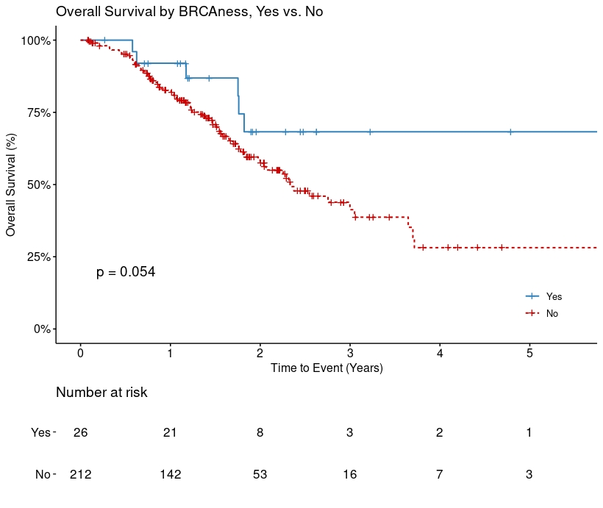

Supplementary Figure 2: Kaplan Meier curves for overall survival AJCC 8th Edition Early versus Late Stage
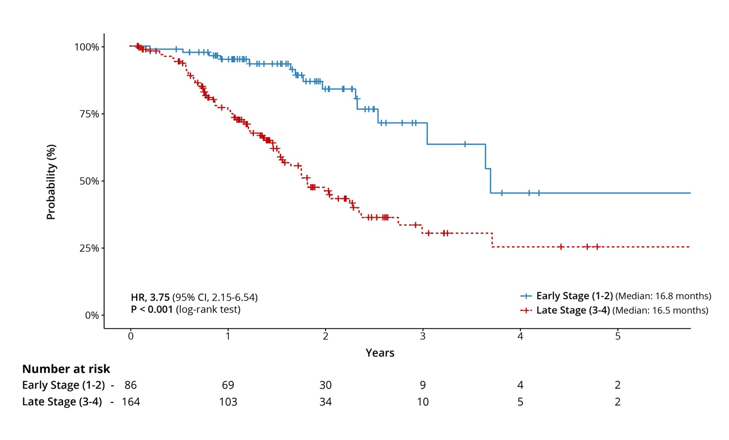

Supplementary Figure 3: Kaplan Meier curves for overall survival with

CA19-9 >300 vs. < 300
