Supplemental Digital Content 1 to:

A potential treatment for congenital sodium diarrhea in patients with activating GUCY2C mutations
Anke H.M. van Vugt, BSc^{1,2#}, Marcel J.C. Bijvelds, PhD^{3#}, Hugo R. de Jonge, PhD³, Kelly F. Meijsen³, Tanja Restin, MD, PhD^{4,5}, Manuel B. Bryant, MD⁴, Antje Ballauff, MD⁶, Bart Koot, MD, PhD⁷, Thomas Müller, MD⁸, Roderick H.J. Houwen, MD, PhD^{1#}, Andreas R. Janecke, MD^{8,9#}, Sabine Middendorp PhD^{1,2,#,*}.
¹Division of Pediatrics, Department of Pediatric Gastroenterology, Wilhelmina Children’s Hospital, University Medical Center Utrecht (UMCU), Utrecht University (UU), Utrecht, the Netherlands
²Regenerative Medicine Center, UMCU, UU, Utrecht, The Netherlands
³Department of Gastroenterology and Hepatology, Erasmus University Medical Center, Rotterdam, The Netherlands
⁴Newborn research Zürich, Department of Neonatology, University Hospital Zurich and University of Zurich, Zurich, Switzerland
⁵ Institute of Physiology, University of Zurich, Zurich, Switzerland
⁶Kinder- und Jugendmedizin, Helios Klinikum, Krefeld, Germany
⁷Emma Children‘s Hospital, Amsterdam UMC, University of Amsterdam, Pediatric Gastroenterology, Amsterdam, The Netherlands
⁸Department of Pediatrics I, Medical University Innsbruck, Innsbruck, Austria
⁹Division of Human Genetics, Medical University Innsbruck, Innsbruck, Austria
#Equal contribution; *Current Address: Gadeta BV, Utrecht, The Netherlands
Correspondence: Andreas R. Janecke, MD; andreas.janecke@i-med.ac.at

MATERIAL AND METHODS
Patients and study design
Patients who were diagnosed with GCC-related diarrhea and who were in long-time care at specialist centers for pediatric gastrointestinal disorders were asked to participate in this study. All human material was obtained with informed consent and in accordance with local ethical requirements. The study adhered to the principles set out in the Declaration of Helsinki. Biopsy specimens were obtained from ileum, duodenum, or rectum as indicated. We used healthy control organoids for each intestinal location.

Patient #1, a boy, is the second child of unrelated healthy Swiss parents. Sonography at 19 weeks gestation showed dilated intestinal loops and polyhydramnios and intestinal obstruction was suspected. At 28 weeks of gestation a cesarean section was performed because of fetal distress. The newborn (weight 2 kg, >P97; length 37 cm, P50) had a severely distended abdomen. Endotracheal intubation was required as well as substantial fluid substitution (up to 400 ml/kg/day). Metabolic acidosis was present with low serum sodium levels (<130 mmol/l) that required sodium substitution above 30 mmol/kg/d. Laparotomy at day 4 of life excluded intestinal atresia; a double-barrel ileostomy was placed and full parenteral nutrition was started. Ileal fluid had high chloride levels (124 mmol/l, normal 10-15 mmol/l) and high sodium levels (159 mmol/l, normal 30-50 mmol/l). Currently, at 2.5 years of age, he is still mainly fed parenterally, with a sodium substitution of 32 mmol/kg/day. The clinical features of patients #2 and #3 were described (1). At ages 13 and 12 years, respectively, they are still mainly fed parenterally.

Organoid cultures
Organoid cultures were generated from biopsy specimens as described (2). Ileum and rectum-derived organoid lines were passaged by mechanical disruption, whereas duodenal organoids were passaged as single cells. Organoids were cultured routinely in expansion medium (EM) containing Wnt3a, Noggin, R-Spondin1 and epidermal growth factor (EGF) in Matrigel, according to established protocols (van Rijn, Ardy et al. 2018). All organoid cultures were morphologically normal, expanded normally, and had similar levels of GUCY2C and CFTR mRNA (Figure S1, below).
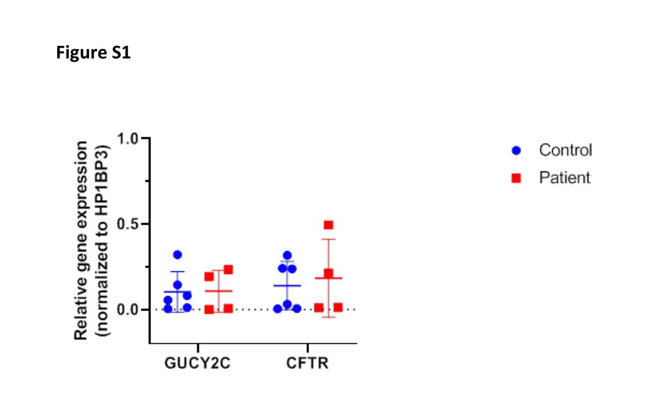
Generation of organoid monolayers
Monolayers were generated from Matrigel-embedded (3D) organoid cultures as described previously (3). In short, organoids were harvested in TrypLE express (Thermo Fisher Scientific 12604021; Bleiswijk, the Netherlands) and seeded as single cells in EM with 10μM ROCK inhibitor Y27632 (Abcam 120129; Cambridge, UK) on Matrigel-coated polyester membrane filters (Transwell #3470; Corning, Wiesbaden, Germany) for 2 days. Monolayer formation was obtained by culturing for another 7 days in EM without Y27632 and assessed by measuring transepithelial electric resistance (TEER) as described previously (3).

cGMP levels in monolayers from intestinal organoids
Monolayers were pre-incubated in EM medium without growth factors and with the broad-spectrum phosphodiesterase (PDE) inhibitor 3-isobutyl-1-methylxanthine (IBMX, 1 mmol/l; Sigma-Aldrich, St Louis, MO, USA), and the GCC-inhibitor SSP2518 (3μmol/l; Shire-Movetis, Turnhout, Belgium) or vehicle (0.1% DMSO). IBMX was added to prevent cGMP hydrolysis and to render the assay independent of fluctuating PDE activities in cells and cell lysates. After 15 minutes pre-incubation, the heat-stable enterotoxin that is produced by enterotoxigenic Escherichia coli strains (ST) (100 nmol/l; Bachem H-6248.0500; Bubendorf, Switzerland), or vehicle (0.002% acetic acid) was added to the apical compartment. After continued incubation for 1 hour, monolayers were harvested in ice-cold phosphate-buffered saline supplemented with ethylenediaminetetraacetic acid (2.5 mmol/l) and Triton X100 (1%) and cGMP concentrations in cell lysates were determined by ELISA (Enzo Life Sciences ADI-901-164; Antwerp, Belgium).

Assessment of chloride secretion across organoid monolayers
Organoid-derived monolayers were mounted in P2302T sliders and inserted in P2300 type Ussing chambers (Physiologic Instruments, San Diego, CA, USA). The monolayers were bathed in Meyler solution (mmol/l: 128 NaCl, 4.7 KCl, 1.3 CaCl₂, 1.0 MgCl₂, 0.3 Na₂HPO₄, 0.4 NaH₂PO₄, 20 NaHCO₃, 10 glucose), maintained at 37°C, and gassed with 95% O₂, 5%CO₂. Short-circuit currents (Isc), representing CFTR-mediated chloride secretion (4, 5) were recorded using a VCC MC8 Multichannel voltage clamp module (Physiologic Instruments, San Diego, CA, USA), connected to a PowerLab 8/35 AD-converter and LabChart 8 software (AD Instruments, Oxford, UK).
In all Ussing chamber experiments, filter-grown monolayers were pre-treated with vardenafil (3 μmol/l; Selleck Chem, Houston, TX, USA) to block phosphodiesterase-5-mediated cGMP hydrolysis. IBMX was not used for this purpose because this broad-spectrum phosphodiesterase inhibitor, by increasing cellular cAMP levels, may stimulate cAMP-dependent protein kinase mediated CFTR activation and thus desensitize cells to the pro-secretory action of the cGMP-linked agonist ST.
The Isc response to the cGMP-linked agonist ST was normalized, i.e. expressed as a percentage of the maximal CFTR activity that was elicited by the combined administration of the cAMP-linked agonist forskolin (10 μmol/l; Sigma-Aldrich, St Louis, MO, USA) and the phosphodiesterase inhibitor IBMX (100 μmol/l), at the end of each experiment (5). In this way the ST-dependent Isc response could be compared directly with the response to a cAMP-linked secretagogue acting independently of ST, GCC and cGMP.

GUCY2C and CFTR transcript quantification by qRT-PCR
RT-PCR was performed as described previously (2). Primers used were GUCY2C-Fw: CAGGTGAGTCAGAACTGCCA, GUCY2C-Rev: CCATCCGTTGTGCATTTGAA; CFTR-Fw: CTTCTGGGAGGAGGGATTTGG and CFTR-Rev: GGCATGCTTTGATGACGCTT. HP1BP3 served as housekeeping gene; Fw: cccacgtcccaagatggat, Rv: ctgatgcaccactcttctggaa.

Statistics
Statistical analyses were performed using Prism 9 (Graphpad Software, San Diego, CA). The effect of GUCY2C genotype and SSP2518 on cyclic GMP production was evaluated by two-way ANOVA, employing Tukey’s correction to account for multiple comparisons. Statistical significance of differences between mean Isc responses in SSP2518 treated and untreated organoid monolayers was analyzed using Student’s t-test (2-sided).
References
1. Muller T, Rasool I, Heinz-Erian P, Mildenberger E, Hulstrunk C, Muller A, Michaud L, Koot BG, Ballauff A, Vodopiutz J, Rosipal S, Petersen BS, Franke A, Fuchs I, Witt H, Zoller H, Janecke AR, Visweswariah SS Congenital secretory diarrhoea caused by activating germline mutations in GUCY2C. Gut 2016;65:1306-13.
2. van Rijn JM, Ardy RC, Kuloglu Z, Harter B, van Haaften-Visser DY, van der Doef HPJ, van Hoesel M, Kansu A, van Vugt AHM, Thian M, Kokke FTM, Krolo A, Basaran MK, Kaya NG, Aksu AU, Dalgic B, Ozcay F, Baris Z, Kain R, Stigter ECA, Lichtenbelt KD, Massink MPG, Duran KJ, Verheij J, Lugtenberg D, Nikkels PGJ, Brouwer HGF, Verkade HJ, Scheenstra R, Spee B, Nieuwenhuis EES, Coffer PJ, Janecke AR, van Haaften G, Houwen RHJ, Muller T, Middendorp S, Boztug K Intestinal Failure and Aberrant Lipid Metabolism in Patients With DGAT1 Deficiency. Gastroenterology 2018;155:130-143 e15.
3. Vogel GF, van Rijn JM, Krainer IM, Janecke AR, Posovszky C, Cohen M, Searle C, Jantchou P, Escher JC, Patey N, Cutz E, Muller T, Middendorp S, Hess MW, Huber LA Disrupted apical exocytosis of cargo vesicles causes enteropathy in FHL5 patients with Munc18-2 mutations. JCI Insight 2017;2.
4. Zomer-van Ommen DD, de Poel E, Kruisselbrink E, Oppelaar H, Vonk AM, Janssens HM, van der Ent CK, Hagemeijer MC, Beekman JM Comparison of ex vivo and in vitro intestinal cystic fibrosis models to measure CFTR-dependent ion channel activity. J Cyst Fibros 2018;17:316-324.
5. Rao MC Physiology of Electrolyte Transport in the Gut: Implications for Disease. Compr Physiol 2019;9:947-1023.

