Supplementary Figure 1: Representative gating strategy for flow cytometric analysis of different leukocyte subsets. Following doublet exclusion and gating on vital lymphoid cells, monocytes or granulocytes based on forward and sideward scatter, we defined the different leukocyte subsets as followed: CD8⁺ T cells as CD3⁺CD8⁺, CD19⁺ B cells as CD3⁻CD19⁺, (A), NK cells as CD3⁻CD56⁺CD16⁺, monocytes as CD3⁻CD56⁻CD16⁺/CD14⁺ (B) and eosinophils as CD16⁻CCR3⁺Siglec8⁺ (C). Next we gated on α4⁺β7⁺ cells and determined VDZ⁺ cells in these subsets.
Supplementary Figure 2: Representative gating of controls for flow cytometry analysis. For definition of α4⁺β7⁺ cells we gated on CD8⁺ T cells (CD3⁺CD8⁺), CD19⁺ B cells (CD3⁻CD19⁺), NK cells (CD3⁻CD56⁺CD16⁺) monocytes (CD3⁻CD56⁻CD16⁺/CD14⁺) and eosinophils (CD16⁻CCR3⁺Siglec8⁺) and further gated for α4⁺β7⁺ in controls without the corresponding antibody (fluorescence minus one, FMO) or stained with the corresponding isotype control.
Supplementary Figure 3: Concentration-dependent adhesion and transmigration of different leukocyte subsets. (A) Dynamic adhesion of magnetic activated cell sorting (MACS) purified CD8⁺ T cells, CD19⁺ B cells, NK cells, monocytes and eosinophils after treatment with different concentrations of VDZ. Quantification of the background-corrected number of cells incubated with or without the indicated concentrations of VDZ (adhering to MAdCAM-1 (sum of eight counted high-power fields). n = 6-12 . (B) Quantitative flow cytometry of transmigrated CD8⁺ T cells, CD19⁺ B cells, NK cells and eosinophils after treatment with the indicated concentrations of VDZ or with corresponding isotype control (untreated). n = 5-8
Results depicted as bar graphs with standard error of the mean (SEM) and single data points. Significant outliers were identified using Grubbs test (p = 0.05) and excluded from analysis. Statistical comparisons were performed using one-way ANOVA with Tukey‘s multiple comparison test. * p < 0.05; ** p < 0.01; *** p < 0.001.

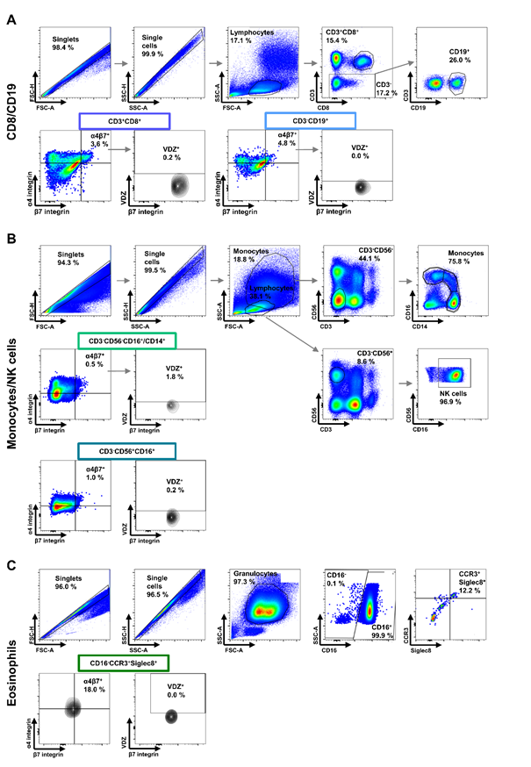
Supplemental Figure 1
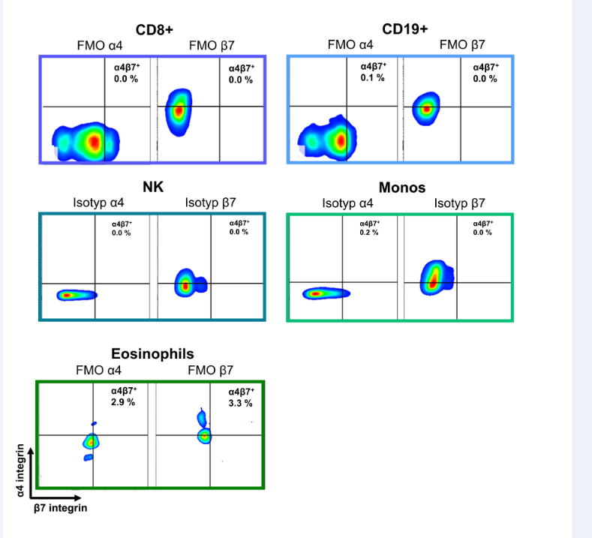Supplemental Figure 2

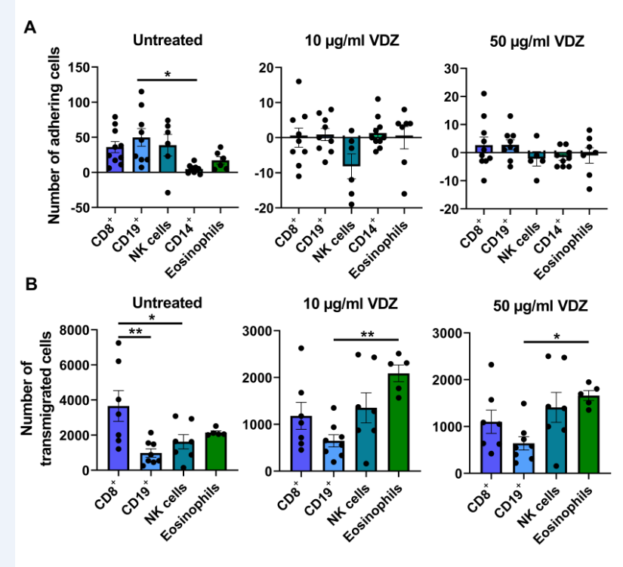Supplemental Figure 3

