Supplementary Material
Supplementary Figure
Supplementary Figure 1. Receiver operator characteristic (ROC) curve of Lp(a) for predicting carotid atherosclerosis in different MAFLD subtypes with and without advanced fibrosis defined by liver stiffness.

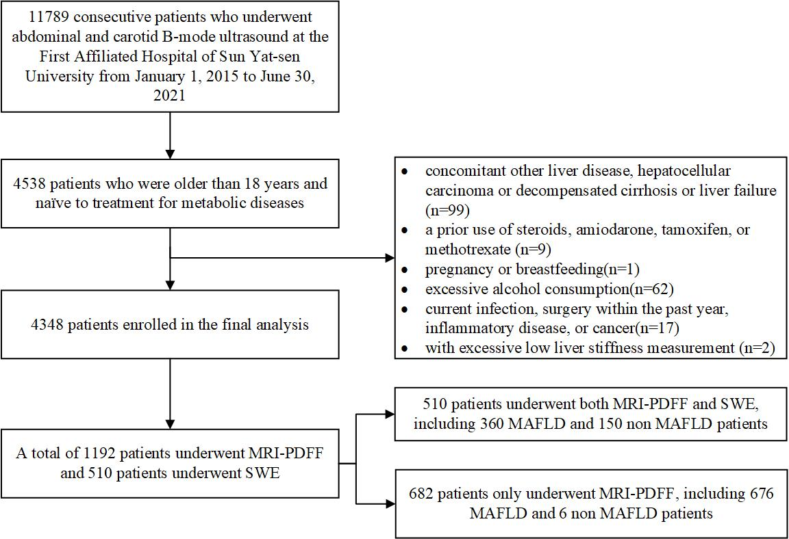
Supplementary Figure 2. The flow chart of enrollment and specific tests.
Supplementary Table
Supplementary Table 1. Comparison of MAFLD patients with and without advanced fibrosis
Variable | NFS≤-1.836  n=967 | NFS>-1.836  n=379 | p value* | LSM<6.3kPa  n=321 | LSM≥6.3kPa  n=173 | p value†
Age (years), mean±SD | 42.9±12.4 | 58.8±11.2 | <0.001 | 39.8±12.2 | 44.2±12.4 | <0.001
Male, n(%) | 662(68.5) | 220(58.1) | <0.001 | 235(73.2) | 128(73.7) | 0.7989
Hypertension, n(%) | 178(18.4) | 180(47.5) | <0.001 | 22(6.9) | 29(16.5) | <0.001
Diabetes, n(%) | 31(3.2) | 142(37.5) | <0.001 | 16(5.0) | 26(14.9) | <0.001
Current smoker, n(%) | 167(17.3) | 86(22.7) | 0.051 | 46(14.3) | 26(15.2) | 0.814
BMI, kg/m² | 25.7±3.2 | 27.5±4.2 | <0.001 | 26.0±3.4 | 27.9±4.0 | <0.001
Waist-to-hip ratio | 0.89±0.05 | 0.91±0.05 | <0.001 | 0.89±0.04 | 0.91±0.05 | <0.001
SBP, mmHg | 131±15 | 135±21 | <0.001 | 129±16 | 135±16 | 0.001
DBP, mmHg | 84±13 | 81±14 | 0.003 | 84±14 | 88±14 | 0.002
Liver and metabolism marker, mean±SD
ALT (U/L)† | 51±44 | 53±49 | <0.001 | 49±45 | 66±54 | <0.001
AST (U/L)† | 34±26 | 36±57 | 0.344 | 34±30 | 52±47 | <0.001
GGT(U/L)† | 59±82 | 56±74 | 0.412 | 53±73 | 83±98 | <0.001
ALB(g/L) | 45.6±15.4 | 41.5±3.7 | <0.001 | 46.1±1.5 | 42.9±3.4 | <0.001
Uric acid (μmol/L) | 406±106 | 394±98 | 0.017 | 409±109 | 424±101 | 0.102
FBG (mmol/L) | 5.1±1.2 | 6.5±3.7 | <0.001 | 5.0±1.2 | 5.5±1.4 | 0.001
FINS (mmol/L)† | 11.2±7.5 | 12.2±9.9 | 0.135 | 10.6±7.5 | 13.5±7.9 | <0.001
HOMA-IR† | 2.5±1.8 | 3.1±1.7 | <0.001 | 2.5±1.7 | 3.3±2.3 | <0.001
Lipid profiles, mean±SD
Total cholesterol (mmol/L) | 5.2±1.3 | 5.2±3.0 | 0.644 | 5.1±1.1 | 5.3±1.5 | 0.022
Triglyceride (mmol/L) | 1.94±1.26 | 2.11±1.87 | 0.068 | 1.67±1.20 | 1.82±1.09 | 0.100
HDL-c (mmol/L) | 1.20±0.43 | 1.14±0.32 | <0.001 | 1.16±0.26 | 1.18±0.34 | 0.783
LDL-c (mmol/L) | 3.17±0.92 | 3.32±0.81 | 0.001 | 3.24±0.73 | 3.41±0.86 | 0.009
ApoA1 (g/L) | 1.28±0.22 | 1.30±0.27 | 0.247 | 1.26±0.29 | 1.25±0.24 | 0.675
ApoB (g/L) | 0.97±0.30 | 1.00±0.29 | 0.020 | 0.94±0.25 | 1.00±0.42 | 0.014
ApoE (mg/L) | 49±21 | 48±21 | 0.137 | 45±16 | 46±16 | 0.085
Lp(a) (mg/L)† | 194±290 | 191±127 | 0.061 | 171±199 | 157±203 | 0.071
PLT (10⁹/L) | 261±53 | 210±46 | <0.001 | 255±54 | 242±64 | 0.001
CIMT≥1.0mm, n(%) | 262(27.1) | 219(57.7) | <0.001 | 54(16.8) | 45(25.8) | 0.004

*p value was comparison of MAFLD patients with NFS≤-1.836 and NFS>-1.836
†p value was comparison of MAFLD patients with LSM<6.3kPa and LSM≥6.3kPa

Supplementary table 2. Associations of quantiles of Lp(a) with carotid atherosclerosis in both MAFLD and non MAFLD patients
Quantile of Lp(a) | All cases |  | Non MAFLD |  | MAFLD |  | MAFLD with advanced fibrosis*
Model 1 | OR (95% CI) | p | OR (95% CI) | p | OR (95% CI) | p | OR (95% CI) | p
Q1 | Reference |  | Reference |  | Reference |  | Reference
Q2 | 1.38(1.11-1.74) | 0.001 | 1.68(1.26-2.25) | <0.001 | 1.34(1.02-1.88) | 0.044 | 1.53(0.65-6.42) | 0.512
Q3 | 1.84(1.48-2.25) | <0.001 | 1.97(1.48-2.62) | <0.001 | 2.09(1.43-3.21) | <0.001 | 0.83(0.21-4.45) | 0.452
Q4 | 2.50(2.03-3.06) | <0.001 | 3.41(2.59-4.49) | <0.001 | 1.90(1.35-2.54) | <0.001 | 0.62(0.21-3.45) | 0.381
P for trend | <0.001 |  | <0.001 |  | <0.001 |  | 0.482
Model 2
Q1 | Reference |  | Reference |  | Reference |  | Reference
Q2 | 1.13(0.87-1.41) | 0.310 | 1.43(1.05-1.97) | 0.026 | 1.03(0.74-1.55) | 0.805 | 1.15(0.39-4.72) | 0.199
Q3 | 1.44(1.14-1.80) | 0.001 | 1.70(1.25-2.31) | 0.001 | 1.50(1.02-2.01) | 0.031 | 1.34(0.86-3.31) | 0.801
Q4 | 2.20(1.73-2.72) | <0.001 | 3.42(2.53-4.63) | <0.001 | 1.33(0.94-1.93) | 0.102 | 0.43(0.91-3.96) | 0.442
P for trend | <0.001 |  | <0.001 |  | 0.071 |  | 0.421
Model 3
Q1 | Reference |  | Reference |  | Reference |  | Reference
Q2 | 1.12(0.87-1.43) | 0.363 | 1.45(1.05-1.99) | 0.024 | 0.98(0.69-1.54) | 0.856 | 1.68(0.42-5.12) | 0.110
Q3 | 1.40(1.13-1.75) | 0.003 | 1.74(1.28-2.38) | <0.001 | 1.36(0.98-2.01) | 0.073 | 1.82(0.82-2.72) | 0.653
Q4 | 2.12(1.70-2.69) | <0.001 | 3.49(2.57-4.75) | <0.001 | 1.20(0.88-1.80) | 0.212 | 0.56(0.39-1.41) | 0.712
P for trend | <0.001 |  | <0.001 |  | 0.214 |  | 0.412
Model 4
Q1 | Reference |  | Reference |  | Reference |  | Reference
Q2 | 1.11(0.85-1.43) | 0.419 | 1.41(1.02-1.96) | 0.039 | 0.96(0.67-1.39) | 0.687 | 1.67(0.48-3.92) | 0.623
Q3 | 1.40(1.09-1.78) | 0.004 | 1.73(1.25-2.39) | 0.001 | 1.32(0.89-1.92) | 0.144 | 1.61(0.68-3.34) | 0.312
Q4 | 2.02(1.59-2.55) | <0.001 | 3.37(2.45-4.63) | <0.001 | 1.11(0.80-1.75) | 0.537 | 1.89(0.52-3.62) | 0.431
P for trend | <0.001 |  | <0.001 |  | 0.263 |  | 0.482
*Advanced fibrosis was defined as LSM≥9kPa
Model 1 was the crude model
Model 2 was adjusted for age and gender
Model 3 was adjusted for factors of Model 2 and BMI, history of type-2 diabetes and smoking
Model 4 was adjusted for factors of Model 3 and ALT, Uric acid, HOMA-IR, total cholesterol, TG, HDL-c and ApoB/ApoA ratio.

Quantile of Lp(a) | Crude model |  | Muti-variable adjusted model†
 | OR(95% CI) | p value | OR(95% CI) | p value
Q1 | Reference |  | Reference
Q2 | 0.75(0.45-1.36) | 0.421 | 0.39(0.10-1.04) | 0.075
Q3 | 0.64(0.24-1.75) | 0.543 | 0.43(0.11-1.60) | 0.207
Q4 | 0.43(0.28-1.10) | 0.084 | 0.23(0.10-1.02) | 0.058
p for trend | 0.144 |  | 0.077
p interaction‡ | 0.022 |  | 0.045
Supplementary Table 3. Multi-variable adjusted logistic regression for the association between carotid atherosclerosis misdiagnosed by Lp(a) regression model and quartile of serum Lp(a) level.
†Adjusting variable including age, sex, BMI, smoking history, ALT, uric acid, HOMA-IR, total cholesterol, triglycerides, HDL-c and ApoB/ApoA ratio.
‡p interaction represents the significance of the coefficient of the interaction term of hepatic fibrosis degree measured by liver stiffness and quartile of Lp(a).

Supplementary Table 4. Sensitivity, specificity, NPV and PPV for cut-offs predicting carotid atherosclerosis.
 | Sensitivity  (%) | Specitivity  (%) | PPV  (%) | NPV  (%) | Lp(a) Cut-off, mg/L
Non MAFLD | 76.9 | 70.1 | 42.6 | 91.2 | 284
MAFLD with NFS≤-1.836 | 74.0 | 69.1 | 45.5 | 88.7 | 213
MAFLD with NFS>-1.836 | 62.3 | 68.5 | 73.4 | 55.2 | 189
MAFLD with LSM<6.3kPa | 77.2 | 73.3 | 36.8 | 92.0 | 253
MAFLD with LSM≥6.3kPa and <9.0kPa | 97.4 | 63.0 | 54.8 | 98.6 | 214
MAFLD with LSM≥9.0kPa | 76.3 | 52.3 | 53.9 | 80.1 | 169
Abbreviation: MAFLD, metabolic associated fatty liver disease; Lp(a), lipoprotein (a); NFS, NAFLD fibrosis score; LSM, liver stiffness measurement; NPV, negative predictive value; PPV, positive predictive value.

Supplementary table 5. The association of carotid atherosclerosis with Lp(a) in different MAFLD subgroup
Quantile of Lp(a) | MAFLD subgroup
 | Overweight/obesity |  | Lean/normal weight |  | Type-2 diabetes
Model 1 | OR (95% CI) | p | OR (95% CI) | p | OR (95% CI) | p
Q1 | Reference |  | Reference |  | Reference
Q2 | 1.16(0.80-1.68) | 0.399 | 2.54(0.94-6.88) | 0.067 | 1.17(0.48-2.88) | 0.726
Q3 | 1.63(1.12-2.36) | 0.011 | 3.3(1.98-7.89) | 0.000 | 1.75(0.76-4.04) | 0.191
Q4 | 1.62(1.13-2.30) | 0.008 | 2.81(1.1-7.16) | 0.030 | 1.92(0.82-4.47) | 0.133
P for trend | 0.017 |  | <0.001 |  | 0.361
Model 2
Q1 | Reference |  | Reference |  | Reference
Q2 | 1.04(0.70-1.56) | 0.875 | 1.31(0.43-4.01) | 0.640 | 0.86(0.32-2.29) | 0.764
Q3 | 1.09(0.71-1.67) | 0.690 | 4.20(1.60-7.06) | 0.004 | 1.60(0.66-3.91) | 0.299
Q4 | 1.28(0.86-1.90) | 0.201 | 1.34(0.47-3.85) | 0.587 | 1.46(0.59-3.59) | 0.414
P for trend | 0.579 |  | 0.010 |  | 0.458
Model 3
Q1 | Reference |  | Reference |  | Reference
Q2 | 1.18(0.67-2.05) | 0.589 | 1.56(0.22-6.23) | 0.658 | 0.86(0.32-2.31) | 0.762
Q3 | 1.19(0.67-2.12) | 0.551 | 1.67(0.71-3.68) | 0.119 | 1.47(0.59-3.61) | 0.406
Q4 | 1.47(0.87-2.55) | 0.162 | 0.88(0.15-5.08) | 0.885 | 1.31(0.52-3.28) | 0.570
P for trend | 0.565 |  | 0.239 |  | 0.638
Model 4
Q1 | Reference |  | Reference |  | Reference
Q2 | 1.28(0.60-2.83) | 0.527 | 1.75(0.07-4.68) | 0.736 | 4.42(0.65-30.19) | 0.130
Q3 | 0.98(0.38-2.52) | 0.973 | 1.32(0.19-8.64) | 0.413 | 3.22(0.54-19.02) | 0.197
Q4 | 1.02(0.42-2.47) | 0.976 | 0.87(0.51-6.36) | 0.343 | 1.29(0.24-7.03) | 0.768
P for trend | 0.909 |  | 0.376 |  | 0.350
Model 1 was the crude model
Model 2 was adjusted for age and gender
Model 3 was adjusted for factors of Model 2 and BMI, history of type-2 diabetes and smoking
Model 4 was adjusted for factors of Model 3 and ALT, Uric acid, HOMA-IR, total cholesterol, TG, HDL-c and ApoB/ApoA ratio.

Supplementary Table 6. Sensitivity, specificity, NPV and PPV for cut-offs predicting carotid atherosclerosis of different MAFLD subgroup
MAFLD subtypes | Sensitivity  (%) | Specitivity  (%) | PPV  (%) | NPV  (%)
Overweight/obesity with LSM<6.3kPa | 66.05 | 84.05 | 13.6 | 31.2
Overweight/obesity with LSM≥6.3kPa | 59.10 | 78.04 | 12.1 | 30.1
Lean/normal weight with LSM <6.3kPa | 100.00 | 66.67 | 23.8 | 0
Lean/normal weight with LSM ≥6.3kPa | 72.5 | 79.4 | 26.5 | 29.1
Type-2 diabetes with LSM <6.3kPa | 71.3 | 72.2 | 27.6 | 29.0
Type-2 diabetes with LSM ≥6.3kPa | 68.9 | 72.3 | 25.6 | 30.1
Abbreviation: MAFLD, metabolic associated fatty liver disease; Lp(a), lipoprotein (a); LSM, liver stiffness measurement; NPV, negative predictive value; PPV, positive predictive value.

