Supplemental Digital Content 3
Supplementary Figure 1: PR (A) and ROC curve (B) for OOB internal training set of the RF model comparing AA cases to control cases using 10 discriminatory VOCs. The sensitivity and specificity were found to be 79% and 70%. AUC ROC=0.798, AUC PR=0.845. C: PR curve for results obtained using the independent test. The sensitivity and specificity were found to be 70% and 90%. AUC PR 0·662.
PR: precision recall, ROC: receiver operating characteristic, OOB: Out of Bag, RF: Random Forest, AA: advanced adenoma, VOC: volatile organic compounds, AUC: area under the curve.
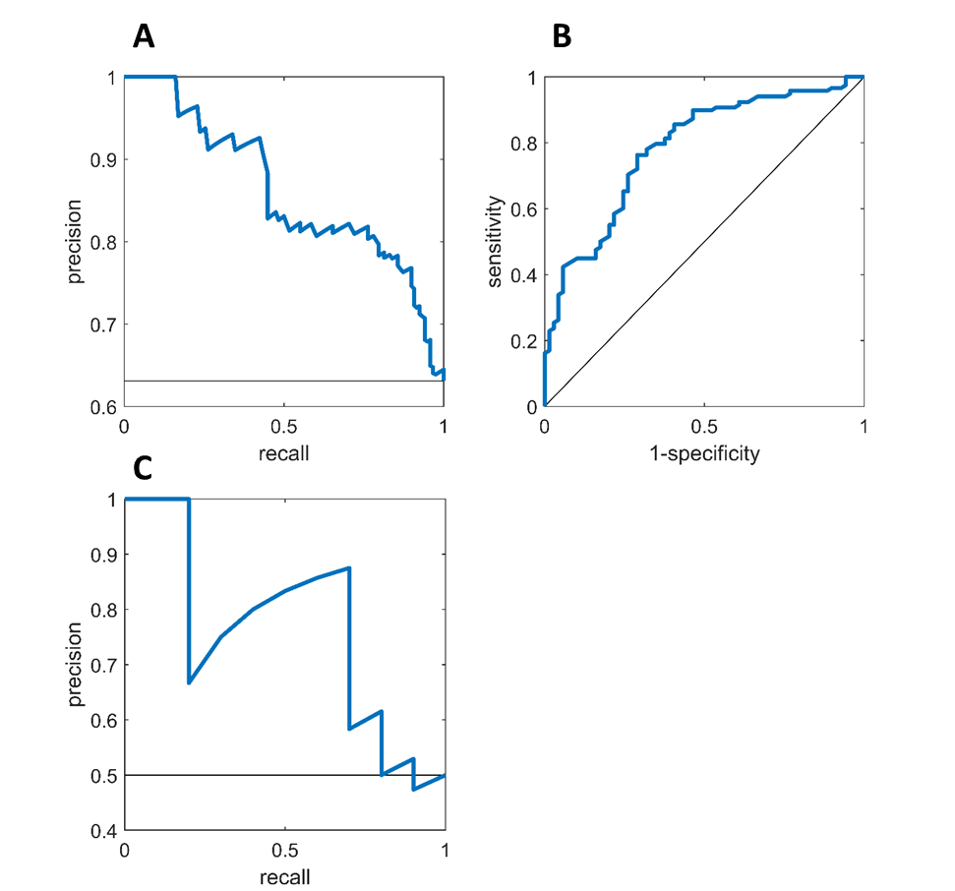

A B

Supplementary Figure 2A: The obtained ROC curve for the discrimination of CRC versus control using the five most important features from Model 2 (i.e. created to compare AA cases to control cases). The sensitivity and specificity were 80% and 70%, respectively. AUC ROC=0.762. B: The obtained ROC curve for the discrimination of CRC and AA combined versus control using the five most important features from Model 2 (i.e. created to compare AA cases to control cases). The sensitivity and specificity were 77% and 70%, respectively. AUC ROC=0.750.

