Supplementary Material
Supplemental Digital Content 1. Crude and age-standardized colorectal cancer incidence (per 100,000), proportion of advanced stages and distribution by location in persons ≥55 years determined based on GePaRD and, for comparison, based on data from the German Centre for Cancer Registry (Zentrum für Krebsregisterdaten, ZfKD).
Supplemental Digital Content 2. Flow chart illustrating the selection of the study population.
Supplemental Digital Content 3. Description of colorectal cancers (CRCs) occurring in cohort 1 and cohort 2 within the entire follow-up, stratified by sex.
Supplemental Digital Content 4. Distribution of colorectal cancers (CRC) occurring within 10 years after screening colonoscopy in cohort 1 and cohort 2 according to location, stratified by age group and sex. Here, distal CRCs are subdivided into CRCs in the distal colon vs. the rectum.
Supplemental Digital Content 5. Colorectal cancers (CRCs) diagnosed at first repeat colonoscopy per 10,000 person-years in cohort 1 and cohort 2, overall and according to site and stage of the CRCs, stratified by sex and age at first repeat colonoscopy.
Supplemental Digital Content 6. Proportion of persons with a colorectal cancer (CRC) detected at first repeat colonoscopy according to years since baseline screening colonoscopy in cohort 1 and cohort 2: Stratification of the analyses underlying Figure 2 by site (A: Proximal, B: Distal) and sex (C: Men, D: Women).
Supplemental Digital Content 7. Number of persons (A), distribution of sex (B) and age (C) in the study populations underlying the proportions shown in Figure 2 (denominators).
Supplemental Digital Content 8. Proportion of persons with a colorectal cancer (CRC) detected at first repeat colonoscopy according to years since baseline screening colonoscopy in cohort 1 and cohort 2: Restriction of the analyses underlying Figure 2 to persons aged 70 years or younger.

Supplemental Digital Content 1. Crude and age-standardized colorectal cancer incidence (per 100,000), proportion of advanced stages and distribution by location in persons ≥55 years determined based on GePaRD and, for comparison, based on data from the German Centre for Cancer Registry (Zentrum für Krebsregisterdaten, ZfKD)¹.

 | Incidence (crude) |  | Incidence (age-standardized²) |  | Advanced |  | Site
 |  |  |  |  |  |  | Proximal |  | Distal
 | GePaRD | ZfKD | GePaRD | ZfKD | GePaRD | ZfKD | GePaRD | ZfKD | GePaRD | ZfKD
Men  2008  2009  2010  2011  2012  2013  2014 | 252.2  245.0  245.3  243.5  220.3  228.8  216.6 | 286.9  270.1  260.3  256.3  248.9  243.5  229.6 | 258.8  249.4  247.2  242.6  219.4  226.4  212.6 | 296.4  276.9  265.1  260.0  250.7  244.1  228.9 | 36.4%  37.7%  40.0%  40.6%  41.2%  42.1%  44.0% | 37.8%  38.6%  38.9%  40.7%  40.8%  41.6%  39.8% | 27.9%  29.2%  28.1%  30.0%  29.8%  29.7%  30.0% | 24.7%  26.1%  26.8%  27.4%  27.8%  28.2%  28.9% | 65.9%  63.5%  60.4%  59.5%  60.3%  60.6%  60.9% | 65.6%  64.6%  64.9%  64.4%  64.5%  63.9%  63.4%
Women  2008  2009  2010  2011  2012  2013  2014 | 175.9  171.8  180.5  175.5  168.6  161.4  160.1 | 193.4  184.0  178.4  174.9  167.9  162.2  154.0 | 191.3  184.1  190.6  183.5  176.4  168.0  166.2 | 196.1  185.1  179.2  175.1  167.9  161.8  153.4 | 37.0%  36.6%  38.6%  36.6%  39.6%  41.1%  40.8% | 37.4%  38.1%  38.3%  39.2%  40.1%  38.8%  38.0% | 36.8%  38.7%  34.7%  37.2%  36.3%  38.5%  39.8% | 32.3%  34.4%  35.0%  36.0%  36.4%  37.0%  38.2% | 54.8%  54.0%  48.9%  46.2%  48.7%  47.7%  47.9% | 54.9%  53.6%  53.3%  52.5%  52.1%  51.9%  51.3%
¹ Based on cancer registries from federal states with an estimated level of completeness ≥95% between 2008 and 2014 (covering ~32 million persons).
² Using the German population of 2014 as the standard population.

Age-standardized¹ incidence per 100,000 persons aged 55 years or older in GePaRD vs. ZfKD by year in males and females.
Males:

Females:

¹ Using the German population of 2014 as the standard population.

Supplemental Digital Content 2. Flow chart illustrating the selection of the study population.

Persons with at least one colonoscopy between 2006 and 2017: N= 4,151,218

Continuous insurance before index colonoscopy <2 years: N=383,618

Residency outside of Germany: N=8,996

Non-valid information on age or sex: N=82

Colonoscopy coded as a diagnostic colonoscopy or person <55 years: N=2,646,513

Codes indicating a prevalent colorectal cancer: N=16,628

Persons with screening colonoscopy included into the study: N= 1,095,381

Supplemental Digital Content 3. Description of colorectal cancers (CRCs) occurring in cohort 1 and cohort 2¹ within the entire follow-up, stratified by sex.

 | Cohort 1 |  | Cohort 2
 | Men | Women | Men | Women
Persons, n | 110,658 | 83,087 | 302,862 | 421,018
CRC incidence per 10,000 person-years | 14.3 (13.4-15.3) | 12.5 (11.5-13.6) | 5.9 (5.6-6.3) | 5.3 (5.1-5.6)
Number of incident CRC cases, n (% of all persons)  Of these,  Site  Proximal, n (% of all CRCs)  Distal, n (% of all CRCs)  Both, n (% of all CRCs)  Unknown, n (% of all CRCs)  Stage  Non-advanced, n (% of all CRCs)  Advanced, n (% of all CRCs) | 905 (0.8%)  430 (47.5%)  379 (41.9%)  20 (2.2%)  76 (8.4%)  632 (69.8%)  273 (30.2%) | 576 (0.7%)  306 (53.1%)  189 (32.8%)  6 (1.0%)  75 (13.0%)  383 (66.5%)  193 (33.5%) | 1,087 (0.4%)  457 (42.0%)  487 (44.8%)  16 (1.5%)  127 (4.8%)  632 (58.1%)  455 (41.9%) | 1,313 (0.3%)  629 (47.9%)  470 (35.8%)  33 (2.5%)  181 (13.8%)  804 (61.2%)  509 (38.8%)

¹ Cohort 1: persons with a snare polypectomy at baseline screening colonoscopy, cohort 2: persons without codes indicating polyps/polypectomy at baseline screening colonoscopy.

Supplemental Digital Content 4. Distribution of colorectal cancers (CRC) occurring within 10 years after screening colonoscopy in cohort 1 and cohort 2 according to location, stratified by age group and sex. Here, distal CRCs are subdivided into CRCs in the distal colon vs. the rectum.

 | Proportion of total CRC¹
 | Proximal | Distal
 |  | Distal colon² | Rectum | Unknown whether distal colon or rectum
Men
Cohort 1
55–64 y. | 48.0% | 26.8% | 22.8% | 2.4%
65–74 y. | 54.4% | 22.4% | 22.2% | 1.0%
75+ y. | 57.7% | 18.7% | 22.0% | 1.6%
Cohort 2
55–64 y. | 43.8% | 25.7% | 28.3% | 2.2%
65–74 y. | 47.3% | 24.8% | 26.8% | 1.1%
75+ y. | 55.3% | 21.7% | 21.7% | 1.3%
Women
Cohort 1
55–64 y. | 56.2% | 21.9% | 20.5% | 1.4%
65–74 y. | 63.2% | 16.1% | 19.8% | 0.8%
75+ y. | 66.7% | 14.9% | 18.4% | 0.0%
Cohort 2
55–64 y. | 53.2% | 20.8% | 24.6% | 1.5%
65–74 y. | 58.0% | 18.7% | 21.3% | 2.0%
75+ y. | 62.2% | 17.8% | 18.9% | 1.1%
¹ Excluding those in the category “Both/ Unknown” in the denominator.
² Tumors located between splenic flexure and rectosigmoid junction.
Supplemental Digital Content 5. Colorectal cancers (CRCs) diagnosed at first repeat colonoscopy per 10,000 person-years in cohort 1 and cohort 2¹, overall and according to site and stage of the CRCs, stratified by sex and age at first repeat colonoscopy.

 | Total | Site |  |  | Stage
 |  | Proximal | Distal | Both/ Unknown | Non-advanced | Advanced
Cohort 1 (N=84,770)  Men  All age groups  55-<65 y.  65-<75 y.  75+ y.  Women  All age groups  55-<65 y.  65-<75 y.  75+ y. | 21.3 (19.8-23.0)  22.7 (20.6-25.0)  16.0 (12.8-19.7)  22.3 (19.3-25.6)  32.5 (27.3-38.4)  19.4 (17.1-21.9)  13.8 (10.5-17.7)  17.1 (14.0-20.7)  32.9 (26.6-40.3) | 9.3 (8.3-10.5)  9.2 (7.9-10.7)  5.9 (4.0-8.3)  8.6 (6.8-10.7)  14.9 (11.5-19.1)  9.5 (7.9-11.3)  5.0 (3.2-7.6)  8.3 (6.2-10.9)  18.9 (14.2-24.7) | 9.7 (8.6-10.8)  11.5 (10.0-13.2)  8.3 (6.0-11.0)  11.9 (9.8-14.4)  14.9 (11.5-19.1)  7.1 (5.7-8.7)  6.2 (4.1-9.0)  6.2 (4.4-8.5)  10.5 (7.1-15.0) | 2.3 (1.8-2.9)  2.0 (1.4-2.7)  1.8 (0.9-3.4)  1.8 (1.0-2.9)  2.6 (1.3-4.7)  2.8 (1.9-3.8)  2.5 (1.3-4.5)  2.6 (1.5-4.2)  3.5 (1.7-6.4) | 15.5 (14.1-16.9)  16.2 (14.5-18.2)  11.4 (8.7-14.6)  16.4 (13.9-19.3)  22.0 (17.8-27.0)  14.4 (12.5-16.6)  11.5 (8.5-15.1)  12.4 (9.7-15.5)  23.5 (18.2-29.8) | 5.9 (5.0-6.8)  6.5 (5.4-7.8)  4.6 (3.0-6.8)  5.8 (4.4-7.6)  10.4 (7.6-14.0)  4.9 (3.8-6.3)  2.3 (1.1-4.2)  4.7 (3.2-6.8)  9.5 (6.2-13.8)
Cohort 2 (N=146,541)  Men  All age groups  55-<65 y.  65-<75 y.  75+ y.  Women  All age groups  55-<65 y.  65-<75 y.  75+ y. | 14.0 (13.2-14.9)  15.0 (13.7-16.3)  8.9 (6.9-11.4)  14.7 (13.0-16.5)  19.6 (17.0-22.5)  13.3 (12.3-14.4)  11.5 (9.5-13.7)  11.9 (10.5-13.3)  17.9 (15.6-20.4) | 6.1 (5.5-6.6)  5.7 (4.9-6.5)  2.8 (1.8-4.3)  5.1 (4.1-6.2)  8.7 (7.0-10.6)  6.4 (5.7-7.1)  4.5 (3.4-6.0)  5.1 (4.3-6.1)  10.4 (8.6-12.3) | 6.3 (5.7-6.8)  7.7 (6.8-8.6)  5.1 (3.6-7.1)  7.8 (6.6-9.2)  9.1 (7.4-11.2)  5.2(4.6-5.9)  4.7 (3.5-6.2)  5.0 (4.1-5.9)  6.1 (4.8-7.6) | 1.7 (1.4-2.0)  1.6 (1.2-2.1)  0.9 (0.4-2.0)  1.8 (1.3-2.5)  1.8 (1.1-2.8)  1.8 (1.4-2.2)  2.2 (1.4-3.3)  1.8 (1.3-2.4)  1.5 (0.9-2.3) | 8.6 (8.0-9.3)  9.0 (8.1-10.0)  6.2 (4.6-8.3)  8.5 (7.3-10.0)  11.8 (9.8-14.0)  8.4 (7.6-9.2)  6.7 (5.2-8.4)  7.1 (6.1-8.3)  12.3 (10.4-14.4) | 5.4 (4.9 (5.9)  5.9 (5.2-6.8)  2.7 (1.7-4.2)  6.1 (5.1-7.4)  7.8 (6.2-9.7)  5.0 (4.3-5.6)  4.8 (3.6-6.3)  4.7 (3.9-5.7)  5.6 (4.3-7.1)
¹ Cohort 1: persons with a snare polypectomy at baseline screening colonoscopy, cohort 2: persons without codes indicating polyps/polypectomy at baseline screening colonoscopy.
Supplemental Digital Content 6. Proportion of persons with a colorectal cancer (CRC) detected at first repeat colonoscopy according to years since baseline screening colonoscopy in cohort 1 and cohort 2¹: Stratification of the analyses underlying Figure 2 by site (A: Proximal, B: Distal) and sex (C: Men, D: Women).
A. Proximal
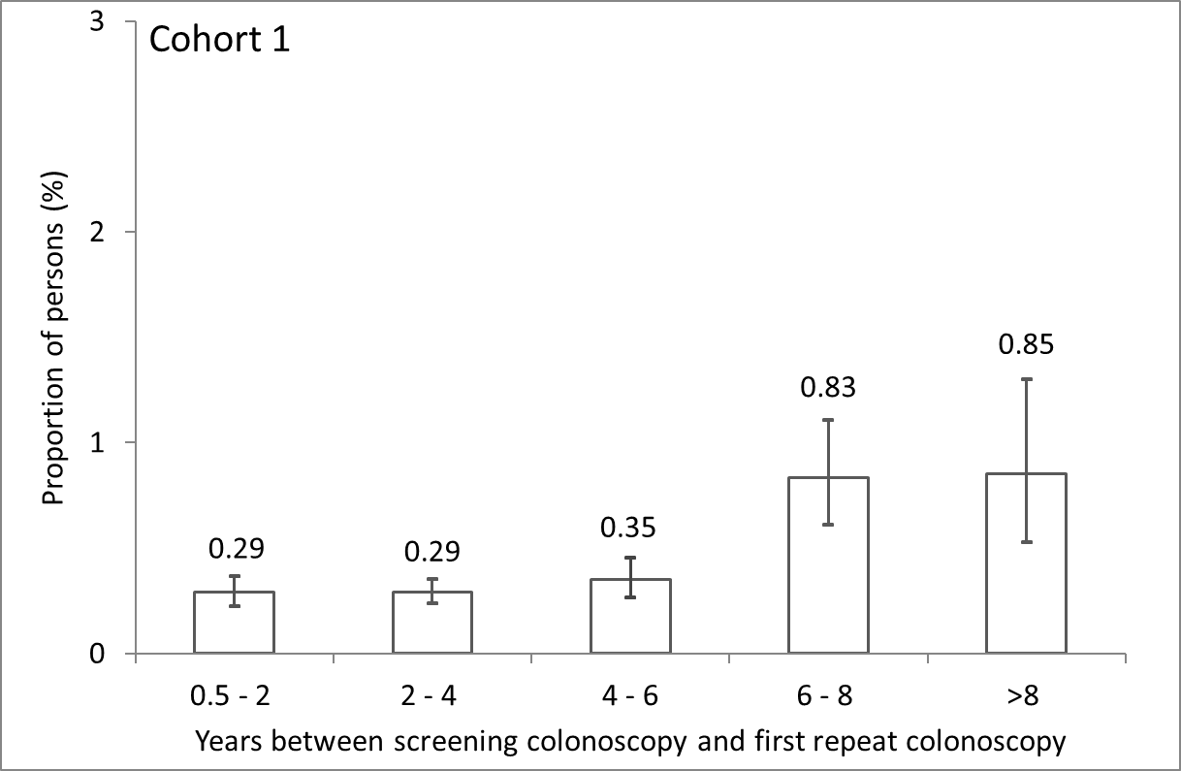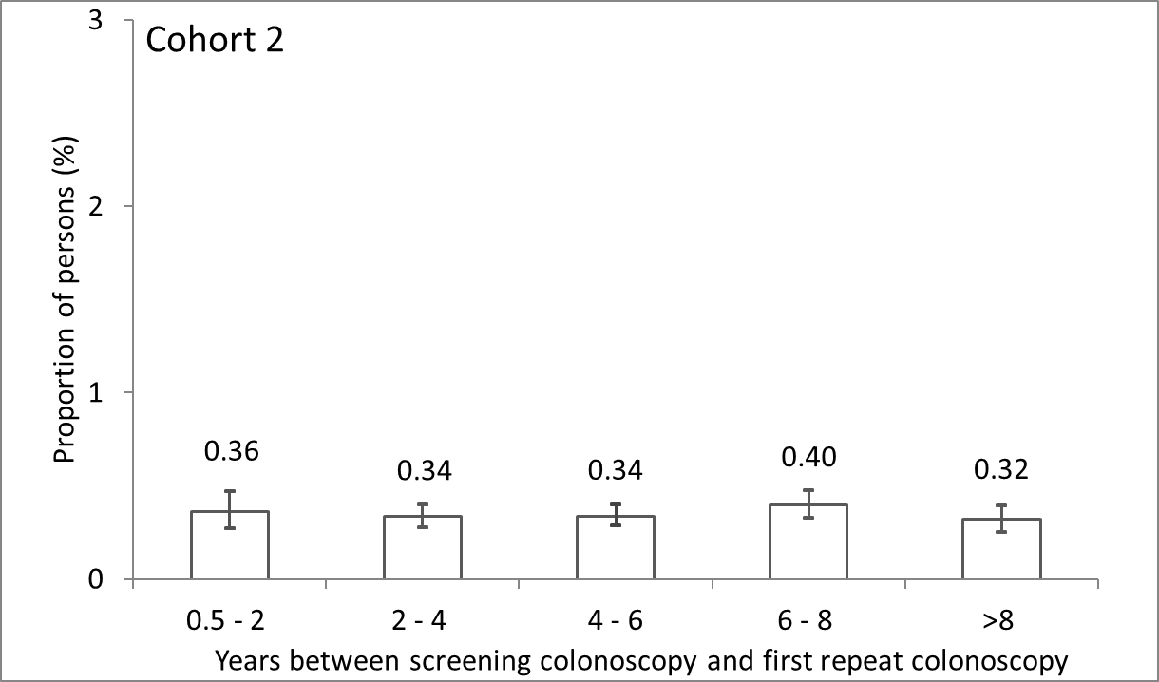
B. Distal
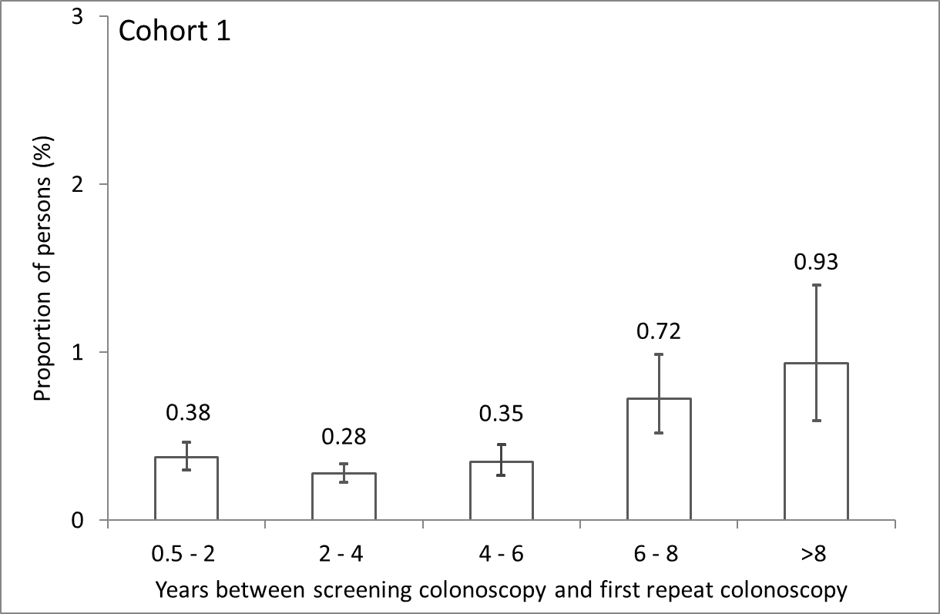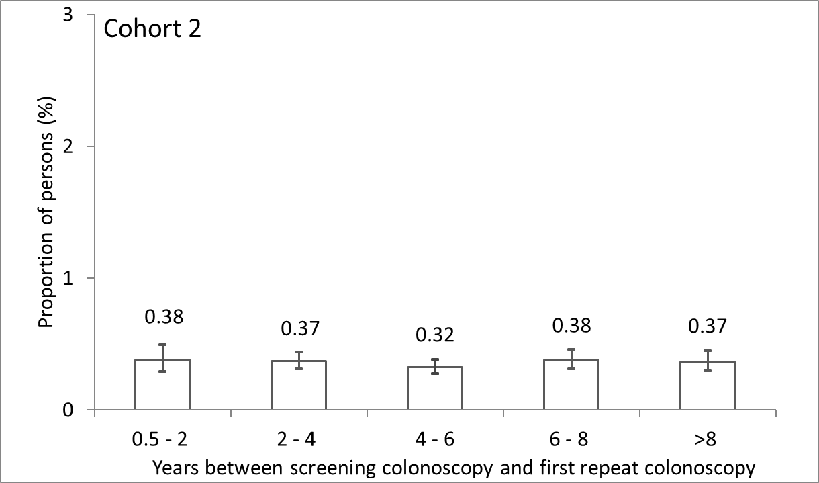
C. Men

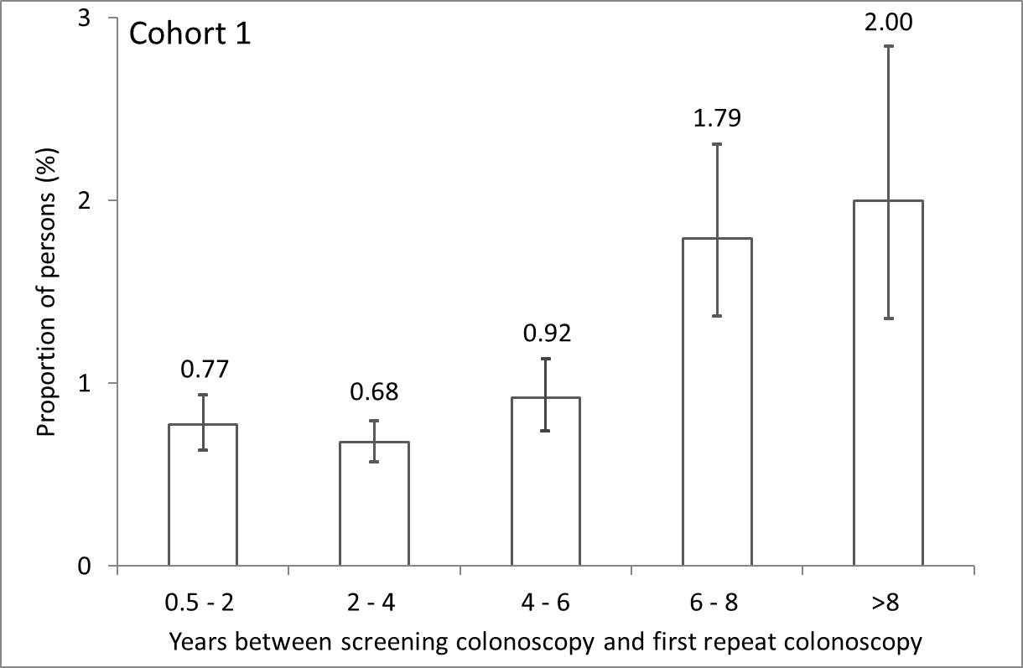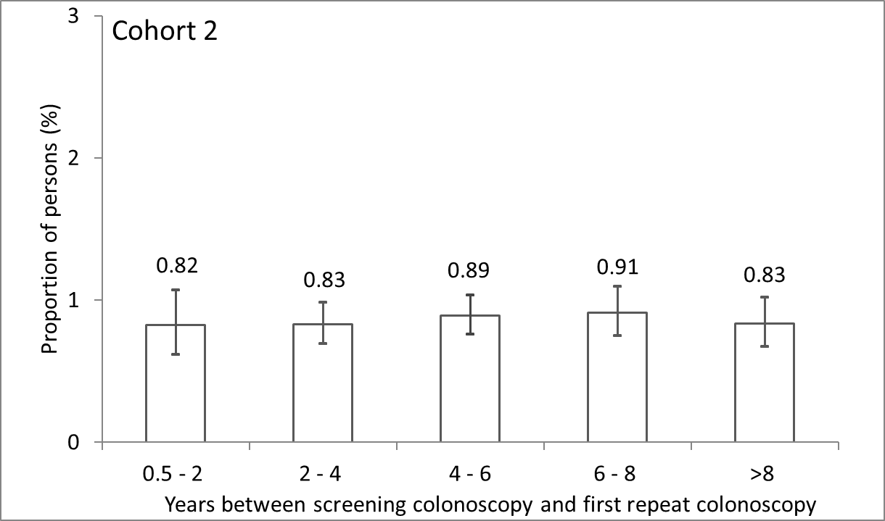
D. Women
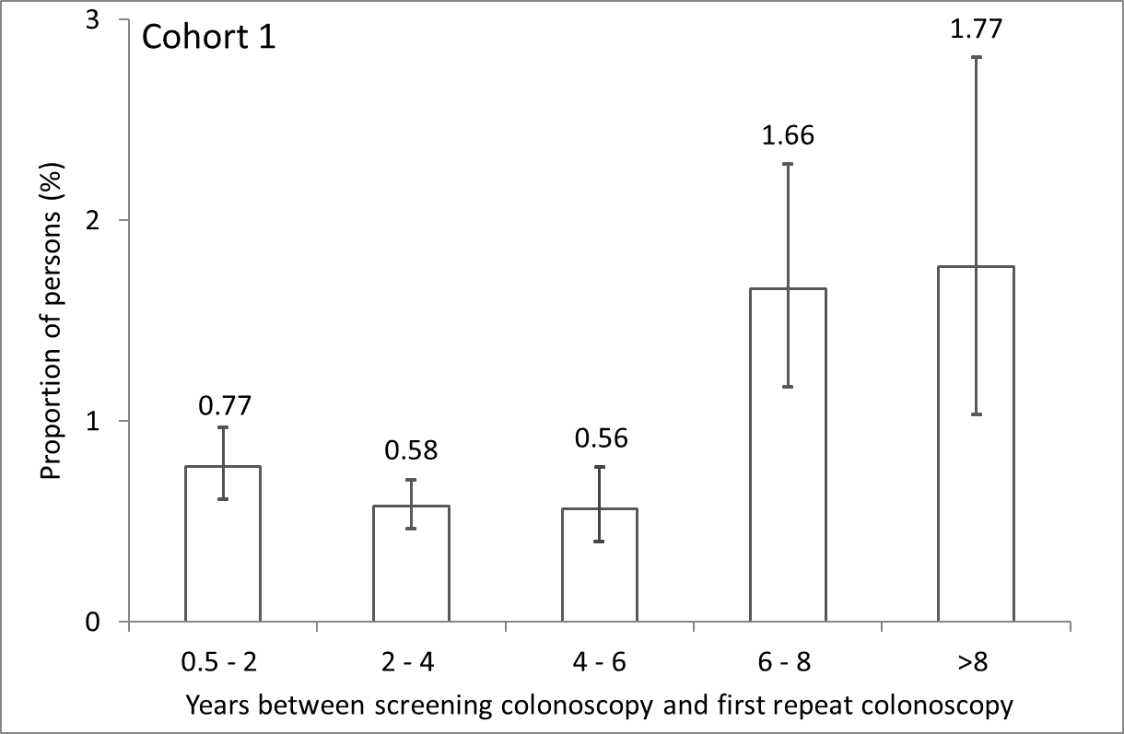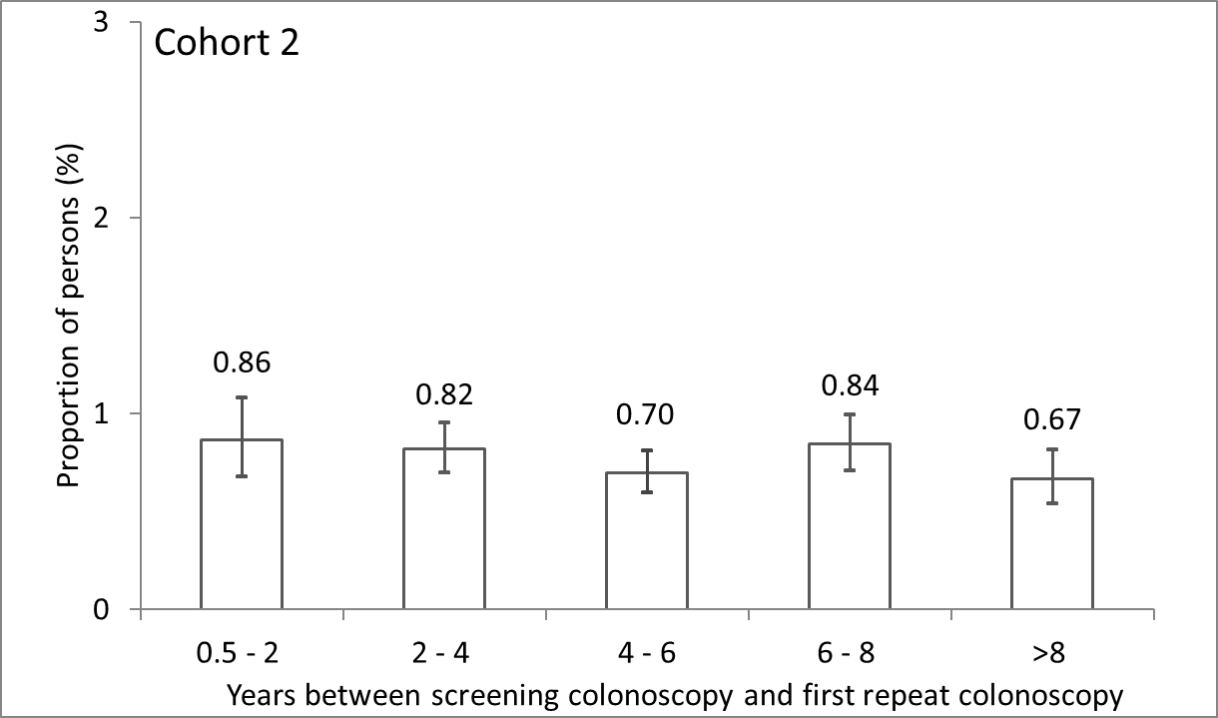
¹ Cohort 1: persons with a snare polypectomy at baseline screening colonoscopy, cohort 2: persons without codes indicating polyps/polypectomy at baseline screening colonoscopy.
Supplemental Digital Content 7. Number of persons (A), distribution of sex (B) and age (C) in the study populations underlying the proportions shown in Figure 2 (denominators).

A. N persons

Years between screening and repeat colonoscopy | Cohort 1 | Cohort 2
0.5-2 years | 23,138 | 15,124
2-4 years | 37,336 | 36,021
4-6 years | 16,313 | 41,847
6-8 years | 5,521 | 28,198
>8 years | 2,462 | 25,351

B. Proportion of males [%].
Years between screening and repeat colonoscopy | Cohort 1 | Cohort 2
0.5-2 years | 58.1 | 43.3
2-4 years | 57.4 | 44.1
4-6 years | 58.6 | 42.7
6-8 years | 59.6 | 42.8
>8 years | 60.9 | 44.5

C. Age [mean (SD)] at first repeat colonoscopy, stratified by sex
Years between screening and repeat colonoscopy | Cohort 1 |  | Cohort 2
 | Male | Female | Male | Female
0.5-2 years | 66.9 (6.9) | 66.4 (7.1) | 67.7 (7.6) | 67.1 (7.6)
2-4 years | 67.9 (6.6) | 67.4 (6.7) | 68.6 (7.1) | 68.0 (7.1)
4-6 years | 69.4 (6.4) | 69.1 (6.6) | 69.5 (6.7) | 69.0 (6.6)
6-8 years | 71.6 (6.3) | 71.4 (6.5) | 70.9 (6.3) | 70.6 (6.3)
>8 years | 73.4 (5.8) | 73.0 (5.9) | 72.4 (5.7) | 71.9 (5.6)

Supplemental Digital Content 8. Proportion of persons with a colorectal cancer (CRC) detected at first repeat colonoscopy according to years since baseline screening colonoscopy in cohort 1 and cohort 2¹: Restriction of the analyses underlying Figure 2 to persons aged 70 years or younger.

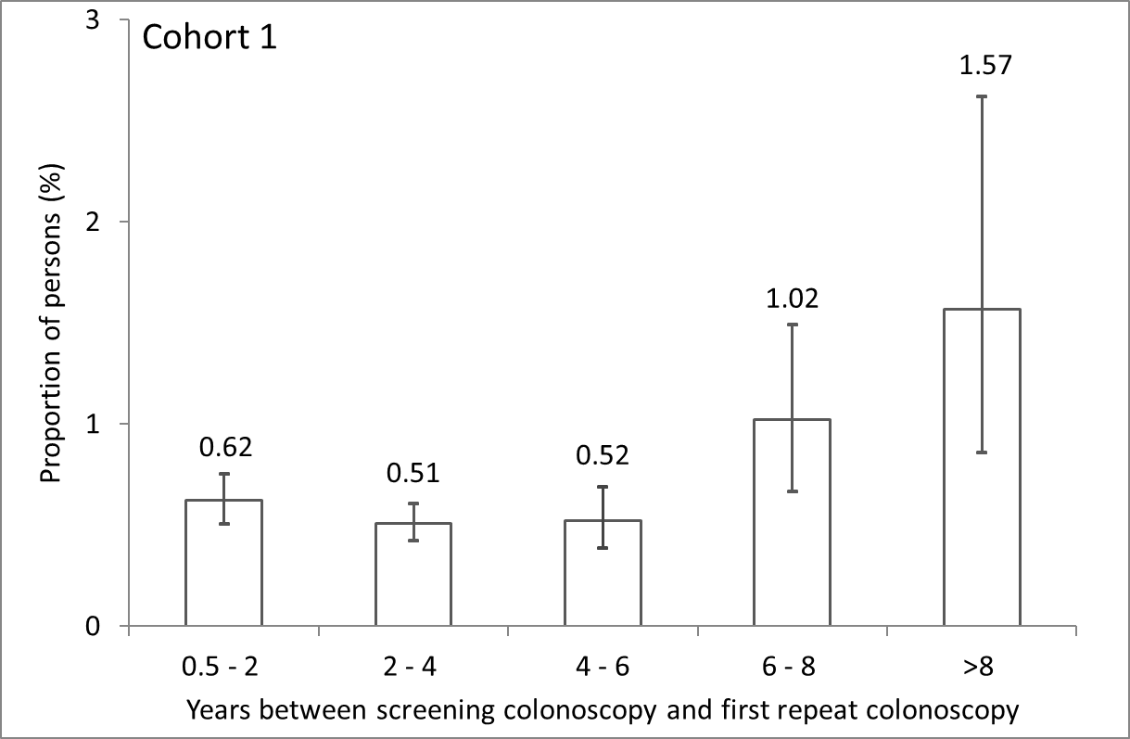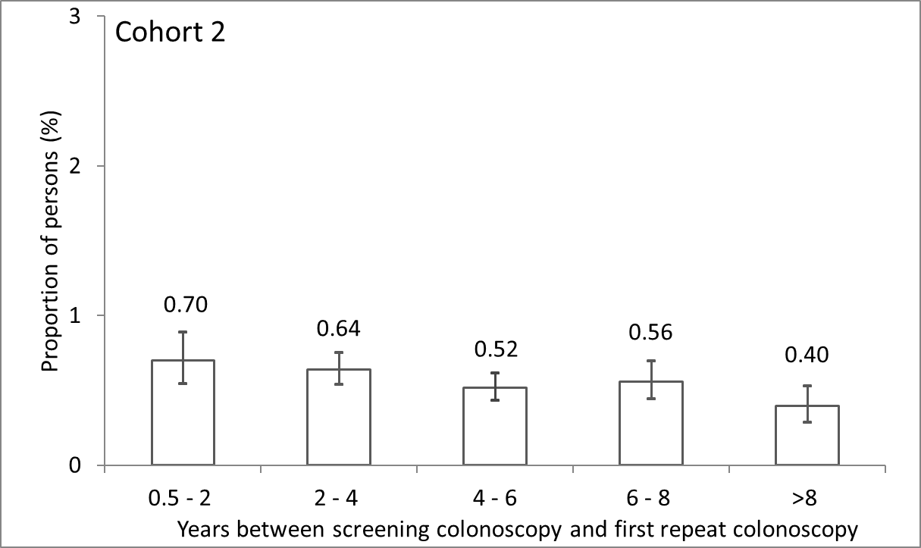
¹ Cohort 1: persons with a snare polypectomy at baseline screening colonoscopy, cohort 2: persons without codes indicating polyps/polypectomy at baseline screening colonoscopy.

