Real world practice of gastric cancer prevention and screening calls for practical prediction models
Siyi He, ^{1#} Dianqin Sun, ^{1#} He Li, ¹ Maomao Cao, ¹ Xinyang Yu, ¹ Lin Lei, ² Ji Peng, ² Jiang Li, ¹ Ni Li, ¹ Wanqing Chen,¹
# The authors contributed equally to this work.

¹ Office of Cancer Screening, National Cancer Center/National Clinical Research Center for Cancer/Cancer Hospital, Chinese Academy of Medical Sciences and Peking Union Medical College/Chinese Academy of Medical Sciences Key Laboratory for National Cancer Big Data Analysis and Implement, Beijing, P. R. China; ²Department of Cancer Prevention and Control, Shenzhen Center for Chronic Disease Control, Shenzhen, Guangdong Province, P. R. China

Correspondence: Wanqing Chen
National Cancer Center/National Clinical Research Center for Cancer/Cancer Hospital, Chinese Academy of Medical Sciences and Peking Union Medical College/Chinese Academy of Medical Sciences Key Laboratory for National Cancer Big Data Analysis and Implement, Beijing 100021, P. R. China
Tel +86 13241914190 ; Fax +86 10 67718227. ; Email chenwq@cicams.ac.cn

Supplemental Materials
Supplementary Appendix 1: Search terms for PubMed and EMBASE 2
Table S1: key items to guide the framing of the review based on CHARMS 3
Table S2: Assessments on risk of bias and applicability of each study, by domains, based on the PROBAST tool 4
Supplementary Figure 1. The quality assessment of the included models. 6

Supplementary Appendix 1: Search terms for PubMed and EMBASE
Pubmed：
#1 "Stomach Neoplasms"[MeSH Terms] OR (("stomach"[Title/Abstract] OR "gastric"[Title/Abstract]) AND ("carcinoma*"[Title/Abstract] OR "cancer*"[Title/Abstract] OR "neoplas*"[Title/Abstract] OR "adenoma*"[Title/Abstract] OR "malignan*"[Title/Abstract] OR "tumor*"[Title/Abstract] OR "tumour*"[Title/Abstract] OR "adenocarcinoma*"[Title/Abstract]))
#2 "risk*"[Title/Abstract] AND ("factor*"[Title/Abstract] OR "variable*"[Title/Abstract] OR "biomarker*"[Title/Abstract] OR "c statistic*"[Title/Abstract] OR "area under the curve"[Title/Abstract] OR "area under the receiver operator characteristic curve"[Title/Abstract])
#3 ("assess*"[Title/Abstract] OR "predict*"[Title/Abstract] OR "calculate*"[Title/Abstract] OR "scor*"[Title/Abstract] OR "stratif*"[Title/Abstract]) AND ("model*"[Title/Abstract] OR "rule"[Title/Abstract] OR "tool"[Title/Abstract] OR "strateg*"[Title/Abstract] OR "algorithm*"[Title/Abstract])
#4 ("Machine Learning"[MeSH Terms] OR "Regression Analysis"[MeSH Terms] OR "Multivariate Analysis"[MeSH Terms] OR "models, statistical"[MeSH Terms] OR "neural networks, computer"[MeSH Terms]) AND "Risk Assessment"[MeSH Terms]
#5 #2 AND #3
#6 #1 AND (#5 OR #4)
EMBASE：
('stomach tumor'/mj OR ((stomach:ab,kw,ti OR gastric:ab,kw,ti OR cardia:ab,kw,ti OR pylorus:ab,kw,ti) AND (carcinoma*:ab,kw,ti OR cancer*:ab,kw,ti OR neoplas*:ab,kw,ti OR adenoma*:ab,kw,ti OR malignan*:ab,kw,ti OR tumor*:ab,kw,ti OR tumour*:ab,kw,ti OR adenocarcinoma*:ab,kw,ti))) AND (('risk algorithm'/mj OR 'risk assessment'/mj OR 'risk scoring system'/mj OR 'risk stratification'/mj OR 'risk calculator'/mj) AND ('machine learning'/mj OR 'regression analysis'/mj OR 'multivariate analysis'/mj OR 'statistical model'/mj OR 'artificial neural network'/mj) OR ('risk':ab,kw,ti AND (factor*:ab,kw,ti OR variable*:ab,kw,ti OR biomarker*:ab,kw,ti OR 'c statistic*':ab,kw,ti OR 'area under the curve':ab,kw,ti OR 'area under the receiver operator characteristic curve':ab,kw,ti) AND (assess*:ab,kw,ti OR predict*:ab,kw,ti OR calculate*:ab,kw,ti OR scor*:ab,kw,ti OR stratif*:ab,kw,ti) AND (model*:ab,kw,ti OR tool:ab,kw,ti OR algorithm*:ab,kw,ti OR rule:ab,kw,ti OR strateg*:ab,kw,ti))) AND [embase]/lim

Supplementary Table S1:
Table S1: key items to guide the framing of the review based on CHARMS
Concept | Criteria
1. Prognostic or diagnostic prediction model? | - Both prognostic or diagnostic prediction models.
2. Intended scope of the review | - Diagnostic models to inform physicians, researchers and general population about their current risk of having gastric cancer.  - Prognostic models to predict the risk of developing gastric cancer in the future for general population.
3. Type of prediction modeling studies | - Any type of prediction models, including model development with/without external validation in independent data, and validation only.
4. Target population to whom the prediction model applies | - Adults at general risk of gastric cancer (both sexes).
5. Outcome to be predicted | - Gastric cancer
6. Time span of prediction | - Any.
7. Intended moment of using the model | - Models to be used in asymptomatic adults to 1) ascertain current status of gastric cancer (i.e., diagnostic) or 2) future risk of gastric cancer (i.e., prognostic).

Supplementary Table S2:
Table S2: Assessments on risk of bias and applicability of each study, by domains, based on the PROBAST tool
Study | Risk of Bias |  |  |  |  | Applicability
 | 1 Participants | 2 Predictors | 3 Outcome | 4 Analysis | Overall | 1 Participants | 2 Predictors | 3 Outcome | Overall
Diagnostic model
Lee DS, et al（2009） | + | - | - | + | + | + | + | + | +
Kaise M, et al (2011) | + | - | + | + | + | - | + | - | +
Ahn HS, et al (2012) | + | + | - | + | + | + | - | - | -
Cho SJ, et al (2013) | + | + | - | + | + | + | + | - | -
Yang AP, et al (2014) | + | - | - | + | + | - | + | + | +
Zhu C, et al (2014) | - | + | - | + | + | - | - | - | -
Kucera R, et al (2016) | + | + | + | + | + | - | + | + | +
Tong W, et al (2016) | + | + | - | + | + | + | + | - | -
In H, et al (2018) | + | + | + | + | + | + | + | ？ | +
Wang S, et al (2018) | + | - | + | + | + | - | - | + | +
Cai Q, et al (2019) | - | - | - | + | + | - | + | + | +
Dong Z, et al (2019) | - | - | - | + | + | + | + | + | +
In H, et al (2020) | + | - | + | + | + | + | + | + | +
Kong X, et al (2020) | - | - | - | + | + | + | + | + | +
Liu T, et al (2020) | - | + | + | + | + | + | - | + | -
Kim YS, et al (2021) | - | + | - | + | + | + | - | + | +
Lee IS, et al (2021) | + | - | - | + | + | - | - | + | -
Song L, et al (2021) | - | - | - | + | + | + | - | + | -
Prognostic model
Shikata K, et al (2012) | - | - | - | + | + | - | + | + | +
Eom BW, et al (2015) | - | - | ？ | + | + | + | + | ？ | +
Charvat H, et al (2016) | ？ | - | ？ | + | + | + | + | ？ | +
Ikeda F, et al (2016) | - | - | + | + | + | + | + | + | +
Iida M, et al (2018) | - | - | - | + | + | - | + | + | +
Ta？naga J, et al (2019) | + | - | + | + | + | + | + | + | +
Charvat H, et al (2020) | ？ | - | + | + | + | - | + | + | +
Jang J, et al (2020) | ？ | - | + | + | + | + | - | + | +
Sarkar S, et al (2021) | + | - | + | + | + | + | + | ？ | +
Trivanovic D, et al (2021) | - | - | + | + | + | - | + | + | -
Note: +: high risk of bias/ applicability; -: low risk of bias/ applicability; ?: No information

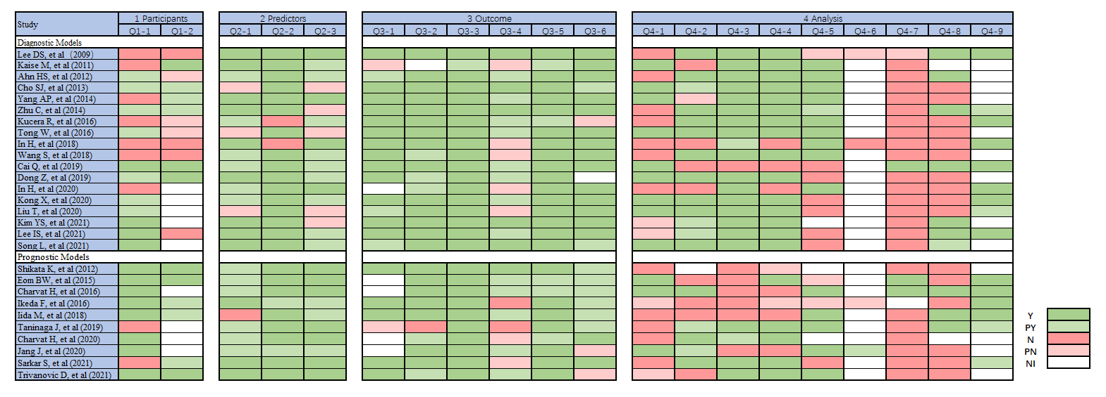
Supplementary Figure S1:
Supplementary Figure 1. The quality assessment of the included models. Each signal question was answered as yes (Y, denoted by dark green), probably yes (PY, denoted by light green), no (N, indicated by dark red), probably no (PN, indicated by light red), or no information (NI, denoted by white). Q = question.
Q1.1: Were appropriate data sources used, e.g., cohort, RCT, or nested case–control study data?
Q1.2: Were all inclusions and exclusions of participants appropriate?
Q2.1: Were predictors defined and assessed in a similar way for all participants?
Q2.2: Were predictor assessments made without knowledge of outcome data?
Q2.3: Are all predictors available at the time the model is intended to be used?
Q3.1: Was the outcome determined appropriately?
Q3.2: Was a prespecified or standard outcome definition used?
Q3.3: Were predictors excluded from the outcome definition?
Q3.4: Was the outcome defined and determined in a similar way for all participants?
Q3.5: Was the outcome determined without knowledge of predictor information?
Q3.6: Was the time interval between predictor assessment and outcome determination appropriate?
Q4.1: Were there a reasonable number of participants with the outcome?
Q4.2: Were continuous and categorical predictors handled appropriately?
Q4.3: Were all enrolled participants included in the analysis?
Q4.4: Were participants with missing data handled appropriately?
Q4.5: Was selection of predictors based on univariable analysis avoided? [development studies only]
Q4.6: Were complexities in the data (e.g., censoring, competing risks, sampling of control participants) accounted for appropriately?
Q4.7: Were relevant model performance measures evaluated appropriately?
Q4.8: Were model overfitting and optimism in model performance accounted for? [development studies only]
Q4.9: Do predictors and their assigned weights in the final model correspond to the results from the reported multivariable analysis? [development studies only]

