Supplemental fig 1. Calibration plots for CBST score on the derivation cohort (A) and the internal validation cohort (B)
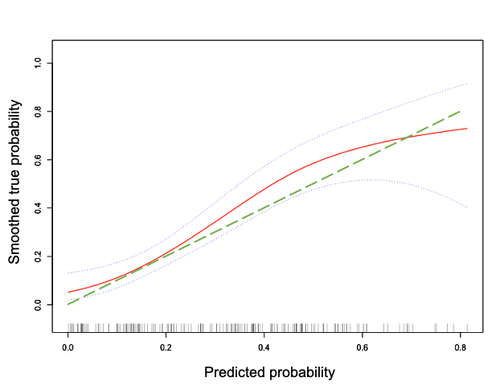

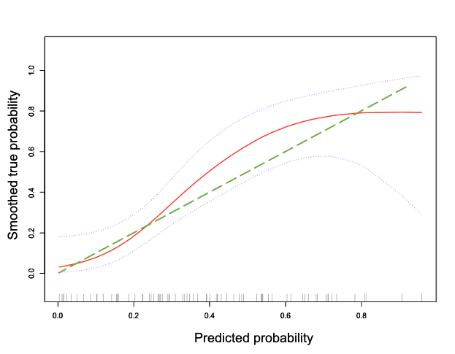

Supplemental table 1: List of parameters selected during the backward stepwise selection on a multivariable logistic regression for the CBST score

Stepwise | Parameters | Estimate | Wald | OR (95% CI) | P
Step 1 | BMI | -0.223 | 4.669 | 0.8(0.653-0.979) | 0.031
 | Waist circumference | 0.043 | 1.304 | 1.044(0.97-1.124) | 0.253
 | AST | 0.011 | 1.285 | 1.012(0.992-1.032) | 0.257
 | Glucose | 0.555 | 2.241 | 1.741(0.842-3.599) | 0.134
 | Insulin | 0.005 | 0.84 | 1.005(0.994-1.017) | 0.36
 | HOMA-IR | -0.025 | 1.579 | 0.975(0.938-1.014) | 0.209
 | HbA1C | -0.028 | 0.004 | 0.973(0.419-2.259) | 0.949
 | CAP | 0.052 | 14.702 | 1.053(1.026-1.082) | <0.001
 | LSM | 0.071 | 0.665 | 1.074(0.905-1.274) | 0.415
 | Intercept | -18.465 | 24.522 |  | <0.001
Step 2 | BMI | -0.223 | 4.67 | 0.8(0.654-0.979) | 0.031
 | Waist circumference | 0.043 | 1.302 | 1.044(0.97-1.123) | 0.254
 | AST | 0.011 | 1.286 | 1.012(0.992-1.032) | 0.257
 | Glucose | 0.541 | 3.198 | 1.717(0.949-3.106) | 0.074
 | Insulin | 0.005 | 0.849 | 1.005(0.994-1.016) | 0.357
 | HOMA-IR | -0.024 | 1.639 | 0.976(0.94-1.013) | 0.2
 | CAP | 0.052 | 14.804 | 1.053(1.026-1.081) | <0.001
 | LSM | 0.07 | 0.673 | 1.072(0.907-1.267) | 0.412
 | intercept | -18.502 | 25.199 |  | <0.001
Step 3 | BMI | -0.216 | 4.455 | 0.806(0.66-0.985) | 0.035
 | Waist circumference | 0.042 | 1.245 | 1.043(0.969-1.122) | 0.265
 | AST | 0.015 | 2.556 | 1.015(0.997-1.034) | 0.11
 | Glucose | 0.579 | 3.807 | 1.784(0.997-3.192) | 0.051
 | Insulin | 0.005 | 0.94 | 1.005(0.995-1.016) | 0.332
 | HOMA-IR | -0.025 | 1.772 | 0.975(0.94-1.012) | 0.183
 | CAP | 0.052 | 15.113 | 1.054(1.026-1.082) | <0.001
 | intercept | -18.545 | 25.502 |  | <0.001
Step 4 | BMI | -0.194 | 3.903 | 0.824(0.68-0.998) | 0.048
 | Waist circumference | 0.042 | 1.316 | 1.043(0.97-1.122) | 0.251
 | AST | 0.016 | 2.916 | 1.016(0.998-1.034) | 0.088
 | Glucose | 0.436 | 2.959 | 1.547(0.941-2.543) | 0.085
 | HOMA-IR | -0.008 | 1.168 | 0.992(0.977-1.007) | 0.28
 | CAP | 0.051 | 14.812 | 1.052(1.025-1.08) | <0.001
 | intercept | -17.89 | 25.238 |  | <0.001
Step 5 | BMI | -0.202 | 4.312 | 0.817(0.675-0.989) | 0.038
 | Waist circumference | 0.04 | 1.194 | 1.041(0.969-1.119) | 0.275
 | AST | 0.014 | 2.476 | 1.014(0.997-1.032) | 0.116
 | Glucose | 0.262 | 1.864 | 1.299(0.892-1.891) | 0.172
 | CAP | 0.05 | 14.641 | 1.051(1.025-1.078) | <0.001
 | intercept | -16.419 | 25.552 |  | <0.001
Step 6 | BMI | -0.126 | 3.649 | 0.882(0.775-1.003) | 0.056
 | AST | 0.015 | 2.664 | 1.015(0.997-1.033) | 0.103
 | Glucose | 0.267 | 1.91 | 1.307(0.894-1.909) | 0.167
 | CAP | 0.052 | 16.749 | 1.054(1.028-1.081) | <0.001
 | intercept | -15.471 | 24.947 |  | <0.001
Step 7 | BMI | -0.143 | 4.856 | 0.867(0.764-0.984) | 0.028
 | AST | 0.017 | 3.871 | 1.017(1-1.035) | 0.049
 | CAP | 0.054 | 18.064 | 1.056(1.03-1.083) | <0.001
 | intercept | -14.28 | 23.769 |  | <0.001
Abbreviations: BMI, body mass index; AST, aspartate aminotransferase; HOMA-IR, homeostasis model assessment of insulin resistance; HbA1c, glycated hemoglobin; CAP, controlled attenuation parameter; LSM, liver stiffness measurement.

Supplemental table 2. Validation of the best cut-off values of CBST in internal validation cohort and external validation cohort
 | Internal validation cohort |  |  | External validation cohort
 | MRI-PDFF  ≥ 20% | MRI-PDFF  ≥ 10% | MRI-PDFF  ≥ 5% | MRI-PDFF  ≥ 20% | MRI-PDFF  ≥ 10% | MRI-PDFF  ≥ 5%
CBST
Cut-off value | -0.5345 | -1.7404 | -1.9959 | -0.5345 | -1.7404 | -1.9959
Sensitivity (%) | 69.0 | 93.5 | 86.3 | 76.5 | 94.2 | 98.8
Specificity (%) | 73.9 | 69.2 | 100 | 46.7 | 5.5 | 9.1
PPV (%) | 62.5 | 96.7 | 100 | 21.3 | 48.5 | 80.8
NPV (%) | 79.1 | 60.0 | 16.7 | 91.3 | 50.0 | 66.7

Abbreviations: MRI-PDFF, magnetic resonance imaging–proton density fat fraction; NPV, negative predictive value; PPV, positive predictive value.

Supplemental table 3: Number of patients correctly or incorrectly classified by the CAP and CBST in the internal validation cohort

 | Internal validation cohort
 | MRI-PDFF ≥ 20% |  | MRI-PDFF ≥ 10% |  | MRI-PDFF ≥ 5%
 | Correctly identified | Incorrectly identified | Correctly identified | Incorrectly identified | Correctly identified | Incorrectly identified
∑ (n) | 29 |  | 62 |  | 73
CBST (n) | 20 | 9 | 58 | 4 | 63 | 10

Supplemental table 4: Number of patients correctly or incorrectly classified by the CAP and CBST in the external validation cohort

 | External validation cohort
 | MRI-PDFF ≥ 20% |  | MRI-PDFF ≥ 10% |  | MRI-PDFF ≥ 5%
 | Correctly identified | Incorrectly identified | Correctly identified | Incorrectly identified | Correctly identified | Incorrectly identified
∑ (n) | 17 |  | 52 |  | 85
CBST (n) | 13 | 4 | 49 | 3 | 84 | 1

