EQ-5D, EQ-5D VAS, SF-36 and SD-6 upper and lower limits for Chronic Conditions, Atopic Dermatitis, and Chronic Hand Eczema
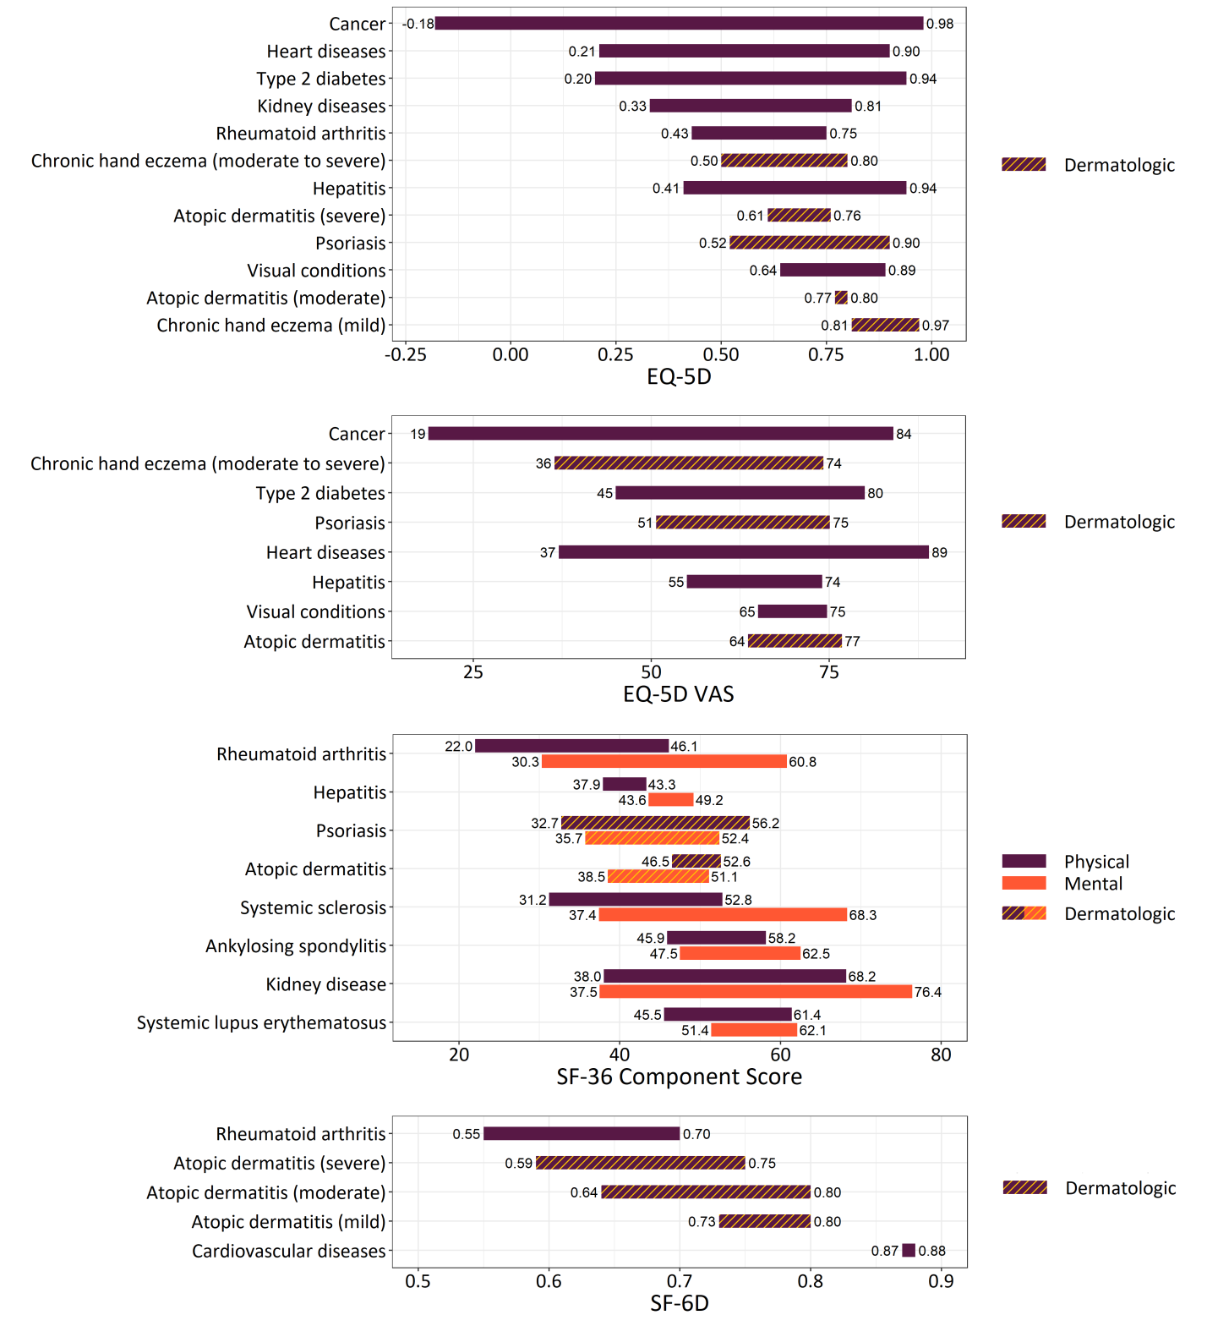

Abbreviations: SF-36 = short form 36 health survey; SF-6D = short form 6 dimensions; VAS = visual analog scale

