Supplemental materials for: Patient-Reported Symptoms and Disease Impacts in Adults With Moderate-to-Severe Atopic Dermatitis: Results From a Phase 2b Study With Oral Janus Kinase 1 Selective Inhibitor Abrocitinib

Supplemental Table 1. Description of PRO Scales Used in Phase 2b Trial
PRO Scales Assessing AD Symptoms and/or Severity
PRO Scale | Description
Pruritus NRS¹⁶ | 11-point scale measuring itching due to AD over the past 24 hours on a horizontal scale from “no itching (0)” to “worst possible itching (10)”
PtGA | A single-item, 5-point Likert scale with “clear (0),” “almost clear (1),” “mild (2),” “moderate (3),” or “severe (4)” as responses to the prompt: “Overall, how would you describe your AD right now?”
POEM¹⁷ | 5-point scale measuring the frequency of each of 7 AD symptoms (dryness, itching, flaking, cracking, sleep loss, bleeding, weeping) over the past week ranging from “no days (0)” to “every day (4)”  Total score ranges from 0–28, with higher score indicating greater symptom impact
PSAAD^{15*} | Diary rating each of 11 AD symptoms (pruritus, pain, dryness, flaking, cracking, bumps, redness, discoloration, bleeding, weeping, swelling) over the past 24 hours on an 11-point NRS ranging from 0 (no symptoms) to 10 (extreme symptoms)  Total score is an average of the 11 responses and ranges from 0–10, with higher score indicating greater symptom severity
PRO Scales Assessing HRQoL and Psychological Impact of AD
PRO Scale | Description
DLQI¹⁸ | 10-item assessment of health-related HRQoL over the past week, focusing on impairment related to symptoms and feelings, daily activities, leisure activities, work or school, personal relationships, and burden of treatment  Total score ranges from 0–30, with higher scores indicating greater HRQoL impairment
HADS¹⁹ | Two 7-item subscales to detect anxiety and depression states over the past week  Scores for each subscale range from 0–21, with scores ≥11 indicating clinical anxiety or depression and scores ≥8 indicating borderline anxiety or depression
*The PSAAD is a symptom-based scale developed by Pfizer following FDA PRO guidance.

Abbreviations: AD, atopic dermatitis; DLQI, Dermatology Life Quality Index; HADS, Hospital Anxiety and Depression Scale; NRS, numeric rating scale; POEM, Patient-Oriented Eczema Measure; PRO, patient-reported outcome; PSAAD, Pruritus and Symptoms Assessment for Atopic Dermatitis; PtGA, patient global assessment; HRQoL, quality of life.

Supplemental Table 2. Demographics and Baseline Disease Characteristics of Patients Included in Analysis of the PSAAD Exploratory End Point
US Patients in Full Analysis Set | Placebo  n = 28 | 10 mg  n = 19 | 30 mg  n = 24 | 100 mg  n = 23 | 200 mg  n = 25
Age, mean (SD), years | 42.4 (15.6) | 50.5 (13.7) | 39.3 (16.9) | 42.0 (19.3) | 43.6 (19.4)
Sex (female), n (%) | 21 (75.0) | 13 (68.4) | 13 (54.2) | 11 (47.8) | 17 (68.0)
Race, n (%)
White | 18 (64.3) | 12 (63.2) | 18 (75.0) | 14 (60.9) | 15 (60.0)
Black | 9 (32.1) | 5 (26.3) | 4 (16.7) | 6 (26.1) | 10 (40.0)
Asian | 1 (3.6) | 2 (10.5) | 2 (8.3) | 2 (8.7) | 0
Other | 0 | 0 | 0 | 1 (4.3) | 0
Disease duration, median (range), years | 22.4 (1.1–67.1) | 30.9 (1.8–54.7) | 17.8 (1.2–52.6) | 17.7 (1.1–66.7) | 16.5 (1.9–68.8)
SCORAD, mean (SD) | 64.6 (9.9) | 67.5 (12.4) | 62.1 (12.9) | 65.4 (13.7) | 64.8 (12.8)
EASI, mean (SD) | 23.9 (10.4) | 24.9 (10.4) | 19.2 (9.8) | 26.2 (11.8) | 23.5 (13.4)
%BSA, mean (SD) | 38.9 (21.5) | 35.4 (18.6) | 26.7 (17.0) | 40.5 (22.0) | 37.4 (24.1)
Pruritus NRS, mean (SD) | 7.9 (1.6) | 8.9 (1.3) | 7.7 (2.1) | 7.5 (2.3) | 8.1 (2.4)
PtGA, n (%)
Almost clear (score of 1) | 0 | 0 | 0 | 1 (4.5) | 0
Mild (score of 2) | 2 (7.4) | 1 (5.3) | 2 (8.7) | 1 (4.5) | 0
Moderate (score of 3) | 12 (44.4) | 0 | 8 (34.8) | 8 (36.4) | 4 (16.7)
Severe (score of 4) | 13 (48.1) | 18 (94.7) | 13 (56.5) | 12 (54.5) | 20 (83.3)
DLQI, mean (SD) | 13.7 (7.3) | 17.4 (7.9) | 14.2 (7.0) | 14.4 (8.5) | 14.5 (6.9)
POEM, mean (SD) | 21.1 (5.0) | 23.5 (4.2) | 20.3 (5.9) | 18.8 (7.3) | 21.0 (6.1)
HADS depression, mean (SD) | 5.4 (4.3) | 5.4 (5.9) | 3.5 (3.2) | 5.9 (4.8) | 5.2 (4.6)
HADS anxiety, mean (SD) | 7.5 (4.0) | 7.6 (5.3) | 5.5 (4.3) | 7.8 (4.6) | 6.6 (4.8)
Abbreviations: %BSA, percentage of treatable body surface area; DLQI, Dermatology Life Quality Index; EASI, Eczema Area and Severity Index; HADS, Hospital Anxiety and Depression Scale; NRS, numeric rating scale; POEM, Patient-Oriented Eczema Measure; PtGA, Patient Global Assessment; SCORAD, SCORing Atopic Dermatitis; SD, standard deviation.

Supplemental Table 3. Pearson Correlation Between Primary Endpoints and PRO Endpoints at Week 12
 |  | IGA Response‡ |  | EASI, % change from baseline
 |  | r | P value | r | P value
Pruritus NRS change from baseline | N=170 | 0.371 | <0.0001 | 0.227 | 0.0029
Pruritus NRS4* | N=170 | 0.305 | <0.0001 | -0.209 | 0.0062
PtGA response† | N=176 | 0.599 | <0.0001 | 0.614 | <0.0001
POEM change from baseline | N=173 | 0.578 | <0.0001 | 0.672 | <0.0001
PSAAD change from baseline | N=73 | 0.509 | <0.0001 | 0.709 | <0.0001
DLQI change from baseline | N=176 | 0.411 | <0.0001 | 0.521 | <0.0001
HADS anxiety | N=176 | 0.223 | 0.0029 | 0.254 | 0.0007
HADS depression | N=176 | 0.168 | 0.0262 | 0.306 | <0.0001
Abbreviations: EASI, Eczema Area and Severity Index; IGA, Investigator’s Global Assessment; POEM, Patient-Oriented Eczema Measure; PtGA, Patient Global Assessment; NRS, numeric rating scale; r, Pearson’s correlation coefficient.
Baseline was defined as the last measurement before first dosing.
*Pruritus-NRS4 response defined as ≥4-point improvement from baseline.
†PtGA response defined as clear (0) or almost clear (1) with ≥2-grade improvement.
‡IGA response defined as clear (0) or almost clear (1) with ≥2-grade improvement.

Supplemental Figure 1. Atopic dermatitis. Percentage improvement in PROs measuring AD symptoms and severity.
(A) Least-squares mean of percentage change from baseline in pruritus NRS. (B) Least-squares mean of percentage change from baseline in POEM. (C) Least-squares mean of percentage change from baseline in PSAAD. Data are shown as mean percentage change ± 90% CI. *P < 0.05 (200 mg vs placebo); #P < 0.05 (100 mg vs placebo).
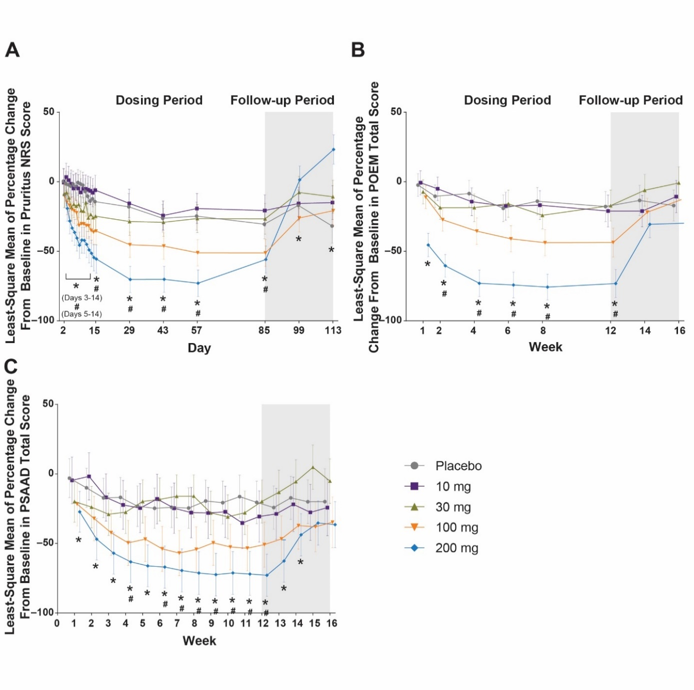
Abbreviations: AD, atopic dermatitis; CI, confidence interval; NRS, numeric rating scale; POEM, Patient-Oriented Eczema Measure; PRO, patient-reported outcome; PSAAD, Pruritus and Symptoms Assessment for Atopic Dermatitis; PtGA, Patient Global Assessment.

Supplemental Figure 2. Atopic dermatitis. Proportion of patients achieving clinically meaningful improvement in PROs measuring AD symptoms and severity at all scheduled timepoints.
(A) Proportions of patients meeting responder criteria for pruritus NRS (baseline pruritus NRS ≥4 achieving ≥4-point improvement). (B) Proportion of patients achieving a minimum clinically important difference in POEM (≥4-point improvement). (C) Proportion of patients achieving a clinically important difference in PSAAD (≥1-point improvement). Data are shown as proportion of patients (observed) ± 90% CI (estimate). *P < 0.05 (200 mg vs placebo); #P < 0.05 (100 mg vs placebo).
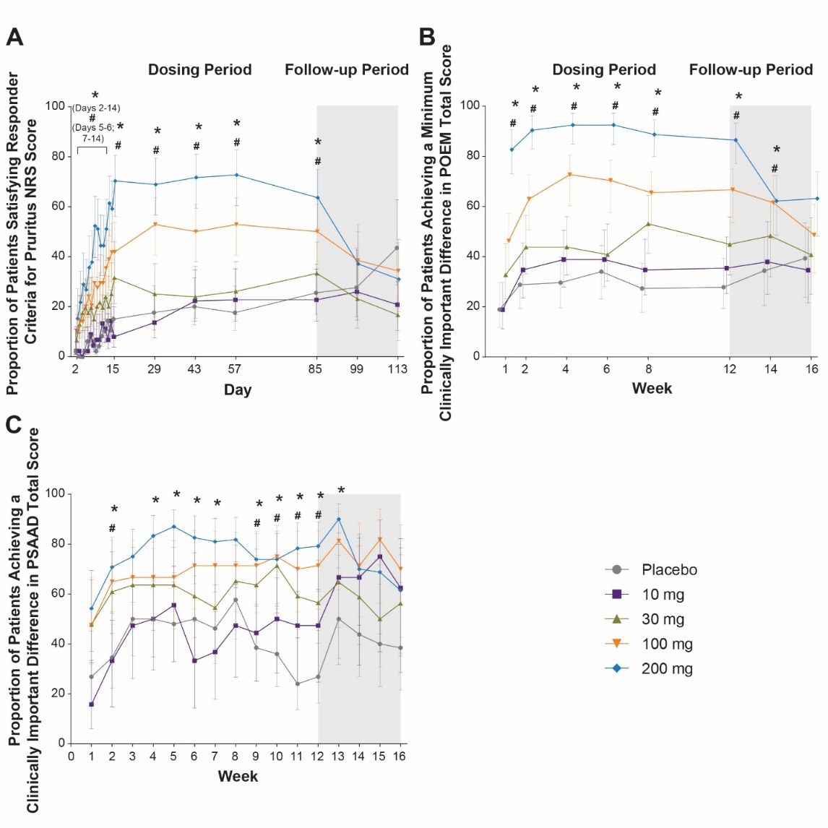
Abbreviations: CI, confidence interval; NRS, numeric rating scale; POEM, Patient-Oriented Eczema Measure; PRO, patient-reported outcome; PSAAD, Pruritus and Symptoms Assessment for Atopic Dermatitis.

Supplemental Figure 3. Atopic dermatitis. Percentage improvement in PROs measuring HRQoL and psychological social impact of AD.
(A) Least squares mean of percentage change from baseline in DLQI. (B) Least squares mean of percentage change from baseline in HADS depression. (C) Least squares mean of percentage change from baseline in HADS anxiety. Data are shown as mean percentage change ± 90% CI. *P < 0.05 (200 mg vs placebo); #P < 0.05 (100 mg vs placebo).
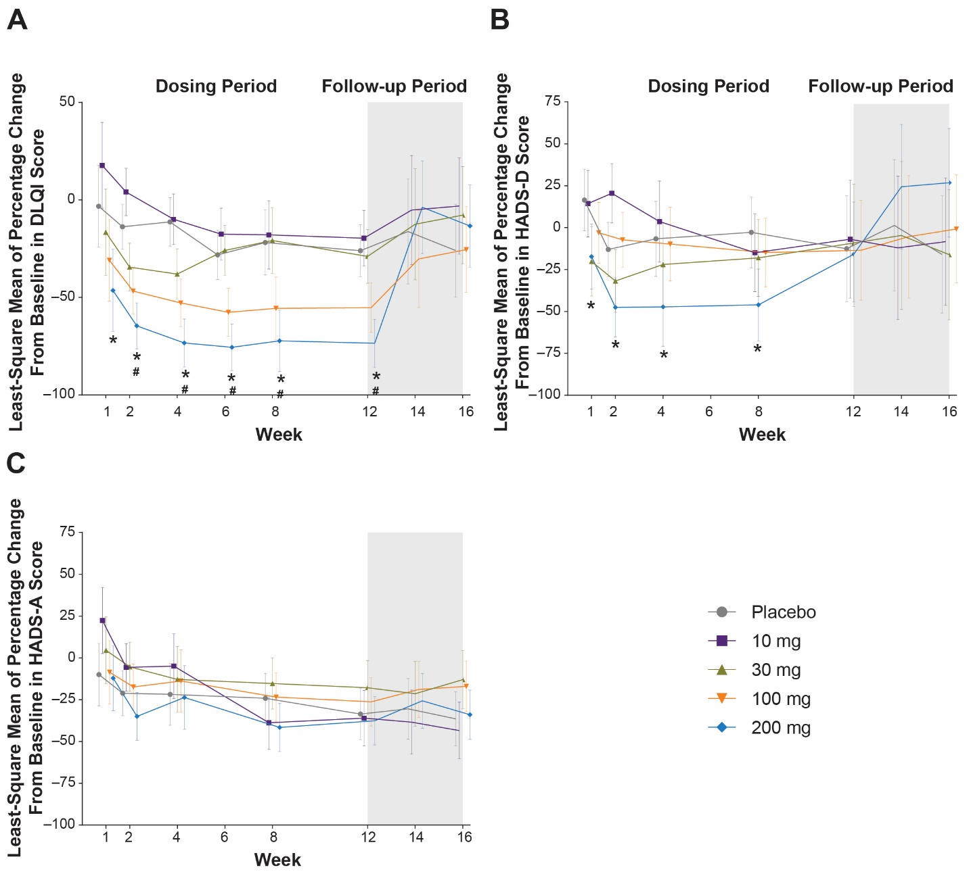
Abbreviations: AD, atopic dermatitis; CI, confidence interval; DLQI, Dermatology Life Quality Index; HADS-A/D, Hospital Anxiety and Depression Scale—Anxiety/Depression; PRO, patient-reported outcome.

Supplemental Figure 4 Atopic dermatitis. Improvement in PROs measuring psychological impact of AD.
(A) Least squares mean of change from baseline in HADS depression. (B) Least squares mean of change from baseline in HADS anxiety. Data are shown as mean change ± 90% CI. *P < 0.05 (200 mg vs placebo); #P < 0.05 (100 mg vs placebo).
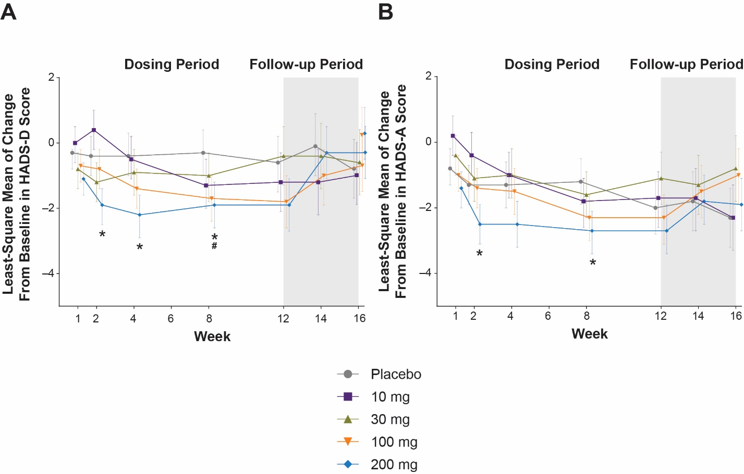Abbreviations: AD, atopic dermatitis; CI, confidence interval; HADS-A/D, Hospital Anxiety and Depression Scale—Anxiety/Depression; PRO, patient-reported outcome.

Supplemental Figure 5. Atopic dermatitis. Proportion of patients with “likely” anxiety or depression at baseline achieving clinically meaningful improvement in HADS.
(A) Proportion of patients with baseline HADS depression (HADS-D) ≥8 achieving HADS-D <8. (B) Proportion of patients with baseline HADS anxiety (HADS-A) ≥8 achieving HADS-D <8. Data are shown as proportion of patients (observed) ± 90% CI (estimate). *P < 0.05 (200 mg vs placebo); #P < 0.05 (100 mg vs placebo).
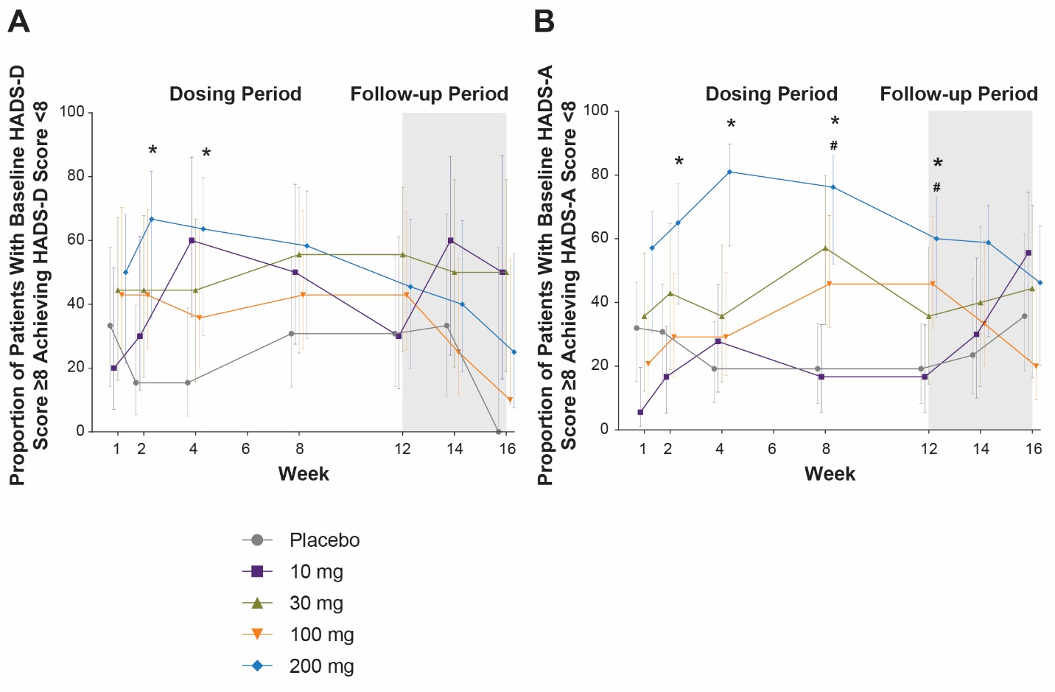
Abbreviations: AD, atopic dermatitis; CI, confidence interval; HADS-A/D, Hospital Anxiety and Depression Scale—Anxiety/Depression; PRO, patient-reported outcome.

