Figure S1: Subject-reported onset of effect
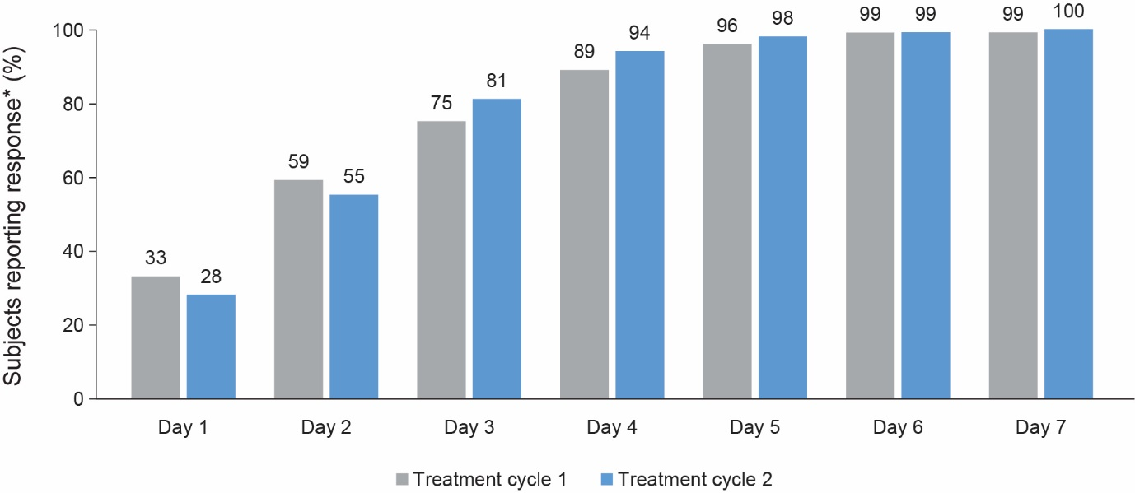
* estimated as derived from Kaplan-Meier analysis

