Figures S1a-g. Photographs of Glabellar Lines at Maximum Frown at Baseline (a) and at Each of Day 2 (b), Day 7 (c), Day 30 (d), Day 90 (e), Day 120 (f) and Day 150 (g) Following Treatment with 20 U PrabotulinumtoxinA in a 29-Year-old Female Patient with Fitzpatrick Skin Type IV
- 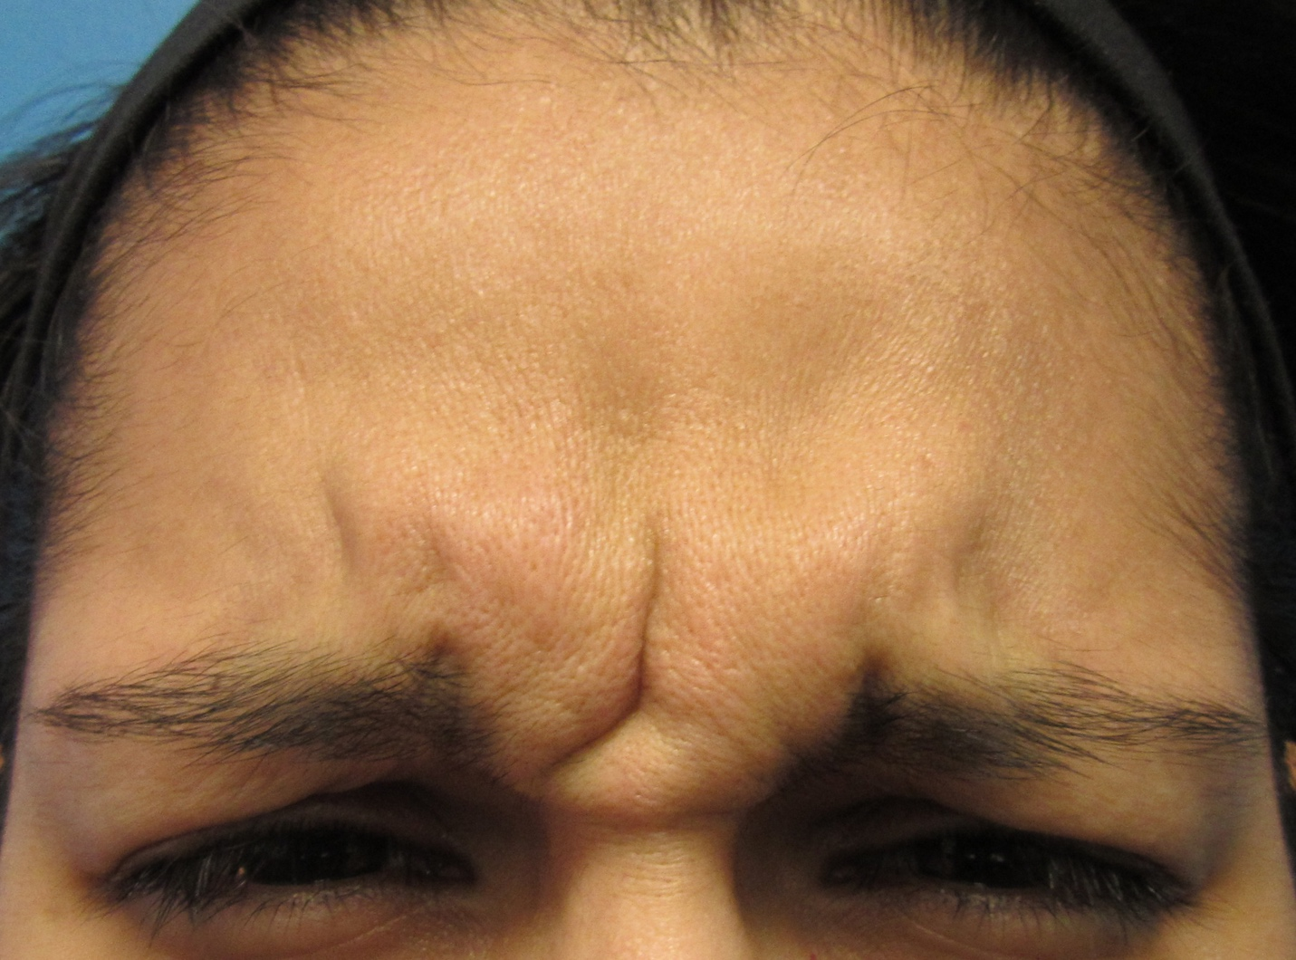
- 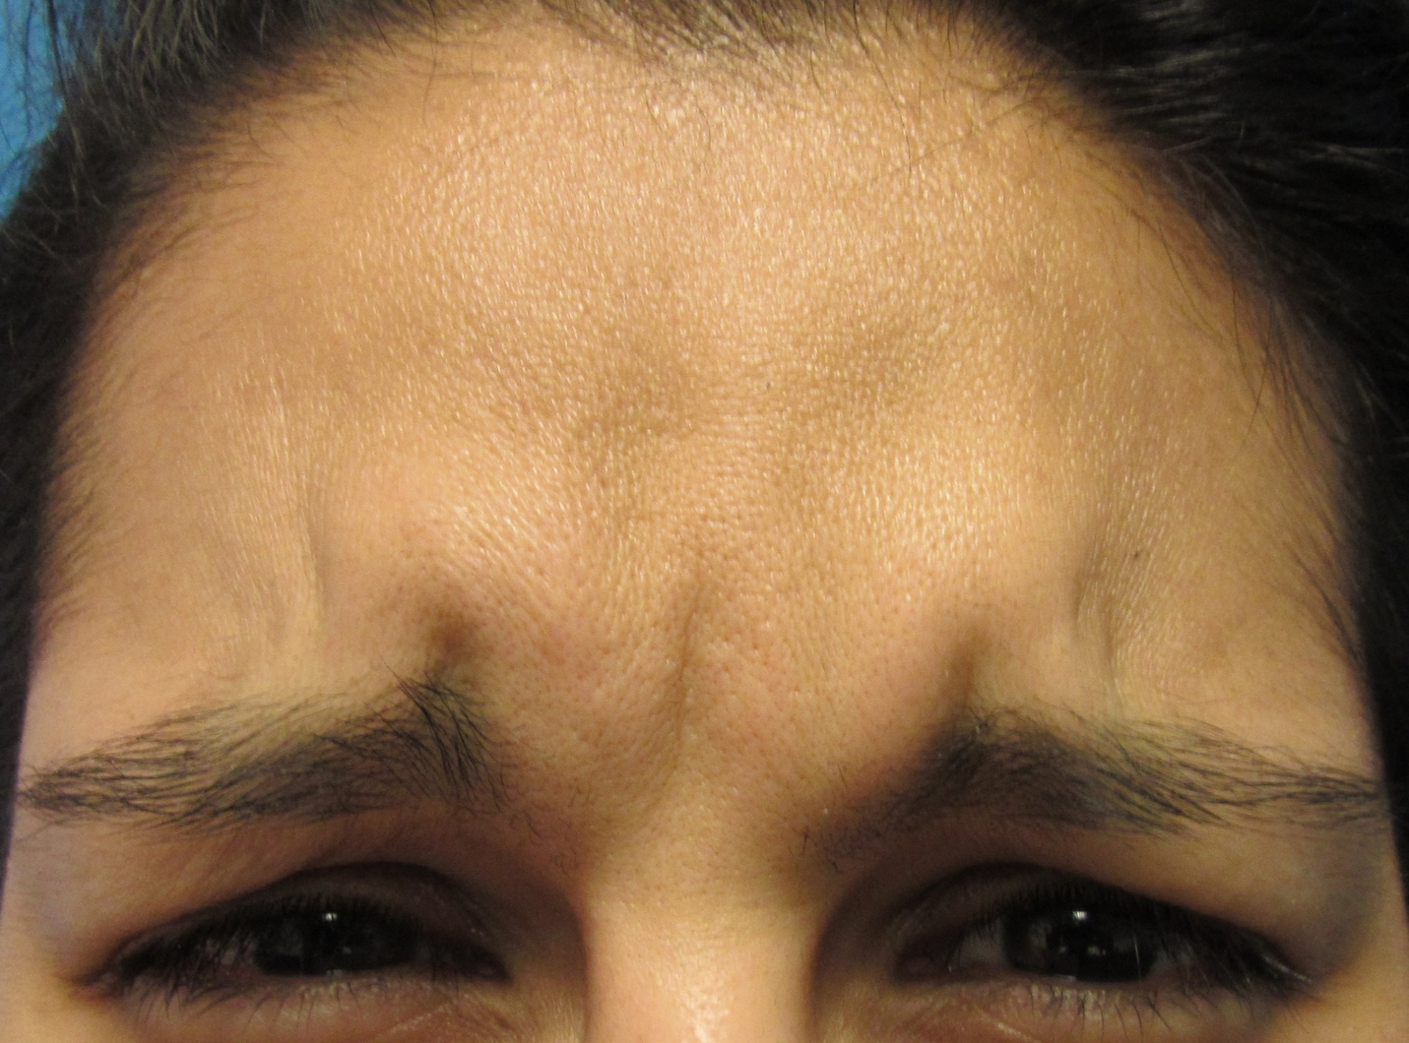
- 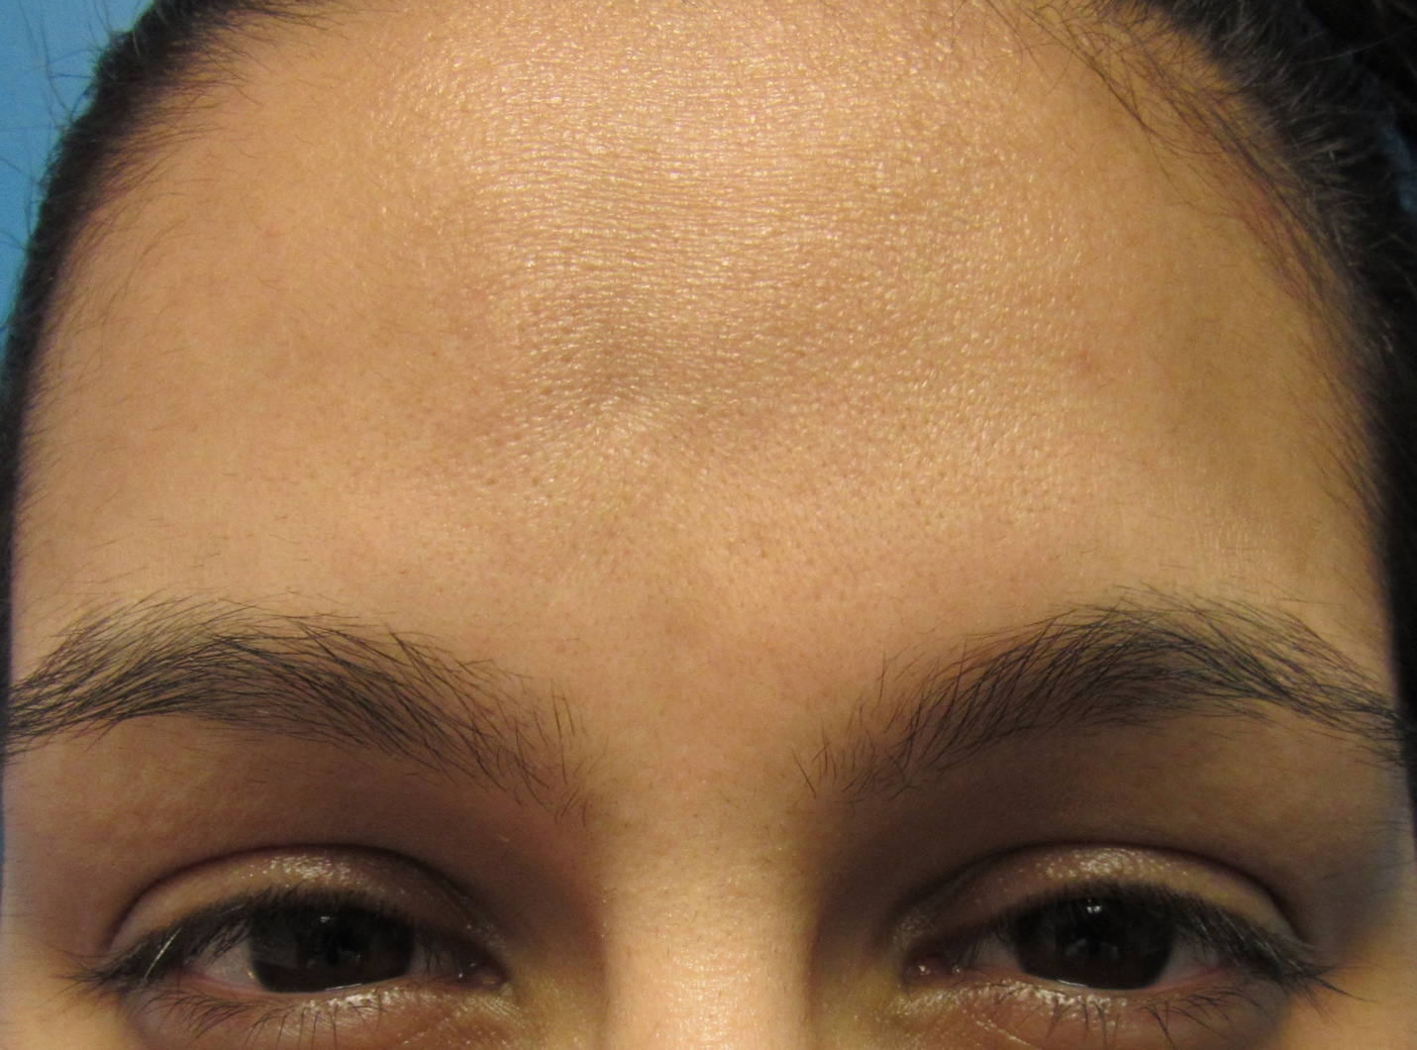
- 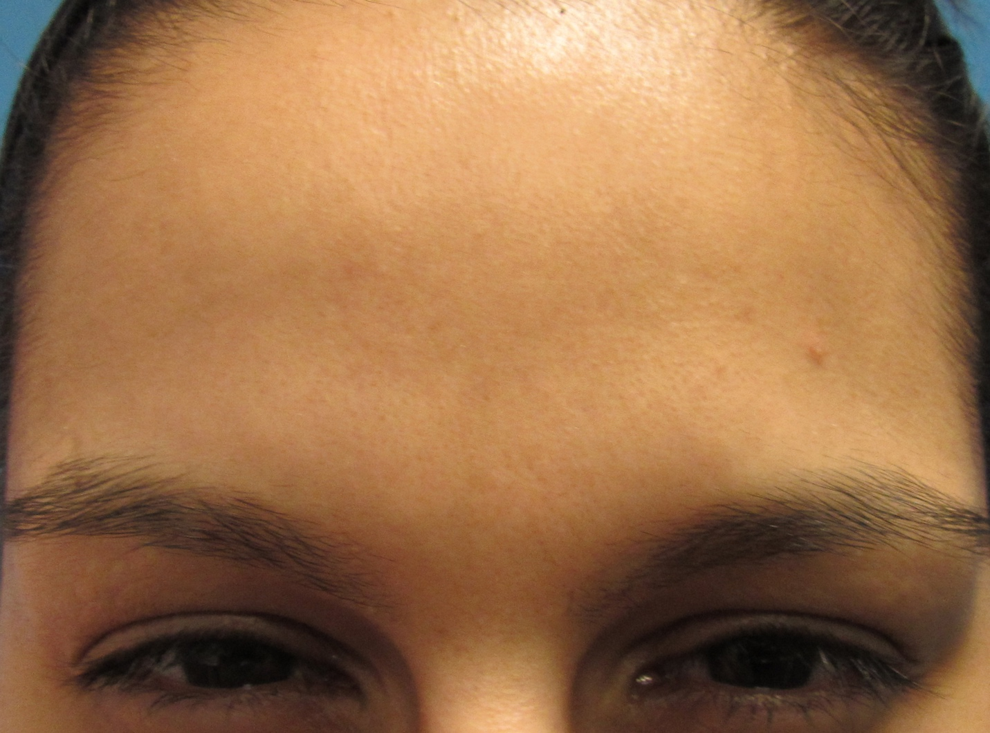
- 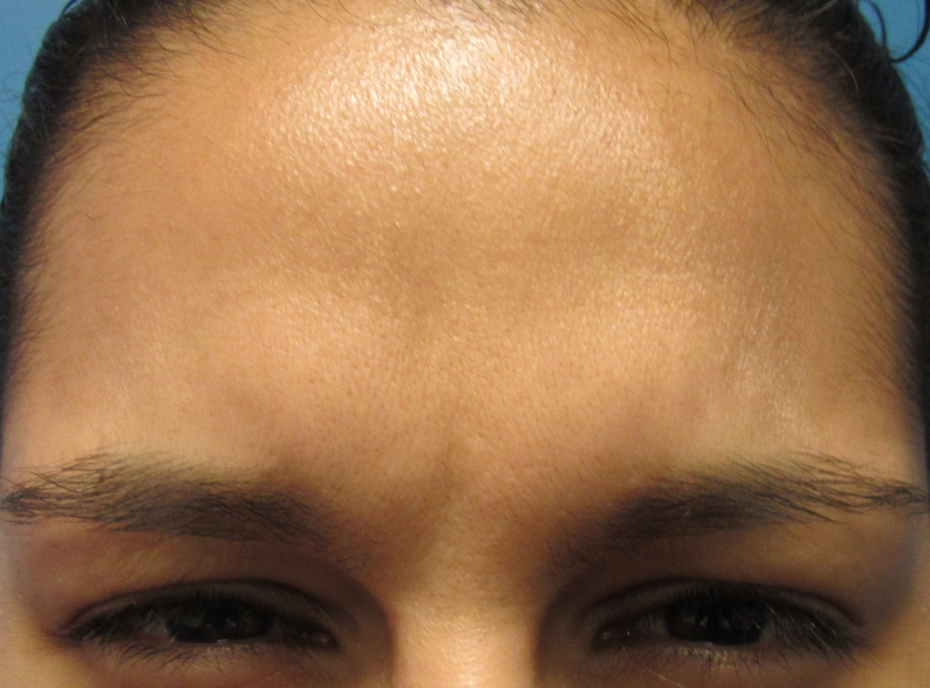
- 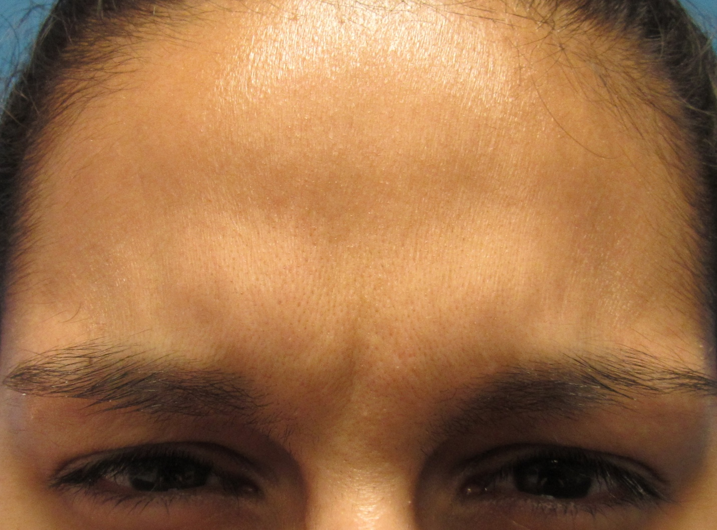
- 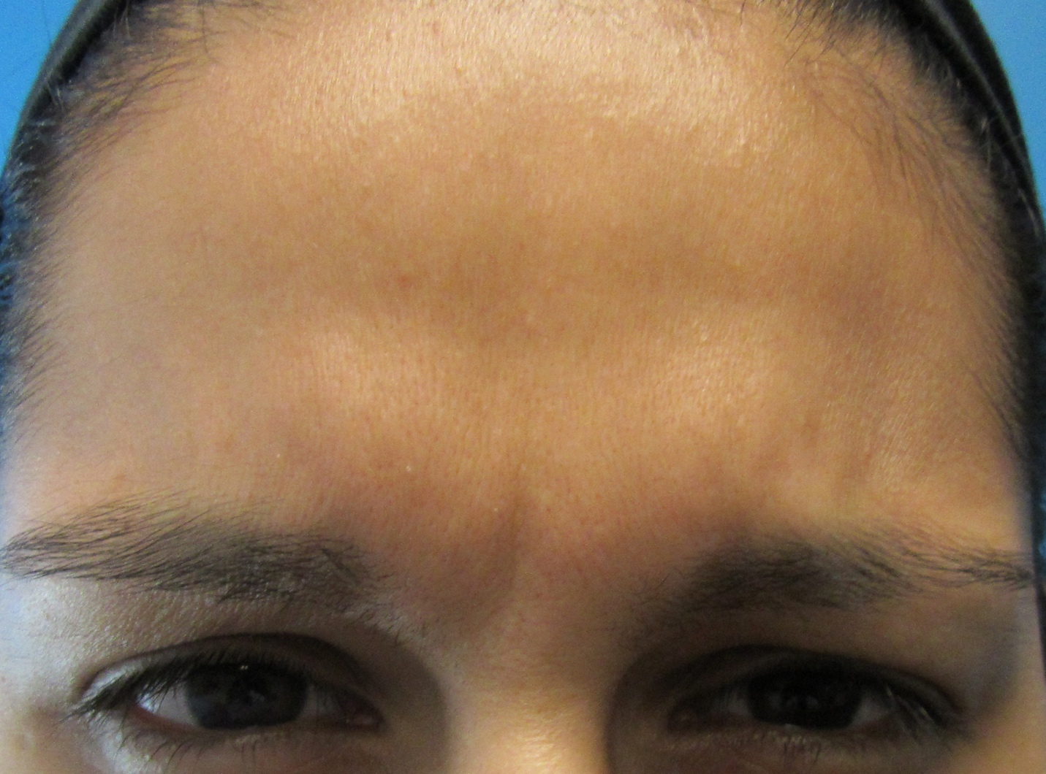

Figure S1 Legend: This representative millennial patient was assessed as having severe glabellar lines at maximum frown at baseline by investigator assessment.

