Supplemental Digital Content

The supplements contain the appendix 1-6.

Appendix 1. Specific searching strategy and history for each database.
- Pubmed:
(((((re-implant*[Title/Abstract]) OR (reimplant*[Title/Abstract])) OR (reinsert*[Title/Abstract])) OR (re-insert*[Title/Abstract])) OR (reoperat*[Title/Abstract])) AND ("Cochlear Implants"[Mesh] OR "Cochlear Implantation"[Mesh]) Sort by: Most Recent

- Web of science:
(((((TS=(re-implant*)) OR TS=(reimplant*)) OR TS=(re-insert*)) OR TS=(reinsert*)) OR TS=(reoperat*)) AND TS=(Cochlear Implant*)

- Ovid Medline
1 exp Cochlear Implantation/ (7515)
2 exp Cochlear Implants/ (10928)
3 re-implant*.mp. (1003)
4 reimplant*.mp. (7952)
5 reinsert*.mp. (2522)
6 re-insert*.mp. (317)
7 reoperat*.mp. (110371)
8 1 or 2 (13937)
9 3 or 4 or 5 or 6 or 7 (120237)
- 8 and 9 (460)

- EMBASE
1 exp cochlear implantation/ (4690)
2 exp cochlea prosthesis/ (16837)
3 re-implant*.mp. (2239)
4 reimplant*.mp. (16236)
5 re-insert*.mp. (777)
6 reinsert*.mp. (3988)
7 reoperat*.mp. (110109)
8 1 or 2 (18325)
9 3 or 4 or 5 or 6 or 7 (130351)
10 8 and 9 (467)
- Chinese National Knowledge Infrastructure,
(篇关摘=人工耳蜗 + 电子耳蜗 + 人工听觉 + 耳蜗植入) AND (篇关摘=再植入 + 再次植入 + 二次植入)
- VIP Chinese Science and Technology Periodicals Database
题名或关键词=人工耳蜗+电子耳蜗+人工听觉+耳蜗植入 AND 题名或关键词=再植入+再次植入+二次植入
- Wanfang Data
题名或关键词:(人工耳蜗 or 电子耳蜗 or 人工听觉 or 耳蜗植入) and 题名或关键词:(再植入 or 再次植入 or 二次植入)

Appendix 2. Characteristics of 144 studies included in this literature review.

Author Name | Year of publication | Years Included in Study | country | No. of PCI | Reimplantation |  | ipsilateral |  | contralateral |  | device failure |  | medical reason |  | update |  | other
 |  |  |  |  | No. | % | No. | % | No. | % | No. | % | No. | % | No. | % | No. | %
Ahmad M. Aldhafeeri, et al. | 2021 | 2011.1-2017.7 | Kingdom of Saudi Arabia | 886 | 36 | 4.1% | NR | NR | NR | NR | 27 | 75.0% | 9 | 25.0% | 0 | 0.0% | 0 | 0.0%
Eleanor Layfieldi, et al. | 2021 | 2009.1.1-2018.12.31 | USA | 468 | 30 | 6.4% | NR | NR | NR | NR | 26 | 86.7% | 3 | 10.0% | 0 | 0.0% | 0 | 0.0%
Pabina Rayamajhi, et al. | 2020 | 1997.6-2019.12 | India | 1555 | 81 | 5.2% | 80 | 98.8% | 1 | 1.2% | 68 | 84.0% | 13 | 16.0% | 0 | 0.0% | 0 | 0.0%
Birgul Gumus, et al. | 2020 | 2005.8-2019.8 | Turkey | 490 | 27 | 5.5% | 23 | 85.2% | 4 | 14.8% | 18 | 66.7% | 9 | 33.3% | 0 | 0.0% | 0 | 0.0%
Jingyuan Chen, et al. | 2021 | 1996.1-2019.12 | China | 4447 | 116 | 2.6% | 97 | 83.6% | 9 | 7.8% | 85 | 73.3% | 21 | 18.1% | 0 | 0.0% | 0 | 0.0%
R. Hermann, et al. | 2020 | 2012.1.1-2016.12.31 | France | 4952 | 99 | 2.0% | NR | NR | NR | NR | 49 | 49.5% | 39 | 39.4% | 0 | 0.0% | 11 | 11.1%
Yann-Fuu Kou, et al. | 2020 | 1986-2013 | USA | 834 | 40 | 4.8% | NR | NR | NR | NR | 36 | 90.0% | 4 | 10.0% | 0 | 0.0% | 0 | 0.0%
Muhammed Dağkıran, et al. | 2020 | 2000.3-2-2019.9 | Turkey | 1452 | 40 | 2.8% | NR | NR | NR | NR | 29 | 72.5% | 11 | 27.5% | 0 | 0.0% | 0 | 0.0%
M. Bourdoncle, et al. | 2020 | 2013.3.1-2016.12.31 | France | 772 | 49 | 6.3% | NR | NR | NR | NR | 30 | 61.2% | 19 | 38.8% | 0 | 0.0% | 0 | 0.0%
Ciaran Lane, et al. | 2019 | 1988.1.1-2017.3.31 | Canada | 781 | 23 | 2.9% | NR | NR | NR | NR | 19 | 82.6% | 4 | 17.4% | 0 | 0.0% | 0 | 0.0%
MO Batuk, et al. | 2019 | 1997.11-2017.8 | Turkey | 2058 | 123 | 6.0% | 117 | 95.1% | 6 | 4.9% | 75 | 61.0% | 50 | 40.7% | 2 | 1.6% | 0 | 0.0%
Yi Jiang, et al. | 2019 | 2002.7-2017.5 | China | 3031 | 31 | 1.0% | 26 | 83.9% | 5 | 16.1% | 28 | 90.3% | 3 | 9.7% | 0 | 0.0% | 0 | 0.0%
Abha Kumari, et al. | 2019 | 1997-2016 | India | 1500 | 53 | 3.5% | NR | NR | NR | NR | 39 | 73.6% | 14 | 26.4% | 0 | 0.0% | 0 | 0.0%
Shawn M. Stevens, et al. | 2019 | 2001-2016 | USA | 512 | 20 | 3.9% | 17 | 85.0% | 3 | 15.0% | 20 | 100.0% | 0 | 0.0% | 0 | 0.0% | 0 | 0.0%
Meredith A. Holcomb, et al. | 2018 | NR | USA | NR | 10 | NR | NR | NR | NR | NR | 1 | 10.0% | 0 | 0.0% | 9 | 90.0% | 0 | 0.0%
Maria Stella Arantes do Amaral, et al. | 2018 | 2004-2015 | Brazil | 265 | 9 | 3.4% | 8 | 88.9% | 1 | 11.1% | 2 | 22.2% | 7 | 77.8% | 0 | 0.0% | 0 | 0.0%
Recep Karamert, et al. | 2019 | 2002.7-2018.3 | Turkey | 802 | 42 | 5.2% | 24 | 57.1% | 18 | 42.9% | 30 | 71.4% | 19 | 45.2% | 0 | 0.0% | 0 | 0.0%
C. Wijaya, et al. | 2019 | 1995.1-2016.6 | Ireland | 1017 | 56 | 5.5% | 50 | 89.3% | 6 | 10.7% | 35 | 62.5% | 21 | 37.5% | 0 | 0.0% | 0 | 0.0%
Maria Stella A. Amaral, et al. | 2019 | 2004-2016 | Brazil | 158 | 2 | 1.3% | 2 | 100.0% | 0 | 0.0% | 0 | 0.0% | 2 | 100.0% | 0 | 0.0% | 0 | 0.0%
Simple Ravikumar Bhadania, et al. | 2018 | 2004.6-2014.6 | India | 250 | 10 | 4.0% | NR | NR | NR | NR | 3 | 30.0% | 7 | 70.0% | 0 | 0.0% | 0 | 0.0%
L. Distinguin, et al. | 2017 | 1996-2013 | France | 665 | 69 | 10.4% | NR | NR | NR | NR | 50 | 72.5% | 15 | 21.7% | 4 | 5.8% | 0 | 0.0%
Jeffrey Yeung, et al. | 2018 | 1995.1-2015.12 | USA | 806 | 62 | 7.7% | 62 | 100.0% | 0 | 0.0% | 50 | 80.6% | 12 | 19.4% | 0 | 0.0% | 0 | 0.0%
Ashish Vashishth, et al. | 2018 | NR | Italy | 36 | 4 | 11.1% | 3 | 75.0% | 1 | 25.0% | 0 | 0.0% | 4 | 100.0% | 0 | 0.0% | 0 | 0.0%
Philip A. Gardner, et al. | 2018 | 2004-2014 | USA | 579 | 31 | 5.4% | NR | NR | NR | NR | 27 | 87.1% | 4 | 12.9% | 0 | 0.0% | 0 | 0.0%
David Ulanovsk, et al. | 2017 | 2000-2012 | Israel | 350 | 26 | 7.4% | NR | NR | NR | NR | 19 | 73.1% | 7 | 26.9% | 0 | 0.0% | 0 | 0.0%
Timmermans M, et al. | 2018 | 1987-2017 | The Netherland +Belgium | 2571 | 77 | 3.0% | NR | NR | NR | NR | NR | NR | NR | NR | NR | NR | NR | NR
Al Hussein Awad, et al. | 2017 | 2014.10-2016.7 | Egypt | 163 | 6 | 3.7% | 4 | 66.7% | 2 | 33.3% | 3 | 50.0% | 3 | 50.0% | 0 | 0.0% | 0 | 0.0%
Cubillana-Herrero JD, et al. | 2018 | 2003.1-2010.12 | Spain | 64 | 3 | 4.7% | NR | NR | NR | NR | 2 | 66.7% | 1 | 33.3% | 0 | 0.0% | 0 | 0.0%
Mariana Reis, et al. | 2017 | 2006.1-2015.6 | Australia | 1968 | 87 | 4.4% | NR | NR | NR | NR | 53 | 60.9% | 34 | 39.1% | 0 | 0.0% | 0 | 0.0%
Chung-Feng Hwang, et al. | 2016 | 1999-2014 | China | 589 | 13 | 2.2% | NR | NR | NR | NR | 8 | 61.5% | 5 | 38.5% | 0 | 0.0% | 0 | 0.0%
Uma Patnaik, et al. | 2016 | 1997.1-2015.1 | India | 534 | 18 | 3.4% | NR | NR | NR | NR | 10 | 55.6% | 8 | 44.4% | 0 | 0.0% | 0 | 0.0%
R. Manrique-Huarte, et al. | 2015 | 1989-2012 | Spain | 962 | 38 | 4.0% | 38 | 100.0% | 0 | 0.0% | 22 | 57.9% | 16 | 42.1% | 0 | 0.0% | 0 | 0.0%
Benjamin J. Googe, et al. | 2016 | 2003.4-2014.10 | USA | 248 | 7 | 2.8% | 7 | 100.0% | 0 | 0.0% | 7 | 100.0% | 0 | 0.0% | 0 | 0.0% | 0 | 0.0%
Francoise Sterkers, et al. | 2015 | 1990-2013 | France | 539 | 45 | 8.3% | 44 | 97.8% | 1 | 2.2% | 35 | 77.8% | 10 | 22.2% | 0 | 0.0% | 0 | 0.0%
Gutiérrez-Salazar A, et al. | 2015 | 1991.10-2011.5 | Spain | 808 | 51 | 6.3% | NR | NR | NR | NR | 25 | 49.0% | 19 | 37.3% | 7 | 13.7% | 0 | 0.0%
Marion Blanchard, et al. | 2014 | 1990.1-2012.6 | France | 877 | 62 | 7.1% | NR | NR | NR | NR | NR | NR | NR | NR | NR | NR | NR | NR
Marilena Trozzi, et al. | 2014 | 1992.2-2013.1 | UK | 778 | 30 | 3.9% | 30 | 100.0% | 0 | 0.0% | 17 | 56.7% | 13 | 43.3% | 0 | 0.0% | 0 | 0.0%
Anna Balakina, et al. | 2015 | 2006.1.1-2014.12.31 | Russia | 606 | 30 | 5.0% | NR | NR | NR | NR | NR | NR | NR | NR | NR | NR | NR | NR
Levent Olgun, et al. | 2015 | NR | Turkey | 1924 | 96 | 5.0% | NR | NR | NR | NR | NR | NR | NR | NR | NR | NR | NR | NR
Margaret T. Dillon, et al. | 2015 | NR | USA | NR | 29 | NR | NR | NR | NR | NR | 29 | 100.0% | 0 | 0.0% | 0 | 0.0% | 0 | 0.0%
Dragan Dankuc, et al. | 2015 | 2002-2013 | Serbia | 100 | 1 | 1.0% | NR | NR | NR | NR | NR | NR | NR | NR | NR | NR | NR | NR
Yuksel Olgun, et al. | 2014 | 1998-2012.7 | Turkey | 957 | 52 | 5.4% | NR | NR | NR | NR | 41 | 78.8% | 9 | 17.3% | 0 | 0.0% | 2 | 3.8%
A. Farinetti, et al. | 2014 | 1993.3-2013.1 | France | 475 | 11 | 2.3% | 6 | 54.5% | 5 | 45.5% | 9 | 81.8% | 2 | 18.2% | 0 | 0.0% | 0 | 0.0%
Catherine S. Birman, et al. | 2014 | NR | Australia | NR | 108 | NR | 105 | 97.2% | 3 | 2.8% | 82 | 75.9% | 21 | 19.4% | 0 | 0.0% | 5 | 4.6%
Simran Mahtani, et al. | 2014 | 1988-2012 | UK | 649 | 32 | 4.9% | 32 | 100.0% | 0 | 0.0% | 23 | 71.9% | 7 | 21.9% | 2 | 6.3% | 0 | 0.0%
Jeffrey T. Wang, et al. | 2014 | 1982.1-2011.6 | Australia | 2827 | 201 | 7.1% | NR | NR | NR | NR | NR | NR | NR | NR | NR | NR | NR | NR
Jumin Sunde, et al. | 2013 | 2000.1-2012.4 | USA | 439 | 13 | 3.0% | NR | NR | NR | NR | 5 | 38.5% | 8 | 61.5% | 0 | 0.0% | 0 | 0.0%
David S. Chen, et al. | 2013 | 1999-2011 | USA | 445 | 15 | 3.4% | NR | NR | NR | NR | NR | NR | NR | NR | NR | NR | NR | NR
Jun Ikeya, et al. | 2013 | 1985.12-2007.4 | Japan | 366 | 57 | 15.6% | 40 | 70.2% | 17 | 29.8% | NR | NR | NR | NR | NR | NR | NR | NR
Ozgur Tarkan, et al. | 2013 | 2000.3-2012.3 | Turkey | 475 | 13 | 2.7% | 10 | 76.9% | 3 | 23.1% | 10 | 76.9% | 3 | 23.1% | 0 | 0.0% | 0 | 0.0%
Seung-Ho Shin, et al. | 2013 | 1988-2011 | Korea | 816 | 22 | 2.7% | NR | NR | NR | NR | 14 | 63.6% | 8 | 36.4% | 0 | 0.0% | 0 | 0.0%
Maria Conceição Peixoto , et al. | 2013 | 1992-2001 | Portugal | 132 | 9 | 6.8% | NR | NR | NR | NR | NR | NR | NR | NR | NR | NR | NR | NR
Seied Basir Hashemi, et al. | 2012 | 2003-2009 | Iran | 275 | 5 | 1.8% | NR | NR | NR | NR | 5 | 100.0% | 0 | 0.0% | 0 | 0.0% | 0 | 0.0%
A. Ciorba, et al. | 2012 | 2003.1.1-2009.12.31 | Italy | 438 | 13 | 3.0% | NR | NR | NR | NR | 9 | 69.2% | 4 | 30.8% | 0 | 0.0% | NR | NR
L Masterson, et al. | 2012 | 1986.3-2010.10 | UK | 746 | 33 | 4.4% | 24 | 72.7% | 9 | 27.3% | 20 | 60.6% | 13 | 39.4% | 0 | 0.0% | 0 | 0.0%
Kadir Serkan Orhan, et al. | 2012 | 2005.9-2010.6 | Turkey | 344 | 8 | 2.3% | 7 | 87.5% | 1 | 12.5% | 3 | 37.5% | 5 | 62.5% | 0 | 0.0% | 0 | 0.0%
Antoine Eskander, et al. | 2011 | 1990-2010.6 | Canada | 971 | 35 | 3.6% | NR | NR | NR | NR | 30 | 85.7% | 5 | 14.3% | 0 | 0.0% | 0 | 0.0%
Georgios A. Stamatiou, et al. | 2011 | 1986.4-2010.6 | Greece | 212 | 7 | 3.3% | NR | NR | NR | NR | 6 | 85.7% | 1 | 14.3% | 0 | 0.0% | 0 | 0.0%
Emmanuel Lescanne, et al. | 2011 | 1994.1-2010.6 | France | 144 | 8 | 5.6% | NR | NR | NR | NR | 5 | 62.5% | 3 | 37.5% | 0 | 0.0% | 0 | 0.0%
Nathan S. Alexande, et al. | 2011 | 1995.7-2009.12 | USA | 320 | 13 | 4.1% | NR | NR | NR | NR | 13 | 100.0% | 0 | 0.0% | 0 | 0.0% | 0 | 0.0%
Doug Chung, et al. | 2010 | 1979-2008 | USA | 1387 | 113 | 8.1% | NR | NR | NR | NR | 40 | 35.4% | 31 | 27.4% | 0 | 0.0% | 42 | 37.2%
Kenneth H. Lee, et al. | 2010 | 1999-2006 | USA | 23 | 1 | 4.3% | NR | NR | NR | NR | 0 | 0.0% | 1 | 100.0% | 0 | 0.0% | 0 | 0.0%
César Orús Dotú, et al. | 2010 | 1993-2008 | Spain | 146 | 34 | 23.3% | 34 | 100.0% | 0 | 0.0% | 22 | 64.7% | 12 | 35.3% | 0 | 0.0% | 0 | 0.0%
Natalie Loundon, et al. | 2010 | 1990.1.1-2008.4.30 | France | 434 | 13 | 3.0% | NR | NR | NR | NR | NR | NR | NR | NR | NR | NR | NR | NR
Jerry W . Lin, et al. | 2010 | 1993-2008 | USA | 264 | 25 | 9.5% | NR | NR | NR | NR | 19 | 76.0% | 6 | 24.0% | 0 | 0.0% | 0 | 0.0%
Andrea L. Marlowe, et al. | 2010 | 1991-2006 | USA | 420 | 62 | 14.8% | 60 | 96.8% | 2 | 3.2% | 46 | 74.2% | 14 | 22.6% | 2 | 3.2% | 0 | 0.0%
KOS, Maria Izabel, et al. | 2010 | 1985-2009 | Geneva | 206 | 16 | 7.8% | NR | NR | NR | NR | 15 | 93.8% | 1 | 6.3% | 0 | 0.0% | 0 | 0.0%
Jan Gosepath, et al. | 2009 | 1990-2007 | Germany | 422 | 56 | 13.3% | NR | NR | NR | NR | 48 | 85.7% | 8 | 14.3% | 0 | 0.0% | 0 | 0.0%
Taryn Davids, et al. | 2009 | 2002.1-2007.12 | Canada | 446 | 16 | 3.6% | NR | NR | NR | NR | 14 | 87.5% | 2 | 12.5% | 0 | 0.0% | 0 | 0.0%
MI Trotter, et al. | 2009 | 1982.9-2006.10 | Australia | 1106 | 58 | 5.2% | 49 | 84.5% | 9 | 15.5% | 43 | 74.1% | 15 | 25.9% | 0 | 0.0% | 0 | 0.0%
Kevin D. Brown, et al. | 2009 | 1992-2006 | USA | 806 | 44 | 5.5% | 40 | 90.9% | 4 | 9.1% | 34 | 77.3% | 10 | 22.7% | 0 | 0.0% | 0 | 0.0%
Tommaso Sorrentino, et al. | 2009 | 1989-2009 | France | 487 | 20 | 4.1% | 18 | 90.0% | 2 | 10.0% | 11 | 55.0% | 9 | 45.0% | 0 | 0.0% | 0 | 0.0%
Frederic Venail, et al. | 2008 | 1989.6-2006.12 | France | 500 | 36 | 7.2% | 31 | 86.1% | 3 | 8.3% | 30 | 83.3% | 5 | 13.9% | 1 | 2.8% | 0 | 0.0%
Joong Ho Ahn, et al. | 2008 | 1999.4-2006.7 | Korea | 80 | 3 | 3.8% | NR | NR | NR | NR | 2 | 66.7% | 1 | 33.3% | 0 | 0.0% | 0 | 0.0%
Alejandro Rivas, et al. | 2008 | 1990-2006 | USA | 825 | 48 | 5.8% | 44 | 91.7% | 4 | 8.3% | 35 | 72.9% | 13 | 27.1% | 0 | 0.0% | 0 | 0.0%
Robert D. Cullen, et al. | 2008 | 1991-2005 | USA | 952 | 107 | 11.2% | NR | NR | NR | NR | 65 | 60.7% | 42 | 39.3% | 0 | 0.0% | 0 | 0.0%
Mathieu Côté, et al. | 2007 | 1984-2005 | Canada | 668 | 43 | 6.4% | 35 | 81.4% | 8 | 18.6% | 35 | 81.4% | 8 | 18.6% | 0 | 0.0% | 0 | 0.0%
Lela Migirov, et al. | 2007 | 1989.6-2005.4 | Israel | 405 | 29 | 7.2% | 23 | 79.3% | 6 | 20.7% | 24 | 82.8% | 5 | 17.2% | 0 | 0.0% | 0 | 0.0%
Jose N. Fayad, et al. | 2006 | 1987-2005 | USA | 496 | 18 | 3.6% | 18 | 100.0% | 0 | 0.0% | 15 | 83.3% | 3 | 16.7% | 0 | 0.0% | 0 | 0.0%
Elizabeth A. R. Beadle, et al. | 2005 | 1989.1-1992.12 | Greece | 30 | 9 | 30.0% | 8 | 88.9% | 1 | 11.1% | 9 | 100.0% | 0 | 0.0% | 0 | 0.0% | 0 | 0.0%
Sunil N Dutt, et al. | 2005 | 1999-2001 | France | 111 | 4 | 3.6% | 2 | 50.0% | 2 | 50.0% | 1 | 25.0% | 3 | 75.0% | 0 | 0.0% | 0 | 0.0%
Tolga Kandogan, et al. | 2005 | 1998-2004.6 | Turkey | 227 | 22 | 9.7% | NR | NR | NR | NR | 22 | 100.0% | 0 | 0.0% | 0 | 0.0% | 0 | 0.0%
Amy-Anne Donatelli Lassig, et al. | 2005 | 1985-2003 | USA | NR | 61 | NR | 54 | 88.5% | 7 | 11.5% | 34 | 55.7% | 21 | 34.4% | 6 | 9.8% | 0 | 0.0%
Jan Bernd Weise, et al. | 2005 | 1990.8-2003.11 | Germany | 110 | 6 | 5.5% | 4 | 66.7% | 2 | 33.3% | 3 | 50.0% | 3 | 50.0% | 0 | 0.0% | 0 | 0.0%
Jaydip Ray, et al. | 2004 | 1990-2002 | UK | 288 | 16 | 5.6% | 8 | 50.0% | 8 | 50.0% | 9 | 56.3% | 6 | 37.5% | 1 | 6.3% | 0 | 0.0%
Susan Waltzman, et al. | 2004 | 1997-2003 | USA | NR | 27 | NR | NR | NR | NR | NR | 21 | 77.8% | 6 | 22.2% | 0 | 0.0% | 0 | 0.0%
Jadip Ray, et al. | 2004 | 1984.6-2003.6 | Australia | 844 | 72 | 8.5% | 52 | 72.2% | 20 | 27.8% | 37 | 51.4% | 35 | 48.6% | 0 | 0.0% | 0 | 0.0%
Jose N. Fayad, et al. | 2004 | 1990-2002.12 | USA | 638 | 46 | 7.2% | NR | NR | NR | NR | 40 | 87.0% | 6 | 13.0% | 0 | 0.0% | 0 | 0.0%
C.H. Raine, et al. | 2004 | 1990-2004 | UK | 305 | 27 | 8.9% | NR | NR | NR | NR | 20 | 74.1% | 3 | 11.1% | 4 | 14.8% | 0 | 0.0%
Emmanuel Am Mylanus, et al. | 2003 | 1989-2001 | The Netherland | 140 | 3 | 2.1% | NR | NR | NR | NR | NR | NR | NR | NR | NR | NR | NR | NR
Geert De Ceulaer, et al. | 2003 | NR | UK+Belgium | 92 | 5 | NR | NR | NR | NR | NR | 5 | 100.0% | 0 | 0.0% | 0 | 0.0% | 0 | 0.0%
Jafar Hamzavi, et al. | 2003 | NR | Germany | 66 | 18 | 27.3% | NR | NR | NR | NR | 7 | 38.9% | 0 | 0.0% | 11 | 61.1% | 0 | 0.0%
George Alexiades, et al. | 2001 | 1984.2-2000.12 | USA | 618 | 33 | 5.3% | 33 | 100.0% | 0 | 0.0% | 29 | 87.9% | 4 | 12.1% | 0 | 0.0% | 0 | 0.0%
Simon C. Parisier, et al. | 2001 | 1990-1999 | USA | 403 | 27 | 6.7% | 27 | 100.0% | 0 | 0.0% | 27 | 100.0% | 0 | 0.0% | 0 | 0.0% | 0 | 0.0%
Ahmed Handoussa, et al. | 2000 | 1993-2000 | Arabia | 73 | 5 | 6.8% | 5 | 100.0% | 0 | 0.0% | 4 | 80.0% | 1 | 20.0% | 0 | 0.0% | 0 | 0.0%
Otto Ribari, et al. | 2000 | 1985-1999 | Hungary | 80 | 15 | 18.8% | 8 | 53.3% | 7 | 46.7% | 6 | 40.0% | 9 | 60.0% | 0 | 0.0% | 0 | 0.0%
Gysin Claudien, et al. | 2000 | 1990-1998 | Canada | 100 | 4 | 4.0% | NR | NR | NR | NR | 4 | 100.0% | 0 | 0.0% | 0 | 0.0% | 0 | 0.0%
Filipo, R, et al. | 1999 | 1993.3-1998 | Italy | 31 | 5 | 16.1% | NR | NR | NR | NR | 1 | 20.0% | 4 | 80.0% | 0 | 0.0% | 0 | 0.0%
Thomas J. Balkany, et al. | 1999 | 1990-1997 | USA | 175 | 16 | 9.1% | NR | NR | NR | NR | 6 | 37.5% | 10 | 62.5% | 0 | 0.0% | 0 | 0.0%
Henson, A M, et al. | 1999 | 1987-1996 | USA | NR | 28 | NR | 28 | 100.0% | 0 | 0.0% | 27 | 96.4% | 1 | 3.6% | 0 | 0.0% | 0 | 0.0%
Antje Aschendorff, et al. | 1997 | 1993-1997 | Germany | 105 | 2 | 1.9% | NR | NR | NR | NR | 2 | 100.0% | 0 | 0.0% | 0 | 0.0% | 0 | 0.0%
Shakeel R. Saeed, et al. | 1995 | 1988-1995 | UK | 92 | 3 | 3.3% | 2 | 66.7% | 1 | 33.3% | 2 | 66.7% | 1 | 33.3% | 0 | 0.0% | 0 | 0.0%
Hongbo Ren, et al. | 2020 | 2009.6-2018.12 | China | 1119 | 24 | 2.1% | 20 | 83.3% | 4 | 16.7% | 20 | 83.3% | 4 | 16.7% | 0 | 0.0% | 0 | 0.0%
Jing Luo, et al. | 2020 | 2003.1-2018.10 | China | 1689 | 21 | 1.2% | NR | NR | NR | NR | 5 | 23.8% | 16 | 76.2% | 0 | 0.0% | 0 | 0.0%
Shuguang Han, et al. | 2019 | 2015.1-2018.6 | China | NR | 39 | NR | 34 | 87.2% | 5 | 12.8% | 30 | 76.9% | 9 | 23.1% | 0 | 0.0% | 0 | 0.0%
Shanshan Zhang, et al. | 2019 | 2012.11-22018.7 | China | NR | 17 | NR | 16 | 94.1% | 1 | 5.9% | 11 | 64.7% | 5 | 29.4% | 0 | 0.0% | 1 | 5.9%
HongyanTang , et al. | 2019 | 2013.9-2019.6 | China | 784 | 23 | 2.9% | 20 | 87.0% | 3 | 13.0% | 16 | 69.6% | 7 | 30.4% | 0 | 0.0% | 0 | 0.0%
Chunhui Sun, et al. | 2020 | 2009.1-2017.12 | China | 1693 | 12 | 0.7% | 7 | 58.3% | 5 | 41.7% | 5 | 41.7% | 7 | 58.3% | 0 | 0.0% | 0 | 0.0%
Xinjian Li, et al. | 2019 | 2016.1-2017.12 | China | 129 | 7 | 5.4% | 7 | 100.0% | 0 | 0.0% | 7 | 100.0% | 0 | 0.0% | 0 | 0.0% | 0 | 0.0%
Yueshuai Song, et al. | 2018 | 2015.1-2018.6 | China | 536 | 33 | 6.2% | 32 | 97.0% | 1 | 3.0% | 30 | 90.9% | 3 | 9.1% | 0 | 0.0% | 0 | 0.0%
Yuan Lu, et al. | 2014 | 2002-2012 | China | NR | 25 | NR | 21 | 84.0% | 4 | 16.0% | 13 | 52.0% | 12 | 48.0% | 0 | 0.0% | 0 | 0.0%
Yuanyuan Jing, et al. | 2013 | 2005.3-2012.12 | China | NR | 31 | NR | NR | NR | NR | NR | 0 | 0.0% | 15 | 48.4% | 1 | 3.2% | 15 | 48.4%
Linge Wang et al. | 2011 | 2007.5-2010.11 | China | NR | 23 | NR | NR | NR | NR | NR | 11 | 47.8% | 9 | 39.1% | 0 | 0.0% | 3 | 13.0%
Shuyi Zhao, et al. | 2008 | 2002.2-2006.11 | China | 103 | 4 | 3.9% | 4 | 100.0% | 0 | 0.0% | 4 | 100.0% | 0 | 0.0% | 0 | 0.0% | 0 | 0.0%
Lisheng Yu, et al. | 2004 | 2000.6-2004.3 | China | 36 | 6 | 16.7% | NR | NR | NR | NR | 5 | 83.3% | 1 | 16.7% | 0 | 0.0% | 0 | 0.0%
Daohang Zhang, et al. | 2008 | 1998.1-2008.2 | China | 1068 | 7 | 0.7% | NR | NR | NR | NR | 5 | 71.4% | 0 | 0.0% | 0 | 0.0% | 2 | 28.6%
Jianhua Qiu, et al. | 2010 | 2000.12-2010.8 | China | 416 | 2 | 0.5% | 0 | 0.0% | 2 | ##### | 0 | 0.0% | 2 | 100.0% | 0 | 0.0% | NR | NR
Zheming Wu, et al. | 2018 | 1999-2004 | China | 589 | 14 | 2.4% | NR | NR | NR | NR | NR | NR | NR | NR | NR | NR | NR | NR
Shiming Yang, et al. | 2013 | 1997.3-2013.5 | China | 1681 | 15 | 0.9% | NR | NR | NR | NR | NR | NR | NR | NR | NR | NR | NR | NR
Willi Roßberg,et al. | 2021 | NR | Germany | NR | 5 | NR | 5 | 100.0% | 0 | 0.0% | 3 | 60.0% | 1 | 20.0% | 1 | 20.0% | 0 | 0.0%
Chanida Kanchanalarp,et al. | 2005 | 1999-2003 | Thailand | 10 | 3 | 30.0% | NR | NR | NR | NR | 0 | 0.0% | 3 | 100.0% | 0 | 0.0% | 0 | 0.0%
Robert L. Webb,et al. | 1991 | 1982.9.14-1991 | Australia | 97 | 3 | 3.1% | 2 | 66.7% | 1 | 33.3% | 3 | 100.0% | 0 | 0.0% | 0 | 0.0% | 0 | 0.0%
Ian M, Windmill,et al. | 1990 | 1987-1990 | USA | 17 | 3 | 17.6% | 1 | 33.3% | 2 | 66.7% | NR | NR | NR | NR | NR | NR | NR | NR
Noel L. Cohen,et al. | 1993 | 1993 | USA | 80 | 4 | 5.0% | NR | NR | NR | NR | 4 | 100.0% | 0 | 0.0% | 0 | 0.0% | 0 | 0.0%
Baren JP,et al. | 2014 | 1990-2012 | UK | 831 | 67 | 8.1% | NR | NR | NR | NR | NR | NR | NR | NR | NR | NR | NR | NR
Kyle S. Kimura | 2020 | 2005-2015 | USA | 1469 | 81 | 5.5% | NR | NR | NR | NR | 67 | 82.7% | 14 | 17.3% | 0 | 0.0% | 0 | 0.0%
Smith A.J, et al. | 2020 | NR | NR | 358 | 12 | 3.4% | NR | NR | NR | NR | NR | NR | NR | NR | NR | NR | NR | NR
Jun Ho Lee, et al. | 2016 | 1988.3-2015.6 | Korea | 1729 | 48 | 2.8% | NR | NR | NR | NR | 46 | 95.8% | 2 | 4.2% | 0 | 0.0% | 0 | 0.0%
Daniel Jun Yi Wong, et al. | 2016 | 2001-2010 | Australia | 150 | 5 | 3.3% | NR | NR | NR | NR | 5 | 100.0% | 0 | 0.0% | 0 | 0.0% | 0 | 0.0%
S. Raghunandhan, et al. | 2011 | 2006.11-2010.11 | India | 300 | 10 | 3.3% | NR | NR | NR | NR | 5 | 50.0% | 5 | 50.0% | 0 | 0.0% | 0 | 0.0%
Glynn, F, et al. | 2012 | 1988-2011 | NR | 637 | 31 | 4.9% | NR | NR | NR | NR | 19 | 61.3% | 10 | 32.3% | 2 | 6.5% | 0 | 0.0%
Al-Muhaimeed, et al. | 2011 | NR | Saudi Arabia | 117 | 4 | 3.4% | NR | NR | NR | NR | 0 | 0.0% | 4 | 100.0% | 0 | 0.0% | 0 | 0.0%
Sh. Mohammadi, et al. | 2011 | 1992-2009 | Iran | 1412 | 74 | 5.2% | NR | NR | NR | NR | 67 | 90.5% | 7 | 9.5% | 0 | 0.0% | 0 | 0.0%
T Ovesen, et al. | 2009 | 1998-2007 | Denmark | 311 | 2 | 0.6% | 2 | 100.0% | 0 | 0.0% | 0 | 0.0% | 2 | 100.0% | 0 | 0.0% | 0 | 0.0%
J. Ray, et al. | 1998 | 1986-1997 | UK | 132 | 9 | 6.8% | 4 | 44.4% | 5 | 55.6% | 4 | 44.4% | 1 | 11.1% | 4 | 44.4% | 0 | 0.0%
Richard T. Miyamoto, et al. | 1997 |  | USA | 180 | 20 | 11.1% | NR | NR | NR | NR | 11 | 55.0% | 9 | 45.0% | 0 | 0.0% | 0 | 0.0%
Robert K. Jackler, et al. | 1989 | NR | USA | 1280 | 38 | 3.0% | NR | NR | NR | NR | 16 | 42.1% | 22 | 57.9% | 0 | 0.0% | 0 | 0.0%
Tapani Jauhiainen, et al. |  | 1984-1985 | Finland | 10 | 3 | 30.0% | NR | NR | NR | NR | 3 | 100.0% | 0 | 0.0% | 0 | 0.0% | 0 | 0.0%
L Ali, et al. | 2010 | 2009-2010 | NR | 33 | 1 | 3.0% | NR | NR | NR | NR | 1 | 100.0% | 0 | 0.0% | 0 | 0.0% | 0 | 0.0%
Yasheng Yuan, et al. | 2014 | 2007.10-2009.10 | China | NR | 7 | NR | NR | NR | NR | NR | 2 | 28.6% | 5 | 71.4% | 0 | 0.0% | 0 | 0.0%
Xinmeng Men, et al. | 2017 | 2013.12-2015.9 | China | 78 | 3 | 3.8% | NR | NR | NR | NR | 3 | 100.0% | 0 | 0.0% | 0 | 0.0% | 0 | 0.0%
Wenkui Lin, et al. | 2020 | 2010.5-2019.4 | China | 497 | 3 | 0.6% | 3 | 100.0% | 0 | 0.0% | 1 | 33.3% | 1 | 33.3% | 0 | 0.0% | 1 | 33.3%
Yu Wang, et al. | 2017 | 2002.3-2016.11 | China | 280 | 3 | 1.1% | 2 | 66.7% | 1 | 33.3% | 2 | 66.7% | 1 | 33.3% | 0 | 0.0% | 0 | 0.0%
Sadie Khwaja, et al. | 2012 | NR | UK | 22 | 1 | 4.5% | NR | NR | NR | NR | 1 | 100.0% | 0 | 0.0% | 0 | 0.0% | 0 | 0.0%
PCI: Primary Cochlear Implantation. NR: Not reported.

Appendix 3. The forest plot of the pooled prevalence of cochlear reimplantation in children.
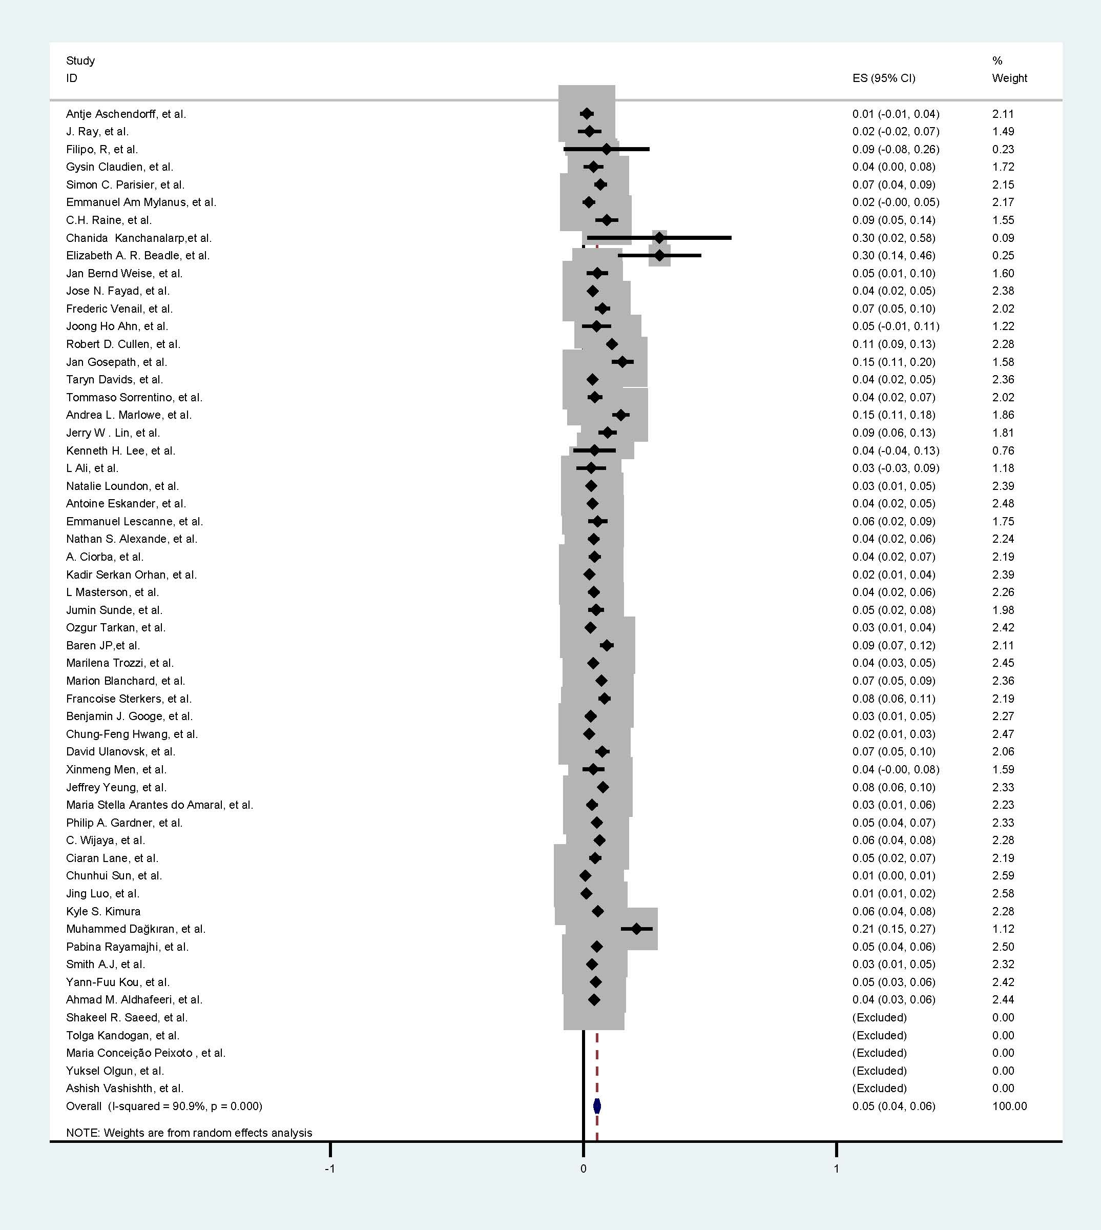
Appendix 4. The forest plot of the pooled prevalence of cochlear reimplantation in adults.
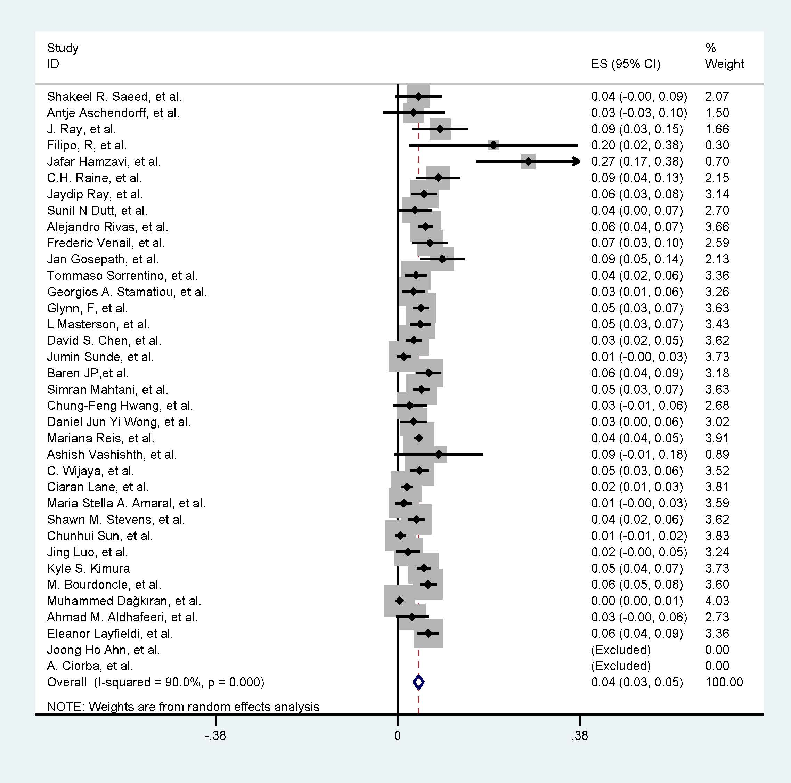

Appendix 5. The sensitivity analysis of included studies: the impact on the pooled estimate caused by each study.
Study omitted | Estimate | 95% Confidence interval
 |  | Lower limits | Upper limits
Ahmad M. Aldhafeeri, et al. | 0.0467 | 0.0424 | 0.0511
Eleanor Layfieldi, et al. | 0.0465 | 0.0422 | 0.0508
Pabina Rayamajhi, et al. | 0.0466 | 0.0423 | 0.0509
Birgul Gumus, et al. | 0.0465 | 0.0422 | 0.0508
Jingyuan Chen, et al. | 0.0470 | 0.0426 | 0.0514
R. Hermann, et al. | 0.0471 | 0.0427 | 0.0516
Yann-Fuu Kou, et al. | 0.0467 | 0.0423 | 0.0510
Muhammed Dağkıran, et al. | 0.0469 | 0.0426 | 0.0513
M. Bourdoncle, et al. | 0.0465 | 0.0422 | 0.0508
Ciaran Lane, et al. | 0.0469 | 0.0425 | 0.0512
MO Batuk, et al. | 0.0465 | 0.0422 | 0.0508
Yi Jiang, et al. | 0.0471 | 0.0428 | 0.0515
Abha Kumari, et al. | 0.0468 | 0.0425 | 0.0512
Shawn M. Stevens, et al. | 0.0467 | 0.0424 | 0.0511
Maria Stella Arantes do Amaral, et al. | 0.0468 | 0.0425 | 0.0511
Recep Karamert, et al. | 0.0467 | 0.0424 | 0.0510
C. Wijaya, et al. | 0.0466 | 0.0423 | 0.0509
Maria Stella A. Amaral, et al. | 0.0470 | 0.0427 | 0.0513
Simple Ravikumar Bhadania, et al. | 0.0467 | 0.0424 | 0.0510
L. Distinguin, et al. | 0.0461 | 0.0419 | 0.0504
Jeffrey Yeung, et al. | 0.0464 | 0.0421 | 0.0506
Ashish Vashishth, et al. | 0.0466 | 0.0423 | 0.0509
Philip A. Gardner, et al. | 0.0466 | 0.0423 | 0.0509
David Ulanovsk, et al. | 0.0464 | 0.0422 | 0.0507
Timmermans M, et al. | 0.0469 | 0.0425 | 0.0513
Al Hussein Awad, et al. | 0.0467 | 0.0424 | 0.0511
Cubillana-Herrero JD, et al. | 0.0467 | 0.0424 | 0.0510
Mariana Reis, et al. | 0.0467 | 0.0424 | 0.0510
Chung-Feng Hwang, et al. | 0.0469 | 0.0426 | 0.0513
Uma Patnaik, et al. | 0.0468 | 0.0425 | 0.0511
R. Manrique-Huarte, et al. | 0.0468 | 0.0424 | 0.0511
Benjamin J. Googe, et al. | 0.0468 | 0.0425 | 0.0511
Francoise Sterkers, et al. | 0.0463 | 0.0420 | 0.0506
Gutiérrez-Salazar A, et al. | 0.0465 | 0.0422 | 0.0508
Marion Blanchard, et al. | 0.0464 | 0.0421 | 0.0507
Marilena Trozzi, et al. | 0.0468 | 0.0424 | 0.0511
Anna Balakina, et al. | 0.0466 | 0.0423 | 0.0510
Levent Olgun, et al. | 0.0466 | 0.0423 | 0.0509
Dragan Dankuc, et al. | 0.0470 | 0.0427 | 0.0513
Yuksel Olgun, et al. | 0.0466 | 0.0423 | 0.0509
A. Farinetti, et al. | 0.0469 | 0.0426 | 0.0512
Simran Mahtani, et al. | 0.0466 | 0.0423 | 0.0510
Jeffrey T. Wang, et al. | 0.0463 | 0.0421 | 0.0505
Jumin Sunde, et al. | 0.0468 | 0.0425 | 0.0512
David S. Chen, et al. | 0.0468 | 0.0425 | 0.0511
Jun Ikeya, et al. | 0.0459 | 0.0417 | 0.0502
Ozgur Tarkan, et al. | 0.0469 | 0.0425 | 0.0512
Seung-Ho Shin, et al. | 0.0469 | 0.0426 | 0.0512
Maria Conceição Peixoto, et al. | 0.0466 | 0.0423 | 0.0509
Seied Basir Hashemi, et al. | 0.0469 | 0.0426 | 0.0513
A. Ciorba, et al. | 0.0468 | 0.0425 | 0.0512
L Masterson, et al. | 0.0467 | 0.0424 | 0.0510
Kadir Serkan Orhan, et al. | 0.0469 | 0.0426 | 0.0512
Antoine Eskander, et al. | 0.0468 | 0.0425 | 0.0511
Georgios A. Stamatiou, et al. | 0.0468 | 0.0425 | 0.0511
Emmanuel Lescanne, et al. | 0.0466 | 0.0423 | 0.0509
Nathan S. Alexande, et al. | 0.0467 | 0.0424 | 0.0510
Doug Chung, et al. | 0.0463 | 0.0420 | 0.0505
Kenneth H. Lee, et al. | 0.0467 | 0.0424 | 0.0510
César Orús Dotú, et al. | 0.0469 | 0.0425 | 0.0512
Natalie Loundon, et al. | 0.0468 | 0.0425 | 0.0512
Jerry W. Lin, et al. | 0.0463 | 0.0421 | 0.0506
Andrea L. Marlowe, et al. | 0.0459 | 0.0417 | 0.0502
KOS, Maria Izabel, et al. | 0.0465 | 0.0422 | 0.0508
Jan Gosepath, et al. | 0.0460 | 0.0418 | 0.0503
Taryn Davids, et al. | 0.0468 | 0.0425 | 0.0511
MI Trotter, et al. | 0.0466 | 0.0423 | 0.0509
Kevin D. Brown, et al. | 0.0466 | 0.0423 | 0.0509
Tommaso Sorrentino, et al. | 0.0467 | 0.0424 | 0.0510
Frederic Venail, et al. | 0.0464 | 0.0421 | 0.0507
Joong Ho Ahn, et al. | 0.0467 | 0.0424 | 0.0510
Alejandro Rivas, et al. | 0.0465 | 0.0422 | 0.0509
Robert D. Cullen, et al. | 0.0460 | 0.0418 | 0.0502
Mathieu Côté, et al. | 0.0465 | 0.0422 | 0.0508
Lela Migirov, et al. | 0.0465 | 0.0422 | 0.0508
Jose N. Fayad, et al. | 0.0468 | 0.0425 | 0.0511
Elizabeth A. R. Beadle, et al. | 0.0465 | 0.0422 | 0.0508
Sunil N Dutt, et al. | 0.0467 | 0.0424 | 0.0510
Tolga Kandogan, et al. | 0.0464 | 0.0421 | 0.0507
Jan Bernd Weise, et al. | 0.0466 | 0.0423 | 0.0509
Jaydip Ray, et al. | 0.0466 | 0.0423 | 0.0509
Jaydip Ray, et al. | 0.0463 | 0.0420 | 0.0505
Jose N. Fayad, et al. | 0.0464 | 0.0421 | 0.0507
C.H. Raine, et al. | 0.0464 | 0.0421 | 0.0507
Emmanuel Am Mylanus, et al. | 0.0469 | 0.0426 | 0.0512
Jafar Hamzavi, et al. | 0.0463 | 0.0420 | 0.0506
George Alexiades, et al. | 0.0466 | 0.0423 | 0.0509
Simon C. Parisier, et al. | 0.0465 | 0.0422 | 0.0508
Ahmed Handoussa, et al. | 0.0466 | 0.0423 | 0.0509
Otto Ribari, et al. | 0.0464 | 0.0421 | 0.0506
Gysin Claudien, et al. | 0.0467 | 0.0424 | 0.0510
Filipo, R, et al. | 0.0465 | 0.0423 | 0.0508
Thomas J. Balkany, et al. | 0.0464 | 0.0421 | 0.0507
Antje Aschendorff, et al. | 0.0469 | 0.0426 | 0.0512
Shakeel R. Saeed, et al. | 0.0468 | 0.0424 | 0.0511
Hongbo Ren, et al. | 0.0470 | 0.0426 | 0.0513
Jing Luo, et al. | 0.0471 | 0.0427 | 0.0514
HongyanTang , et al. | 0.0469 | 0.0425 | 0.0512
Chunhui Sun, et al. | 0.0471 | 0.0428 | 0.0514
Xinjian Li, et al. | 0.0466 | 0.0423 | 0.0509
Yueshuai Song, et al. | 0.0465 | 0.0422 | 0.0508
Shuyi Zhao, et al. | 0.0467 | 0.0424 | 0.0510
Lisheng Yu, et al. | 0.0465 | 0.0422 | 0.0508
Daohang Zhang, et al. | 0.0471 | 0.0428 | 0.0514
Jianhua Qiu, et al. | 0.0471 | 0.0428 | 0.0514
Zheming Wu, et al. | 0.0469 | 0.0426 | 0.0512
Shiming Yang, et al. | 0.0471 | 0.0428 | 0.0514
Chanida Kanchanalarp, et al. | 0.0466 | 0.0423 | 0.0509
Robert L. Webb, et al. | 0.0468 | 0.0425 | 0.0511
Ian M, Windmill, et al. | 0.0466 | 0.0423 | 0.0509
Noel L. Cohen, et al. | 0.0467 | 0.0423 | 0.0510
Baren JP, et al. | 0.0463 | 0.0420 | 0.0506
Kyle S. Kimura | 0.0466 | 0.0423 | 0.0509
Smith A.J, et al. | 0.0468 | 0.0425 | 0.0511
Jun Ho Lee, et al. | 0.0469 | 0.0426 | 0.0513
Daniel Jun Yi Wong, et al. | 0.0468 | 0.0425 | 0.0511
S. Raghunandhan, et al. | 0.0468 | 0.0425 | 0.0511
Glynn, F, et al. | 0.0466 | 0.0423 | 0.0510
Al-Muhaimeed, et al. | 0.0468 | 0.0424 | 0.0511
Sh. Mohammadi, et al. | 0.0466 | 0.0423 | 0.0509
T Ovesen, et al. | 0.0471 | 0.0428 | 0.0514
J. Ray, et al. | 0.0466 | 0.0423 | 0.0509
Richard T. Miyamoto, et al. | 0.0463 | 0.0420 | 0.0506
Robert K. Jackler, et al. | 0.0469 | 0.0425 | 0.0512
Tapani Jauhininen, et al. | 0.0466 | 0.0423 | 0.0509
L Ali, et al. | 0.0467 | 0.0424 | 0.0510
Xinmeng Men, et al. | 0.0467 | 0.0424 | 0.0510
Wenkui Lin, et al. | 0.0471 | 0.0428 | 0.0514
Yu Wang, et al. | 0.0470 | 0.0427 | 0.0513
Sadie Khwaja, et al. | 0.0467 | 0.0424 | 0.0510
Combined | 0.0467 | 0.0424 | 0.0510

Appendix 6. The Funnel plot of included studies for examining publication bias.

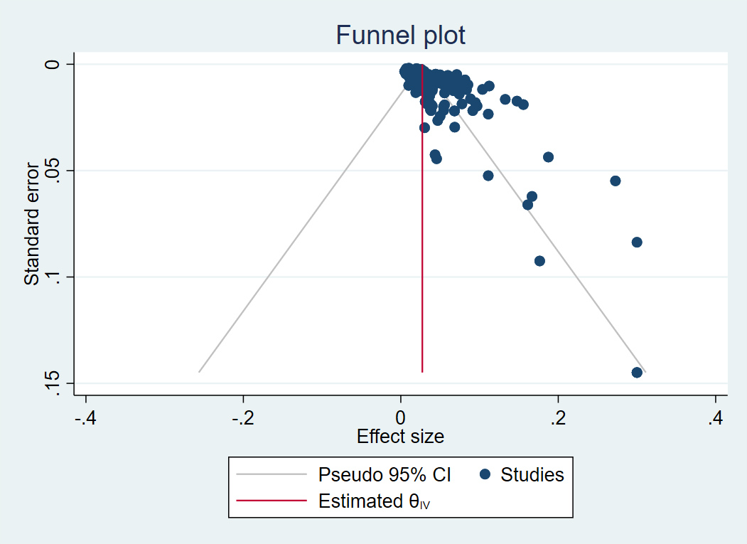
The spots represented included studies which reported the reimplantation rate, and were orientated by the reimplantation rate (the X axis)
and the standard error of the reimplantation rate (the Y axis). The red line means the synthesized rate of cochlear reimplantation.

