Heat and mortality in New York City since the beginning of the 20th century
eAppendix
______

R Code for the main analysis………………………………………………… ………………….2
eFigures
eFigure 1 Mean summer temperature histograms for New York City by decade…...……………6
eFigure 2 Temperature – mortality curves of overall cumulative relative risk for New York City by decade (separate plots)……………………………………………………………..…………..7
eFigure 3 Lagged relative risks at 29°C relative to 22°C by decade (separate plots)………….....8
eFigure 4 Temperature – mortality curves for the 15-44 age group………………………………9
eFigure 5 Lag-mortality curves for the 15-44 age group…………………………………...…….9
eFigure 6 Temperature – mortality curves for the 45-64 age group…………………….….……10
eFigure 7 Lag-mortality curves for the 45-64 age group………………………………...….…..10
eFigure 8 Temperature – mortality curves for the over 65 age group………………...…………11
eFigure 9 Lag-mortality curves for the for the over 65 age group………………. ………..……11
eTables
eTable 1 Annual deaths a) reported in the Summary of Vital Statistics for NYC and b) calculated from daily mortality data used in this study……………………………………….……..………12
eTable 2 Sensitivity analysis on lag duration and number of degrees of freedom for the temperature and lag…………………………………………………….………………..……….14
eTable 3 Akaike’s Information Criterion for quasi-Poisson (Q-AIC) for all models …..……... 15

R Code for main analysis
# LOAD PACKAGES
library(dlnm) ; library(splines) ; library(mvmeta)

# LOAD THE RAW DATA FOR SELECTED YEARS
rawdata <- subset(read.csv(file="NYC.csv"),
year%in%c(1900:1948,1973:2006))

# CREATE THE DATASET
data <- data.frame(
date = with(rawdata,as.Date(paste(year,month,day,sep="-"))),
year = rawdata$year,
month = rawdata$month,
day = rawdata$day,
dow = weekdays(with(rawdata,as.Date(paste(year,month,day,sep="-"))),abbr=T),
doy = as.numeric(format(with(rawdata,as.Date(paste(year,month,day,sep="-"))),"%j")),
death = rawdata$totalover15,
tmean = with(rawdata,((tmax-32)*5/9 + (tmin-32)*5/9)/2)
)

# CREATE DECADES
declow <- 1900+c(0,10,20,30,40,73,80,90,100)
dechigh <- 1900+c(9,19,29,39,48,79,89,99,106)
decadelab1 <- paste(declow,dechigh,sep=" - ")
decadelab2 <- paste(1900+c(0:4,7:10)*10,"s",sep="")
data$decade <- cut(data$year,breaks=1900+c(0:4,7:11)*10,
labels=decadelab2,right=F)

# RESTRICT TO SUMMER MONTHS
datasum <- subset(data, month%in%6:9)
#############################################################################
# REGRESSION MODELS
# CREATE A LIST OF PREDICTION FROM DLNM FOR EACH DECADE
predlist <- lapply(levels(datasum$decade), function(sub) {

# SELECT DATA
datadec <- datasum[datasum$decade==sub,]
range <- c(ceiling(min(datadec$tmean,na.rm=T)),
floor(max(datadec$tmean,na.rm=T)))
# CREATE THE CROSS-BASIS FOR A SEASONAL ANALYSIS:
# - QUADRATIC SPLINE WITH 4 DF (TWO EQUALLY SPACED KNOTS) FOR TEMPERATURE
# - NATURAL SPLINE WITH 4 DF (2 KNOTS IN LOG SCALE) FOR LAG
varknots <- equalknots(datadec$tmean,fun="bs",degree=2,df=4)
lagknots <- logknots(5,fun="ns",df=4)
cb <- crossbasis(datadec$tmean,lag=5,argvar=list(fun="bs",degree=2,
knots=varknots,cen=22),arglag=list(knots=lagknots),group=datadec$year)

# RUN THE MODEL
model <- glm(death ~ cb+dow+ns(doy,4)+ns(year,2),family=quasipoisson(),datadec)

# RETURN THE PREDICTION
return(crosspred(cb,model,at=range[1]:range[2],bylag=0.2))
})
names(predlist) <- decadelab2

#############################################################################
# COMPARISON BETWEEN PERIODS AND TEST ON TREND
# CREATE VECTOR OF ESTIMATES AND VARIANCES
est <- sapply(predlist,function(x) x$allfit["29"])
var <- sapply(predlist,function(x) x$allse["29"])^2

# CREATE META-VARIABLE WITH PERIODS AND TREND
period <- factor(rep(c("1900-1948","1973-2006"),c(5,4)))
trend <- seq(period)

# COMPARE PERIODS
meta1 <- mvmeta(est~period,var)
summary(meta1)
newdata <- data.frame(period=unique(period),row.names=unique(period))
exp(predict(meta1,newdata,ci=T))

# TEST ON TREND (ONLY SECOND PERIOD)
meta2 <- mvmeta(est~trend,var,subset=period=="1973-2006")
summary(meta2)
exp(predict(meta2,ci=T))
(1-exp(coef(meta2)[2]))*100
(1-exp(coef(meta2)[2]+1.96*sqrt(vcov(meta2)[2,2])))*100
(1-exp(coef(meta2)[2]-1.96*sqrt(vcov(meta2)[2,2])))*100

############################################################################
# TABLES
# TABLE 1
tab1 <- cbind(
mean = tapply(data$tmean,data$decade,mean,na.rm=T),
"90th" = tapply(data$tmean,data$decade,quantile,0.9,na.rm=T),
"95th" = tapply(data$tmean,data$decade,quantile,0.95,na.rm=T),
"99th" = tapply(data$tmean,data$decade,quantile,0.99,na.rm=T)
)
format(tab1,digits=3)

# TABLE 2 (FOR ALL-CAUSE MORTALITY ONLY)
tab2 <- t(sapply(predlist, function(x) with(x,cbind(allRRfit,allRRlow,
allRRhigh)[as.character("29"),])))
colnames(tab2) <- c("Est","95%CIlow","95%CIhigh")
format(tab2,digits=3)

#############################################################################
# FIGURES
col <- rev(rainbow(length(predlist)))
# FIGURE 1
pdf("fig1.pdf",width=5,height=4)
layout(1)
par(mar=c(4.5,4,1,1))

plot(predlist[[1]],"overall",type="n",ci="n",col=1,ylim=c(0.8,4),xlim=c(5,35),
lwd=1.5,ylab="Relative Risk",xlab="Mean Temperature (°C)")

for(i in seq(predlist)) lines(predlist[[i]],col=col[i])

legend("topleft",decadelab2,col=col,lwd=1.5,bty="n",cex=0.7,ncol=3)

dev.off()

# FIGURE 2
pdf("fig2.pdf",width=5,height=4)
layout(1)
par(mar=c(4.5,4,1,1))

plot(predlist[[1]],var=29,type="n",ci="n",col=1,ylim=c(0.9,1.3),
ylab="Relative Risk",xlab="Lag (Days)")

for(i in seq(predlist)) lines(predlist[[i]],var=29,col=col[i])

legend("topright",decadelab2,col=col,lwd=1.5,bty="n",cex=0.7,ncol=3)

dev.off()

# FIGURE 3
pdf("fig3.pdf",width=8,height=5)
par(mar=c(4,4,1,2))
layout(1)

plot(1:12,seq(1,1.5,length=12),type="n",xaxt="n",xlab="Decade",
ylab="Cumulative Relative Risk at 29°C vs 22°C",frame.plot=F)
axis(1,at=1:12,labels=F)
axis(1,at=1:11+0.5,labels=paste(1900+0:10*10,"s",sep=""),tick=F,cex.axis=0.8)

seqdec <- c(1:5,8:11)+0.5
for(i in seq(predlist)) {
points(seqdec[i],predlist[[i]]$allRRfit["29"],pch=19,cex=1.3)
arrows(seqdec[i],predlist[[i]]$allRRlow["29"],seqdec[i],
predlist[[i]]$allRRhigh["29"],code=3,angle=90,length=0.03,lwd=1)
}
abline(h=1)

dev.off()
#

eFigures
eFigure 1 Mean summer temperature histograms for New York City by decade, 1900s-2000s 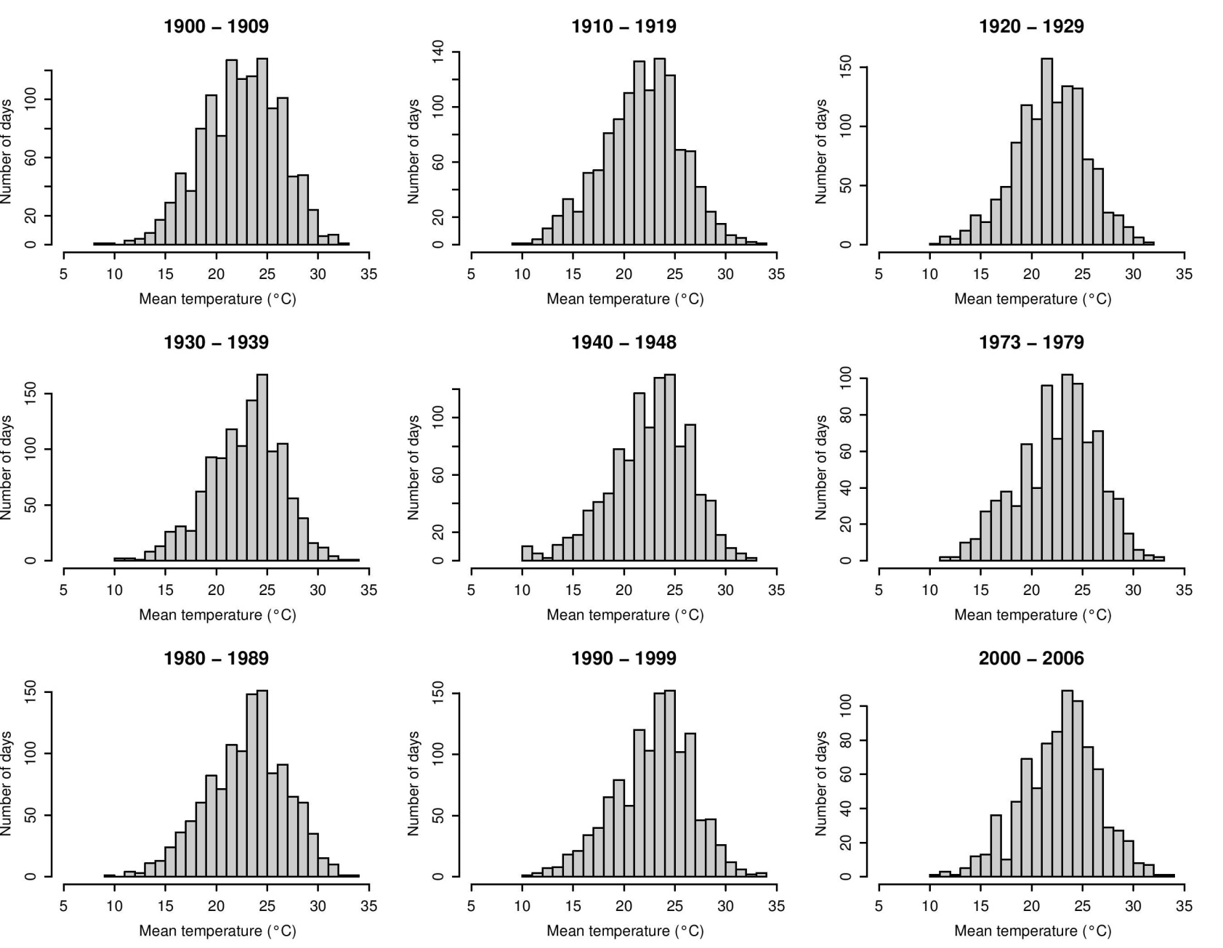
eFigure 2 Temperature – mortality curves of overall cumulative relative risk for New York City by decade, 1900s -2000s (separate plots). Calculated using a distributed lag non-linear model with a quadratic spline with 4 degrees of freedom for the temperature and a natural cubic spline with 4 degrees of freedom for the lag and 22°C as a reference temperature.
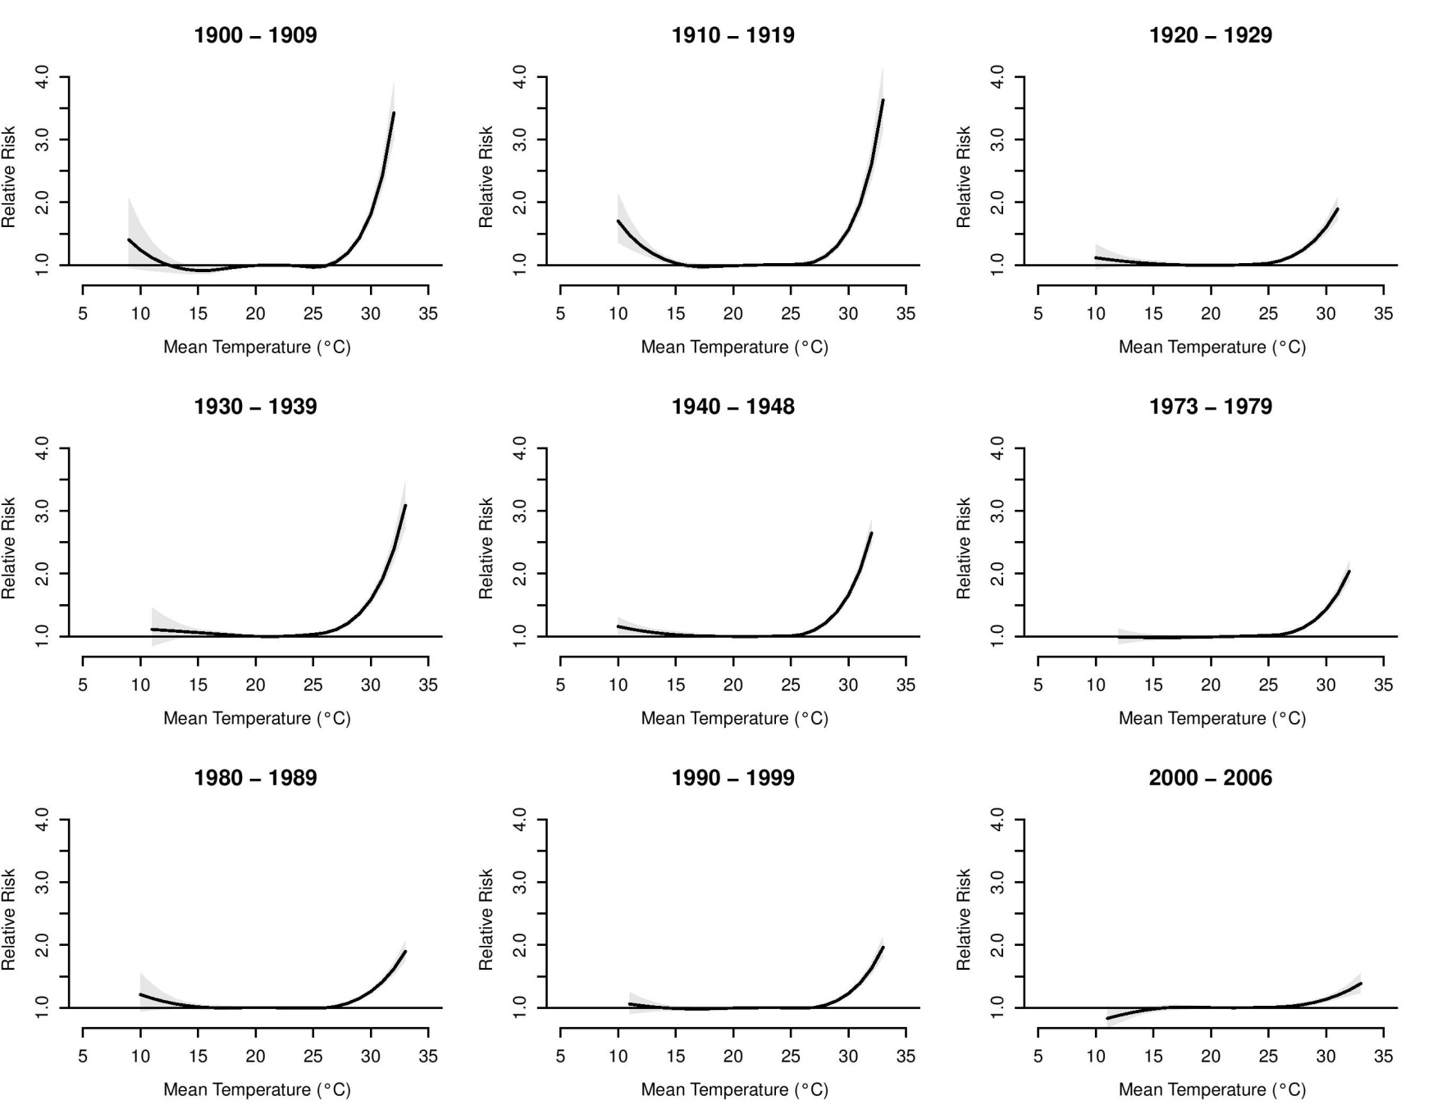
eFigure 3 Lagged relative risks at 29°C relative to 22°C by decade, 1900s-2000s (separate charts). Calculated using a distributed lag non-linear model with a quadratic spline with 4 degrees of freedom for the temperature and a natural cubic spline with 4 degrees of freedom for the lag.
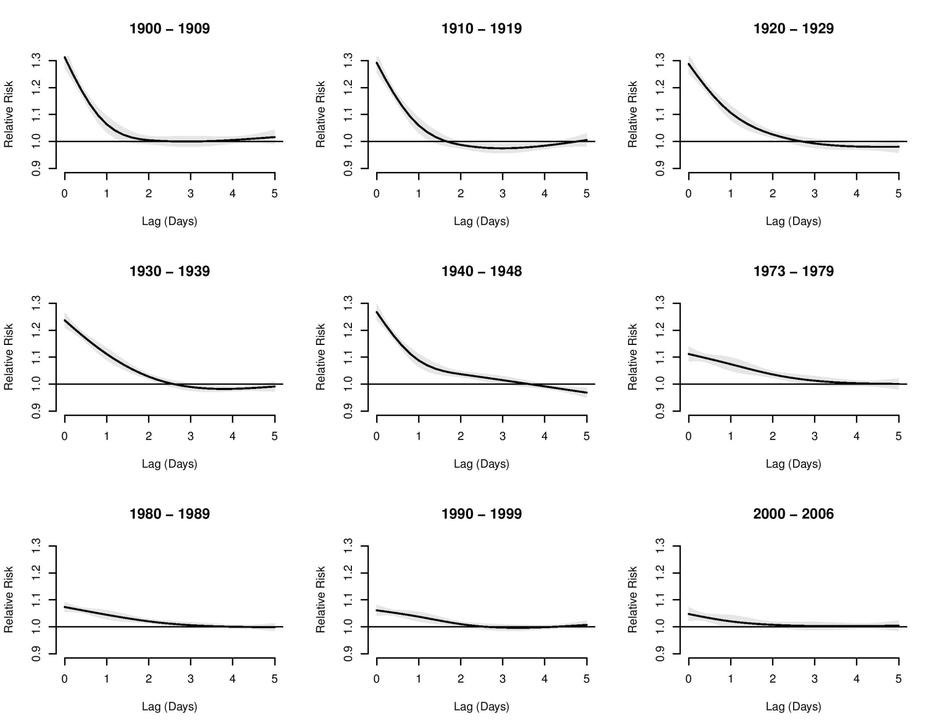

eFigure 4 Temperature – mortality curves of overall cumulative risk for New York City by decade, 1900s -2000s for the 15-44 age group. Calculated using a distributed lag non-linear model with a quadratic spline with 4 degrees of freedom for the temperature and a natural cubic spline with 4 degrees of freedom for the lag and 22°C (corresponding to approximately the 80th percentile of annual temperature) as a reference temperature.

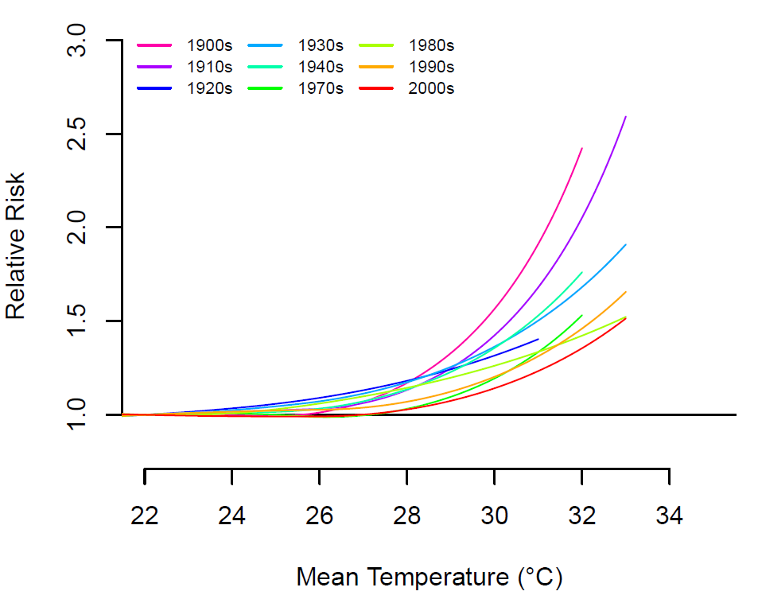

eFigure 5 Lag-mortality curve associated with 29°C (corresponding to approximate the 99th percentile of annual temperature) relative to 22°C (corresponding to approximately the 80th percentile of annual temperature) on mortality in New York City by decade, 1900s-2000s for the 15-44 age group. Calculated using a distributed lag non-linear model with a quadratic spline with 4 degrees of freedom for the temperature and a natural cubic spline with 4 degrees of freedom for the lag.
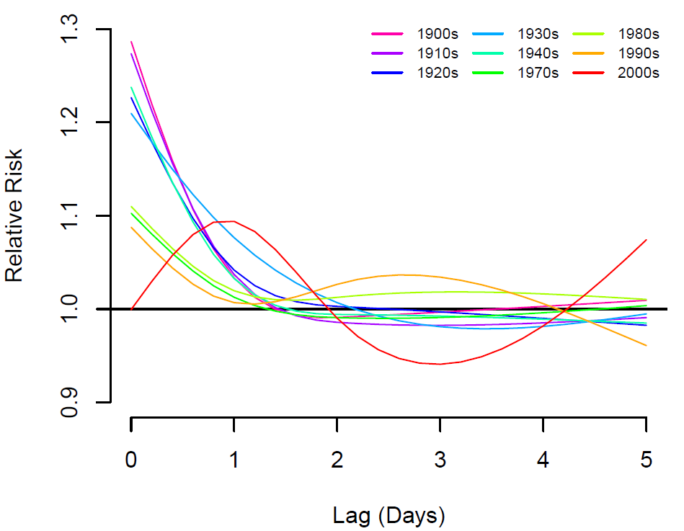

eFigure 6 Temperature – mortality curves of overall cumulative risk for New York City by decade, 1900s -2000s, for the 45-64 age group. Calculated using a distributed lag non-linear model with a quadratic spline with 4 degrees of freedom for the temperature and a natural cubic spline with 4 degrees of freedom for the lag and 22°C (corresponding to approximately the 80th percentile of annual temperature) as a reference temperature.

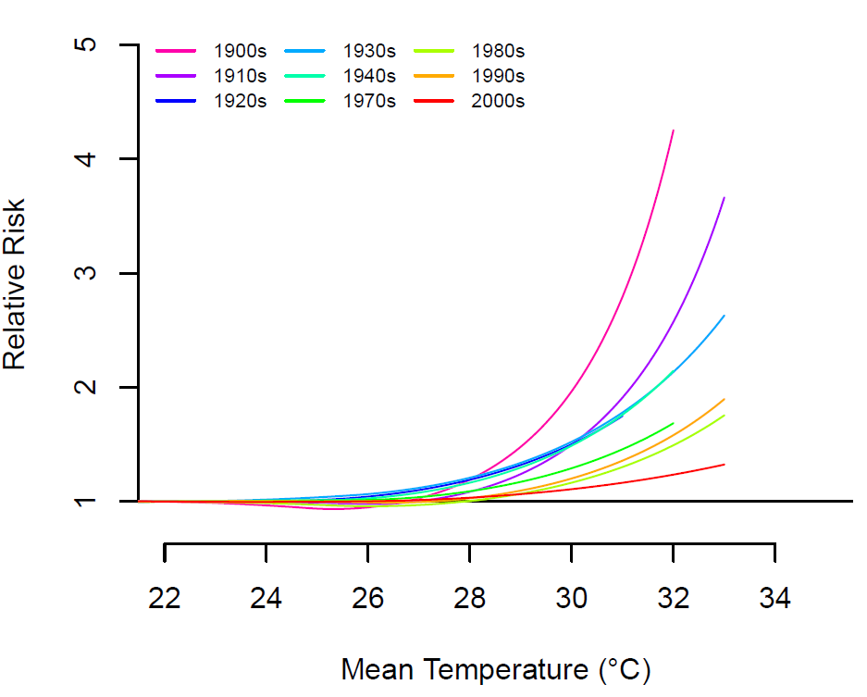

eFigure 7 Lag-mortality curve associated with 29°C (corresponding to approximate the 99th percentile of annual temperature) relative to 22°C (corresponding to approximately the 80th percentile of annual temperature) on mortality in New York City by decade, 1900s-2000s, for the 45-64 age group. Calculated using a distributed lag non-linear model with a quadratic spline with 4 degrees of freedom for the temperature and a natural cubic spline with 4 degrees of freedom for the lag.
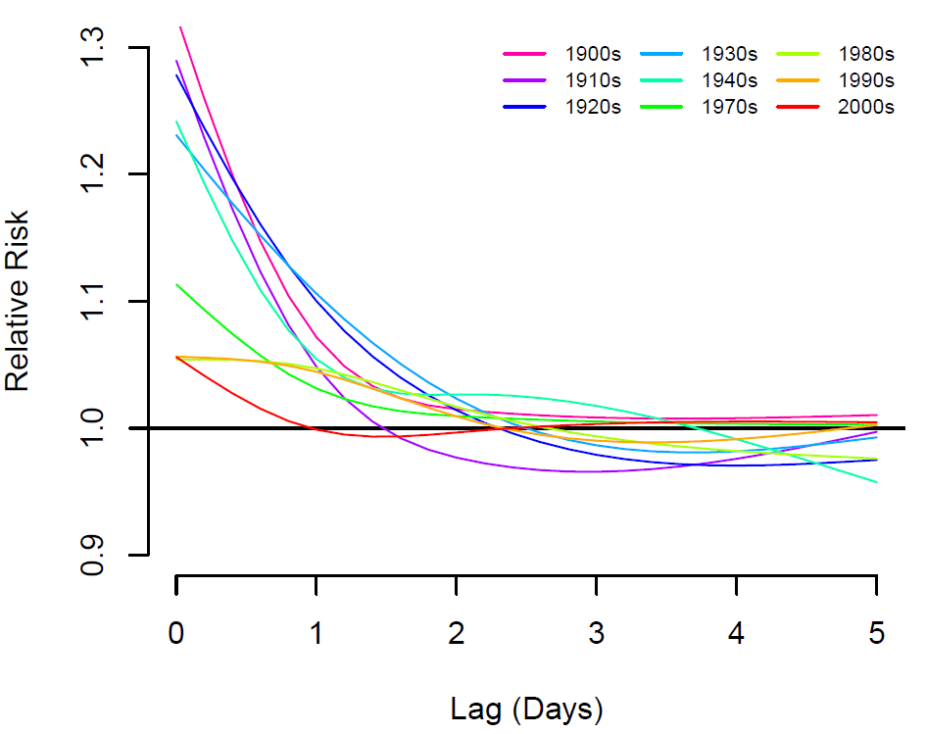

eFigure 8 Temperature – mortality curves of overall cumulative risk for New York City by decade, 1900s -2000s, for the over 65 age group. Calculated using a distributed lag non-linear model with a quadratic spline with 4 degrees of freedom for the temperature and a natural cubic spline with 4 degrees of freedom for the lag and 22°C (corresponding to approximately the 80th percentile of annual temperature) as a reference temperature.

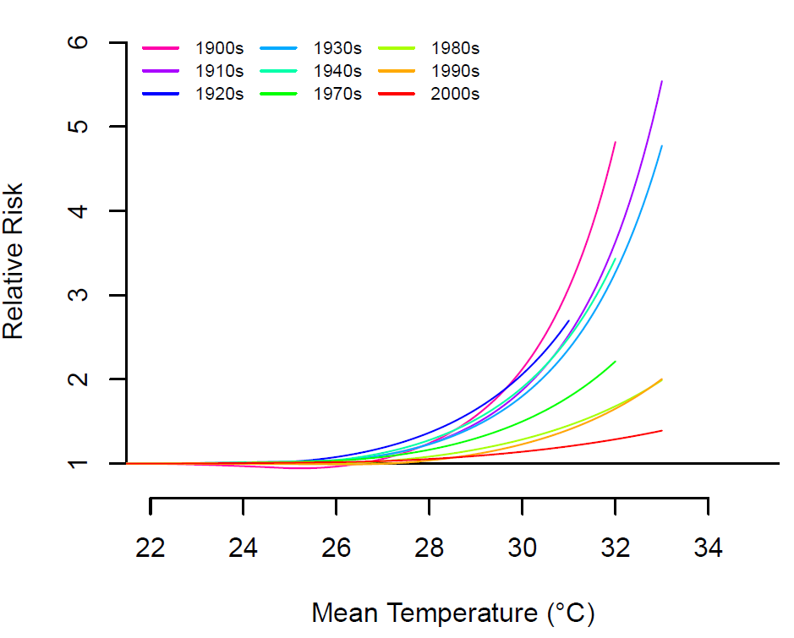

eFigure 9 Lag-mortality curve associated with 29°C (corresponding to approximate the 99th percentile of annual temperature) relative to 22°C (corresponding to approximately the 80th percentile of annual temperature) on mortality in New York City by decade, 1900s-2000s, for the over 65 age group. Calculated using a distributed lag non-linear model with a quadratic spline with 4 degrees of freedom for the temperature and a natural cubic spline with 4 degrees of freedom for the lag.

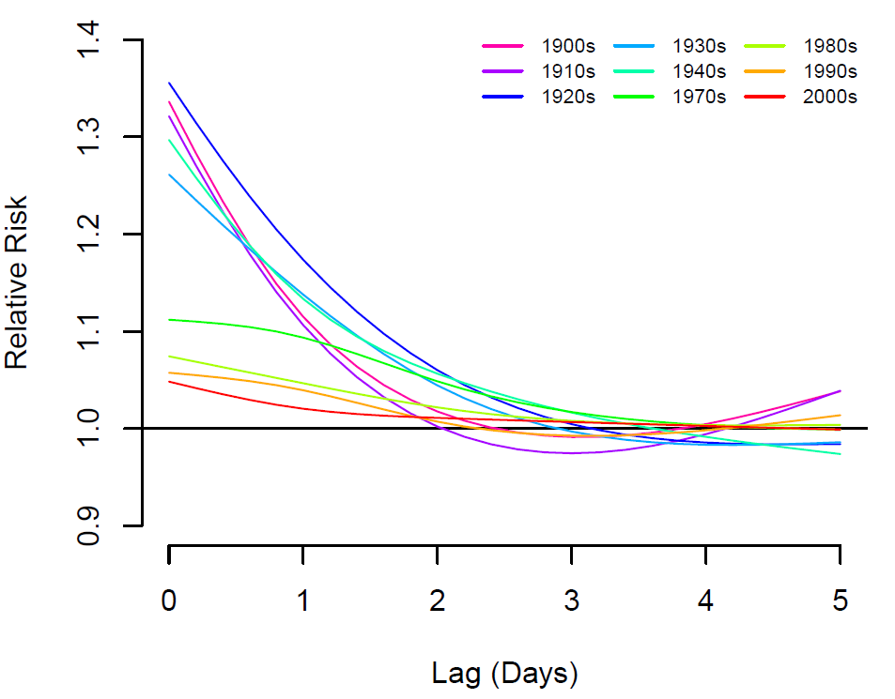

eTable 1 Annual deaths a) reported in the Summary of Vital Statistics for NYC and b) calculated from daily mortality data used in this study.
Year | Reported deaths ª | Calculated deaths ^{b} | Difference, % of reported
1898 | 66294 | 66473 | 0.27
1899 | 65343 | 65623 | 0.43
1900 | 70872 | 71356 | 0.68
1901 | 70980 | 70993 | 0.02
1902 | 68132 | 68361 | 0.34
1903 | 67864 | 68252 | 0.57
1904 | 78060 | 78388 | 0.42
1905 | 73714 | 74317 | 0.82
1906 | 76203 | 76746 | 0.71
1907 | 79205 | 79651 | 0.56
1908 | 73072 | 73575 | 0.69
1909 | 74375 | 74557 | 0.24
1910 | 76742 | 77714 | 1.27
1911 | 75423 | 75934 | 0.68
1912 | 73013 | 73311 | 0.41
1913 | 70902 | 74408 | 4.94
1914 | 74803 | 75755 | 1.27
1915 | 76193 | 78210 | 2.65
1916 | 78307 | 78873 | 0.72
1917 | 78575 | 78802 | 0.29
1918 | 98119 | 98904 | 0.80
1919 | 74433 | 75534 | 1.48
1920 | 73249 | 74831 | 2.16
1921 | 64257 | 65802 | 2.40
1922 | 69690 | 71466 | 2.55
1923 | 69452 | 71514 | 2.97
1924 | 71252 | 73250 | 2.80
1925 | 71914 | 73098 | 1.65
1926 | 76082 | 77157 | 1.41
1927 | 70430 | 71073 | 0.91
1928 | 78091 | 79387 | 1.66
1929 | 77482 | 79245 | 2.28
1930 | 74888 | 77077 | 2.92
1931 | 77418 | 78619 | 1.55
1932 | 74319 | 75345 | 1.38
1933 | 75153 | 76174 | 1.36
1934 | 75857 | 76927 | 1.41
1935 | 75057 | 76064 | 1.34
1936 | 77638 | 77996 | 0.46
1937 | 77465 | 77716 | 0.32
1938 | 73775 | 74033 | 0.35
1939 | 75439 | 75762 | 0.43
1940 | 76008 | 76576 | 0.75
1941 | 74553 | 75174 | 0.83
1942 | 75675 | 76363 | 0.91
1943 | 83174 | 83971 | 0.96
1944 | 78783 | 79528 | 0.95
1945 | 79726 | 80620 | 1.12
1946 | 78481 | 79477 | 1.27
1947 | 80733 | 82680 | 2.41
1948 | 81651 | 82864 | 1.49

eTable 2 Sensitivity analysis on lag duration and number of degrees of freedom for the temperature and lag. Overall cumulative relative risk at 29˚C (corresponding to approximately the 99th percentile of annual temperature) relative to 22°C (corresponding to approximately the 80th percentile of annual temperature) on mortality in adults (age 15 or older) in New York City by decade, 1900s-2000s.
Model | lag | lag df | temp df | 1900 - 1909 | 1910 - 1919 | 1920 - 1929 | 1930 - 1939 | 1940 - 1948 | 1973 - 1979 | 1980 - 1989 | 1990 - 1999 | 2000 - 2006
main | 5 | 4 | 4 | 1.43 (1.37,1.49) | 1.30 (1.25,1.36) | 1.39 (1.34,1.45) | 1.36 (1.32,1.41) | 1.39 (1.35,1.44) | 1.26 (1.22,1.29) | 1.15 (1.12,1.17) | 1.11 (1.09,1.14) | 1.09 (1.05,1.12)
2 | 5 | 3 | 4 | 1.43 (1.37,1.49) | 1.30 (1.24,1.35) | 1.39 (1.33,1.45) | 1.36 (1.31,1.40) | 1.39 (1.35,1,43) | 1.26 (1.22,1.29) | 1.15 (1.12,1.17) | 1.11 (1.09,1.14) | 1.08 (1.05,1.12)
3 | 5 | 3 | 5 | 1.25 (1.19,1.31) | 1.24 (1.17,1.32) | 1.35 (1.29,1.42) | 1.29 (1.24,1.34) | 1.33 (1.29,1.38) | 1.24 (1.20,1.29) | 1.14 (1.11,1.17) | 1.07 (1.04,1.11) | 1.09 (1.04,1.13)
4 | 5 | 3 | 6 | 1.16 (1.10,1.22) | 1.29 (1.21,1.37) | 1.32 (1.25,1.38) | 1.24 (1.18, 1.30) | 1.29 (1.24, 1.34) | 1.25 (1.20, 1.31) | 1.13 (1.10, 1.16) | 1.09 (1.05, 1.12) | 1.09 (1.04,1.13)
5 | 5 | 4 | 5 | 1.26 (1.20,1.32) | 1.25 (1.18,1.32) | 1.36 (1.30, 1.42) | 1.30 (1.25, 1.35) | 1.34 (1.29, 1.39) | 1.24 (1.20, 1.29) | 1.14 (1.11, 1.17) | 1.08 (1.04, 1.11) | 1.09 (1.04, 1.13)
6 | 5 | 4 | 6 | 1.16 (1.11, 1.22) | 1.30 (1.23, 1.38) | 1.32 (1.26, 1.39) | 1.25 (1.19, 1.31) | 1.30 (1.24, 1.35) | 1.26 (1.21, 1.31) | 1.13 (1.10, 1.17) | 1.09 (1.06, 1.12) | 1.09 (1.04, 1.13)
7 | 5 | 5 | 4 | 1.42 (1.36, 1.48) | 1.30 (1.25, 1.36) | 1.39 (1.33, 1.45) | 1.36 (1.32, 1.41) | 1.39 (1.34, 1.43) | 1.25 (1.22, 1.29) | 1.15 (1.12, 1.17) | 1.11 (1.08, 1.14) | 1.08 (1.05, 1.12)
8 | 5 | 5 | 5 | 1.25 (1.20, 1.31) | 1.25 (1.18, 1.33) | 1.36 (1.30, 1.42) | 1.29 (1.24, 1.34) | 1.34 (1.29, 1.38) | 1.24 (1.20, 1.28) | 1.14 (1.11, 1.17) | 1.07 (1.04, 1.11) | 1.08 (1.04, 1.13)
9 | 5 | 5 | 6 | 1.16 (1.11, 1.22) | 1.30 (1.23, 1.38) | 1.32 (1.25, 1.38) | 1.25 (1.19, 1.31) | 1.29 (1.24, 1.34) | 1.25 (1.20, 1.30) | 1.13 (1.10, 1.17) | 1.09 (1.05, 1.12) | 1.09 (1.04, 1.13)
10 | 10 | 3 | 4 | 1.35 (1.28, 1.43) | 1.28 (1.20, 1.36) | 1.20 (1.12, 1.28) | 1.28 (1.22, 1.35) | 1.29 (1.24, 1.35) | 1.25 (1.20, 1.31) | 1.15 (1.11, 1.18) | 1.12 (1.08, 1.16) | 1.11 (1.06, 1.15)
11 | 10 | 3 | 5 | 1.16 (1.09, 1.24) | 1.24 (1.14, 1.36) | 1.19 (1.12, 1.28) | 1.22 (1.16, 1.29) | 1.23 (1.17, 1.29) | 1.23 (1.17, 1.29) | 1.13 (1.09, 1.17) | 1.08 (1.04, 1.12) | 1.10 (1.04, 1.16)
12 | 10 | 3 | 6 | 1.10 (1.02, 1.18) | 1.33 (1.22, 1.46) | 1.19 (1.11, 1.28) | 1.17 (1.10, 1.25) | 1.19 (1.13, 1.26) | 1.23 (1.17, 1.30) | 1.12 (1.08, 1.17) | 1.10 (1.06, 1.14) | 1.10 (1.05, 1.16)
13 | 10 | 4 | 4 | 1.36 (1.29, 1.44) | 1.29 (1.22, 1.36) | 1.22 (1.15, 1.30) | 1.30 (1.24, 1.36) | 1.30 (1.25, 1.36) | 1.26 (1.21, 1.31) | 1.15 (1.12, 1.18) | 1.13 (1.09, 1.16) | 1.11 (1.07, 1.16)
14 | 10 | 4 | 5 | 1.17 (1.10, 1.25) | 1.26 (1.16, 1.37) | 1.22 (1.14, 1.30) | 1.24 (1.18, 1.30) | 1.25 (1.19, 1.31) | 1.23 (1.17, 1.29) | 1.13 (1.09, 1.17) | 1.09 (1.05, 1.13) | 1.11 (1.05, 1.16)
15 | 10 | 4 | 6 | 1.10 (1.03, 1.18) | 1.36 (1.25, 1.48) | 1.22 (1.14, 1.31) | 1.19 (1.12, 1.26) | 1.21 (1.15, 1.28) | 1.24 (1.17, 1.31) | 1.13 (1.08, 1.17) | 1.10 (1.06, 1.14) | 1.11 (1.05, 1.16)
16 | 10 | 5 | 4 | 1.36 (1.29, 1.44) | 1.28 (1.21, 1.35) | 1.22 (1.15, 1.30) | 1.29 (1.23, 1.35) | 1.31 (1.25, 1.36) | 1.25 (1.21, 1.31) | 1.15 (1.11, 1.18) | 1.12 (1.09, 1.16) | 1.11 (1.07, 1.16)
17 | 10 | 5 | 5 | 1.17 (1.10, 1.24) | 1.27 (1.17, 1.37) | 1.21 (1.14, 1.29) | 1.23 (1.17, 1.29) | 1.25 (1.19, 1.31) | 1.23 (1.17, 1.29) | 1.13 (1.09, 1.17) | 1.09 (1.05, 1.13) | 1.11 (1.05, 1.16)
18 | 10 | 5 | 6 | 1.11 (1.03, 1.18) | 1.36 (1.25, 1.48) | 1.22 (1.14, 1.30) | 1.18 (1.11, 1.25) | 1.22 (1.16, 1.28) | 1.24 (1.17, 1.31) | 1.13 (1.09, 1.17) | 1.10 (1.06, 1.14) | 1.11 (1.05, 1.16)

eTable 3 Akaike’s Information Criterion for quasi-Poisson (Q-AIC) for models presented in Table S 2
Model | lag | lag df | temp df | 1900 - 1909 | 1910 - 1919 | 1920 - 1929 | 1930 - 1939 | 1940 - 1948 | 1973 - 1979 | 1980 - 1989 | 1990 - 1999 | 2000 - 2006
main | 5 | 4 | 4 | 9962 | 9764 | 9523 | 9749 | 9221 | 7054 | 9705 | 9551 | 6505
2 | 5 | 3 | 4 | 9993 | 9832 | 9555 | 9784 | 9244 | 7053 | 9704 | 9554 | 6512
3 | 5 | 3 | 5 | 9716 | 9833 | 9534 | 9746 | 9201 | 7066 | 9706 | 9539 | 6510
4 | 5 | 3 | 6 | 9563 | 9852 | 9528 | 9735 | 9174 | 7065 | 9717 | 9550 | 6508
5 | 5 | 4 | 5 | 9690 | 9766 | 9500 | 9708 | 9187 | 7072 | 9708 | 9538 | 6506
6 | 5 | 4 | 6 | 9539 | 9786 | 9492 | 9689 | 9155 | 7074 | 9716 | 9551 | 6509
7 | 5 | 5 | 4 | 9931 | 9774 | 9533 | 9751 | 9213 | 7060 | 9713 | 9555 | 6503
8 | 5 | 5 | 5 | 9668 | 9779 | 9507 | 9703 | 9178 | 7080 | 9718 | 9545 | 6506
9 | 5 | 5 | 6 | 9529 | 9799 | 9502 | 9674 | 9150 | 7083 | 9727 | 9560 | 6511
10 | 10 | 3 | 4 | 9784 | 9639 | 9111 | 9471 | 8902 | 6771 | 9300 | 9180 | 6217
11 | 10 | 3 | 5 | 9489 | 9633 | 9105 | 9458 | 8859 | 6781 | 9303 | 9161 | 6219
12 | 10 | 3 | 6 | 9338 | 9652 | 9106 | 9451 | 8846 | 6784 | 9315 | 9163 | 6219
13 | 10 | 4 | 4 | 9566 | 9353 | 8925 | 9305 | 8727 | 6740 | 9280 | 9147 | 6209
14 | 10 | 4 | 5 | 9280 | 9341 | 8926 | 9272 | 8688 | 6754 | 9287 | 9129 | 6213
15 | 10 | 4 | 6 | 9140 | 9350 | 8925 | 9264 | 8672 | 6754 | 9301 | 9133 | 6212
16 | 10 | 5 | 4 | 9552 | 9320 | 8918 | 9273 | 8735 | 6745 | 9282 | 9147 | 6207
17 | 10 | 5 | 5 | 9269 | 9312 | 8921 | 9241 | 8699 | 6762 | 9289 | 9129 | 6214
18 | 10 | 5 | 6 | 9126 | 9325 | 8922 | 9235 | 8681 | 6765 | 9299 | 9136 | 6218

