eAppendix: Exposure assessment
Exposure data of particulate matter with an aerodynamic diameter smaller than 10 micrometers (PM₁₀), nitrogen dioxides (NO₂), and accumulated ozone (O₃-AOT40: Excess ozone accumulated over a threshold of 40 ppb) for the period 2001 to 2005 were obtained from the German Federal Environment Agency (Umweltbundesamt II). In brief, annual (PM₁₀, NO₂) and quinquennial (O₃) average concentrations for the ambient air pollutants are based on measurements of 150 German monitoring stations. These data are then smoothed on a grid with a cell size of eight by eight kilometers using the chemical REM-CALGRID (RCG) model which is continuously fitted with meteorological and air pollution time-series data from Germany and Europe^{1,2}. Average concentrations were calculated for each five-digit postcode area by intersection of the eight by eight kilometers grid with the German postcode map. Each postcode area obtained an area-weighted mean of PM₁₀, NO₂, and O₃ of covered raster cells. Intersection was done with ArcGIS (Version 9, Environmental Systems Research Institute (ESRI), California, USA). Further details of measures of air pollutants have been described elsewhere³.

- Flemming J, Reimer E, Stern R (2002) Data assimilation for CT-modelling based on optimum interpolation, in ITM Air pollution modelling and its applications XXIV, eds. C. Borrego und G. Schayes, NATO CMS, Kluwer Academic/Plenum Publishers, New York.
- Stern R, Flemming J (2004) Formulation of criteria to be used for the determination of the accuracy of model calculations according to the requirements of the EU Directives for air quality – Examples using the chemical transport model REM-CALGRID. Final report for the environmental agency of Germany (Umweltbundesamt). http://www.umweltbundesamt.de/sites/default/files/medien/publikation/long/3614.pdf . Accessed July 06, 2015.
- Tamayo T, Rathmann W, Krämer U, Sugiri D, Grabert M, Holl RW. Is particle pollution in outdoor air associated with metabolic control in type 2 diabetes? PLoS One. 2014; 9:e91639.

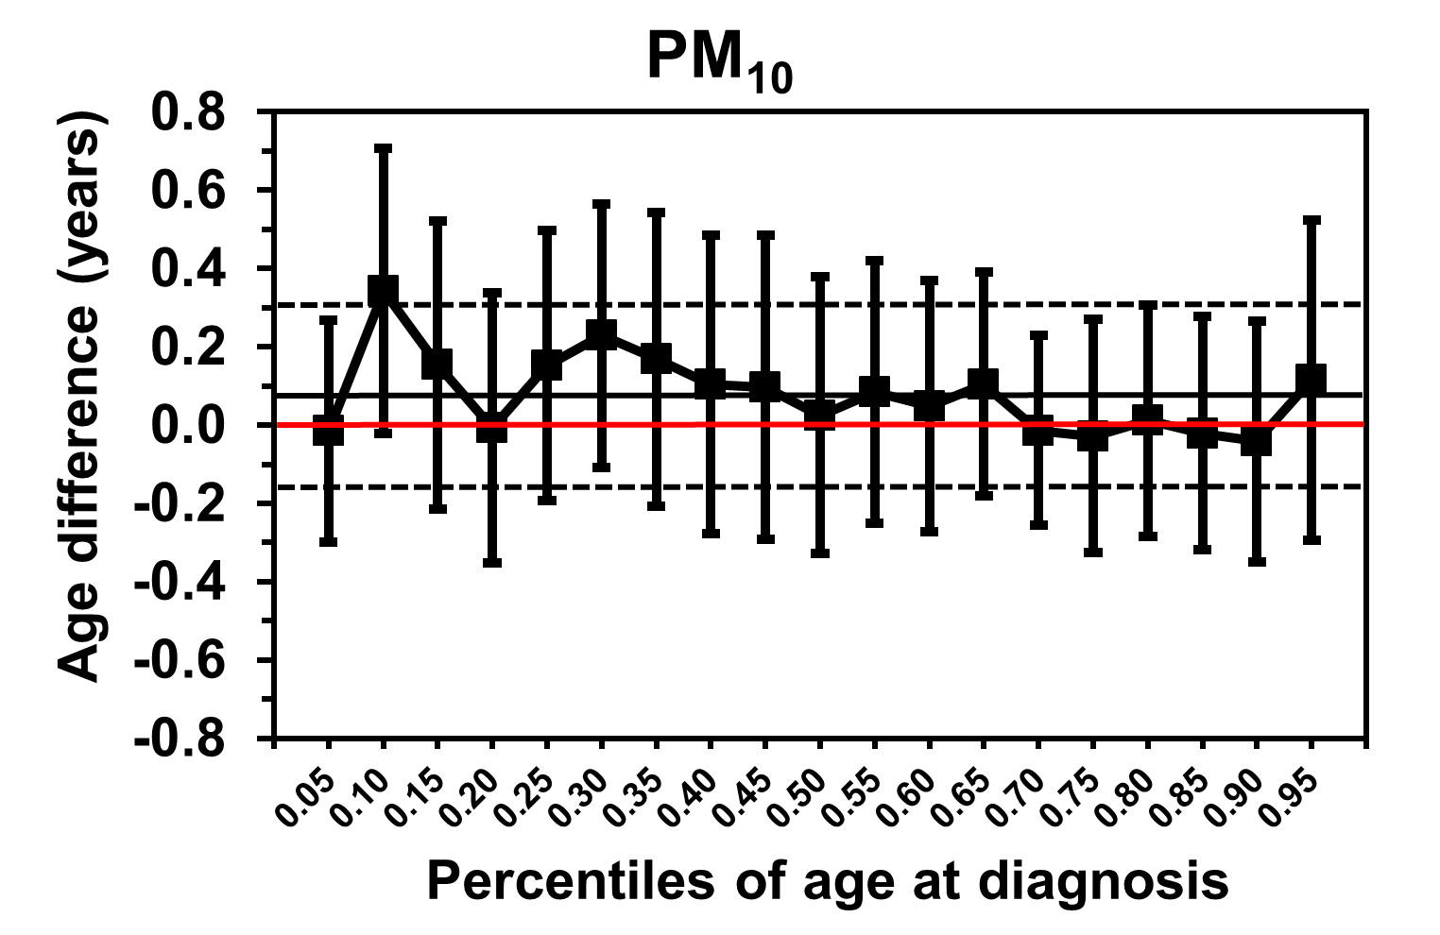 | 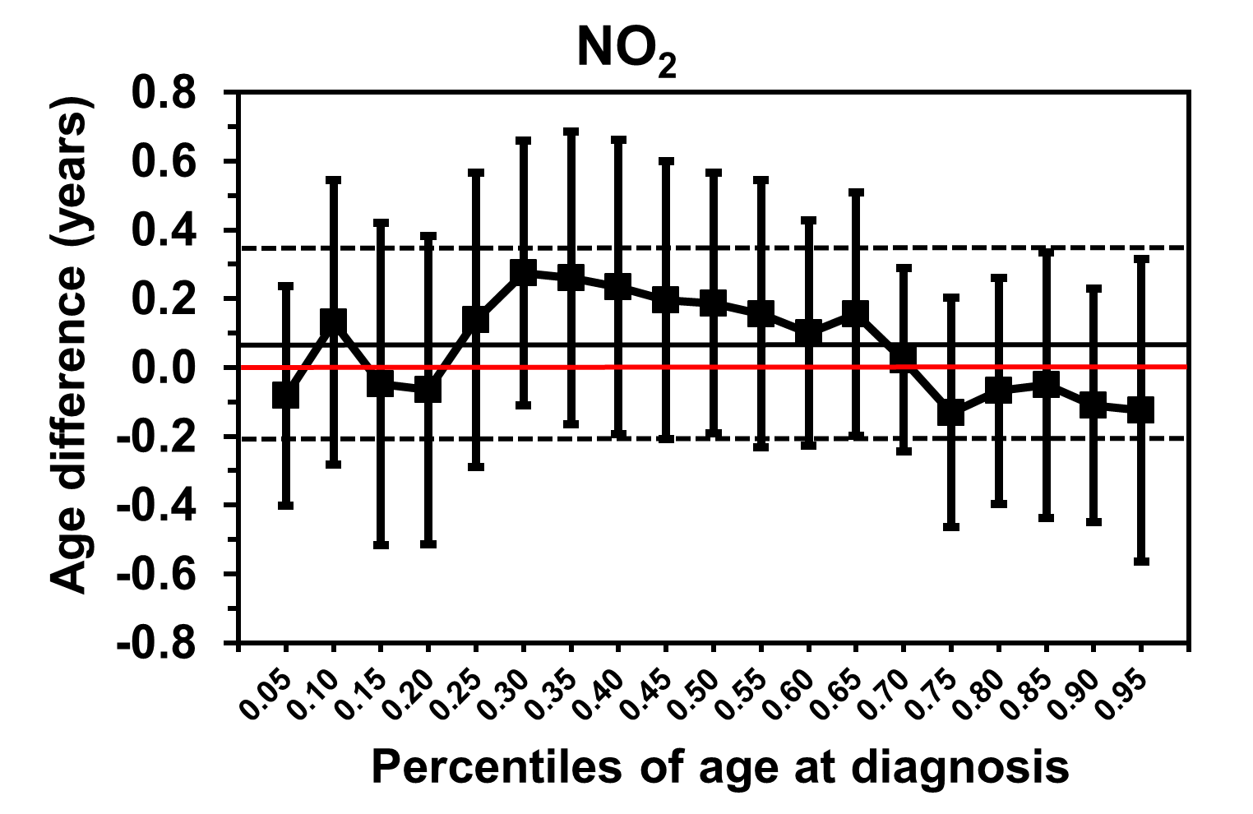 | 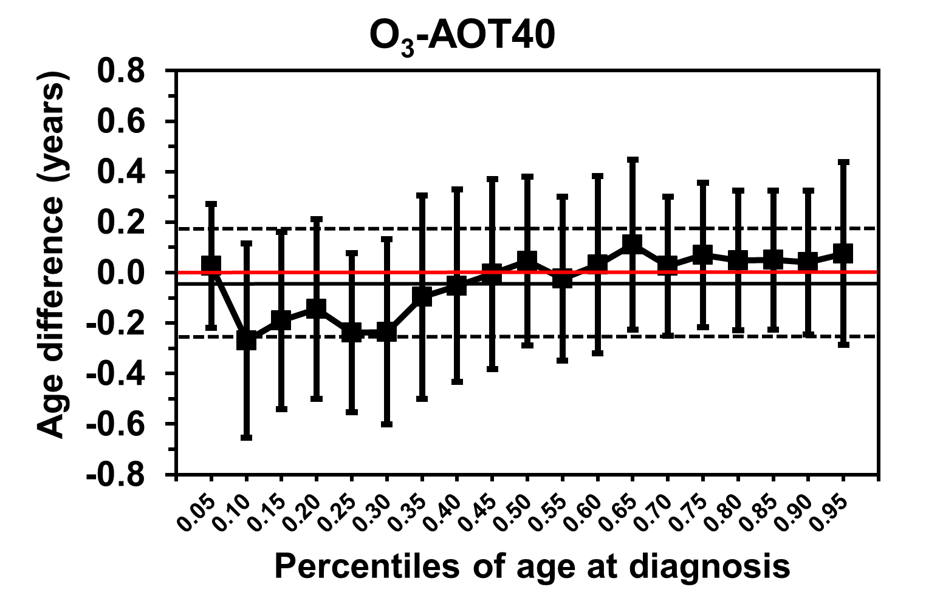
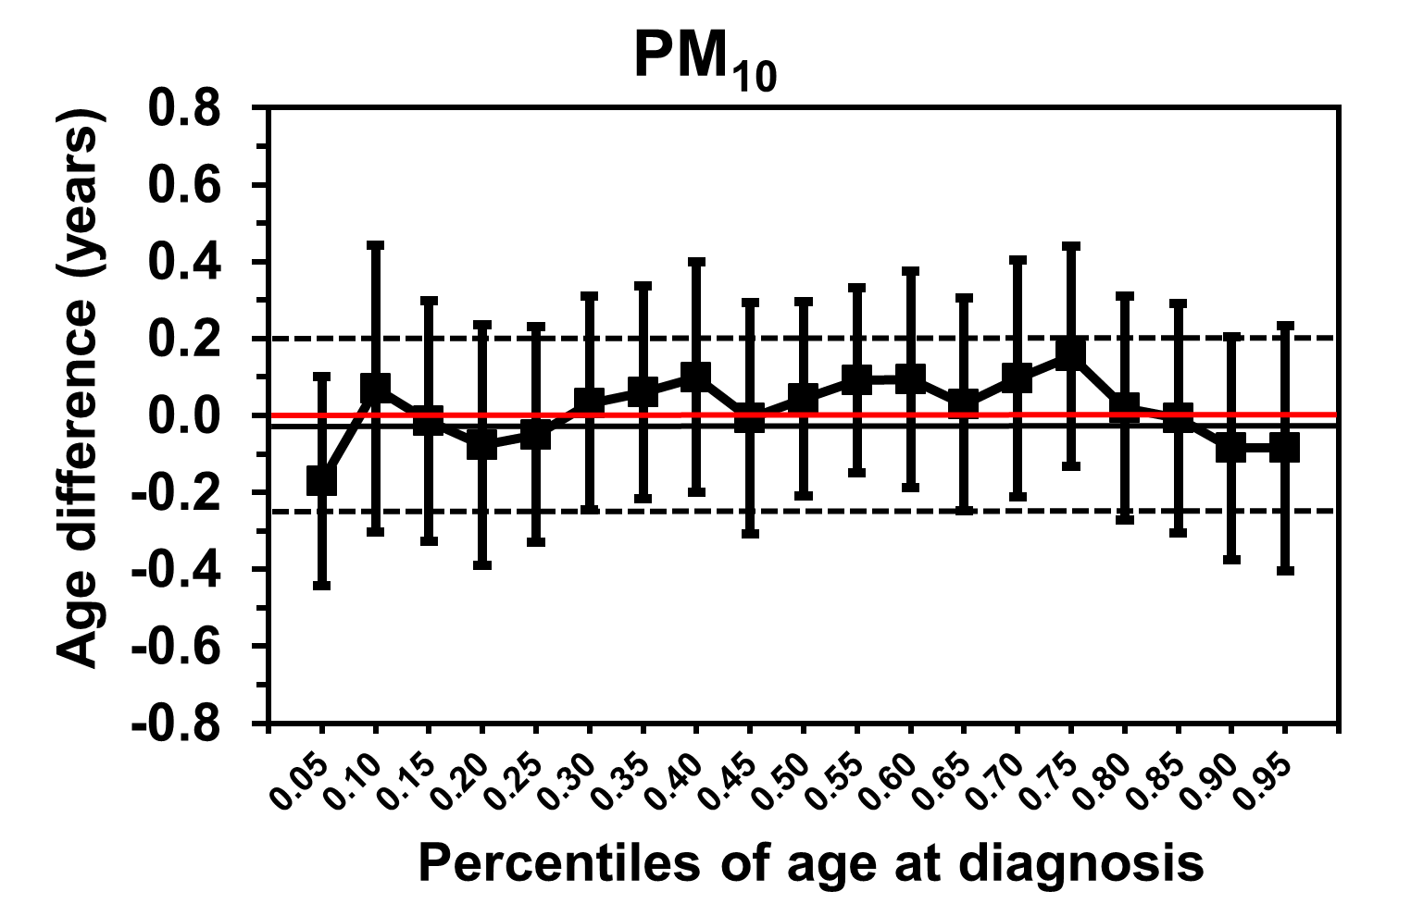 | 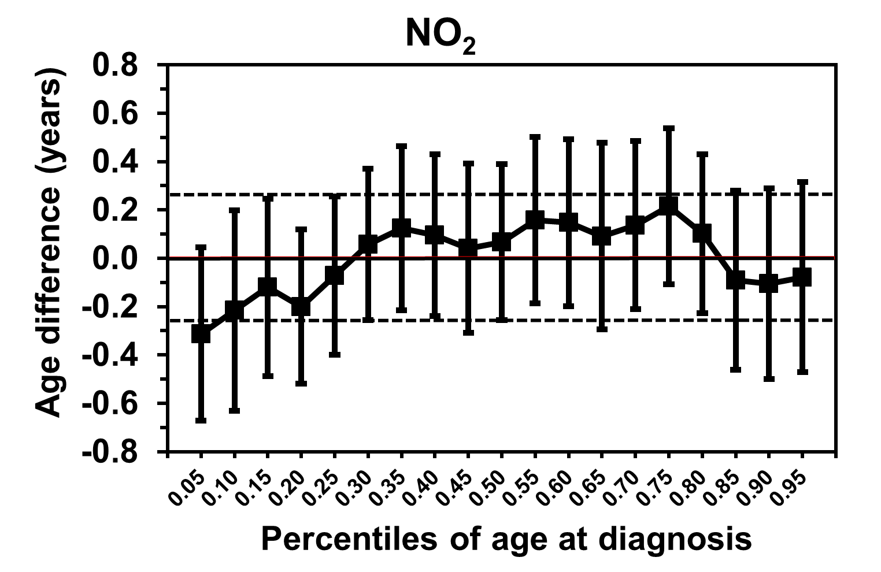 | 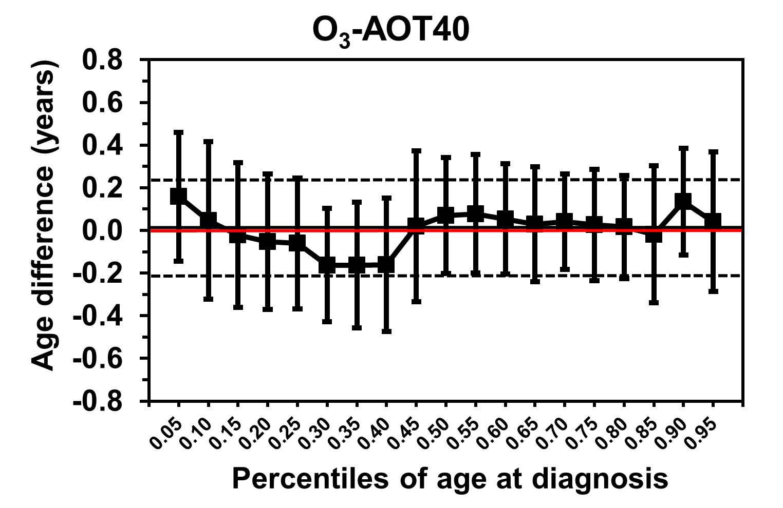

eFigure 1 Point estimates and 95% confidence intervals for differences in mean and percentiles (5th to 95th by 5%) of the age at diagnosis of type 1 diabetes per 2 SD increases in PM₁₀, NO₂, and O₃-AOT40 (accumulated ozone), adjusted for sex, German vs. Non-German nationality, German Index of Multiple Deprivation, family history of T1D, level of urbanization of residence (upper panel), and additionally for body mass index at onset (lower panel). The dots represent specific quantile regression estimates and are connected by dashes to visualize trends by age quantiles, the whiskers represent 95% CI. The horizontal black lines represent the linear regression coefficients and their respective confidence intervals. The horizontal red line depicts the age difference zero as reference. (Incident cases of 2006 to 2014, exposure data of 2001 to 2005.)

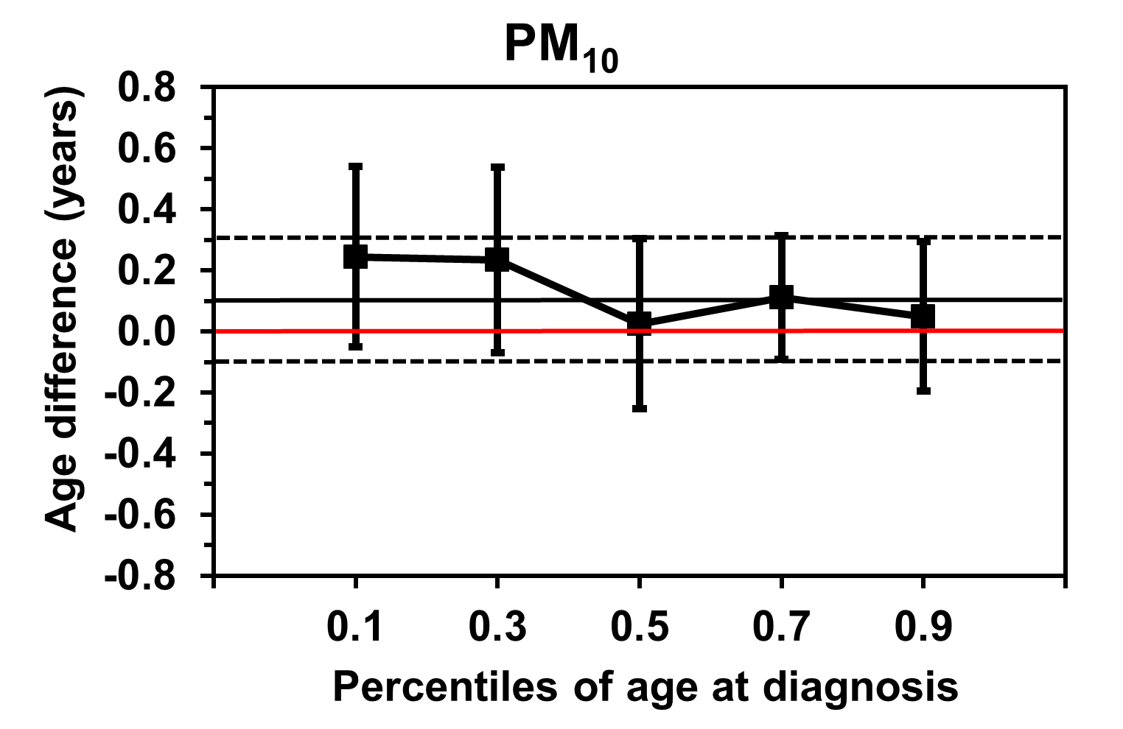 | 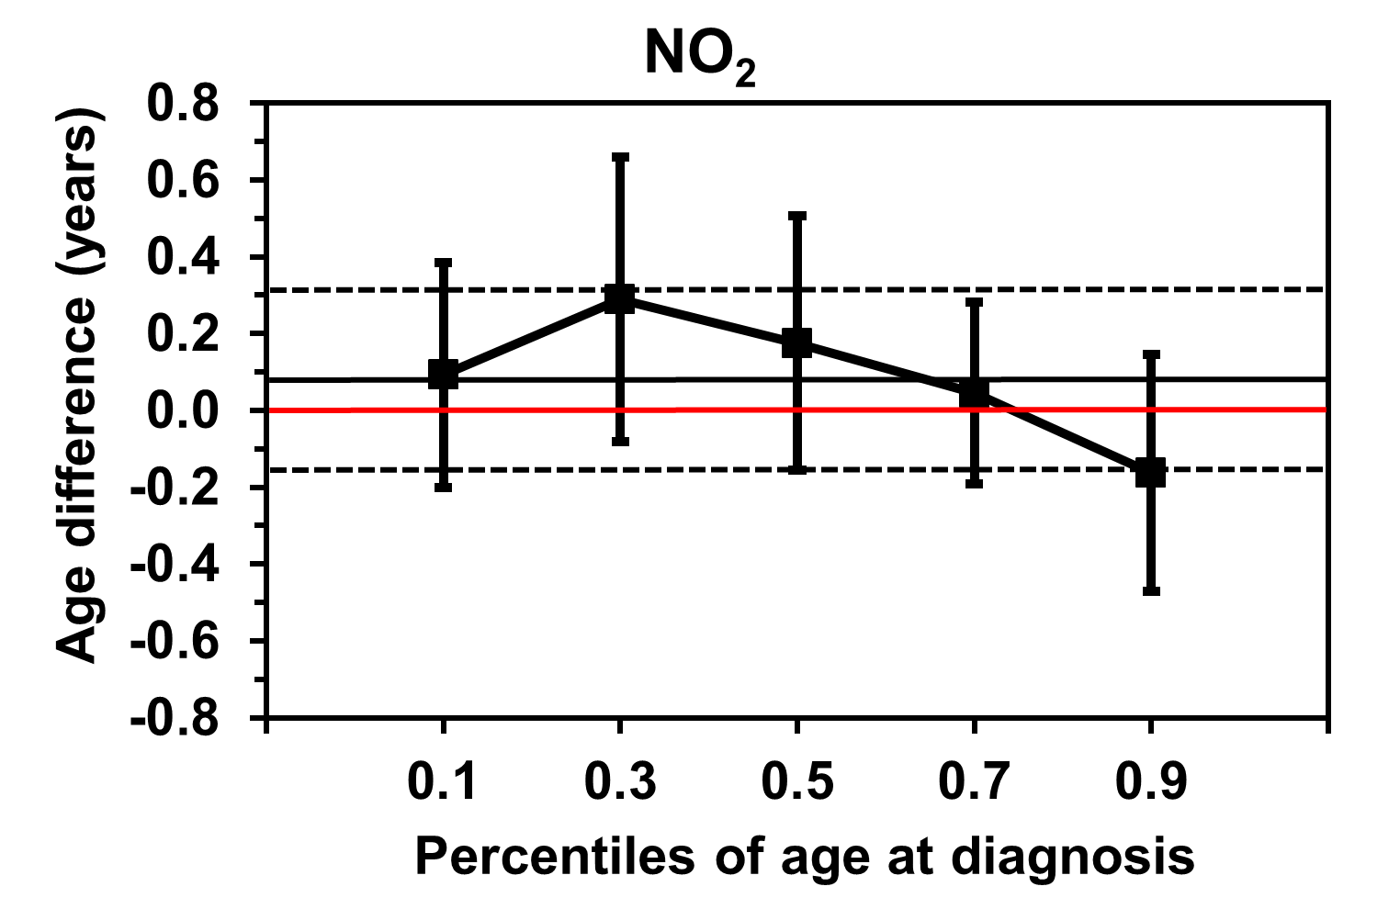 | 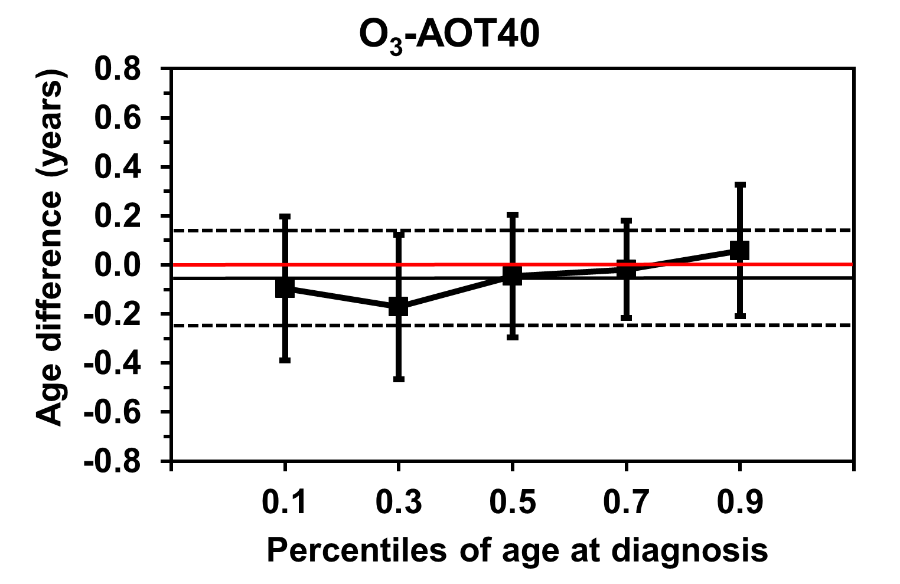
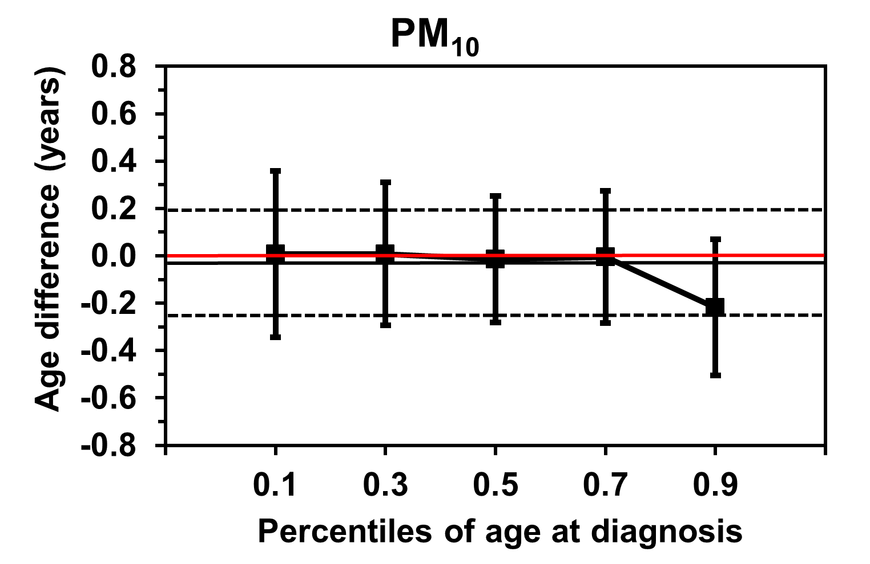 | 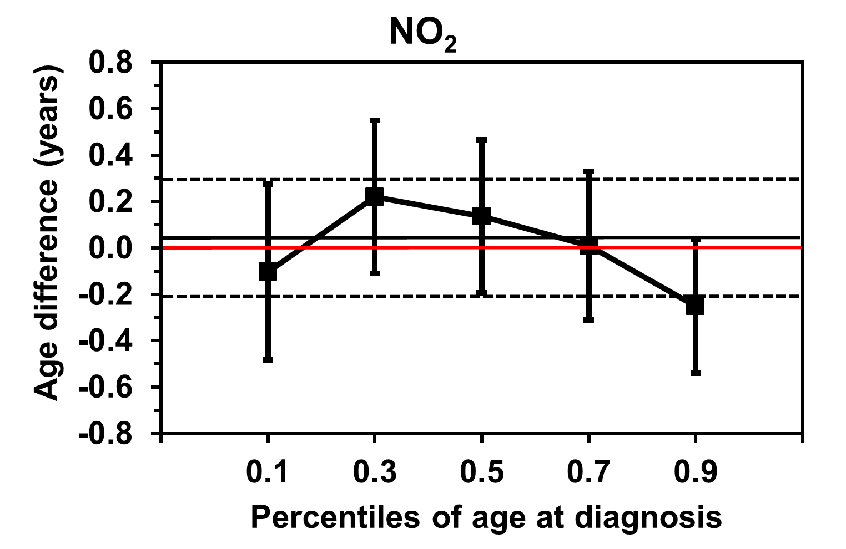 | 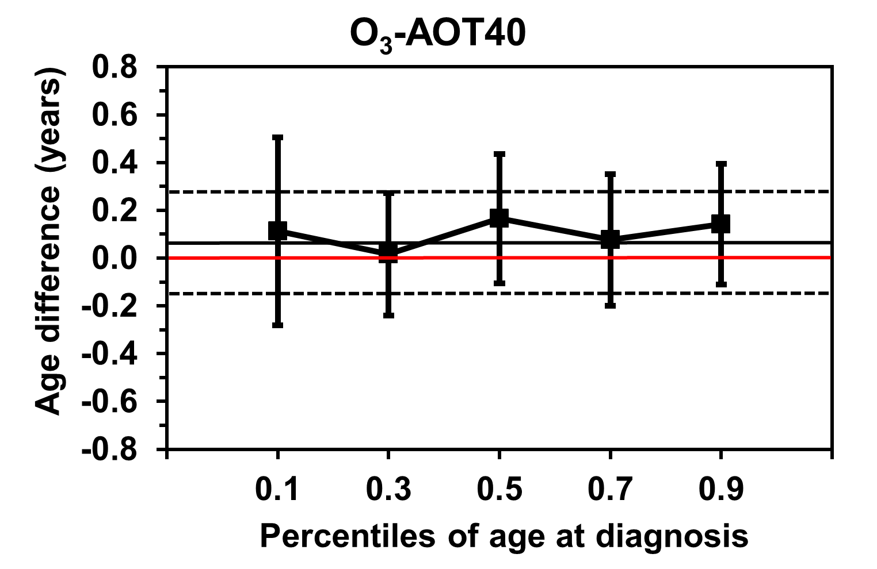

eFigure 2 Point estimates and 95% confidence intervals for differences in mean and percentiles (10th, 30th, 50th (median), 70th, 90th) of the age at diagnosis of type 1 diabetes per 2 SD increases in PM₁₀, NO₂, and O₃-AOT40 (accumulated ozone), adjusted for sex, German vs. Non-German nationality, German Index of Multiple Deprivation, family history of T1D, level of urbanization of residence (upper panel), and additionally for body mass index at onset (lower panel). The dots represent specific quantile regression estimates and are connected by dashes to visualize trends by age quantiles, the whiskers represent 95% CI. The horizontal black lines represent the linear regression coefficients and their respective confidence intervals. The horizontal red line depicts the age difference zero as reference. (Incident cases of 2002 to 2014, exposure data of 2001 to 2009.)

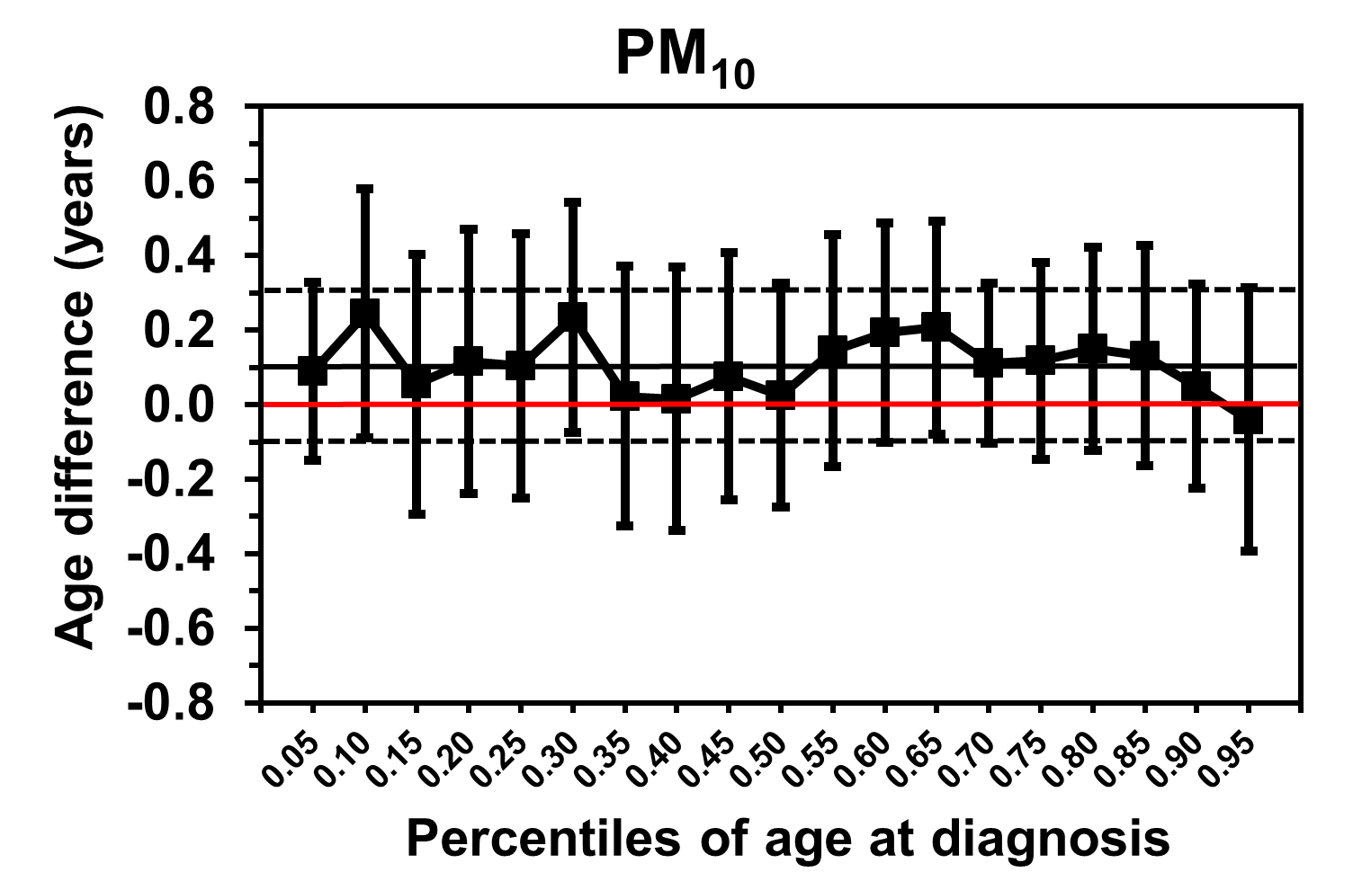 | 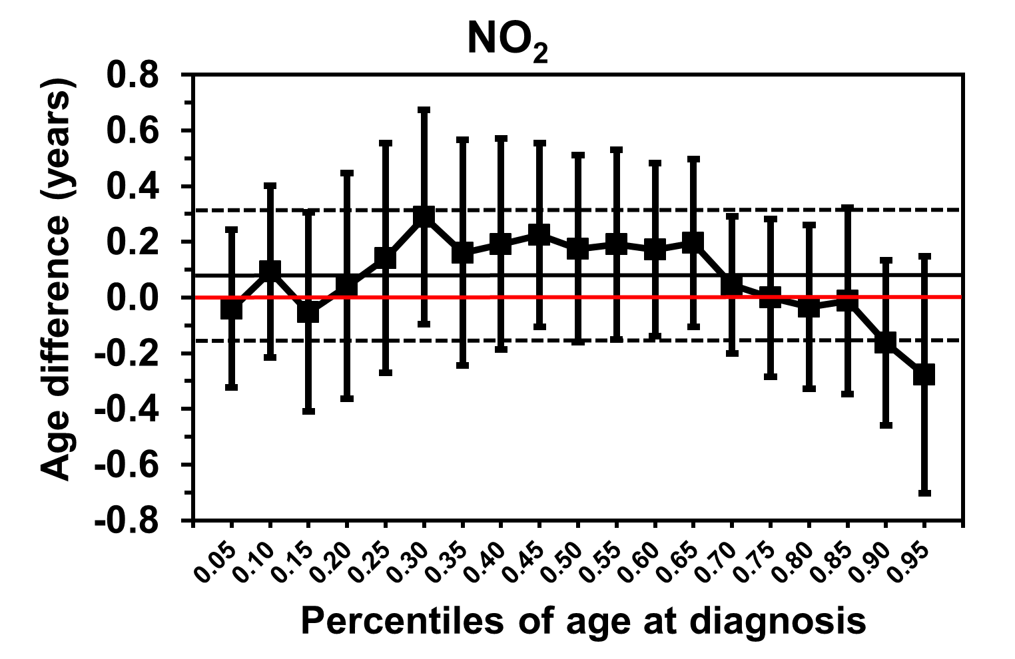 | 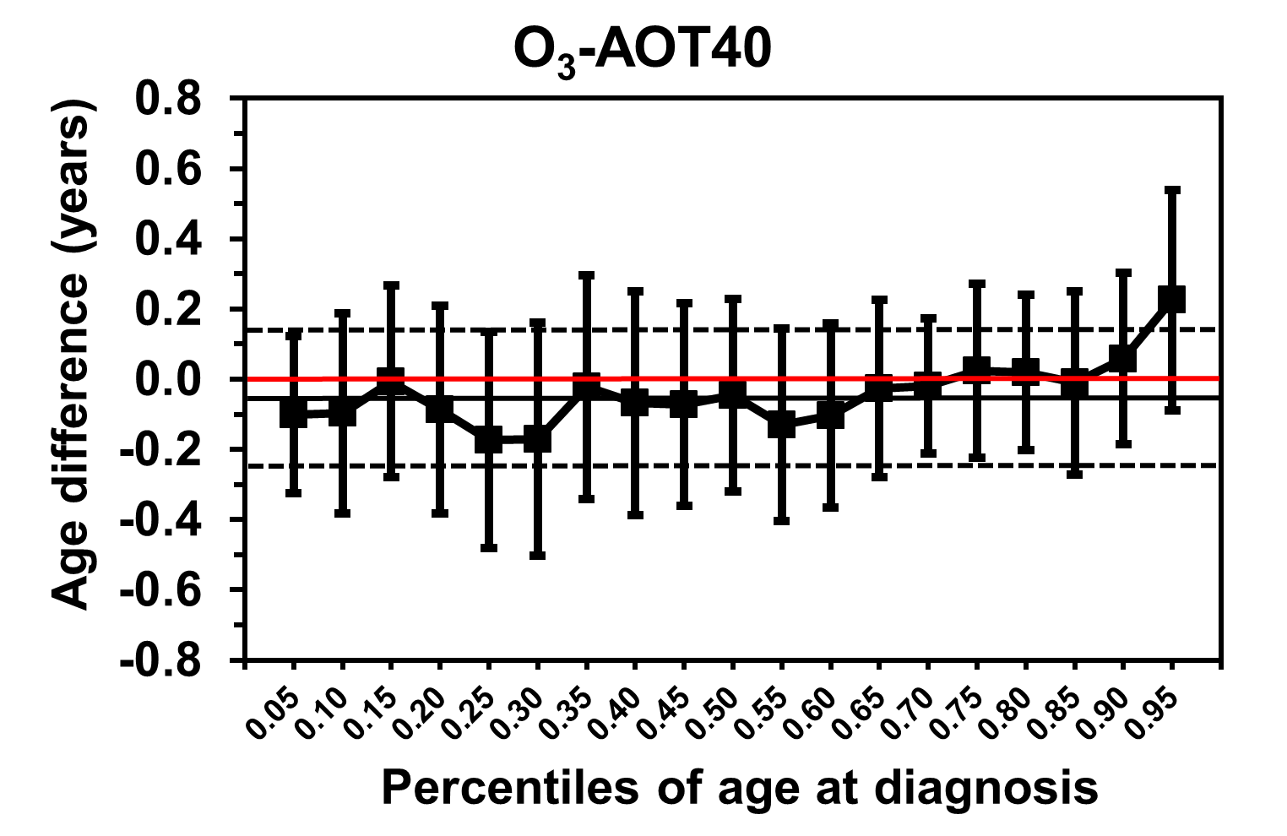
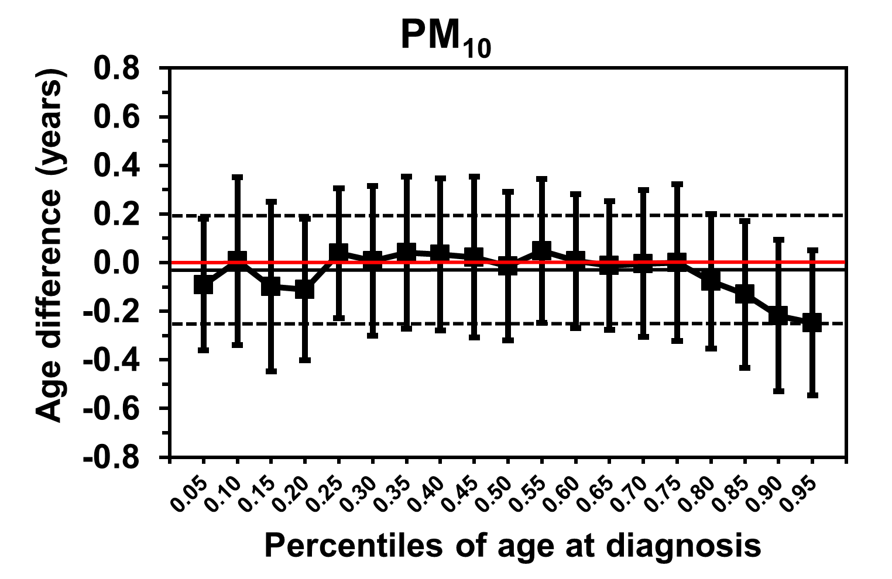 | 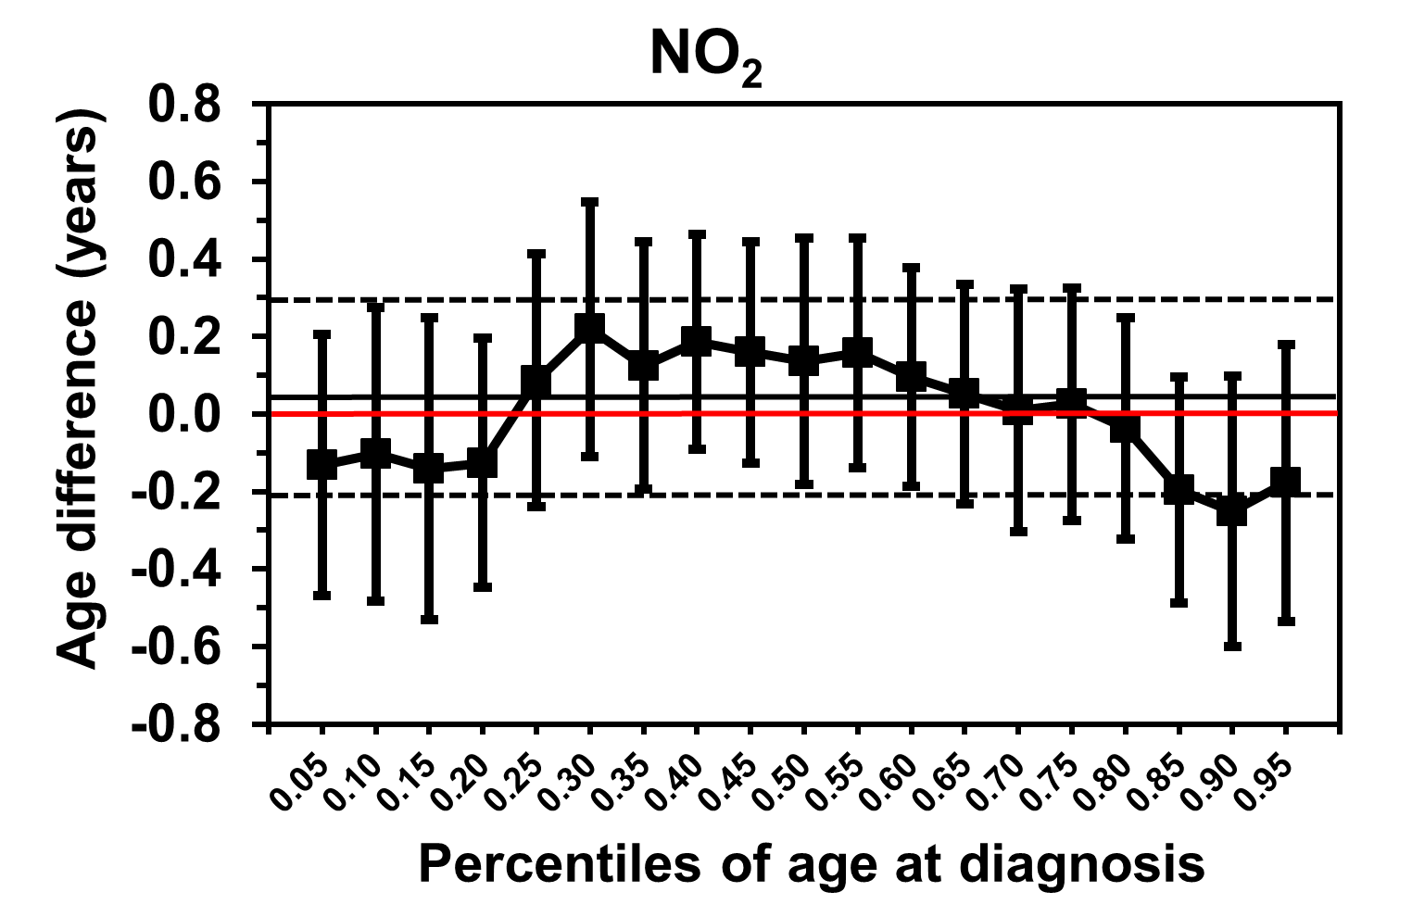 | 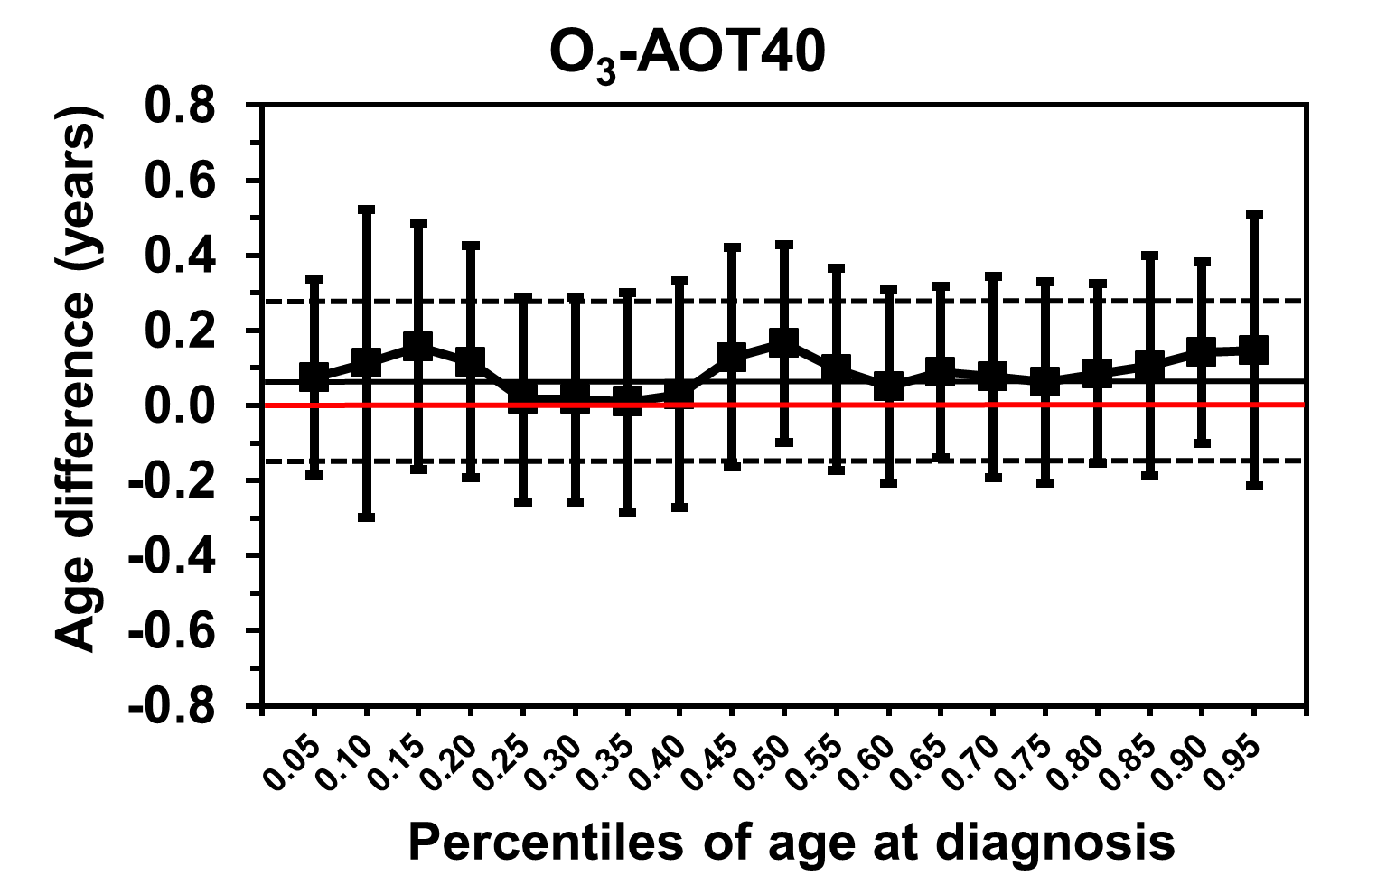

eFigure 3 Point estimates and 95% confidence intervals for differences in mean and percentiles (5th to 95th by 5%) of the age at diagnosis of type 1 diabetes per 2 SD increases in PM₁₀, NO₂, and O₃-AOT40 (accumulated ozone), adjusted for sex, German vs. Non-German nationality, German Index of Multiple Deprivation, family history of T1D, level of urbanization of residence (upper panel), and additionally for body mass index at onset (lower panel). The dots represent specific quantile regression estimates and are connected by dashes to visualize trends by age quantiles, the whiskers represent 95% CI. The horizontal black lines represent the linear regression coefficients and their respective confidence intervals. The horizontal red line depicts the age difference zero as reference. (Incident cases of 2002 to 2014, exposure data of 2001 to 2009.)

