Effectiveness of containment measures against COVID-19 in Singapore – implications for national containment efforts: Supplementary Information

eTable 1: Case definitions used in Singapore.
Date | Suspect case definition
2 January 2020 (Initial) | - A person with clinical signs and symptoms suggestive of pneumonia or severe respiratory infection with breathlessness AND travel to or residence in Wuhan city within the last 14 days; or  - A person with an acute respiratory illness of any degree of severity who, within 14 days before onset of illness, had close contact¹ with a pneumonia case of unknown cause linked to the Wuhan cluster.
21 January 2020 | - A person with clinical signs and symptoms suggestive of pneumonia or severe respiratory infection with breathlessness AND travel to mainland China within 14 days before onset of illness; or  - A person with an acute respiratory illness of any degree of severity who, within 14 days before onset of illness, had been to a hospital in mainland China or had close contact¹ with a case of 2019 novel coronavirus infection.
25 January 2020 | - A person with clinical signs and symptoms suggestive of pneumonia or severe respiratory infection with breathlessness AND travel to mainland China within 14 days before onset of illness; or  - A person with an acute respiratory illness of any degree of severity who, within 14 days before onset of illness had:  - Been to Wuhan city or Hubei Province, China; OR  - Been to a hospital in mainland China; OR  - Had close contact¹ with a case of 2019 novel coronavirus infection.
4 February 2020 (current) | - A person with clinical signs and symptoms suggestive of pneumonia or severe respiratory infection with breathlessness AND travel to mainland China within 14 days before onset of illness; or  - A person with an acute respiratory illness of any degree of severity who, within 14 days before onset of illness had:  - Been to Hubei Province (including Wuhan city) or Zhejiang Province (including Hangzhou city), China; OR  - Been to a hospital in mainland China; OR  - Had close contact¹ with a case of 2019 novel coronavirus infection; OR  - Had frequent or close contact during work² with recent travellers from mainland China (travel history in the last 14 days).
9 March 2020 | - A person with clinical signs and symptoms suggestive of pneumonia or severe respiratory infection with breathlessness AND who within 14 days before onset of illness had travelled abroad (i.e. to any country outside of Singapore).  - A person with an acute respiratory illness of any degree of severity who, within 14 days before onset of illness had:  - Been to any of the areas requiring heightened vigilance³ as listed on the Healthcare Professionals Portal: https://www.moh.gov.sg/hpp/all-healthcare-professionals; OR  - Been to any hospital abroad; OR  - Close contact⁴ with a case of COVID-19 infection.
16 April 2020 | - A person with clinical signs and symptoms suggestive of Community-Acquired Pneumonia⁵ or community-acquired severe respiratory infection with breathlessness.  - A person with an acute respiratory illness of any degree of severity (e.g. symptoms of cough, sore throat, runny nose, anosmia), with or without fever, who, within 14 days before onset of illness had:  - Travelled abroad (outside Singapore); OR  - Close contact⁴ with a case of COVID-19 infection OR  - Stayed in a foreign worker dormitory⁶
8 May 2020 | - A person with clinical signs and symptoms suggestive of Community-Acquired Pneumonia⁵  - A person with an acute respiratory illness of any degree of severity (e.g. symptoms of cough, sore throat, runny nose, anosmia), with or without fever, who, within 14 days before onset of illness had:  - Travelled abroad (outside Singapore); OR  - Close contact⁴ with a case of COVID-19 infection OR  - Stayed in a foreign worker dormitory⁶  - Worked in occupations or environments with higher risk of exposure to COVID-19 cases⁷  - Any person with prolonged febrile⁸ acute respiratory infection (ARI) symptoms of 4 days or more, and not recovering

¹ Close contact is defined as: Anyone who provided care for the patient, including a health care worker or family member, or who had other similarly close physical contact; Anyone who stayed (e.g. lived with, visited) at the same place as a case.
² Persons who attended business meetings/discussions, frontline staff in hospitality and tourism (e.g. hotels, shops, tours) with regular dealings with travellers from mainland China.
³ Refers to affected areas with high disease load or high connectivity to Singapore. As of 9 March 2020, these are: Mainland China, Republic of Korea, Italy, Iran, France, Germany, Spain, Japan and the United Kingdom. Please check the Healthcare Professionals Portal regularly for updates.
⁴ Close contact is defined as: Anyone who provided care for the patient, including a health care worker or family member, or who had other similarly close physical contact; Anyone who stayed (e.g. household members) at the same place as a case; Anyone who had close (i.e. less than 2m) and prolonged contact (30 min or more) with a case (e.g. shared a meal).
⁵ Excludes cases of nosocomial pneumonia and aspiration pneumonia with no links to confirmed cases
⁶ Separate processes apply to foreign workers from a dormitory that has dedicated medical station /clinic or dedicated workflow for assessment and swabbing
⁷ These include but are not limited to any staff (healthcare worker and non-healthcare worker) working in:
- Public and private healthcare settings, spanning acute care, primary care, intermediate and long-term care and community care settings
- Dormitories or involved in dormitory outbreak control operations
- Isolation / quarantine facilities
- Community care facilities (CCFs)/ community recovery facilities (CRFs)
- Ambulance and dedicated patient transport (including private hire vehicles).
⁸ Fever, of any duration, with measured or reported temperature of > 37.5ºC.

COVID-19 Outbreak Containment Measures in Singapore
Suspect case definition for COVID-19 is constantly updated. At any point in time, all suspect and laboratory-confirmed COVID-19 case are isolated and their close contacts (i.e. persons who spend a at least 30 minutes within 2 metres of a confirmed case) will be quarantine for 14 days since the last exposure with the case. Additional public health measures are also implemented and calibrated over time to minimise the risk of COVID-19 transmission in Singapore. The major measures are documented as follows.
eTable 2: COVID-19 outbreak containment measures
Date | Measure
3 Jan | Temperature screening for inbound travelers arriving on flights from Wuhan
 | Suspect cases referred to hospital for assessment
 | Health Advisory Posters to advise all travelers on the precautionary measures to take when travelling or arriving from Wuhan
22 Jan | Expand temperature screening at airport and issue Health Advisory Notices for all inbound travelers on flights arriving from China.
24 Jan | Temperature screening at all sea and land checkpoints.
28 Jan | High risk travelers from Hubei Province who are in Singapore are place under quarantine.
 | Returning persons with travel history in Hubei or with PRC passports issued in Hubei are placed under quarantine.
28 Jan | All persons who interact closely with vulnerable populations in certain sectors (e.g. childcare and education, healthcare and eldercare) with recent travel history to mainland China within the last 14 days will be issued an advisory for them to be placed on a 14-day leave of absence from the day of their return from China.
29 Jan | All new visitors with recent Hubei travel history within the last 14 days, or those with PRC passports issued in Hubei will not be allowed entry into Singapore, or transit through Singapore.
31 Jan | Residents and Long-term pass holders with recent travel history to mainland China within the last 14 days will be issued an advisory for them to be placed on a 14-day leave of absence from the day of their return from China.
 | Enhanced surveillance test COVID-19 among (a) ICU patients and deaths with unknown cause, (b) all pneumonia cases in hospitals, and (c) influenza-like illness cases in sentinel primary care clinics.
1 Feb | All new visitors with recent travel history to mainland China within the last 14 days will not be allowed entry into Singapore, or transit through Singapore
1 Feb | Nationwide mask distribution
7 Feb | Advisory to event organizers to cancel or defer non-essential large-scale events
9 Feb | All foreign domestic workers were to request for entry approval before entering Singapore.
10 Feb | Advisory to all foreign workers dormitories to step up cleaning and precautionary measures
14 Feb | Reactivation of Public Health Preparedness Clinics (PHPCs) to enhance and tighten disease surveillance
 | Healthcare professionals advised to issue 5-day medical certificates for patients with respiratory symptoms
19 Feb | New Stay-Home Notice for all returnees with recent travel history to China (outside Hubei) within the last 14 days. Under the SHN, they will have to remain in their place of residence at all times during the 14-day period.
4 Mar | All new visitors with recent travel history to Iran, northern Italy or the Republic of Korea within the last 14 days will not be allowed entry into Singapore.
 | Returning residents or Long-term pass holders with recent travel history to Iran, northern Italy or the Republic of Korea within the last 14 days will be issued with a Stay-Home Notice (SHN) to remain in their place of residence at all times for a 14-day period after returning to Singapore.
5 Mar | Travellers entering Singapore and exhibiting fever and/or other symptoms of respiratory illness but who do not meet the clinical suspect case definition may be required to undergo a COVID-19 swab test at the checkpoint.
5 Mar | All work pass holders (including dependents) with travel history to South Korea, northern Italy or Iran within the last 14 days and planning to enter/return to Singapore are required to obtain MOM’s approval before they commence their journey.
13 Mar | Travellers entering Singapore and exhibiting fever and/or other symptoms of respiratory illness but who do not meet the clinical suspect case definition may be required to undergo a COVID-19 swab test at the checkpoint AND all such travelers will be issued a 14-day SHN, which they will have to serve in full even if the result of the swab test is negative.
13 Mar | Introduction of social distancing measures for events and gatherings, workplaces and public venues
15 Mar | Singaporeans are advised to defer all non-essential travel aboard to reduce the risk of Singaporeans being infected with the virus when abroad, and spreading it to other Singaporeans when they return.
16 Mar | Short term visitors with recent travel history to Italy, France, Spain and Germany within the last 14 days will not be allowed entry into Singapore, or transit through Singapore.
 | Returning residents or Long-term pass holders with recent travel history to Italy, France, Spain and Germany within the last 14 days will be issued with a Stay-Home Notice (SHN) to remain in their place of residence at all times for a 14-day period after returning to Singapore.
 | All new and existing work pass holders (including dependents) with travel history to Italy, France, Spain and Germany within the last 14 days and planning to enter/return to Singapore are required to obtain MOM’s approval before they commence their journey.
17 Mar | Returning residents or Long-term pass holders with recent travel history to ASEAN countries, Japan, Switzerland, or the United Kingdom within the last 14 days will be issued with a Stay-Home Notice (SHN) to remain in their place of residence at all times for a 14-day period after returning to Singapore.
 | All short-term visitors who are nationals of ay ASEAN country will have to submit requisite information on their health to the Singapore Overseas Mission in the country they are resident before their intended date of travel.
 | All new and exisiting work pass holders (including dependents) with travel history to ASEAN countries, Japan, Switzerland, or the United Kingdom within the last 14 days and planning to enter/return to Singapore are required to obtain MOM’s approval before they commence their journey.
18 Mar | Singaporeans are advised to defer all travel aboard to reduce the risk of Singaporeans being infected with the virus when abroad, and spreading it to other Singaporeans when they return.
21 Mar | All Singaporeans, Permanent Residents, Long-term pass holders and short term visitors entering Singapore will be issued a 14-day Stay-Home Notice.
 | All new and exisiting work pass holders (including dependents) planning to enter/return to Singapore are required to obtain MOM’s approval before they commence their journey.
20 Mar | Tightening of safe distancing measures for events and gatherings, public venues, workplaces, and suspension of senior-centric activities
24 Mar | All short-term visitors (from anywhere in the world) will not be allowed to enter or transit through Singapore. Furthermore, the Ministry of Manpower will only allow the entry/ return of work pass holders, including their dependents, for those providing essential services, such as in healthcare and transport.
26 Mar | All US/US returnees are to serve their Stay-Home Notices at dedicated facilities.
27 Mar | Closure of entertainment venues, suspension of tuition and enrichment centres, suspension of all religious services and congregations, deferment or cancellation of all events and mass gatherings and existing measures for workplaces continue to apply.

eFigure 1: MCMC trace plots

Trace plot of mean $μ$

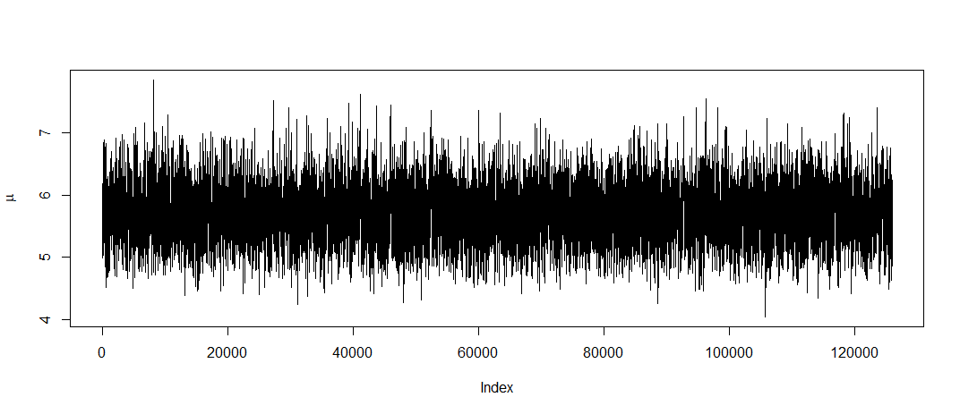

Trace plot of sigma
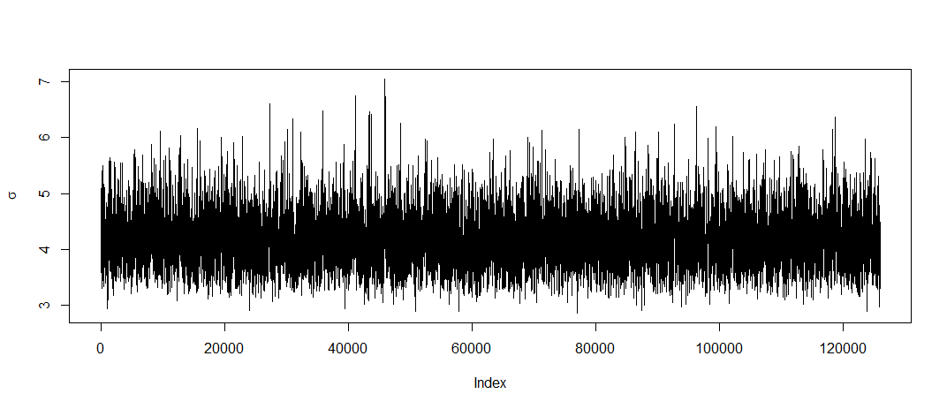
Trace plot of likelihood
