eTable 1: Description of time dependent characteristics at 6 months, 1 year and 2 years post first dialysis session after registration on the waiting list

 | At 6 months |  | At 1 year |  | At 2 years
 | Percent. | 95%CI | Percent. | 95%CI |  | Percent. | 95%CI
Positive anti-HLA class I antibodies | 21.4% | [20.8%;22.1%] | 21.4% | [20.8%;22.1%] |  | 21.5% | [20.8%;22.1%]
Positive anti-HLA class II antibodies | 14.0% | [13.5%;14.5%] | 14.0% | [13.5%;14.5%] |  | 14.0% | [13.5%;14.5%]
History of diabetes | 22.3% | [21.6%;23.0%] | 22.5% | [21.8%;23.2%] |  | 22.7% | [22.0%;23.4%]
History of malignancy | 3.0% | [2.8%;3.2%] | 3.5% | [3.2%;3.7%] |  | 4.5% | [4.2%;4.8%]
History of liver cirrhosis | 0.6% | [0.5%;0.7%] | 0.6% | [0.5%;0.7%] |  | 0.8% | [0.6%;0.9%]
History of heart failure | 8.7% | [8.3%;9.1%] | 9.0% | [8.6%;9.4%] |  | 9.8% | [9.3%;10.2%]
History of coronary heart disease | 9.9% | [9.5%;10.3%] | 10.6% | [10.2%;11.1%] |  | 11.8% | [11.3%;12.3%]
History of acute coronary disease | 4.3% | [4.1%;4.6%] | 4.6% | [4.3%;4.8%] |  | 4.9% | [4.6%;5.2%]
History of abdominal aortic aneurysm | 1.0% | [0.9%;1.1%] | 1.1% | [1.0%;1.2%] |  | 1.3% | [1.1%;1.5%]
History of peripheral arterial disease | 7.4% | [7.1%;7.8%] | 8.0% | [7.6%;8.4%] |  | 9.4% | [8.9%;9.8%]
History of cerebrovascular disease | 4.9% | [4.6%;5.1%] | 5.2% | [4.9%;5.5%] |  | 5.7% | [5.4%;6.0%]
History of arrhythmia | 6.2% | [5.9%;6.5%] | 6.7% | [6.4%;7.1%] |  | 7.8% | [7.4%;8.2%]
History of chronic lung disease | 4.7% | [4.4%;5.0%] | 5.0% | [4.7%;5.3%] |  | 5.5% | [5.2%;5.8%]
History of oxygen inhalation therapies | 1.5% | [1.4%;1.7%] | 1.7% | [1.5%;1.8%] |  | 2.0% | [1.8%;2.2%]
History of smoking | 34.0% | [33.1%;35.0%] | 35.0% | [34.1%;36.0%] |  | 36.1% | [35.1%;37.1%]
History of hepatitis B infection | 1.3% | [1.2%;1.5%] | 1.4% | [1.2%;1.5%] |  | 1.5% | [1.3%;1.7%]
History of hepatitis C infection | 1.4% | [1.2%;1.5%] | 1.4% | [1.3%;1.6%] |  | 1.6% | [1.4%;1.7%]
History of HIV infection | 1.2% | [1.1%;1.4%] | 1.3% | [1.1%;1.4%] |  | 1.3% | [1.1%;1.4%]
History of AIDS | 0.5% | [0.4%;0.6%] | 0.5% | [0.4%;0.6%] |  | 0.5% | [0.4%;0.6%]
History of psychiatric disorder | 1.1% | [1.0%;1.2%] | 1.2% | [1.1%;1.4%] |  | 1.5% | [1.3%;1.6%]
History of amputation of lower limbs | 0.6% | [0.5%;0.7%] | 0.6% | [0.5%;0.8%] |  | 0.9% | [0.8%;1.1%]
History of paralysis | 0.7% | [0.6%;0.8%] | 0.7% | [0.6%;0.9%] |  | 0.9% | [0.7%;1.0%]
History of blindness | 1.8% | [1.7%;2.0%] | 2.1% | [1.9%;2.3%] |  | 2.3% | [2.1%;2.5%]
History of walking difficulties | 2.3% | [2.1%;2.5%] | 2.5% | [2.3%;2.7%] |  | 3.2% | [2.9%;3.5%]
Acronyms: HLA = Human Leucocyte Antigen, HIV = Human Immunodeficiency Virus, AIDS = Acquired Immune Deficiency Syndrome.

eFigure 1: Directed acyclic graph without adjustment (Panel A). Panel B depicts the same directed acyclic graph after adjustment on orange squared variables. Acronyms: O2 = Oxygen inhalation therapies, COPD = Chronic lung disease, ESRD = End-Stage Renal Disease, BMI = Body Mass Index, cPRA = Calculated Panel Reactive Antibody, HLA = Human Leucocyte Antigen, ABO = Blood group, HCV = Hepatitis C, HVB = Hepatitis B, HIV = Human Immunodeficiency Virus, AIDS = Acquired Human Immunodeficiency Syndrome
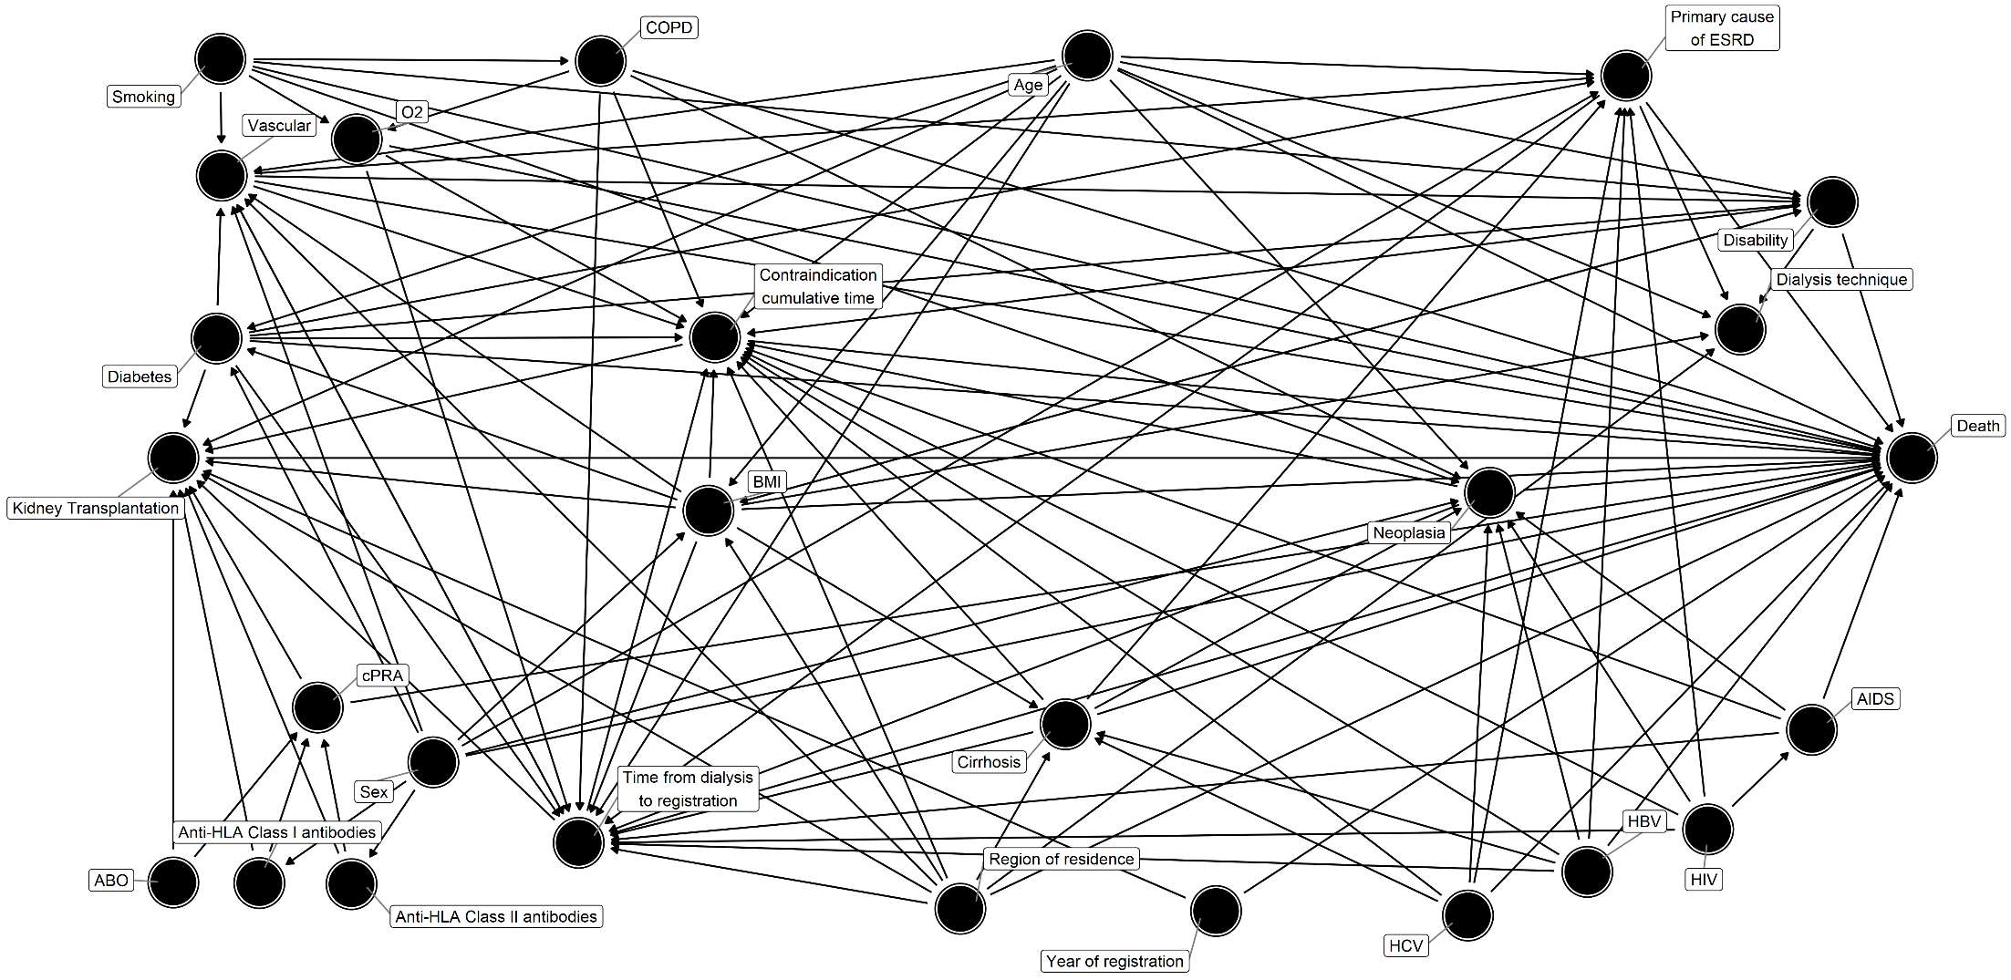
A

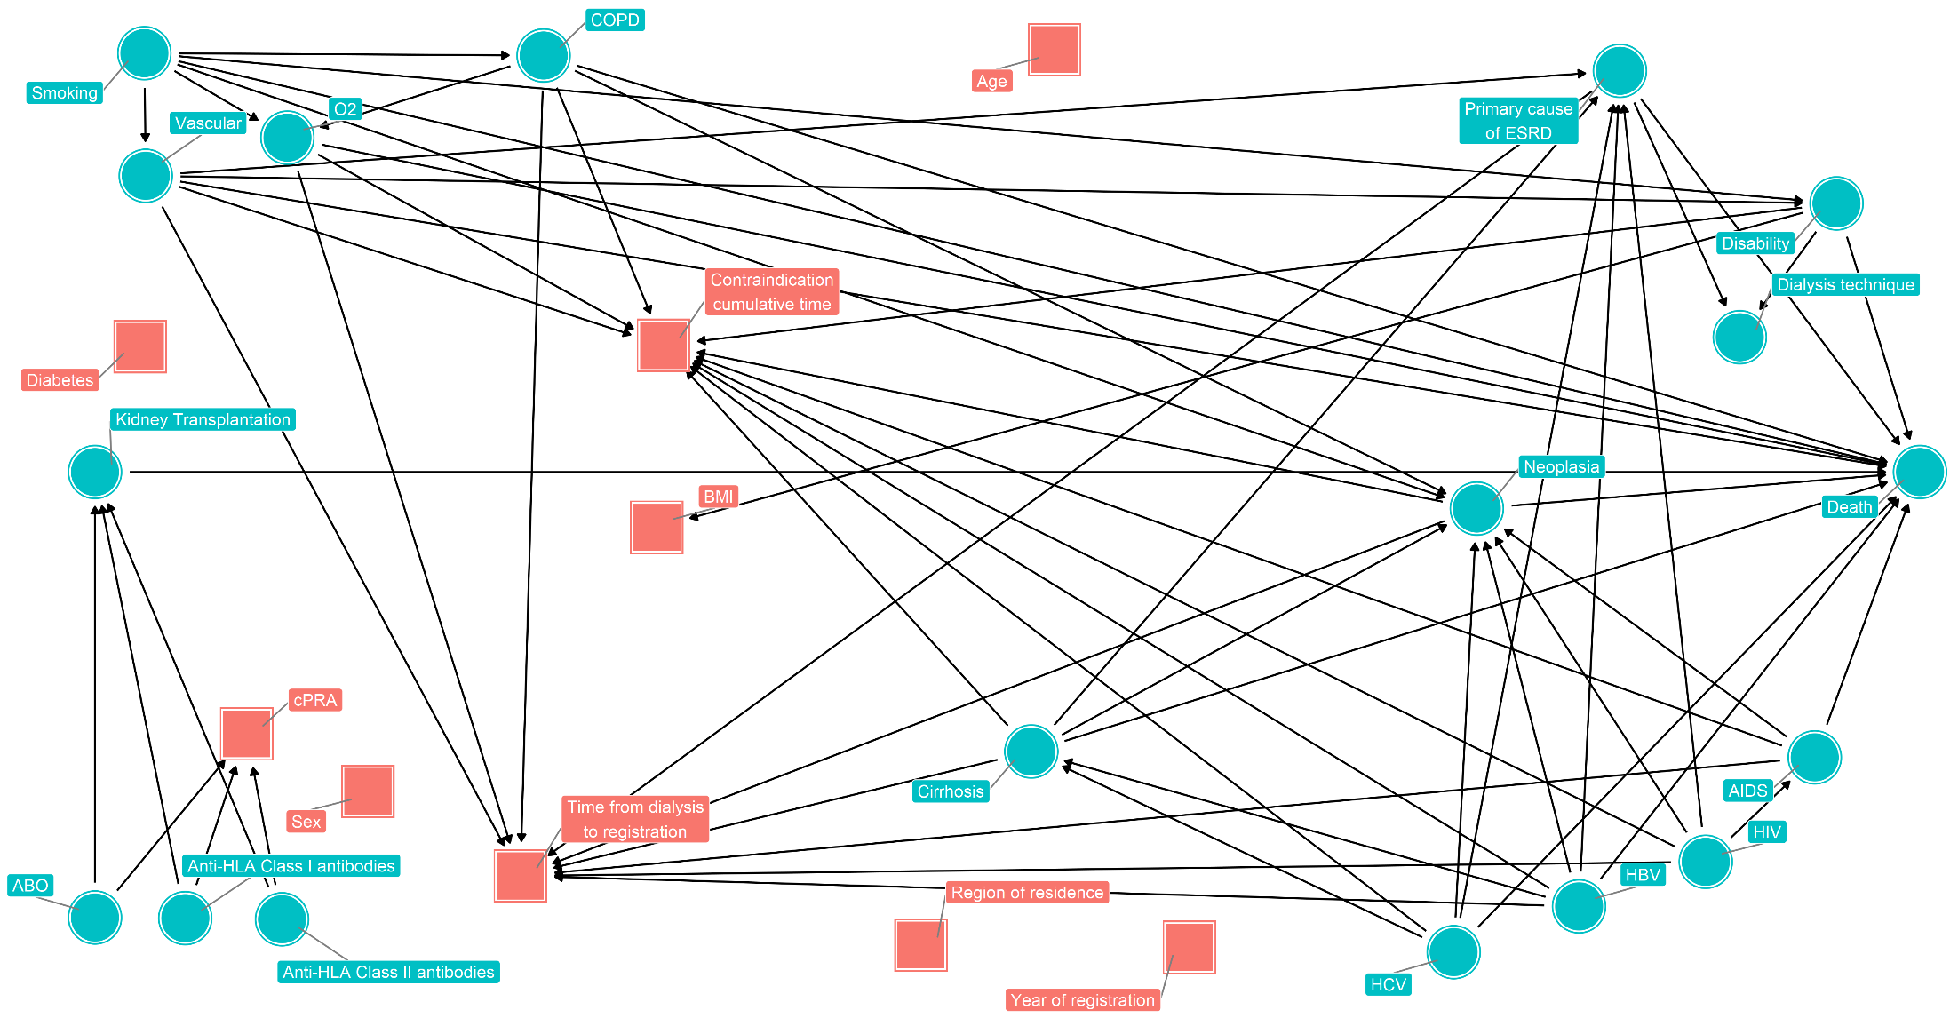
B

eTable 2: Multivariate Cox models of the time-to-death and the time-to-transplantation (the corresponding linear predictor represents the propensity score of the main analyses).

 | Transplantation |  |  |  | Death
 | HR | 95%CI |  | p-value | HR | 95%CI | p-value
Recipient age (per 10 years) | 1.04 | [1.03 - 1.06] |  | < 0.01 | 1.75 | [1.68 - 1.81] | < 0.01
Male recipient | 0.96 | [0.93 - 0.99] |  | 0.01 | 1.28 | [1.18 - 1.39] | < 0.01
Recipient BMI (per 5 kg/m²) | 0.94 | [0.92 - 0.95] |  | < 0.01 | 0.74 | [0.71 - 0.78] | < 0.01
Year of inscription on waiting list |  |  |  | < 0.01 |  |  | < 0.01
- 2005-2007 | Ref. | - |  |  | Ref. | -
- 2008-2010 | 0.98 | [0.93 - 1.03] |  |  | 1.07 | [0.95 - 1.20]
- 2011-2013 | 1.00 | [0.95 - 1.05] |  |  | 1.28 | [1.12 - 1.46]
- 2014-2016 | 1.28 | [1.21 - 1.34] |  |  | 1.60 | [1.35 - 1.89]
Time from dialysis to inscription (year) | 1.01 | [1.00 - 1.03] |  | 0.02 | 1.19 | [1.15 - 1.22] | < 0.01
Contraindication cumulative time (year) | 0.85 | [0.83 - 0.86] |  | < 0.01 | 1.16 | [1.13 - 1.19] | < 0.01
Calculated Panel Reactive Antibody > 0% | 0.53 | [0.51 - 0.55] |  | < 0.01 | 0.93 | [0.85 - 1.01] | 0.08
Diabetes | 0.87 | [0.84 - 0.91] |  | < 0.01 | 2.16 | [1.98 - 2.34] | < 0.01
Recipient region of residence was a covariate included in this model (not shown). N=103 patients were excluded because of missing data in at least one variable retained in the model. Acronyms: BMI = Body Mass Index

eTable 3: Description of the 103 excluded patients for missing data on variables included in the propensity score

Median [interquartile range]  Effective (%) | Characteristics | Missing data
Recipient age (years) | 54.4 [42.9;61.9] | 0 (0%)
Male recipient | 64 (62%) | 0 (0%)
Recipient BMI (kg/m²) | 26.0 [24.4;27.6] | 90 (87%)
Year of inscription on waiting list |  | 0 (0%)
- 2005-2007 | 47 (46%)
- 2008-2010 | 32 (31%)
- 2011-2013 | 16 (16%)
- 2014-2016 | 8 (7.8%)
Primary cause of end stage renal disease |  | 0 (0%)
- Diabetic nephropathy | 14 (14%)
- Hypertension | 21 (20%)
- Other | 12 (12%)
- Polycystic Kidney Disease | 16 (16%)
- Primary glomerulopathy | 28 (27%)
- Pyelonephritis | 3 (2.9%)
- Unknown | 9 (8.7%)
Recipient blood group |  | 0 (0%)
- A | 47 (46%)
- AB | 10 (9.7%)
- B | 12 (12%)
- O | 34 (33%)
Dialysis technique |  | 0 (0%)
- Hemodialysis | 89 (86%)
- Peritoneal dialysis | 14 (14%)
Time from dialysis to inscription (days) | 100.0 [-78.0;246.5] | 0 (0%)
Calculated Panel Reactive Antibody (%) | 0.0 [0.0;31.8] | 0 (0%)
Potential matched donors | 275.0 [104.5;505.0] | 0 (0%)
Positive anti-HLA class I antibodies | 13 (13%) | 0 (0%)
Positive anti-HLA class II antibodies | 13 (13%) | 0 (0%)
History of diabetes | 16 (16%) | 0 (0%)
History of malignancy | 1 (1.0%) | 0 (0%)
History of liver cirrhosis | 0 (0.0%) | 0 (0%)
History of heart failure | 8 (7.8%) | 0 (0%)
History of coronary heart disease | 7 (6.8%) | 0 (0%)
History of acute coronary disease | 1 (1.0%) | 0 (0%)
History of abdominal aortic aneurysm | 0 (0.0%) | 0 (0%)
History of peripheral arterial disease | 6 (5.8%) | 0 (0%)
History of cerebrovascular disease | 2 (1.9%) | 0 (0%)
History of arrhythmia | 5 (4.9%) | 0 (0%)
History of chronic lung disease | 1 (1.0%) | 0 (0%)
History of oxygen inhalation therapies | 0 (0.0%) | 0 (0%)
History of smoking | 22 (21%) | 0 (0%)
History of hepatitis B infection | 2 (1.9%) | 0 (0%)
History of hepatitis C infection | 2 (1.9%) | 0 (0%)
History of HIV infection | 1 (1.0%) | 0 (0%)
History of AIDS | 1 (1.0%) | 0 (0%)
History of psychiatric disorder | 0 (0.0%) | 0 (0%)
History of amputation of lower limbs | 0 (0.0%) | 0 (0%)
History of paralysis | 0 (0.0%) | 0 (0%)
History of blindness | 0 (0.0%) | 0 (0%)
History of walking difficulties | 2 (1.9%) | 0 (0%)
Time between dialysis and first inscription could have negatives values because of preemptive listing. Acronyms: BMI = Body Mass Index, DOM-TOM = overseas departments, HLA = Human Leucocyte Antigen, HIV = Human Immunodeficiency Virus, AIDS = Acquired Immune Deficiency Syndrome.

eTable 4: Characteristics of matched and unmatched patients at the first dialysis session after placement on the waiting list

Median [interquartile range]  Effective (%) | Unmatched patients  (N=1836) | Matched patients  (N=21292) | p-value
Recipient age (years) | 57.7 [49.3;64.2] | 54.8 [43.9;63.4] | <0.01
Male recipient | 1184 (65%) | 13635 (64%) | 0.72
Recipient BMI (kg/m²) | 26.0 [22.8;30.1] | 24.9 [22.1;28.4] | <0.01
Year of inscription on waiting list |  |  | <0.01
- 2005-2007 | 48 (2.6%) | 2702 (13%)
- 2008-2010 | 179 (9.7%) | 5830 (27%)
- 2011-2013 | 448 (24%) | 7016 (33%)
- 2014-2016 | 1161 (63%) | 5744 (27%)
Primary cause of end stage renal disease |  |  | <0.01
- Diabetic nephropathy | 446 (24%) | 2605 (12%)
- Hypertension | 351 (19%) | 3237 (15%)
- Other | 238 (13%) | 3400 (16%)
- Polycystic Kidney Disease | 198 (11%) | 3480 (16%)
- Primary glomerulopathy | 283 (15%) | 5034 (24%)
- Pyelonephritis | 78 (4.2%) | 1037 (4.9%)
- Unknown | 242 (13%) | 2499 (12%)
Recipient blood group |  |  | <0.01
- A | 574 (31%) | 8428 (40%)
- AB | 61 (3.3%) | 874 (4.1%)
- B | 314 (17%) | 2546 (12%)
- O | 887 (48%) | 9444 (44%)
Dialysis technique |  |  | <0.01
- Hemodialysis | 1630 (89%) | 17981 (85%)
- Peritoneal dialysis | 206 (11%) | 3310 (16%)
Time from dialysis to inscription (days) | 245.0 [21.5;496.0] | 193.0 [-1.0;414.0] | <0.01
Calculated Panel Reactive Antibody > 0% | 1270 (69%) | 7835 (37%) | <0.01
Potential matched donors | 277.0 [93.0;518.2] | 424.0 [179.0;634.0] | <0.01
Positive anti-HLA class I antibodies | 513 (28%) | 4453 (21%) | <0.01
Positive anti-HLA class II antibodies | 315 (17%) | 2923 (14%) | <0.01
History of diabetes | 724 (39%) | 4412 (21%) | <0.01
History of malignancy | 77 (4.2%) | 564 (2.6%) | <0.01
History of liver cirrhosis | 20 (1.1%) | 112 (0.5%) | <0.01
History of heart failure | 223 (12%) | 1709 (8.0%) | <0.01
History of coronary heart disease | 260 (14%) | 1898 (8.9%) | <0.01
History of acute coronary disease | 116 (6.3%) | 844 (4.0%) | <0.01
History of abdominal aortic aneurysm | 31 (1.7%) | 193 (0.9%) | <0.01
History of peripheral arterial disease | 219 (12%) | 1387 (6.5%) | <0.01
History of cerebrovascular disease | 132 (7.2%) | 948 (4.5%) | <0.01
History of arrhythmia | 133 (7.2%) | 1210 (5.7%) | 0.01
History of chronic lung disease | 113 (6.2%) | 935 (4.4%) | <0.01
History of oxygen inhalation therapies | 50 (2.7%) | 288 (1.4%) | <0.01
History of smoking | 639 (35%) | 7079 (33%) | 0.18
History of hepatitis B infection | 39 (2.1%) | 257 (1.2%) | <0.01
History of hepatitis C infection | 40 (2.2%) | 275 (1.3%) | <0.01
History of HIV infection | 42 (2.3%) | 239 (1.1%) | <0.01
History of AIDS | 19 (1.0%) | 84 (0.4%) | <0.01
History of psychiatric disorder | 23 (1.3%) | 223 (1.0%) | 0.48
History of amputation of lower limbs | 11 (0.6%) | 104 (0.5%) | 0.64
History of paralysis | 11 (0.6%) | 132 (0.6%) | 1.00
History of blindness | 52 (2.8%) | 334 (1.6%) | <0.01
History of walking difficulties | 74 (4.0%) | 413 (1.9%) | <0.01
Time between dialysis and the first inscription could have negative values because of preemptive listing. Acronyms: BMI = Body Mass Index, HLA = Human Leucocyte Antigen, HIV = Human Immunodeficiency Virus, AIDS = Acquired Immune Deficiency Syndrome.

eTable 5: Patient characteristics in the transplantation and awaiting KT groups at the time of pseudo randomization. Optimal matching algorithm has been used in this analysis.

Median [interquartile range]  Effective (%) | Awaiting transplantation group  N=10882 | Transplantation group N=10882 | Standardized difference
Recipient age (years) | 57.1 [46.1;65.3] | 55.4 [44.5;64.1] | 10.1%
Male recipient | 7005 (64%) | 6955 (64%) | 0.7%
Recipient BMI (kg/m²) | 25.2 [22.3;28.6] | 25.0 [22.1;28.4] | 4.5%
Year of inscription on waiting list |  |  | 19%
- 2005-2007 | 1242 (11%) | 1483 (14%)
- 2008-2010 | 2691 (25%) | 3143 (29%)
- 2011-2013 | 3426 (32%) | 3605 (33%)
- 2014-2016 | 3523 (32%) | 2651 (24%)
Primary cause of end stage renal disease |  |  | 6.3%
- Diabetic nephropathy | 1712 (16%) | 1759 (16%)
- Hypertension | 2480 (23%) | 2638 (24%)
- Other | 1705 (16%) | 1614 (15%)
- Polycystic Kidney Disease | 1319 (12%) | 1268 (12%)
- Primary glomerulopathy | 1408 (13%) | 1247 (12%)
- Pyelonephritis | 1751 (16%) | 1802 (17%)
- Unknown | 507 (4.7%) | 554 (5.1%)
Recipient blood group |  |  | 37%
- A | 3394 (31%) | 5194 (48%)
- AB | 364 (3.3%) | 529 (4.9%)
- B | 1557 (14%) | 1070 (9.8%)
- O | 5567 (51%) | 4089 (38%)
Dialysis technique |  |  | 1.4%
- Hemodialysis | 9223 (85%) | 9166 (84%)
- Peritoneal dialysis | 1659 (15%) | 1715 (16%)
Time from dialysis to inscription (days) | 207.0 [5.0;440.0] | 183.0 [-5.0;397.0] | 6.3%
Preemptive inscription on waiting list | 2667 (25%) | 2788 (26%) | 2.4%
Contraindication cumulative time (days) | 49.0 [0.0;208.0] | 38.0 [0.0;184.0] | 6.9%
Calculated Panel Reactive Antibody > 0% | 4099 (38%) | 3969 (37%) | 2.2%
Potential matched donors | 410.0 [158.0;630.0] | 434.0 [203.0;639.0] | 7.8%
Positive anti-HLA class I antibodies | 2339 (22%) | 2247 (21%) | 1.9%
Positive anti-HLA class II antibodies | 1532 (14%) | 1451 (13%) | 2.1%
History of diabetes | 2452 (23%) | 2142 (20%) | 6.6%
History of malignancy | 401 (3.7%) | 335 (3.1%) | 3.3%
History of liver cirrhosis | 83 (0.8%) | 57 (0.5%) | 3%
History of heart failure | 1096 (10%) | 859 (7.9%) | 7.4%
History of coronary heart disease | 1274 (12%) | 982 (9.0%) | 8.6%
History of acute coronary disease | 537 (4.9%) | 430 (4.0%) | 4.7%
History of abdominal aortic aneurysm | 146 (1.3%) | 97 (0.9%) | 4.3%
History of peripheral arterial disease | 962 (8.8%) | 745 (6.8%) | 7.3%
History of cerebrovascular disease | 579 (5.3%) | 531 (4.9%) | 2%
History of arrhythmia | 804 (7.4%) | 673 (6.2%) | 4.7%
History of chronic lung disease | 598 (5.5%) | 494 (4.5%) | 4.3%
History of oxygen inhalation therapies | 208 (1.9%) | 165 (1.5%) | 3%
History of smoking | 3964 (36%) | 3688 (34%) | 4.7%
History of hepatitis B infection | 188 (1.7%) | 115 (1.1%) | 5.7%
History of hepatitis C infection | 151 (1.4%) | 160 (1.5%) | 0.7%
History of HIV infection | 148 (1.4%) | 107 (1.0%) | 3.5%
History of AIDS | 62 (0.6%) | 32 (0.3%) | 4.2%
History of psychiatric disorder | 172 (1.6%) | 105 (1.0%) | 5.5%
History of amputation of lower limbs | 73 (0.7%) | 63 (0.6%) | 1.2%
History of paralysis | 88 (0.8%) | 75 (0.7%) | 1.4%
History of blindness | 231 (2.1%) | 201 (1.8%) | 2%
History of walking difficulties | 313 (2.9%) | 219 (2.0%) | 5.6%
Acronyms: BMI = Body Mass Index, HLA = Human Leucocyte Antigen, HIV = Human Immunodeficiency Virus, AIDS = Acquired Immune Deficiency Syndrome

eTable 6: Mean life expectancy according to several follow-up times post pseudo randomization with an optimal matching algorithm

Time  (years) | Transplantation group  mean life expectancy |  | Awaiting transplantation group  mean life expectancy |  | Mean life expectancy difference |  | Relative mean life expectancy gain
 | RMST | 95%CI | RMST | 95%CI | ΔRMST | 95%CI | % | 95%CI
1 | 0.98 years | [0.98;0.98] | 0.98 years | [0.98;0.98] | 0.04 months | [-0.01;0.09] | 0.37% | [-0.03 ; 0.77]
3 | 2.88 years | [2.87;2.90] | 2.80 years | [2.78;2.81] | 1.05 months | [0.82;1.28] | 3.11% | [2.43 ; 3.82]
5 | 4.70 years | [4.68;4.73] | 4.48 years | [4.45;4.51] | 2.74 months | [2.26;3.21] | 5.09% | [4.18 ; 6.00]
10 | 8.81 years | [8.73;8.88] | 8.18 years | [8.09;8.28] | 7.50 months | [5.99;8.90] | 7.62% | [6.06 ; 9.14]
Acronyms: : RMST = Restricted Mean Survival Time, Δ = Delta, % = Percentage

eFigure 2: Patient survival in the transplantation and awaiting transplantation groups in the optimal matched sub-cohort.

