Supplementary Digital Content
eTable 1: Distribution of participant demographic and health related variables in the UK Biobank, including participants with a history of CVD or cancer (n= 371 974)
Variable | Level | UK Biobank N Unweighted | UK Biobank % Unweighted | UK Biobank % Post-Stratified
Age group (years) | 40-49 | 92 489 | 24·86 | 38·05
 | 50-59 | 125 783 | 33·81 | 31·76
 | 60-70 | 153 702 | 41·32 | 30·19
Sex | Female | 193 635 | 52·06 | 50·78
 | Male | 178 339 | 47·94 | 49·22
Qualification | College or university degree | 178 020 | 47·86 | 32·39
 | Highschool diploma | 143 213 | 38·50 | 39·69
 | Other/None | 50 741 | 13·64 | 27·92
METS | >=7·5 MET-hrs/wk | 324 486 | 87·23 | 69·23
 | >0, <7·5 MET-hrs/wk | 42 390 | 11·40 | 26·74
 | No PA | 5098 | 1·37 | 4·03
Fruit and Vegetables | At least 10 portions/day | 32 252 | 8·67 | 7·36
 | 5 to 9 portions/day | 164 737 | 44·29 | 39·51
 | under 5 portions/day | 171 134 | 46·01 | 51·76
 | Unknown | 3851 | 1·04 | 1·37
Alcohol use | Never | 13 761 | 3·70 | 4·49
 | Previous | 12 273 | 3·30 | 4·02
 | Current: < almost daily | 265 269 | 71·31 | 72·30
 | Current: >=almost daily | 80 492 | 21·64 | 19·13
 | Unknown | 179 | 0·05 | 0·07
Smoking status | Never | 204 484 | 54·97 | 50·53
 | Previous | 130 122 | 34·98 | 35·20
 | Current | 37 368 | 10·05 | 14·27
Unhealthy index | Tertile 1: Most healthy | 123 670 | 33·25 | 25·84
 | Tertile 2 | 135 861 | 36·52 | 31·67
 | Tertile 3: Least healthy | 108 429 | 29·15 | 41·07
 | Unknown | 4014 | 1·08 | 1·43
Previous cancer diagnosis | No | 353 192 | 94·95 | 95·39
 | Yes | 18 782 | 5·05 | 4·61
Previous CVD diagnosis | No | 315 629 | 84·85 | 84·33
 | Yes | 56 345 | 15·15 | 15·67
BMI category (kg/m²⁾ | Underweight (<18.5) | 1732 | 0·47 | 0·45
 | Normal (18.5 -24.9) | 122 864 | 33·03 | 28·53
 | Overweight (25.0 -29.9) | 160 810 | 43·23 | 43·38
 | Obese I (30.0 -34.9) | 63 178 | 16·98 | 19·26
 | Obese II (35.0 -39.9) | 17 130 | 4·61 | 5·91
 | Obese III ≥ 40.0 | 6260 | 1·68 | 2·47

eTable 2: Distribution of participant demographic and health related variables in the UK Biobank, excluding participants with a history of CVD or cancer, with multiple imputation (n= 400 793)
Variable | Level | UK Biobank N Unweighted | UKB % Unweighted | UK Biobank % PS
Age group (years) | 40-49 | 106 527 | 26·58 | 42·36
 | 50-59 | 138 260 | 34·50 | 31·90
 | 60-70 | 156 006 | 38·92 | 25·74
Sex | Female | 221 658 | 55·30 | 51·30
 | Male | 179 135 | 44·70 | 48·70
Education Qualification | College or university degree | 183 829 | 45·87 | 34·13
 | Highschool diploma | 155 765 | 38·86 | 41·13
 | Other/None | 61 199 | 15·27 | 24·74
Physical Activity | >=7·5 MET-hrs/wk | 345 075 | 86·10 | 71·00
 | >0, <7·5 MET-hrs/wk | 49 598 | 12·37 | 25·18
 | No PA | 6 120 | 1·53 | 3·82
Fruit and Vegetable Consumption | At least 10 portions/day | 34 180 | 8·53 | 7·30
 | 5 to 9 portions/day | 176 385 | 44·01 | 39·70
 | under 5 portions/day | 190 228 | 47·46 | 53·01
Alcohol use frequency | Never | 17 038 | 4·25 | 4·80
 | Previous | 12735 | 3·18 | 3·63
 | Current: < almost daily | 288 462 | 71·97 | 73·04
 | Current: >=almost daily | 82 558 | 20·60 | 18·52
Smoking status | Never | 225 700 | 56·31 | 52·35
 | Previous | 132 565 | 33·08 | 32·95
 | Current | 42 528 | 10·61 | 14·69
Unhealthy index | Tertile 1: Most healthy | 136 358 | 34·02 | 27·11
 | Tertile 2 | 140 914 | 35·16 | 30·68
 | Tertile 3: Least healthy | 123 520 | 30·82 | 42·21
BMI category (kg/m²⁾ | Underweight (<18.5) | 2 055 | 0·51 | 0·49
 | Normal (18.5 -24.9) | 135 676 | 33·85 | 30·21
 | Overweight (25.0 -29.9) | 172 370 | 43·01 | 43·31
 | Obese I (30.0 -34.9) | 66 339 | 16·55 | 18·40
 | Obese II (35.0 -39.9) | 17 813 | 4·44 | 5·37
 | Obese III ≥ 40.0 | 6 540 | 1·63 | 2·22

eTable 3: Frequencies of post-stratification variables in the Health Survey for England and the UK Biobank (n= 371 974)
Variable | Level | HSE N Unweighted | HSE % Weighted | UK Biobank N Crude | UK Biobank % post-stratified
Age group (years) | 40-49 | 2383 | 38·05 | 92 489 | 38·05
 | 50-59 | 2141 | 31·76 | 125 783 | 31·76
 | 60-70 | 2142 | 30·19 | 153 702 | 30·19
Sex | Female | 3588 | 50·78 | 193 635 | 50·78
 | Male | 3078 | 49·22 | 178 339 | 49·22
Education Qualification | College or university degree | 2150 | 32·39 | 178 020 | 32·39
 | Highschool diploma | 2620 | 39·69 | 143 213 | 39·69
 | Other/None | 1896 | 27·92 | 50 741 | 27·92
Physical Activity | >=7·5 MET-hrs/wk | 4613 | 69·23 | 324 486 | 69·23
 | <7·5 MET-hrs/wk | 2053 | 30·77 | 47 488 | 30·77
Fruit and Vegetables | At least 5 portions/day | 2040 | 30·28 | 196 989 | 46·88
 | Under 5 portions/day | 4626 | 69·72 | 171 134 | 51·76
BMI category (kg/m²) | Not overweight (<25) | 1969 | 28·98 | 124 596 | 28·98
 | Overweight or Obese (≥25) | 4697 | 71·02 | 247 378 | 71·02
Alcohol use | <almost daily | 5236 | 78·75 | 291 354 | 80·81
 | Almost Daily | 1429 | 21·24 | 80 492 | 19·13
Smoking status | Never | 3350 | 50·53 | 204 484 | 50·53
 | Ever | 3316 | 49·47 | 167 490 | 49·47

eTable 4: Actual mid-year annual mortality rates in the UK population and (per 1000 person-years) unweighted and post-stratified mortality rates in the UK Biobank
Sex | Level | UK population |  |  |  |  |  | UK Biobank
 |  | 2011 | 2012 | Crude | 2014 | 2015 | 2016 | Crude | Post-stratified
Females | Age 40-50 | 1·46 | 1·41 | 1·41 | 1·45 | 1·46 | 1·48 | 1·09 | 1·35
 | Age 51-60 | 3·70 | 3·64 | 3·55 | 3·47 | 3·51 | 3·58 | 2·54 | 3·28
 | Age 61-70 | 8·77 | 8·77 | 8·73 | 8·57 | 8·76 | 8·83 | 5·81 | 7·36
Males | Age 40-50 | 2·25 | 2·22 | 2·27 | 2·27 | 2·33 | 2·40 | 1·65 | 2·05
 | Age 51-60 | 5·55 | 5·29 | 5·37 | 5·21 | 5·24 | 5·24 | 4·26 | 5·86
 | Age 61-70 | 13·43 | 13·24 | 13·29 | 13·16 | 13·30 | 13·34 | 10·52 | 13·09

eFigure 1: Comparison of the sex distributions in the weighted and unweighted UK Biobank and the actual UK population (2011 Census).
Males | Females

eFigure 2: Adjusted hazard ratio of each lifestyle risk factor for CVD mortality, including people with history of cancer and CVD (n= 371,974)
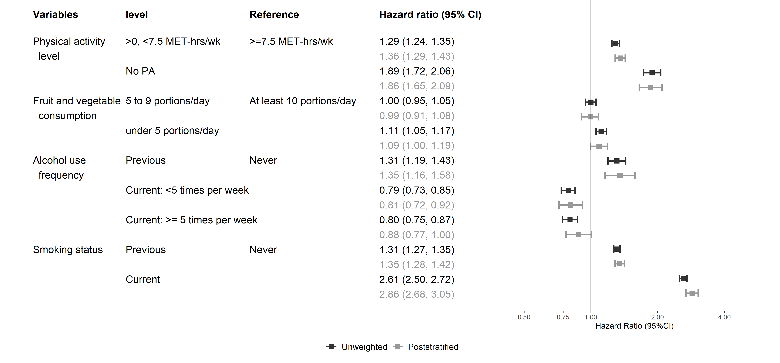

*Model additionally adjusted for age, sex, highest qualification, history of CVD and cancer.
eFigure 3: Adjusted hazard ratios* of lifestyle index for cause mortality, excluding people with history of cancer or CVD
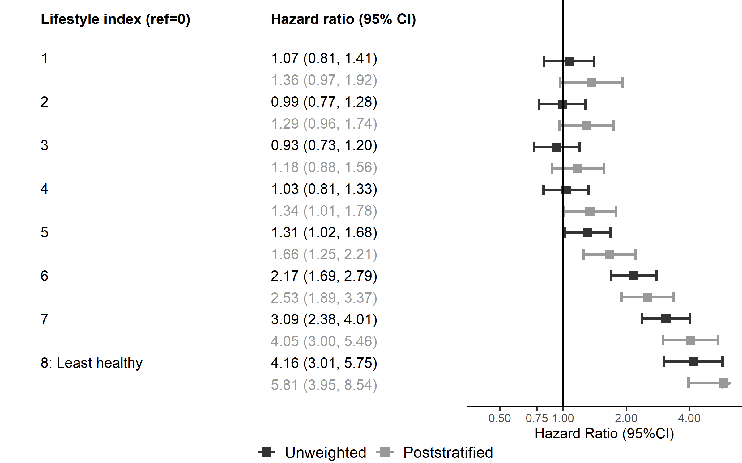

*Model adjusted for age, sex, highest education qualification

eFigure 4: Adjusted hazard ratios* of lifestyle index tertiles and all-cause mortality, including people with history of cancer and CVD (n=371,902)
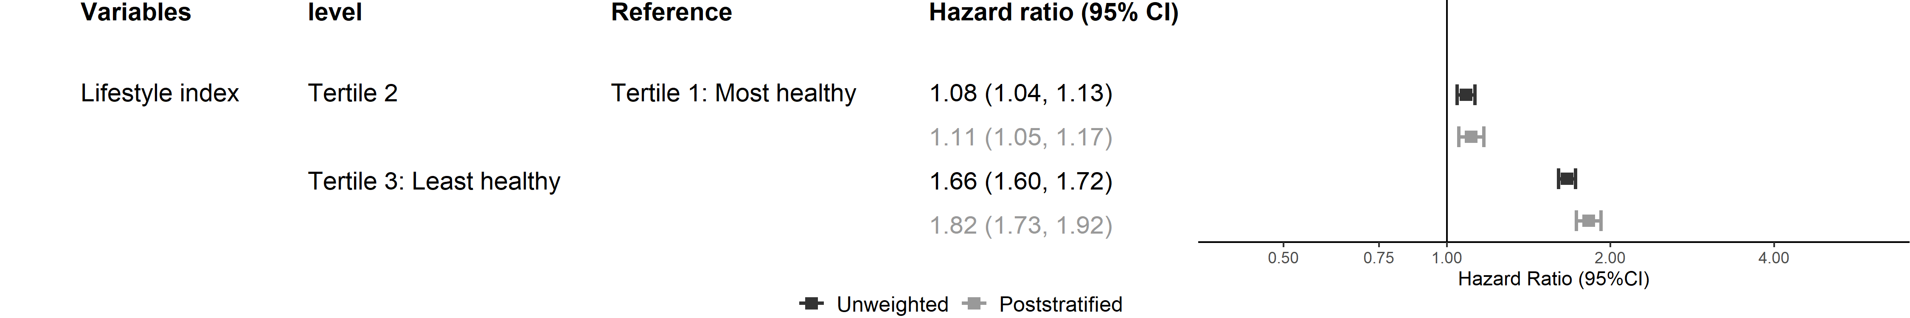
*Model adjusted for age, sex, highest qualification, and history of CVD or cancer

eFigure 5: Adjusted hazard ratio of each lifestyle risk factor for all-cause mortality, excluding people with history of cancer and CVD, with multiple imputation (n= 400,793)
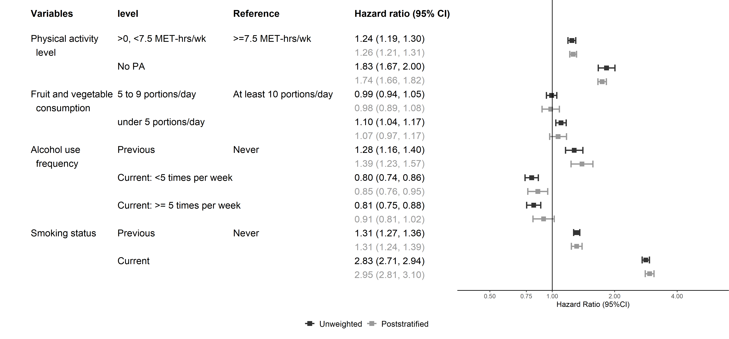
*Model additionally adjusted for age, sex, highest qualification.

eFigure 6: Adjusted hazard ratios* of lifestyle index for CVD mortality, excluding people with history of cancer or CVD, with multiple imputation (n= 400,793)
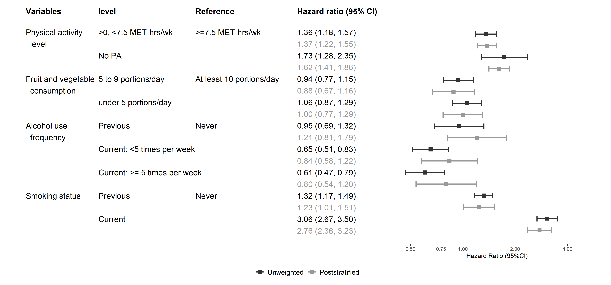

*Model additionally adjusted for age, sex, highest qualification.

eFigure 7: Adjusted hazard ratios* of lifestyle index tertiles for cancer mortality, excluding people with history of cancer and CVD, with multiple imputation (n= 400,793)
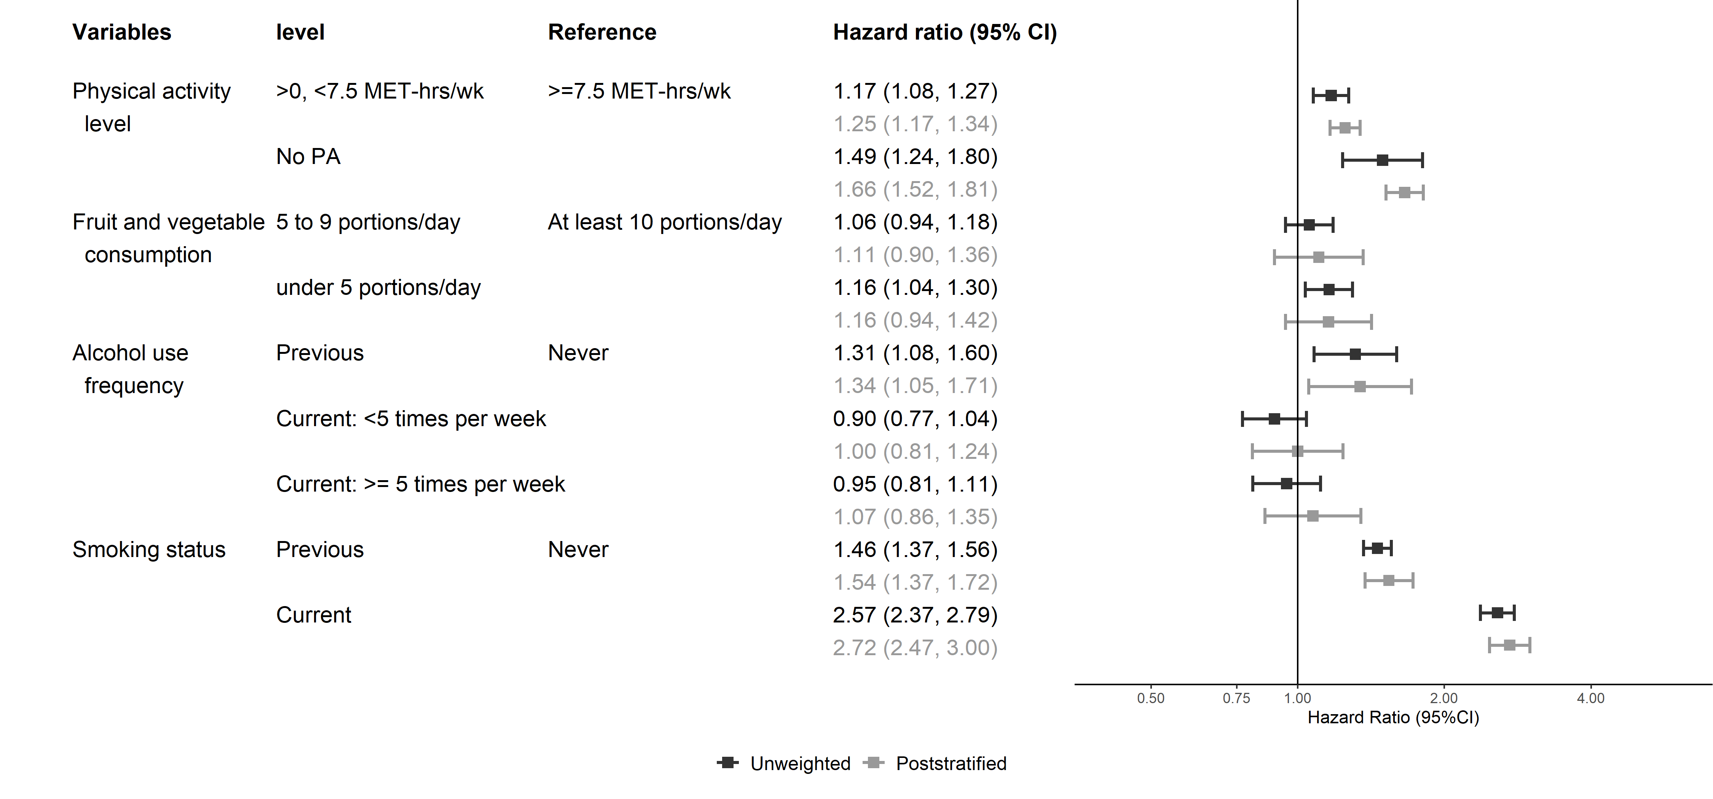

*Model additionally adjusted for age, sex, highest qualification.

