### Surveillance-to-Diagnostic Testing Program for Asymptomatic SARS-CoV-2 Infections on a Large, Urban Campus - Georgia Institute of Technology, Fall 2020

### 

### **Running title: Asymptomatic SARS-CoV-2 College Testing**

*Greg Gibson, PhD1,2; *Joshua S. Weitz, PhD1,2,3; *Michael P. Shannon, PhD 4; Benjamin Holton, MD5; Anton Bryksin, PhD 2; Brian Liu, BSEE4, MBA; Madeline Sieglinger, BS1; Ashley R. Coenen, BS3; Conan Zhao, BS1,6; Stephen J. Beckett, PhD1; Sandra Bramblett, BS7; JulieAnne Williamson, MSEE, MSIE8; Michael Farrell, PhD **4**, MBA; Alexander Ortiz, MBA8; Chaouki T. Abdallah, PhD9; Andrés J. García, PhD2,10.

**Supplementary Figures.**



**eFigure S1. Testing rates in Fall 2020 in residence halls.** (A) The total number of surveillance tests per day during the Fall semester 2020. By week 3, the laboratory was fully operational and capable of handling more than 1500 tests per day, Monday through Friday. (B) For one typical large dormitory with 479 residents, targeted messaging to encourage testing after positives were detected may have increased participation for example after 10/11 and 10/25, but no clear spike was observed above background. Some of the larger residences such as this one had between 50% and 70% participation each week.

**Supplementary Figure 2.**

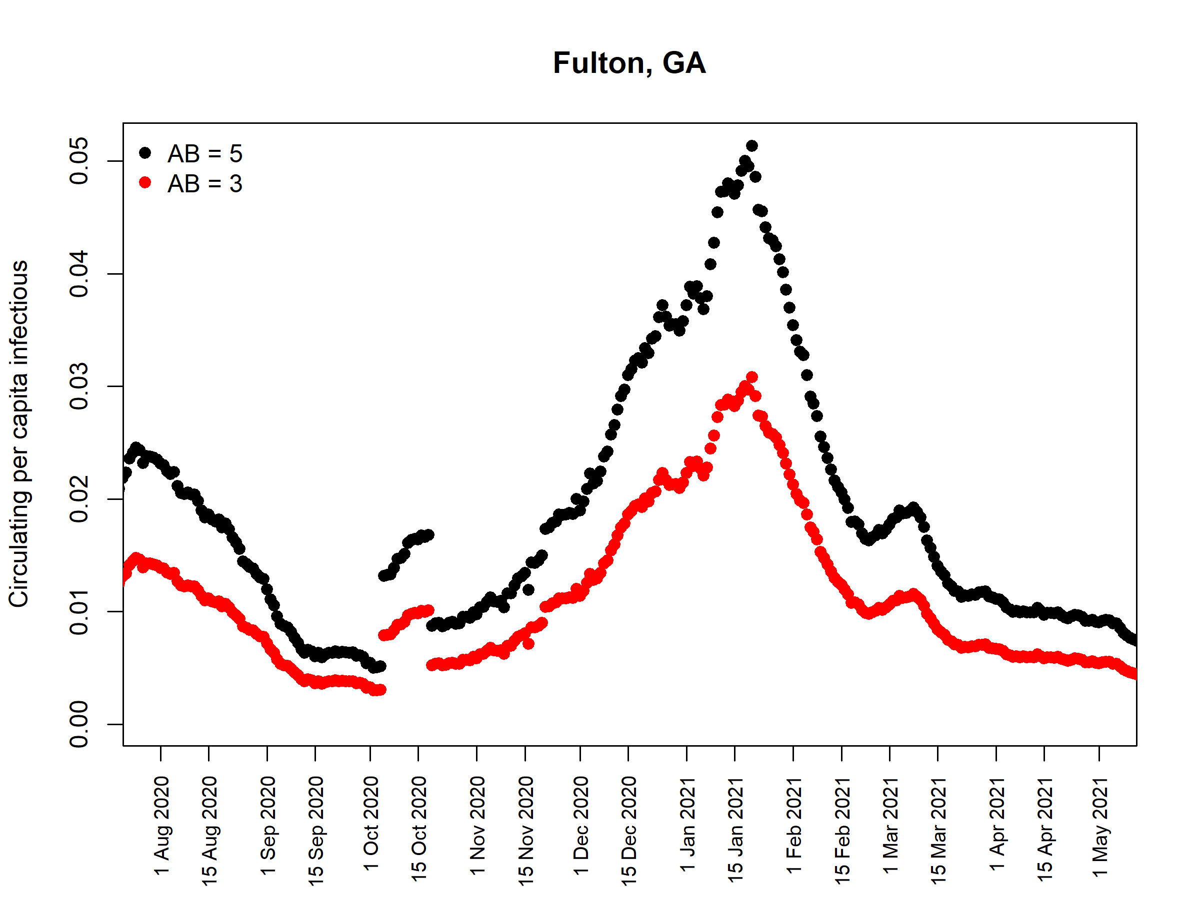

**eFigure S2**. Modeled positivity in Fulton Country, August 2020 through April 2021. Using the method described in (1), the prevalence of infected individuals (within 10 days of PCR positive) assumes that many cases remain unreported. We use an ascertainment bias of AB=3 and AB=5 in Fulton county – the county in within which Georgia Tech is located. As of May 2021, the CDC estimates that 1 in 4.2 cases was ascertained https://www.cdc.gov/coronavirus/2019-ncov/cases-updates/burden.html. The background rate dropped to ~0.5% in October, but rebounded to levels well above those maintained on campus.