eAppendices

eAppendix 1. Selection bias in pregnancy trials restricted to livebirths
As we mentioned in the text, spontaneous abortions may be competing events that occur before organogenesis (pregnancy needs to survive until the outcome).¹ However, some spontaneous abortions after organogenesis may themselves result from structural malformations; and elective abortions further reduce the prevalence of some major malformations at birth (pregnancy needs to survive with the outcome for the outcome to be observed). Although we would prefer to include malformations from all conceptuses to evaluate teratogenicity, most studies consider the prevalence of malformations among livebirths since pathology is rarely available for spontaneous abortions and terminations. In eFigure 1, we would assess the effect of A (e.g., vaccine) on M* (detected malformations with some measurement error). Target trials based on databases lacking this information would select cases prevalent at birth as well. Failure to include malformations in pregnancy losses underestimates the incidence of malformations, particularly for defects for which termination is often chosen after prenatal diagnosis (e.g., neural tube defects).^{2,3} Restricting the analysis to livebirths is conditioning on S (a competing event) and T, and using a misclassified outcome (M*), which may induce noncausal associations between A and M*.⁴ A confluence of selection and measurement biases. However, if this missingness is random with respect to vaccination, i.e., no arrow between vaccination and abortions and terminations in eFigure 1, the relative risk for malformations may be unbiased.⁵ We can assess the robustness of the findings to this survivor biases by comparing the frequency of pregnancy losses between vaccinated and nonvaccinated groups; using a composite outcome of losses and malformations; and estimating risk bounds or conducting probabilistic bias analyses to quantity the potential impact of restricting to livebirths.^{6,7}
eFigure 1. Causal directed acyclic graph depicting a periconceptional target trial of vaccination. The potential effect of vaccine exposure in first weeks of pregnancy (A) on the risk of early spontaneous abortions (S), malformations (M), late pregnancy losses or terminations (T) and obstetric outcomes such as preeclampsia (Y). Malformations (M) affect the risk of T, which affects the observation of malformations at birth (M*).
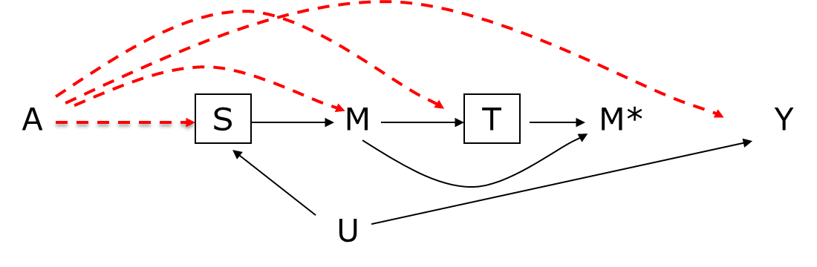

eAppendix 2. Case-crossover and case-time-control designs in pregnancy
Case-crossover^{8,9} and case-time-control designs¹⁰ can be used to study the transient effects of point exposures (e.g., vaccination) on outcomes with clear onset (e.g., spontaneous abortions, preterm delivery) if the exposure has no carry over effects and the effect is constant over time and across people.^{9,11} These designs may bypass some of the challenges discussed in the text (i.e., between person confounding, missing vaccinations and uncertain gestational age).
The case-crossover design uses the data from the cases only, which are used to compute the ratio of the odds of vaccination in, say, the 2 weeks before the event (risk period) divided by the odds of vaccination in a 2-week reference period (say, 4 to 5 weeks before the event). eFigure 2. Because of the stratification within person, this analysis eliminates confounding by time-fixed factors, though not by time-varying factors. It also bypasses the issue of missing vaccinations because the estimation of within-person matched odds ratio includes only women with vaccination in either the risk or reference window (but not both or neither). Moreover, the case-crossover design is independent from gestational age at the time of the outcome, therefore it accommodates data sources with unreliable or missing gestational age (e.g., claims databases). However, the case-crossover design assumes no time trends in vaccinations between the risk and reference periods (i.e., that vaccination probability is not affected by pregnancy recognition).¹²
The case-time-control design corrects for time trends.¹⁰ To do so, data from non-cases (matched to the cases on gestational age risk and reference periods) are used to compute an odds ratio analogous to that of the case-crossover design. Then the case-crossover odds ratio in the cases is divided by this analogous odds ratio in the non-cases. This calculation only corrects for time trends if they are adequately captured on the odds ratio scale and assumes non-cases represent the expected trends in cases under the null. Also, it requires accurate gestational age information. When accurate gestational timing for abortions is missing, we propose a solution in Appendix 3.
Though the odds ratio estimates from case-crossover and case-time-control designs are difficult to interpret quantitatively,⁹ an effect estimate in the same direction as that from the main analysis increases our confidence in the result.¹³
eFigure 2. Schematic representation of 3 designs to study the effect of a point exposure on spontaneous abortions (SAB). The case-crossover (A) compares risk and reference periods within cases with an odds ratio; the case-time-control (B) compares risk and reference periods within non-cases to estimate the odds ratio for exposure trends and corrects the odds ratio from cases for these time trends by dividing the two odds ratios; and the traditional between-person case-control design (C) that compares the frequency of exposure during the risk period between cases and non-cases.¹³ The histogram represents the weekly probability of SAB in the source population of the study.

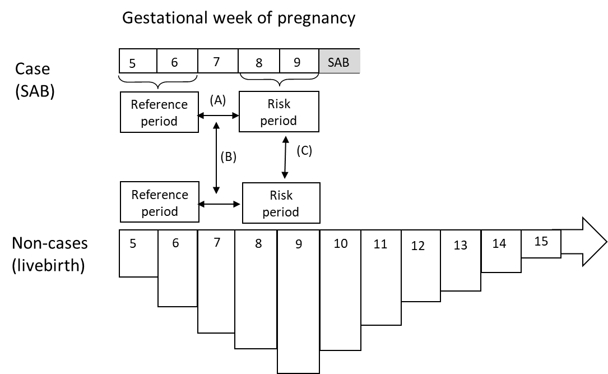
eAppendix 3. Circumventing unreliable information on gestational age
SABs occur with a predictable gestational age distribution in pregnancy (represented in histogram of eFigure 2 above). To assess the acute effect of a vaccine on the risk of SAB, if we had complete information on the gestational age at SAB, we would compare the vaccination status at the time of the SAB (e.g., during the prior 2 weeks) among cases to the frequency of vaccinations among non-cases in that risk set (i.e., same gestational week since start of pregnancy). Alternatively, for each case we could sample a number of non-cases matched on time and compare the exposure at the time of event (e.g., vaccination in the prior 2 weeks) between cases and non-cases (see case-control design in eFigure 2 above). Note that, since SABs are relatively infrequent, we can compare the probability of vaccination in the 2 weeks before the event in the cases with that in a gestational age-matched 2-week window in the livebirths (versus the eligible set of pregnancies at each risk set, which would include future SABs), i.e., controls would be sampled from “non-cases” rather than from person-time. Matching on time is crucial because of potential time trends in vaccination around pregnancy recognition.
In healthcare databases the last menstrual period (LMP) is often calculated subtracting the estimated gestational age at end of pregnancy from the end of pregnancy date. The end of pregnancy date is recorded for both deliveries and pregnancy losses. Since gestational age at delivery can be accurately estimated, the LMP date and thus the gestational age at vaccination is reasonably accurate for livebirths.^{14,15} However, the gestational age at the time of pregnancy losses and thus the LMP and thus the gestational age at vaccination are uncertain for SABs.¹⁶ When confronted with this predicament, we propose a sensitivity analysis that uses information on the distribution of gestational age at SAB in the general population (e.g., from published statistics)^{17,18} rather than the actual gestational age at SAB for individual cases. While we may not know the specific timing of each SAB, we do know the overall expected distribution. For example, in the extreme, imagine that SABs always occur 40% on week 10 and 60% on week 15. We would not have information on the timing of SABs in our data, but we estimate that 40% occur on week 10 and 60% on week 15. Therefore, to obtain the same distribution of exposure windows timing among livebirths, we will consider their vaccination at an index date within weeks 10 and 15 and assign weights of 0.4 and 0.6 (or sampling 40% of control livebirths at their week 10 and 60% at their week 15). Imagine that the vaccination frequency estimated among livebirths was 2 per 1000 on the risk window corresponding to week 10 (e.g., vaccination within 8.5 to 10.5 weeks of gestation) and 1 per 1000 on week 15; on average (2x0.4+1x0.6 per 1000). That estimated vaccination frequency in the exposure window will be the reference for that estimated for the cases using the exposure window before the date of SAB.
Therefore, the distribution of gestational weeks at index date for non-cases will be proportional to the expected distribution for SABs (without ever having to know the gestational age at SAB). We use the risk window before the index date to estimate the expected frequency of vaccination in the non-cases as a reference for the frequency in SAB cases. Under the null, within levels of confounders, the average vaccination frequency in the risk window would be the same for cases and non-cases. However, because the individual matching is broken in the proposed analysis, in the presence of vaccine effects on SAB, the odds ratio estimate would be biased when the vaccination affects the distribution of SABs (e.g., if there are vaccination trends). Also, lack of information on the specific gestational age at SAB would not allow evaluation of potential heterogeneity of effects by week at vaccination. Same rationale would apply to the case-time-control if controls are sampled following the expected distribution of index dates. In conclusion, the proposed analysis is not the optimal approach, it is just a sensitivity analysis in the absence of accurate timing of SABs.

References
1. Chiu YH, Stensrud MJ, Dahabreh IJ, et al. The Effect of Prenatal Treatments on Offspring Events in the Presence of Competing Events: An Application to a Randomized Trial of Fertility Therapies. Epidemiology. 2020;31(5):636-643.
2. Svensson E, Ehrenstein V, Norgaard M, et al. Estimating the proportion of all observed birth defects occurring in pregnancies terminated by a second-trimester abortion. Epidemiology. 2014;25(6):866-871.
3. Friedberg MK, Silverman NH, Moon-Grady AJ, et al. Prenatal detection of congenital heart disease. The Journal of pediatrics. 2009;155(1):26-31, 31 e21.
4. Hernán M, Hernandez-Diaz S, Robins JM. A structural approach to selection bias. Epidemiology. 2004;15(5):615-625.
5. Heinke D, Rich-Edwards JW, Williams PL, et al. Quantification of selection bias in studies of risk factors for birth defects among livebirths. Paediatric and perinatal epidemiology. 2020;34(6):655-664.
6. Greenland S. Basic methods for sensitivity analysis of biases. International journal of epidemiology. 1996;25(6):1107-1116.
7. Khoury MJ, Flanders WD, James LM, Erickson JD. Human teratogens, prenatal mortality, and selection bias. American Journal of Epidemiology. 1989;130:361-370.
8. Maclure M. The Case-Crossover Design: A Method for Studying Transient Effects on the Risk of Acute Events. American Journal of Epidemiology. 1991;133:144-153.
9. Shahn Z, Robins JM, Hernán MA. A formal causal interpretation of the case-crossover design. Biometrics. 2022;in press.
10. Suissa S. The Case-Time-Control Design. Epidemiology. 1995;6:248-253.
11. Maclure M, Mittleman MA. Should we use a case-crossover design? Annual Reviews in Public Health. 2000;21:193-221.
12. Greenland S. Confounding and exposure trends in case-crossover and case-time-control designs. Epidemiology. 1996;7:231-239.
13. Hernandez-Diaz S, Hernán M, Meyer K, Werler MM, Mitchell AA. Case-crossover and case-time-control designs in birth defects epidemiology. Am J Epidemiol. 2003;158(4):385-391.
14. Margulis AV, Setoguchi S, Mittleman MA, Glynn RJ, Dormuth CR, Hernandez-Diaz S. Algorithms to estimate the beginning of pregnancy in administrative databases. Pharmacoepidemiology and drug safety. 2012.
15. Margulis AV, Palmsten K, Andrade SE, et al. Beginning and duration of pregnancy in automated health care databases: review of estimation methods and validation results. Pharmacoepidemiology and drug safety. 2015;24(4):335-342.
16. MacDonald SC, Cohen JM, Panchaud A, McElrath TF, Huybrechts KF, Hernandez-Diaz S. Identifying pregnancies in insurance claims data: Methods and application to retinoid teratogenic surveillance. Pharmacoepidemiology and drug safety. 2019;28(9):1211-1221.
17. Mukherjee S, Velez Edwards DR, Baird DD, Savitz DA, Hartmann KE. Risk of miscarriage among black women and white women in a U.S. Prospective Cohort Study. Am J Epidemiol. 2013;177(11):1271-1278.
18. Savitz DA, Hertz-Piccioto I, Pool C, Olshan AF. Epidemiologic measures of the course and outcome of pregnancy. Epidemiologic reviews. 2002;24(2):91-101.

