eAPPENDICES

Generalized Difference-in-Differences
David B. Richardson, TingYe, Eric J. Tchetgen Tchetgen

eAPPENDIX 1. Identification of the treatment effect.

eAPPENDIX 2. Example computer code.

eAPPENDIX 3. Additional simulations.

eAPPENDIX 1. Identification of the treatment effect.

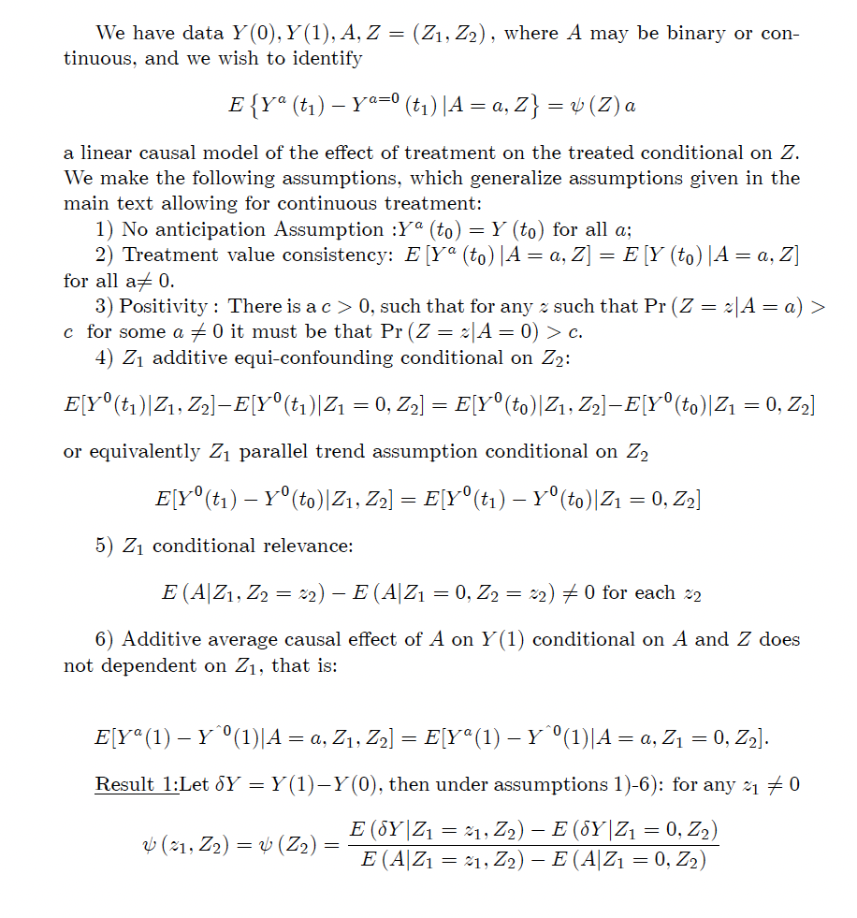
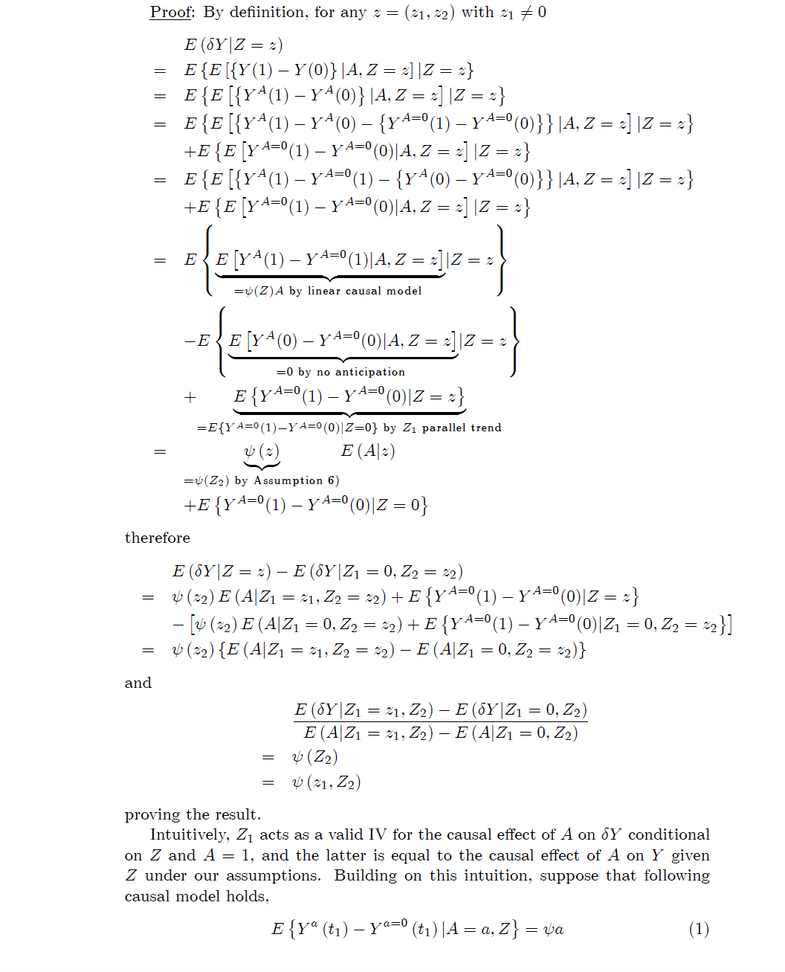
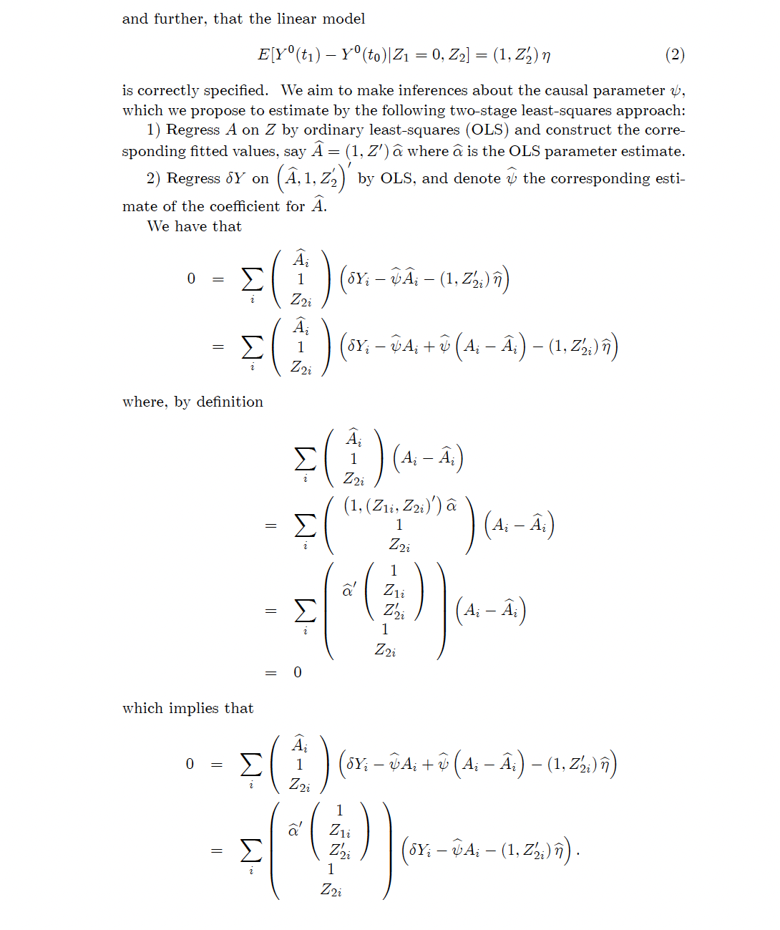

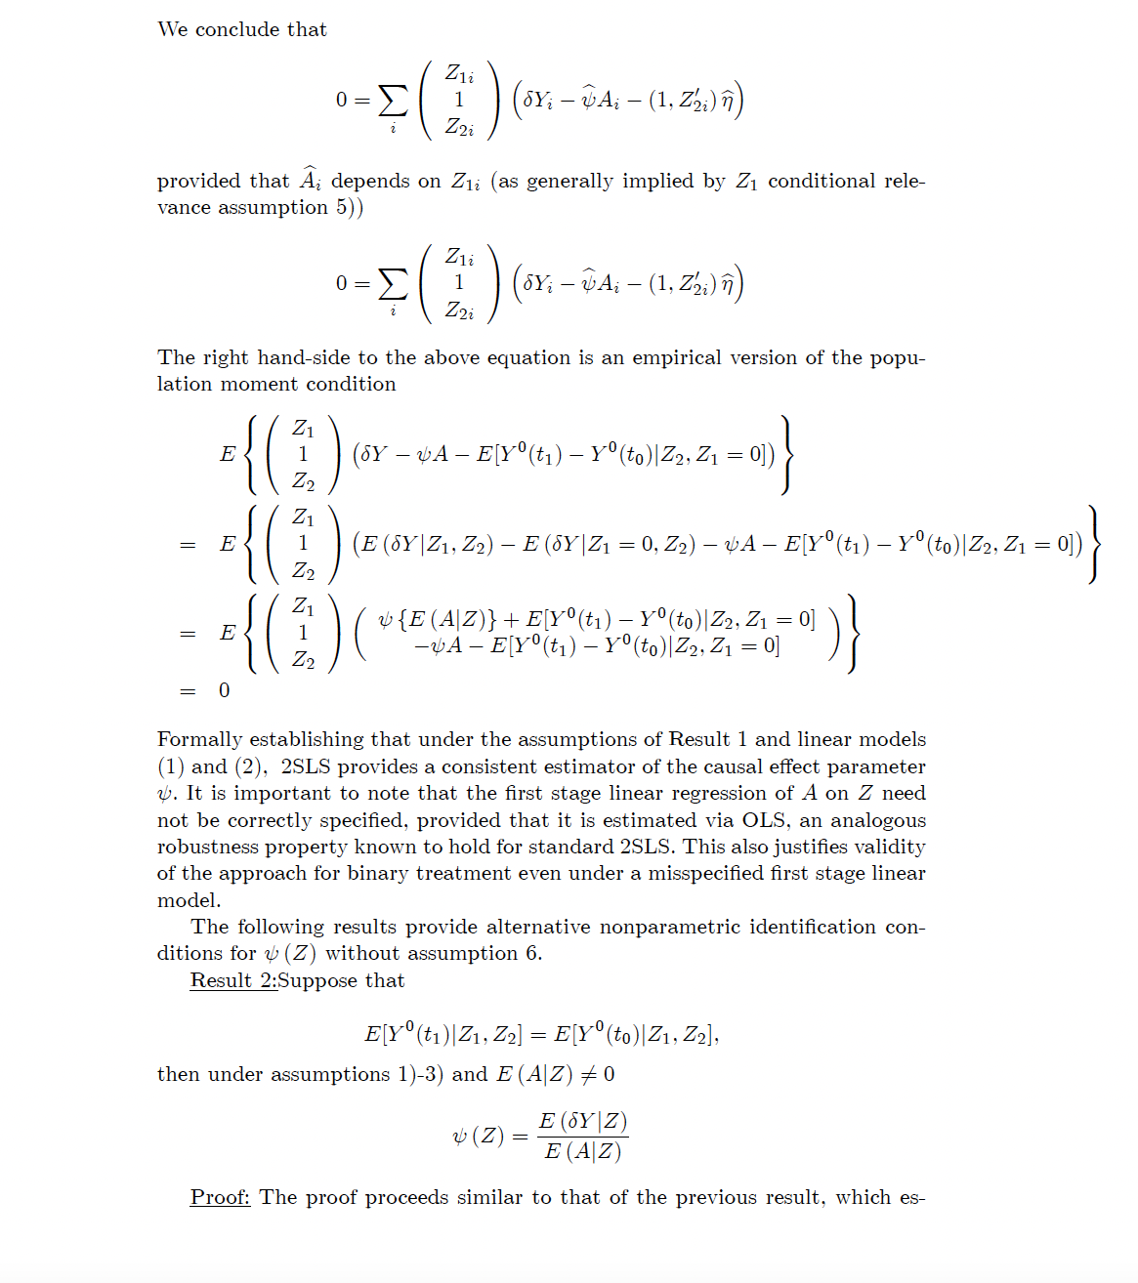
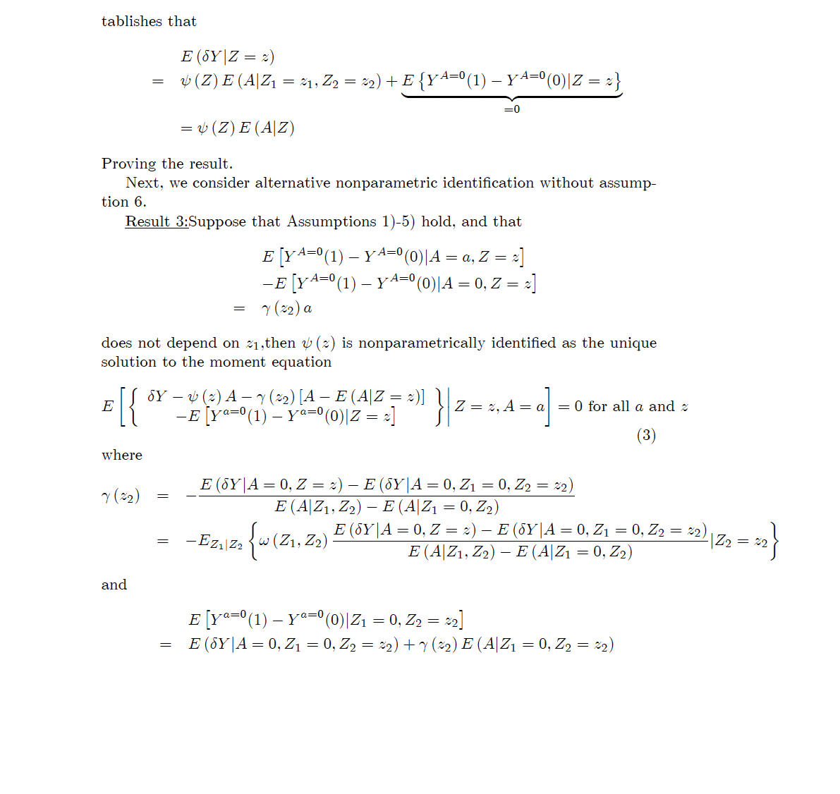
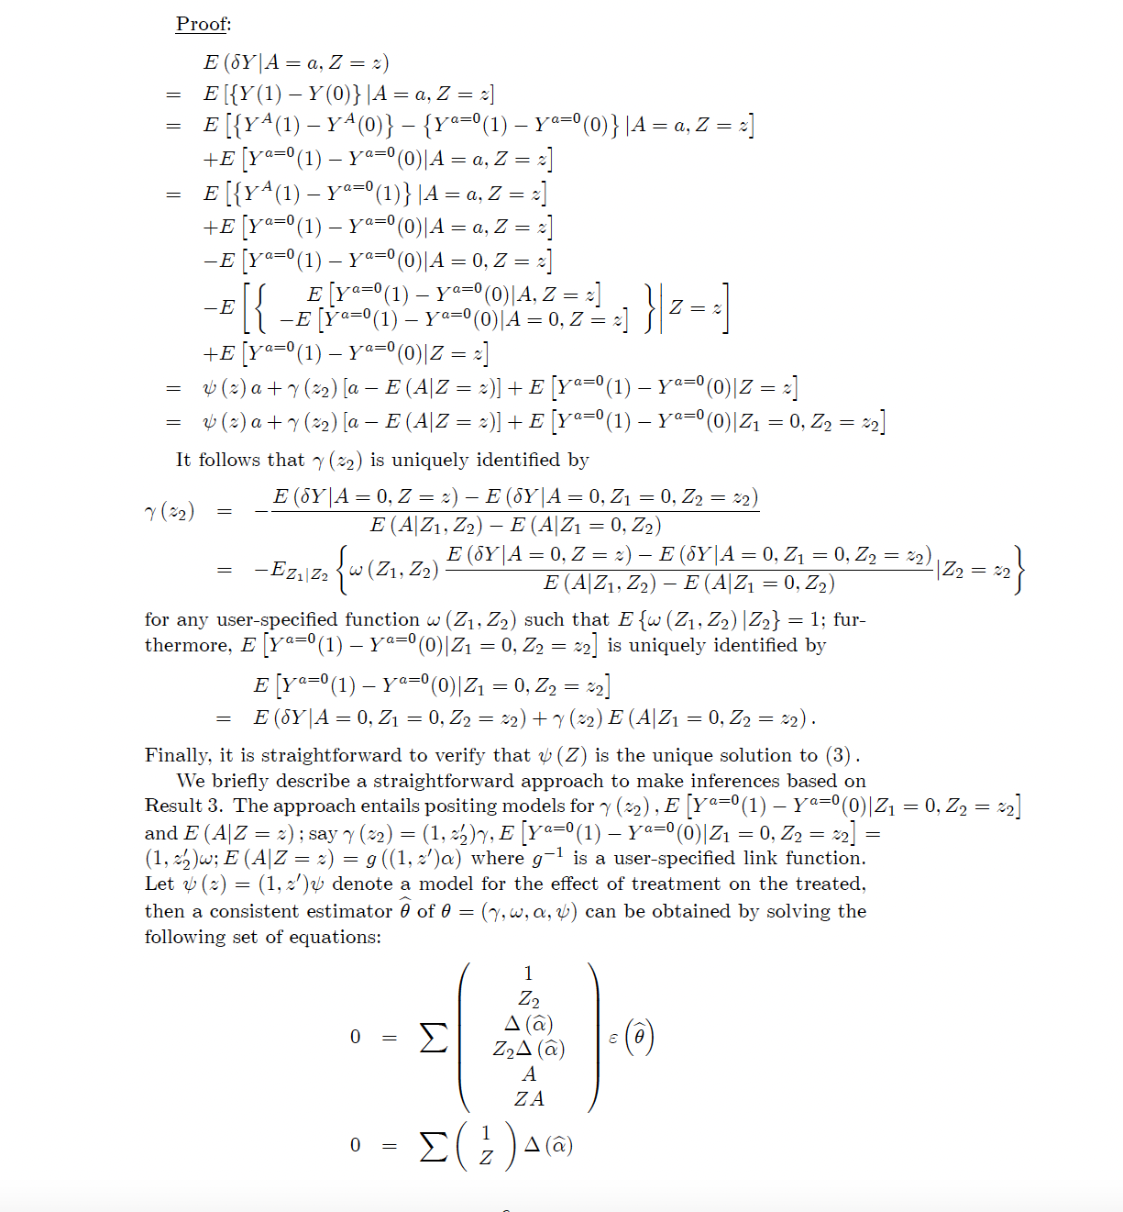

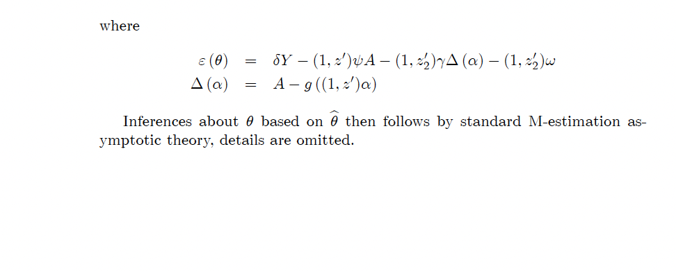

eAPPENDIX 2. Example computer code.
SAS code for a generalized DID estimator.
We assume an exposure variable of primary interest (A), covariate (Z1), and outcome variables (Y0 and Y1) measured at times 0 and 1, respectively. In the example, the original dataset is named ONE.

* Calculate difference between post- and pre-treatment outcomes;
data TWO;
set ONE;
DIFFY=Y1-Y0;

*Fit proposed generalized DID;
proc model data=TWO;
exogenous Z1;
endogenous A DIFFY;
DIFFY = p0 + p1 *A;
A = intercep + p2*Z1;
fit DIFFY A / n2sls FSRSQ;
instruments Z1; run;

R code for a generalized DID estimator

We assume an exposure variable of primary interest (a), covariate (z1), and outcome variables (y_pre and y_post) measured at times 0 and 1, respectively.

library(ivreg)
library(lmtest)
library(sandwich)

gdid<-function(y_pre,y_post,a,z1,robust.se=FALSE){
y_diff<-y_post-y_pre
fit_gdid<-ivreg(y_diff~a|z1)
if(robust.se==TRUE){
se<-coeftest(fit_gdid, vcov = vcovHC, type = "HC3")[2,2]
}else{
se<-summary(fit_gdid)$coefficients[2,2]
}

return(list(est=summary(fit_gdid)$coefficients[2,1],
se=se,
f.statistic=summary(fit_gdid)$diagnostic[1,3]))
}

eAPPENDIX 3. Additional simulations.

Additional simulations were conducted. In each scenario, we considered respectively the case when Z₁ is strongly ($γ_{z}$=2), moderately ($γ_{z}$=1), and weakly ($γ_{z}$=0.4) associated with A.

In simulation A1, U₁ affected Z₁, but otherwise the simulation conformed to the ‘parallel trends’ assumption in simulation scenario 1. We generated an unmeasured covariate, denoted U₁, as a random binary variable. U₁ affected the measured covariate, denoted Z₁, which was a random variable with probability 0.4+0.2 U₁. We assigned A as a random binary variable that took a value of 1 with probability 1/(1+exp(-(-0.1 -0.5×U₁ +$γ_{z}$×Z₁))). The pre-treatment outcome variable, Y(t=0), took a value of (1 +1×U₁ +1×Z₁ + ε), where ε ~N(0,1); and, the post-treatment outcome variable, Y(t=1), took a value of (1 +1×U₁ +1×Z₁ +1×A+ ε).

In simulation A2, U₁ affected Z₁, but otherwise conformed to the second scenario, which violated the ‘parallel trends’ assumption. We generated an unmeasured covariate, denoted U₁, as a random binary variable. U₁ affected the measured covariate, denoted Z₁, which was a random variable with probability 0.4+0.2 U₁. We generated an additional covariate, denoted U_{2,} that was a continuous variable assigned by sampling from a normal (0,1) distribution. We assigned A as a random binary variable that took a value of 1 with probability 1/(1+exp(-(-0.1 -0.5×U₁ -0.5×U₂ +$γ_{z}$×Z₁))). The pre-treatment outcome, Y(t=0), took a value of (1 +1×U₁ +1×U₂ +1×Z₁ + ε); and, the post-treatment outcome, Y(t=1), took a value of (1 +1×U₁ +1×Z₁ +1×A+ ε).

In simulation A3, U₂ affected Z₁, but otherwise conformed to the second scenario, which violated the ‘parallel trends’ assumption. We generated an unmeasured covariate, denoted U₁, as a random binary variable. We generated an additional covariate, denoted U_{2,} that was a continuous variable assigned by sampling from a normal (0,1) distribution. U₂ affected the measured covariate, denoted Z₁, which was a random variable with probability 1/(1+exp(-(-0.5+0.5 U₂). We assigned A as a random binary variable that took a value of 1 with probability 1/(1+exp(-(-0.1 -0.5×U₁ -0.5×U₂ +$γ_{z}$×Z₁))). The pre-treatment outcome, Y(t=0), took a value of (1 +1×U₁ +1×U₂ +1×Z₁ + ε); and, the post-treatment outcome, Y(t=1), took a value of (1 +1×U₁ +1×Z₁ +1×A+ ε).

eTable. Monte Carlo mean, standard deviation (SD), and root MSE (RMSE), average standard error (SE), and coverage probability (CP) of 95% asymptotic confidence interval for 1000 cohorts with 5,000 observations each. Results of simulations of association between exposure, A, measured covariate, Z, unmeasured covariate, U, and outcome, Y.

Scenario | Mean | SD | RMSE | SE | CP
Scenario A1
Strong bespoke IV (Mean F-statistic 1050.5)
GDID method  Standard DID method | 1.00  1.00 | 0.10  0.04 | 0.10  0.04 | 0.10  0.04 | 95.1  96.1
Moderate bespoke IV (Mean F-statistic 248.7)
GDID method | 1.00 | 0.18 | 0.18 | 0.19 | 95.3
Standard DID method  Weak bespoke IV (Mean F-statistic 27.8)  GDID method  Standard DID method | 1.00  1.00  1.00 | 0.04  0.58  0.04 | 0.04  0.58  0.04 | 0.04  0.59  0.04 | 95.3  97.1  95.7
Scenario A2
Strong bespoke IV (Mean F-statistic 956.0)
GDID method  Standard DID method | 1.00  1.39 | 0.13  0.05 | 0.13  0.40 | 0.13  0.05 | 95.6  0.0
Moderate bespoke IV (Mean F-statistic 223.4)
GDID method | 1.00 | 0.24 | 0.24 | 0.24 | 96.1
Standard DID method  Weak bespoke IV (Mean F-statistic 25.2)  GDID method  Standard DID method | 1.45  0.97  1.47 | 0.05  0.77  0.05 | 0.45  0.77  0.47 | 0.05  0.77  0.05 | 0.0  97.1  0.0
Scenario A3  Strong bespoke IV (Mean F-statistic 744.9)  GDID method  Standard DID method | -0.30  1.22 | 0.15  0.05 | 1.30  0.22 | 0.15  0.05 | 0.0  0.7
Moderate bespoke IV (Mean F-statistic 151.1)
GDID method | -1.71 | 0.38 | 2.74 | 0.39 | 0.0
Standard DID method  Weak bespoke IV (Mean F-statistic 7.8)  GDID method  Standard DID method | 1.35  -15.68  1.42 | 0.05  55.78  0.05 | 0.35  58.20  0.42 | 0.05  99.61  0.05 | 0.0  28.8  0.0

