eFigure. Proportions of First Names of Authors’ Genders by Genderize.io
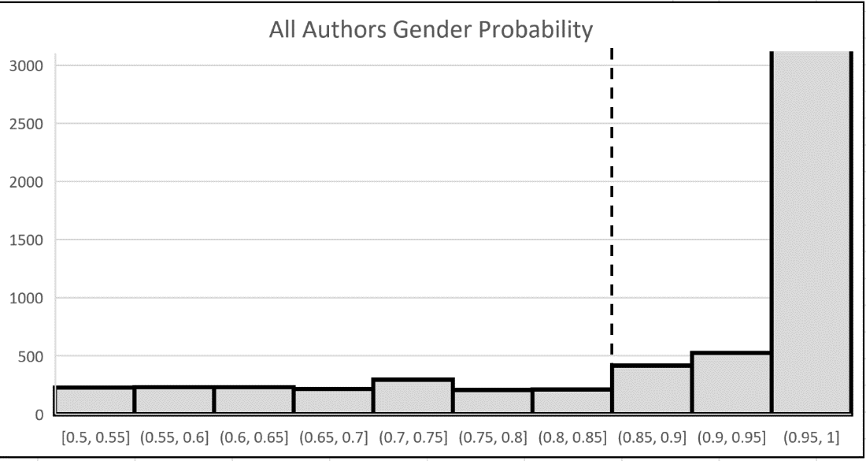

eTable 1a. Quarterly Comparisons of Average Submissions by Authors’ Genders (First Author)
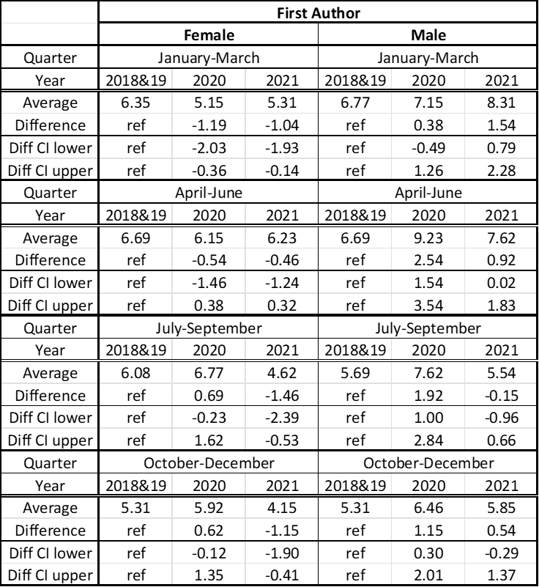

eTable 1b. Quarterly Comparisons of Average Submissions by Authors’ Genders (Last Author)
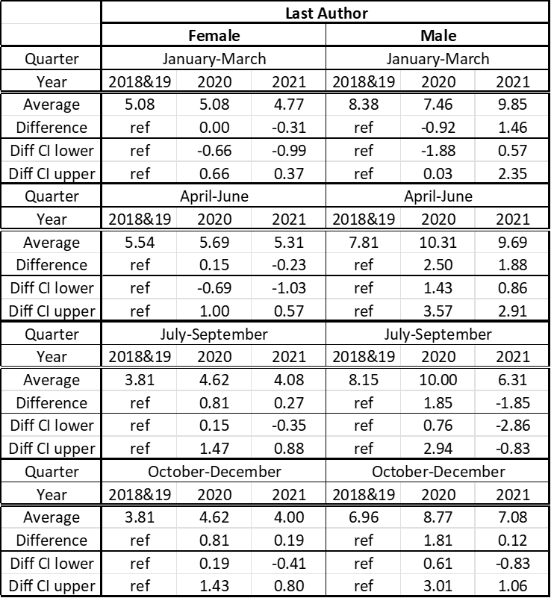

eTable 1c. Quarterly Comparisons of Average Submissions by Authors’ Genders (Corresponding Author)
