Towards a clearer causal question underlying the association between cancer and dementia

Supplemental digital content

Table of Contents

1. Rotterdam Study data operationalization 2
2. Modeling description 3
3. eFigure 1. Distribution of participants under each health status, by age over follow-up 4
4. eFigure 2. Causes of death defined by ICD10 codes for participants who died prior to dementia diagnosis 5
5. eTable 1. Proportion and total number of participants with cancer who remained alive, had dementia or who died over follow-up, by cancer type 6

Rotterdam Study data operationalization
Assessment of incident cancer
Diagnosis of incident cancer was based on medical records of general practitioners (including hospital discharge letters) and furthermore through linkage with Dutch Hospital Data (Landelijke Basisregistratie Ziekenhuiszorg), histology and cytopathology registries in the region (PALGA), and the Netherlands Cancer Registry. Using different sources of cancer diagnoses, the Rotterdam Study aims to capture also the non pathology-confirmed diagnoses. Incident cancer was defined as any primary malignant tumour, excluding non-melanoma skin cancer. Each primary malignant tumour was registered, so that participants could have been diagnosed with multiple cancers. Cancer diagnoses were coded independently by two physicians and classified according to the International Classification of Diseases, 10th revision (ICD-10). In case of discrepancy, consensus was sought through consultation with a physician specialised in internal medicine. Level of uncertainty of diagnosis was established as: certain (pathology-confirmed), probable (e.g., based on imaging features or elevated tumour markers without pathological confirmation), and possible (e.g., based on symptoms and physical examination, without further analysis and without pathological confirmation). Date of diagnosis was based on date of biopsy (solid tumours), laboratory assessment (haematological tumours), or—if unavailable—date of hospital admission or hospital discharge letter. For non pathology-confirmed cancers, we used the date of imaging, date of laboratory assessment, date of physical examination, or—if unavailable—the date of hospital admission or hospital discharge letter. Follow-up was completed up to January 1st, 2014. In case of multiple cancers within one participant, we only included the first diagnosis for analyses.
Assessment of mortality
Information on vital status was updated continuously. Date of death was obtained and verified through notification by the municipal administration. Cause of death was obtained through follow-up of records of general practitioners and hospital discharge letters, and was classified according to the ICD-10 by two research physicians independently. Thereafter, a medical expert in the field reviewed all coded events. Cancer-specific mortality was defined as mortality attributed to malignant neoplasms (ICD-10 C00-C97).

Modeling description
Scenario A: Cancer diagnosis as “ever vs. never” proxy for Pin1
- Treatment weight denominator model
Dependent variable: cancer diagnosis (0 = never, 1 = ever)
Independent variable: age at study entry with natural cubic splines, sex (women vs. men), education (three categories), APOE-ε4 (three categories), smoking status at study entry (three categories), cohort (two categories); no product terms between covariates.
- Censoring by death weight denominator model:
Dependent variable: death status (0 = never, 1 = ever)
Independent variables: age at study entry with natural cubic splines, sex (women vs. men), education (three categories), APOE-ε4 (three categories), cohort (two categories), smoking status at study entry (three categories), hypertension status at study entry (two categories), history of diabetes at study entry (three categories), systolic blood pressure and body mass index at study entry (continuous variables); no product terms between covariates.
Scenario B. Cancer diagnosis as a time-varying proxy for Pin1
- Treatment weight denominator model
Dependent variable: cancer diagnosis status at year k (0 = no, 1 = yes)
Independent variable: age at study entry with cubic splines, sex (women vs. men), education (three categories), APOE-ε4 (three categories), cohort (two categories); time-varying smoking status (three categories), time-varying hypertension status (two categories), time-varying hypertension medication (two categories), incident diagnosis of diabetes (three categories), time-varying systolic blood pressure and body mass (continuous variables); no product terms between covariates.
- Censoring by death weight denominator model:
Dependent variable: death status at year k (0 = no, 1 = yes)
Independent variables: age at study entry with cubic splines, sex (women vs. men), education (five categories), APOE-ε4 (three categories), cohort (two categories); incident cancer diagnosis (yes, no), time-varying smoking status (three categories), time-varying hypertension status (two categories), time-varying hypertension medication (two categories), incident diagnosis of diabetes (three categories), incident heart disease condition (yes, no), incident stroke (yes, no), time-varying systolic blood pressure and body mass (continuous variables) and no product terms between covariates.

eFigure 1. Distribution of participants under each health status, by age over follow-up
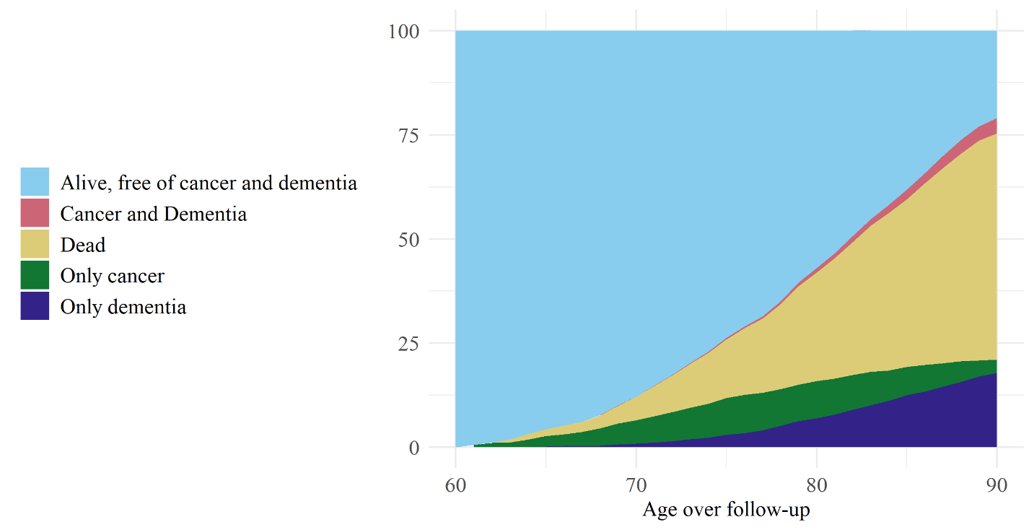

eFigure 2. Causes of death defined by ICD10 codes for participants who died prior to dementia diagnosis

Information on vital status and cause – specific mortality is obtained continuously from the municipal authorities in Rotterdam. General practitioners in the research area report incident events by means of a computerized system, covering 78.8 % of the cohort. General practitioners without the computerized system are requested to notify new events annually. Trained research assistants subsequently collect information from medical records of the general practitioners, hospitals, and nursing homes. Two research physicians independently classify the events according to the ICPC and ICD-10 coding systems. Thereafter, a medical expert in the field reviews all coded events.

eTable 1. Proportion and total number of participants with cancer who remained alive, had dementia or who died over follow-up, by cancer type

Cancer type | Only cancer  % (n) | Cancer and Dementia  % (n) | Dead  % (n)
Central nervous system |  |  | 100 (5)
Unknown primary |  |  | 100 (21)
Pancreatic | 4.2 (1) |  | 95.8 (23)
Other intestinal organs | 5.6 (1) |  | 94.4 (17)
Lung | 6.6 (8) |  | 93.4 (113)
Other | 10 (2) |  | 90 (18)
Stomach | 10 (1) | 10 (1) | 80 (8)
Oesophagus | 21.1 (8) |  | 78.9 (30)
Hematological | 18.6 (13) | 8.6 (6) | 72.9 (51)
Colorectal | 31 (44) | 4.9 (7) | 64.1 (91)
Kidney and renal pelvis | 24 (6) | 12 (3) | 64 (16)
Melanoma | 61.9 (13) | 14.3 (3) | 23.8 (5)
Female genital organs | 29.4 (10) | 8.8 (3) | 61.8 (21)
Head and neck | 51.5 (17) | 6.1 (2) | 42.4 (14)
Bladder | 50 (20) | 5 (2) | 45 (18)
Prostate | 49.4 (83) | 8.9 (15) | 41.7 (70)
Breast | 48.1 (52) | 10.2 (11) | 41.7 (45)

